**NAME: GAIUS DATIABASI IBANGA**

**MATRIC NUMBE: 17/ENG02/029**

**COURSE: ENG382**

**ASSIGNMENT 3**

a)

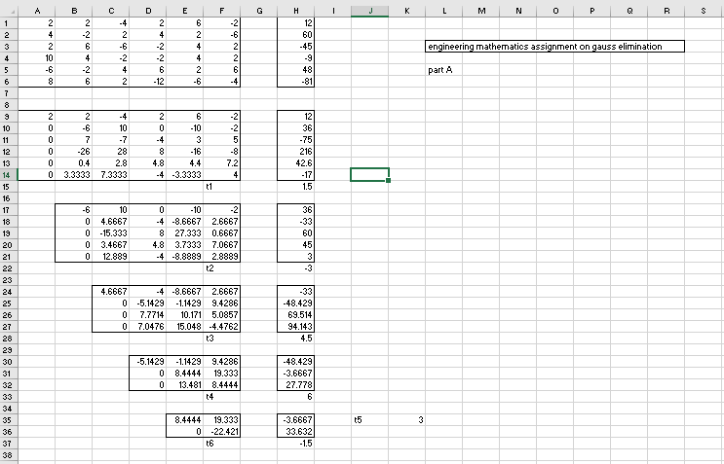

b)

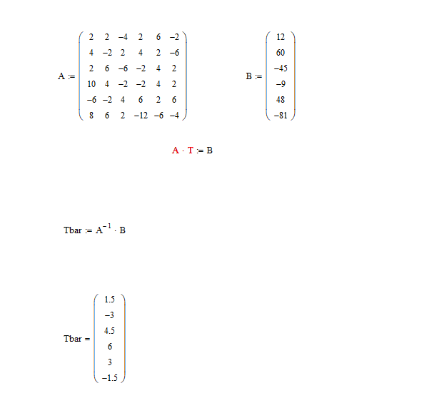

c) 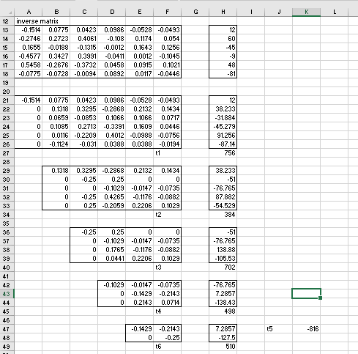

d) 