NAME:EJUONEATSE TOSAN DORCAS
COLLEGE:ENGINEERING
DEPARTMENT:MECHANICAL
MATRIC NO:17/ENG06/029
COURSE:ENG382
Engineering Mathematics Assignment 3
a)
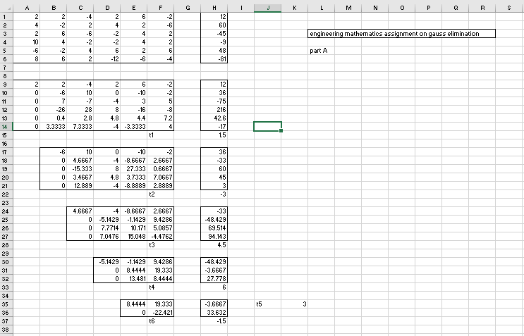

b)
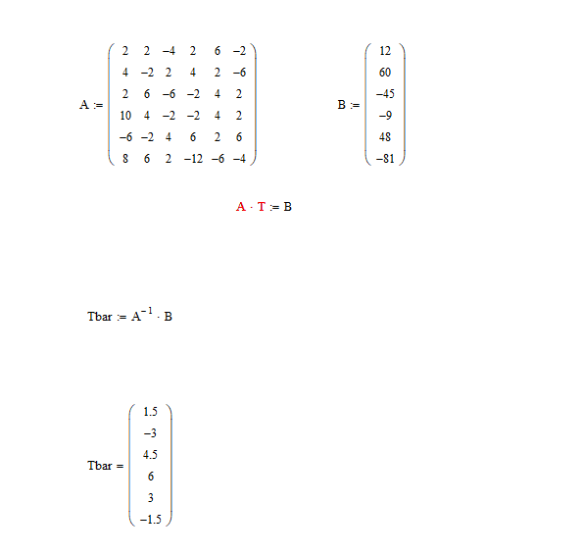

c) 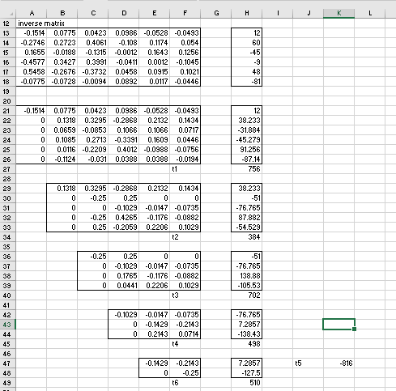
d) 