THE ENGINEERING ASSESSMENT OF WATER QUALITY STANDARDS: PROBLEMS AND WAY FORWARD

BY
AGBEDE GOODNESS YERINMINI
MATRIC NO: 15/ENG03/003

SUBMITTED IN PARTIAL FULFILMENT
OF THE REQUIREMENT FOR THE AWARD OF THE
BACHELOR OF ENGINEEERING (B.ENG) DEGREE IN CIVIL ENGINEERING
TO
ENGR. OYEBODE O. J.
DEPARTMENT OF CIVIL ENGINEERING, COLLEGE OF ENGINEERING, AFE BABALOLA UNIVERSITY, ADO-EKITI,
NIGERIA
MARCH, 2020

ABSTRACT:
Water is the most important in shaping the land and regulating the climate. It is one of the most important compounds that profoundly influence life. The quality of water usually described according to its physical, chemical and biological characteristics. Rapid industrialization and indiscriminate use of chemical fertilizers and pesticides in agriculture are causing heavy and varied pollution in aquatic environment leading to deterioration of water quality and depletion of aquatic biota. Due to use of contaminated water, human population suffers from water borne diseases. It is therefore necessary to check the water quality at regular interval of time. Parameters that may be tested include temperature, pH, turbidity, salinity, nitrates and phosphates. An assessment of the aquatic macro invertebrates can also provide an indication of water quality.
Keywords: Alkalinity, Dissolved Oxygen (D.O.), Eutrophication, Biochemical Oxygen Demand (BOD), Water Quality Index (WQI)

1.0 Introduction
Water is a finite resource that is very essential for the human existence, agriculture, industry etc. Without any doubt, inadequate quantity and quality of water have serious impact on sustainable development. In developing countries, most of which have huge debt burdens, population explosion and moderate to rapid urbanization, people have little or no option but to accept water sources of doubtful quality, due to lack of better alternative sources or due to economic and technological constraints to treat the available water adequately before use .The scarcity of clean water and pollution of fresh water has therefore led to a situation in which one-fifth of the urban dwellers in developing countries and three quarters of their rural dwelling population do not have access to reasonably safe water supplies .
Assessment of water is not only for suitability for human consumption but also in relation to its agricultural, industrial, recreational, commercial uses and its ability to sustain aquatic life. Water quality monitoring is therefore a fundamental tool in the management of freshwater resources. To underpin its importance, World Health Organization (WHO), United Nations Environment Programme (UNEP), United Nations Educational, Scientific and Cultural Organization (UNESCO) and World Meteorological Organization (WMO) launched in 1977, a water monitoring programme to collect detailed information on the quality of global ground and surface water.
Monitoring can be conducted for the following five major purposes:
- characterize waters and identify changes or trends in water quality over time;
- identify specific existing or emerging water quality problems
- gather information to design specific pollution prevention or remediation programs;
- determine whether program goals-such as compliance with pollution regulations or implementation of effective pollution control actions - are being met; and
- respond to emergencies, such as spills and floods.

1.1 Classification of water
Based on its source, water can be divided into ground water and surface water. Both types of water can be exposed to contamination risks from agricultural, industrial, and domestic activities, which may include many types of pollutants such as heavy metals, pesticides, fertilizers, hazardous chemicals, and oils.
Water quality can be classified into four types—potable water, palatable water, contaminated (polluted) water, and infected water. The most common scientific definitions of these types of water quality are as follows:
- Potable water: It is safe to drink, pleasant to taste, and usable for domestic purposes.
- Palatable water: It is esthetically pleasing; it considers the presence of chemicals that do not cause a threat to human health.
- Contaminated (polluted) water: It is that water containing unwanted physical, chemical, biological, or radiological substances, and it is unfit for drinking or domestic use.
- Infected water: It is contaminated with pathogenic organism.

1.2 LITERATURE REVIEW
water quality standards are used for judging the quality of water derived after the treatment process. An evaluation of health risks associated with drinking water is necessary and timely. There are three basic objectives of water treatment, namely, production of water that is safe for human consumption, production of water that is appealing to the customer, and production of water treatment facilities, which can be constructed and operated at a reasonable cost. Standards usually give two values, a guide level (GL) and a maximum admissible concentration (MAC). The GL is the value that is considered satisfactory and constitutes a target value. The MAC is the value that the corresponding concentration in the distributed water must not exceed. Treatment must be provided, where the concentration in the raw water exceeds the MAC. A properly designed plant is not a guarantee of safety of the water and standards regarding them change very often, so plant management must be flexible to ensure continued compliance. Storage and distribution systems need to be accomplished without affecting the quality of the water, and distribution systems should be designed and operated to prevent biological growths, corrosion, and contamination. Standards also specify the methods, frequencies, and nature of the analysis. For total hardness and alkalinity, the standards specify minimum values to be respected when water undergoes softening.

1.3 WATER PARAMETERS USUALLY ANALYSED.
For the assessment of water pollution status of the water bodies, the following water quality parameters were analysed:
(1) Ph.
(2) Specific Conductance
(3) Temperature
(4) Total dissolved solid (TDS)
(5) Total Solids (TS)
(6) Total Alkalinity
(7) Dissolved oxygen (DO)
(8) Chemical oxygen demand (COD)
(9) Biochemical oxygen demand (BOD)
(10) Total Hardness.

1.4 WATER QUALITY PARAMETERS INCLUDED IN WATER ASSESSMENTS
Monitoring lakes requires many different parameters to be sampled. The parameters analysed in this assessment include:

pH
pH is the measure of the acidity of a solution of water. The pH scale commonly ranges from 0 to 14. The scale is not linear but rather it is logarithmic. For example, a solution with a pH of 6 is ten times more acidic than a solution with a pH of 7. Pure water is said to be neutral, with a pH of 7. Water with a pH below 7.0 is considered acidic while water with pH greater than 7.0 is considered basic or alkaline.
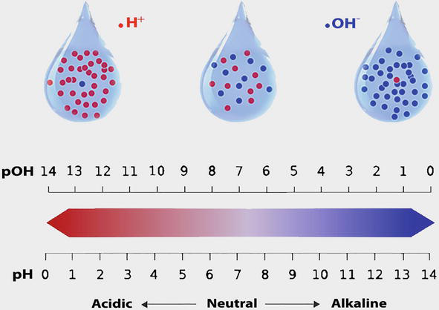
Figure 1.0: Ph Scale

CONDUCTIVITY
Conductivity is a numerical expression of an aqueous solution's capacity to carry an electric current. This ability depends on the presence of ions, their total concentration, mobility, valence and relative concentrations, and on the temperature of the liquid. Solutions of most inorganic acids, bases, and salts are relatively good conductors. In contrast, the conductivity of distilled water is less than 1 µmhos/cm. Because conductivity is the inverse of resistance, the unit of conductance is the mho (ohm spelled backwards), or in low-conductivity natural waters, the micromho.

ALKALINITY
Alkalinity is the sum total of components in the water that tend to elevate the pH to the alkaline side of neutrality. It is measured by titration with standardized acid to a pH value of 4.5 and is expressed commonly as milligrams per litre as calcium carbonate (mg/L as CaCO3). Alkalinity is a measure of the buffering capacity (ability to resist changes in pH) of the water, and since pH has a direct effect on organisms as well as an indirect effect on the toxicity of certain other pollutants in the water, the buffering capacity is important to water quality. Commonly occurring materials in water that increase alkalinity are carbonates, bicarbonates, phosphates and hydroxides.
Limestone bedrock and thick deposits of glacial till are good sources of carbonate buffering. Lakes within such areas are usually well-buffered.

PHOSPHORUS
Phosphorus is an essential plant nutrient and most often controls aquatic plant (algae and aerophyte) growth in freshwater. It is found in fertilizers, human and animal wastes, and yard waste. There is no atmospheric (vapour) form of phosphorus. Because there are few natural sources of phosphorus and the lack of an atmospheric cycle, phosphorus is often a limiting nutrient in aquatic systems. This means that the relative scarcity of phosphorus may limit the ultimate growth and production of algae and rooted aquatic plants. Therefore, management efforts often focus on reducing phosphorus input to a receiving waterway because: (a) it can be managed, and (b) reducing phosphorus can reduce algae production. Two common forms of phosphorus are: Soluble reactive phosphorus (SRP) – SRP is dissolved phosphorus readily usable by algae. SRP is often found in very low concentrations in phosphorus-limited systems where the phosphorus is tied up in the algae and cycled very rapidly. Sources of SRP include fertilizers, animal wastes and septic systems. Total phosphorus (TP) – TP includes dissolved and particulate forms of phosphorus. TP concentrations greater than 0.03 mg/L (or 30g/L) can cause algal blooms in lakes and reservoirs.

NITROGEN
Nitrogen is an essential plant nutrient found in fertilizers, human and animal wastes, yard waste, and the air. About 80% of the atmosphere is nitrogen gas. Nitrogen gas diffuses into water where it can be “fixed” (converted) by blue-green algae to ammonia for algal use. Nitrogen can also enter lakes and streams as inorganic nitrogen and ammonia. Because nitrogen can enter aquatic systems in many forms, there is an abundant supply of available nitrogen in these systems.

LIGHT TRANSMISSION
This measurement uses a light meter (photocell) to determine the rate at which light transmission is diminished in the upper portion of the lake’s water column. Another important light transmission measurement is determination of the 1% light level. The 1% light level is the water depth to which one percent of the surface light penetrates. The 1% light level is considered the lower limit of algal growth in lakes and this area and above is referred to as the euphotic zone.

DISSOLVED OXYGEN (D.O.)
D.O. is the dissolved gaseous form of oxygen. It is essential for respiration of fish and other aquatic organisms. D.O. enters water by diffusion from the atmosphere and as a by- product of photosynthesis.
Table 1.0 Significance Weight and Water Quality Parameters
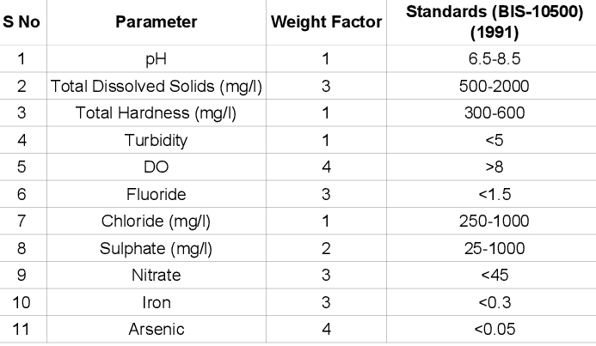

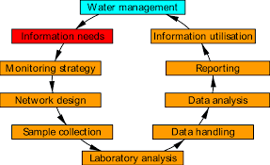
Figure 2.0 Water Quality Assessment Cycle

Table 2: The structure of water quality assessment operations

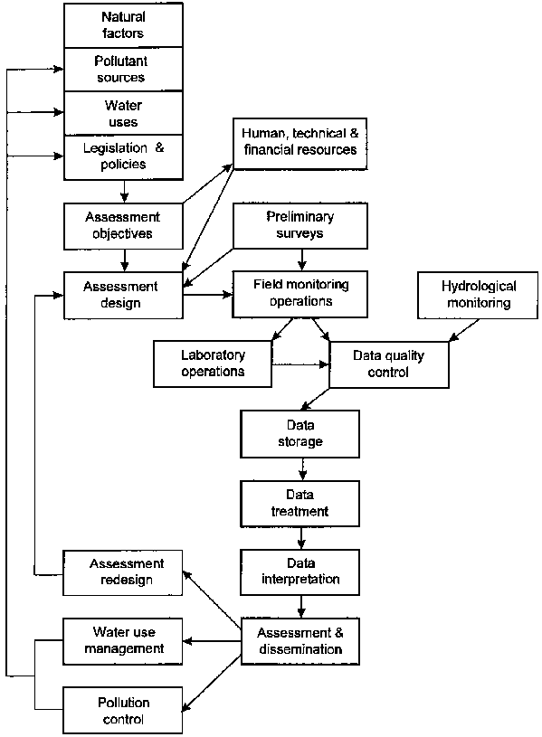

1.5 Water treatment methods
Treatment of raw water to produce water of potable quality can be expensive. It is advisable to determine the quantity of water needing treatment, as not all water used in a fishery harbor or processing plant needs to be of potable quality. Sizing of the equipment is crucial to produce acceptable water at reasonable cost. The main point to remember is that separate systems and pipelines are required for potable and non-potable water to avoid cross contamination. Each system must be clearly identified by contrasting colored pipelines.
Water used for drinking, cleaning fish and ice-making must be free from pathogenic bacteria and may require secondary treatment or even complete treatment depending on chemical elements that need to be removed. Water for other needs like general cleaning may perhaps need only primary treatment.

1.5.1 Primary treatment
There are four methods of primary treatment: chlorination; ozone treatment; ultraviolet treatment; and membrane filtration.
Chlorination: Fresh or sea water can be chlorinated using either chlorine gas or hypochlorite’s. Chlorinated water minimizes slime development on working surfaces and helps control odor.
the main advantages of using chlorine gas are:
• It is the most efficient method of making free chlorine available to raw water.
• It lowers the pH of the water slightly.
• Control is simple; testing simple; and it is not an expensive method.
The main disadvantages are:
• Chlorine gas is toxic and can combine with other chemicals to form combustible and explosive materials.
• Automatic control systems are expensive.
• Chlorine cylinders may not be readily available at small centers.
• Chlorine expands rapidly on heating and hence the cylinders must have fusible plugs set at 70°C. It also reacts with water, releasing heat. Water should not therefore be sprayed on a leaking cylinder.
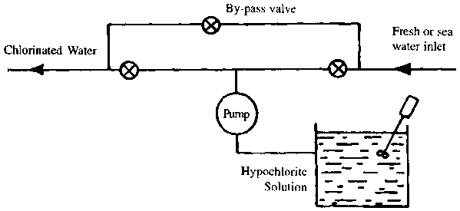
Figure 3.0 Schematic Diagram of Chlorination Test
Ozone treatment: Though the principle is relatively simple, this method needs special equipment, supply of pure oxygen and trained operators. Ozone is generated by passing pure oxygen through an ozone generator. It is then bubbled through a gas diffuser at the bottom of an absorption column, in a direction opposite to the flow of raw water. Retention or contact time is critical and the size of the absorption column depends on the water flow.
The main advantages of ozone treatment are:
• Ozone is a much more powerful germicide than chlorine especially for faecal bacteria.
• It reduces turbidity of water by breaking down organic constituents.
• The process is easily controlled.
The disadvantages are:
• Pure oxygen may not be readily available locally.
• Ozonized water is corrosive to metal piping.
• Ozone decomposes rapidly into oxygen.
• Water has to be aerated prior to use to remove the ozone.
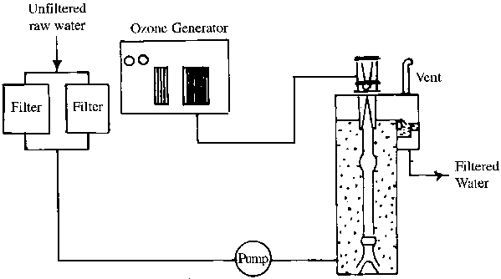
Figure 4.0 Ozone Treatment Test
Ultraviolet irradiation treatment: This method is often used to treat drinking water. Successful commercial installations have been made to purify sea water in large fish processing plants.
The main advantages of U-V treatment are:
• U-V rays in the range of 2500-2600 Angstrom units are lethal to all types of bacteria.
• There is no organoleptic, chemical or physical change to the water quality.
• Overexposure does not have any ill effects.
The main disadvantages are:
• Electricity supply should be reliable.
• Turbidity reduces efficiency.
• Water may require prior treatment like filtration.
• The unit requires regular inspection and maintenance.
• Thickness of the water film should not exceed 7.5 cm.
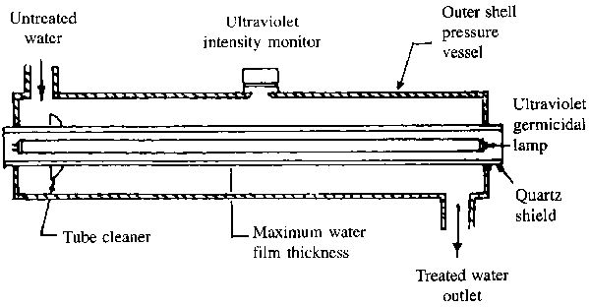
Figure 5.0 Ultraviolet Irradiation Treatment

1.5.2 Secondary treatment
Secondary treatment of water consists of sedimentation and filtration followed by chlorination. Sedimentation can be carried out by holding the raw water in ponds or tanks. The four basic types of filtration are cartridge filtration, rapid sand filtration, multimedia sand filtration, and up-flow filtration.
Cartridge filtration: This system is designed to handle waters of low turbidity and will remove solids in the 5 to 100-micron range.
The main advantages are:
• Low cost and 'in-line' installation.
• Change of cartridge is simple.
• Operation is fool-proof. Once the cartridge is clogged, flow simply stops.
The main disadvantages are:
• Sudden increase in turbidity overloads the system.
• Cartridges may not be readily available and large stocks may be required.
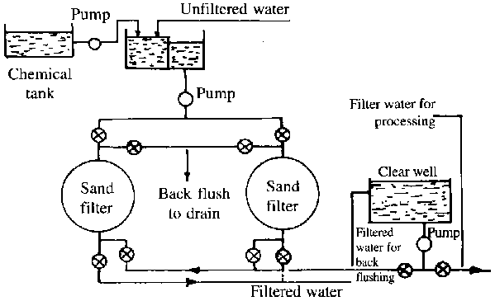
Figure 6.0 Cartridge Test
Rapid sand filtration: This system consists of a layer of gravel with layers of sand of decreasing coarseness above the gravel. As solids build up on top, flow decreases until it stops. This is corrected by back-flushing the system to remove the solid build up on top.
The main advantages are:
• Cost of filtration media is negligible.
• Operation is simple.
The main disadvantages are:
• A holding tank for filtered water is required to provide clear water back flushing.
• Pumping loads increase as sediments build up.

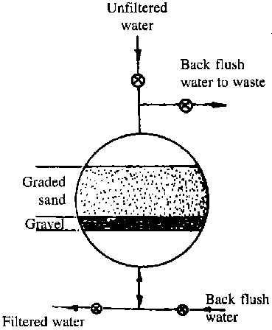
Figure 7.0 Rapid Sand Filtration

1.5.3 Complete treatment
Complete treatment consists of flocculation, coagulation, sedimentation and filtration followed by disinfection. Flocculation and coagulation will assist in removing contaminants in the water, causing turbidity, color odor and taste which cannot be removed by sedimentation alone. This can be achieved by the addition of lime to make the water slightly alkaline, followed by the addition of coagulants like Alum (aluminum sulphate), ferric sulphate or ferric chloride. The resultant precipitate can be removed by sedimentation and filtration.
Chemical treatment may be required to reduce excessive levels of iron, manganese, chalk, and organic matter. Such treatment is usually followed by clarification. Iron may be removed by aeration or chlorination to produce a flocculants which can be removed by filtration. Manganese may be removed by aeration followed by adjustment of pH and up-flow filtration. Most colors can be removed by treatment with ferric sulphate to precipitate the colors.
1.6 PROBLEMS ASSOCIATED WITH ASSESSMENT OF WATER QUALITY
- Lack of Expertise
- Poor Data Collection
- Improper Analysis of Result
- Use of Faulty Equipment During Test.
1.7 SOLUTIONS TO THE PROBLEMS ASSOCIATED WITH THE ASSESSMENT OF WATER QUALITY
- Periodical Checks of Test Equipment
- Use of Proper Data Storage Equipment

Conclusion
This paper has reviewed the water quality assessment and monitoring of surface water. The variation in water quality experienced in Nigeria reflects differences in land management and the physical environment. These differences occur both as a result of natural variability, societal development and pollutant inputs. In addition, water quality in the vicinity of urban areas is influenced by industrial and urban development. Understanding the condition of rivers and streams is critical if Nigeria is to develop effective plans to maintain, manage, and restore them. Water quality is affected in many ways. It changes with the seasons and geographic areas, even when there is no pollution present, therefore we must pay close attention to water quality by monitoring and testing. Like most other countries, the provision of quality water to the ever increasing population of Nigerians cannot be over emphasized. Without an adequate water supply, the millions of Nigerians will suffer, agriculture will be hampered, and the recreational industry will suffer. Therefore, a system that monitors the changing quality of the surface-water resources is highly necessary, and must be put in place by all Federal and State Agencies concerned. Water quality monitoring is therefore, pertinent for provision of data baseline that will be useful for policy makers and stakeholders to formulate policy that will favor protection and management of water resources. The issue of surface water pollution need to be addressed urgently by the Government to safeguard the public health.

Recommendations
Water quality assessment should always be seen in the wider context of the management of water resources, encompassing both the quality and quantity aspects. The usefulness of the information obtained from monitoring is severely limited unless an administrative and legal framework (together with an institutional and financial commitment to appropriate follow-up action) exists at local, regional, or even international, level. Four main reasons for obtaining inadequate information from assessment programmes have been defined.
These reasons are equally applicable to surface waters and are as follows:
- The objectives of the assessment were not properly defined.
- The monitoring system was installed with insufficient knowledge of the water body.
- There was inadequate planning of sample collection, handling, storage and analysis.
- Data were poorly archived.
A further reason could be added:
• Data were improperly interpreted and reported.
To ensure that these mistakes are avoided the basic rules for a successful assessment programme are proposed below.
The Ten Basic Rules for a Successful Assessment Programme
- The objectives must be defined first and the programme adapted to them and not vice versa (as was often the case for multi-purpose monitoring in the past). Adequate financial support must then be obtained.
- The type and nature of the water body must be fully understood (most frequently through preliminary surveys), particularly the spatial and temporal variability within the whole water body.
- The appropriate media (water, particulate matter, biota) must be chosen.
- The variables, type of samples, sampling frequency and station location must be chosen carefully with respect to the objectives.
- The field, analytical equipment and laboratory facilities must be selected in relation to the objectives and not vice versa.
- A complete, and operational, data treatment scheme must be established.
- The monitoring of the quality of the aquatic environment must be coupled with the appropriate hydrological monitoring.
- The analytical quality of data must be regularly checked through internal and external control.
- The data should be given to decision makers, not merely as a list of variables and their concentrations, but interpreted and assessed by experts with relevant recommendations for management action.
- The programme must be evaluated periodically, especially if the general situation or any particular influence on the environment is changed, either naturally or by measures taken in the catchment area.

References
Abu, G. O. and Egenonu, C. (2008). The current pollution status of the new Calabar River in the Niger Delta region of Southern Nigeria: A survey of antibiogram profiles of its bacterial isolates. African Journal of Environmental Science and Technology, Vol. 2, Issue 6, (June 2008), Pp. 134-14. ISSN 1996-0786.
Adebayo, O. T., Balogun, A. M. and Olubiyi, O. A. (2007). Chemical analysis of some industrial effluents that discharge into Lagos Lagoon, Nigeria. Research Journal of Environmental Sciences, Vol. 1, No. 4, pp. 196-199. ISSN 1819-3412.
Adeboyejo, O. A., Clarke, E.O. and Olarinmoye, M.O. (2011). Organochlorine Pesticide Residues in water, sediments, Fin and Shell-fish samples from Lagos Lagoon Complex, Nigeria. Researcher, Vol. 3, pp. 38-45.
www.sciencepub.net/researcher/research0303/06_4630research0303
Adeyemi, D., Anyakora, C., Ukpo, G. and Adedayo, A.and Darko, G. (2011). Evaluation of the levels of organochlorine pesticide residues in water samples of Lagos Lagoon using solid phase extraction method. Journal of Environmental Chemistry and Ecotoxicology, Vol. 3, No. 6, (June 2011), pp. 160-166. ISSN-2141-226X
Agbogu, V. N., Umoh, V. J., Okuofu, C. A., Ameh, J. B., Smith, S. I. (2006). Study of the bacteriological and physicochemical indicators of pollution of surface waters in Zaria, Nigeria. African Journal of Biotechnology, Vol. 5, No. 9, (May 2006), pp. 732737. ISSN 1684–5315.
Ahmed, K. and Tanko A. I. (2000). Assessment of water quality changes for irrigation in the River Hadejia Catchment. Journal of Arid Agriculture, Vol. 10, pp 89-94.
Aina, E. O. A. and Adedipe, N. O. (Eds.) (1996). Water Quality Monitoring and Environmental Status in Nigeria. FEPA Monograph 6, FEPA, Abuja, Nigeria, p239.
Ajao, E. A. and Anurigwo, S. (2002). Land – based sources of pollution in the Niger Delta, Nigeria. Ambio Journal of the Human Environment, Vol. 31, No. 5, pp. 442 – 445. ISSN: 0044-7447.
Ajibade, L.T. (2004). Assessment of water quality near River Asa, Ilorin, Nigeria. The Environmentalist, Vol. 24, No 1, pp. 11-18. DOI:10.1023/B:ENVR.0000046342. 65791.07.
Alatriste-Mondragon, F., Iranpourb, R. and Ahringa, B. K. (2003). Toxicity of di-(2-ethylhexyl) phthalate on the anaerobic digestion of wastewater sludge. Water Resources, Vol. 37, No. 6, (March 2003), pp. 1260-1269. Doi:10.1016/S0043-1354(02)00387-1
Arditsoglou, A. and Voutsa, D. (2008). Determination of phenolic and steroid endocrine disrupting compounds in environmental matrices. Environmental Science and Pollution Research, Vol. 15, No. 3, pp. 228-236. DOI: 10.1065/espr2007.12.459
Arimoro, F. O., Ikomi, R. B. and Osalor, E. C. (2007). The impact of sawmill wood wastes on the water quality and fish communities of Benin River, Niger Delta Area, Nigeria.
International Journal of Science and Technology. Vol. 2, No. 1, pp. 1-12.
web.firat.edu.tr/fenbilimleri/Dergiler/TJST/arsiv/.../1_%20francis.pdf
Ayenimo, J. G., Adeeyinwo, C. E. and Amoo, I. A. (2005). Heavy metal pollutants in Warri River, Nigeria. Kragujevac Journal of Science, Vol. 27, pp. 43-50. ISSN 1450-9636
Benson, N. U., Essien, J. P., Williams, A. B., & Ebong, G. A. (2007). Petroleum hydrocarbon accumulation potential in shellfishes from littoral waters of the Bight of Bonny, Niger Delta (Nigeria). Research Journal of Environmental Sciences, Vol. 1, No. 1, pp. 11–19. ISSN 1819-3412.
Benson, N. U. and Etesin, U. M. (2008). Metal contamination of surface water, sediment and Tympanotonus fuscatus var. radula of Iko River and environmental impact due to Utapete gas flare station, Nigeria. The Environmentalist, Vol. 28, No. 3, (May 2008), pp. 195–202. DOI: 10.1007/s10669-007-9127-3.
Calamari, D. and Naeve, H. (Eds.) (1994). Review of pollution in the African aquatic environment. CIFA Technical Paper No. 25, FAO, Rome, 118 pp.
CCME, (2008). Canadian Soil Quality Guidelines for the Protection of Environmental and Human Health: Benzo [a] Pyrene (1997). In: Canadian Environmental Quality Guidelines, 1999, Canadian Council of Ministers of the Environment, Winnipeg.
Dada, A.Y. (1997). Evaluation of Kano State Environmental Management Programme-1995 on industrial pollution: Case study of Challawa and Sharada Industrial areas, Postgraduate Diploma Dissertation, Department of Geography, Bayero University, Kano.
Diamanti-Kandarakis E, Bourguignon,J- P., Giudice, L. C., Hauser, R., Prins, G. S., Soto, M., Zoeller, R. T. and Gore, A. C. (2009). Endocrine-Disrupting Chemicals: An Endocrine Society Scientific Statement. Endocrine Reviews, Vol. 30, No. 4, (June 2009), pp. 293-
Edet, A. and Worden, R. H. (2009). Monitoring of the physical parameters and evaluation of the chemical composition of river and groundwater in Calabar (Southeastern Nigeria).Environmental Monitoring and Assessment, 157, Issues 1-4, 243-258. ISSN: 0167-6369
Egborge, A. B. M. (1994). Water pollution in Nigeria - Biodiversity and Chemistry of Warri River. Ben Miller Books (Nig) Ltd.
Emoyan, O. O. (2009). Quantification and distribution of Polynuclear Aromatic Hydrocarbons (PAHs) in surface waters in the vicinity of Kokori Oil Field, Nigeria. Journal of Applied Science & Environmental Management, Vol. 13, No. 4. Pp. 39 – 42. ISSN 1119-8362.
Esoka PA and Umaru JM. (2006). Industrial effluent and water pollution in Kakuri area, Kaduna South, Nigeria. Journal of Industrial pollution and control, Vol. 22, No 1, pp. 93-100. ISSN 0970-2083.
Ezemonye, L. I., Ikpesu, T. O. and Tongo, I. (2009). Distribution of endosulfan in water, sediment and fish from Warri river, Niger delta, Nigeria. African Journal of Ecology, 48, No 1, pp. 248–254. doi/10.1111/j.1365-2028.2009.
Fatoki, O. S. and Ogunfowokan, A. O. (1993). Determination of phthalate ester plasticizers in the aquatic environment of south western Nigeria. Environment International, 19: 619–623.
Federal Government of Nigeria. (1988). Federal Environmental Protection Agency Decree 58, 1988, Federal Ministry of Information and Culture, Lagos, Nigeria.
FEPA (1991) Guidelines and Standards for Environmental Pollution Control in Nigeria. National Environmental Standards-Parts 2 and 3, Government Press, Lagos, pp: 238

