A TERM PAPER

SUSTAINABLE APPROACH TO WASTEWATER MANAGEMENT IN THE FEDERAL UNIVERSITY OF TECHNOLOGY, AKURE, NIGERIA

BY

IBRAHIM, Ismail Abimbola
MATRIC NO: 15/ENGO3/015

SUBMITTED TO
ENGR OLUWADARE OYEBODE
THE DEPARTMENT OF CIVIL ENGINEERING
COLLEGE OF ENGINEERING,
AFE BABALOLA UNIVERSITY
ADO-EKITI, NIGERIA.

IN PARTIAL FULFILLMENT OF REQUIREMENT FOR THE WASTEWATER AND WASTEWATER ENGINEERING COURSE

MARCH, 2019

Abstract
Proper disposal of wastewater still remains a major concern in developing countries. As population grows and urbanization increases, more wastewater is generated and there is great awareness on the health and environmental implication of poorly disposed wastewater. This research work develops a sustainable approach to wastewater disposal in the Federal University of Technology, Akure. The existing wastewater disposal system in use in the study area is the septic tank - soakaway system for individual buildings. This approach presents serious problems due to the choice of inappropriate technology, improper siting of infrastructure, lack of adherence to correct design concepts and lack of proper maintenance. Wastewater samples were collected and their properties determined through laboratory tests to ascertain the concentrations of significant physical, chemical and bacteriological constituents for the selection of appropriate wastewater treatment processes. The total estimate of the wastewater generated from various locations was 2.075 million liters per day based on the population of approximately 26,131. Taking into consideration the available pipe sizes in the market a pipe size of 100 mm was found to be suitable for wastewater conveyance from the office and residential areas based on the contributory population. The proposed wastewater treatment plant (three anaerobic ponds of 57.42 m x19.14 m x5 m connected in series) is to be sited at the lowest topographical level which is of suitable distance from the office and residential areas. Implementing this wastewater management approach in the university will mitigate the negative effect of septic tank - soakaway system and present an environmentally sustainable wastewater management approach.

Introduction
Disposal of wastewater is a serious problem especially in developing countries where it causes groundwater and surface water contamination and creates environmental pollution. The dramatic increases in population followed by increased water consumption have led to increased wastewater that in turn poses problems to urban communities. Some of these problems include sanitation and environmental issues, disturbed balance of groundwater and contamination of water resources. Wastewater is considered as one of the main contaminants of water so that every cubic meter of untreated sewage may seriously contaminate about 40-60 cubic meters of fresh water (Alder et. al., 2000). Proper means of wastewater disposal is crucial to public health and the environment. This helps maintain a cleaner environment and reduces the chances of spreading diseases. Proper waste disposal also reduces the probability of contamination of the soil and groundwater (McGhee, 1991). The first step in wastewater management is to collect wastewater from different communities and transmit it to the treatment plants so that it may be treated to an acceptable standard (Wyasu and Kure, 2012).
The current disposal method in use is the septic tank - soakaway system and the rapid population growth generates greater concern over the potential for soil and groundwater pollution which depends upon the soil characteristics, density of disposal systems in a given geographical area. Wells are common groundwater source readily explored to meet community water requirement or make up the short fall (Adekunle, 2008). These wells serve as major source of water for household uses (drinking, cooking, washing etc.). Commonest cause of pollution is attributed to close proximity of septic tanks - soakaway to wells (Onunkwo and Uzoije, 2011). As a general guidance, personal drinking water wells should have a minimum horizontal distance of 15 m to 30 m from such potential sources of groundwater contamination. The distance of few wells within the study area are ranging from 25 – 40 m. It is worth noting that all these wells are provided for toilet flushing and maintenance of basic sanitation. Water Quality (2013) recommended that all wells providing drinking water is checked at least once a year for bacteria.
An improperly functioning septic system can introduce nitrogen, phosphorus, organic matter, and bacterial and viral pathogens into the groundwater. Conversion of septic tank waste system into a central municipal system should be a vital consideration when considering options for managing wastewater. With the current emphasis on environmental health and water pollution issues, there is an increasing awareness of the need to dispose of this wastewater safely and beneficially. Therefore, this study is aimed at developing a realistic approach to wastewater collection and disposal system in the developed area of The Federal University of Technology, Akure in a sustainable manner.

Materials and Methods.
Description of the Study Area.
The study area is located within Federal University of Technology, Akure. It lies between latitudes 7º18′03′′N - 7º18′06′′N and Longitudes 5º08′02′′E - 5º08′05′′E (Figure 1). The topography is low lying. The mean annual temperature is 24ºC-27ºC while the annual rainfall, varies between 1500 mm and 3500 mm. The soil is made up of ferruginous tropical soils. Crystalline acid rocks constitute the main parent material of these soils. The main features include a sandy surface horizon underlain by a weakly developed clayey, mottled and occasionally concretionary sub-soil. The soil is however sensitive to erosion and occasional water logging as a result of the clay sub-soil. The soils have an exceptional clayey texture, but combine good drainage and aeration with good properties of moisture and nutrient retention. Geologically, rocks of the Nigerian Precambrian basement complex generally underlie Akure Township. The Federal University of Technology, Akure is underlain by rocks of the Precambrian Basement Complex of Southwestern Nigeria (Rahaman, 1989).

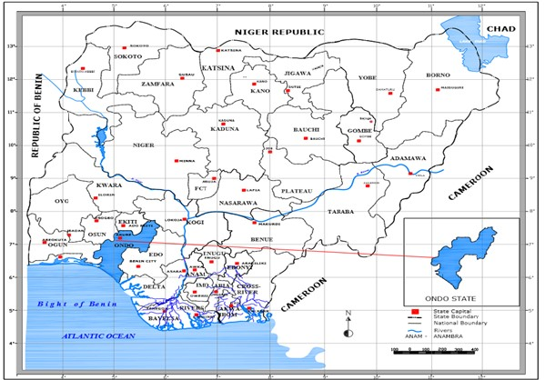
Figure 1: Map of Nigeria Showing Ondo State Reconnaissance Survey and Digitalization of Map
Topographic map prepared for The Federal University of Technology, Akure (FUTA) by the Regional Centre for Training in Aerospace Survey (RECTAS) in 2006 was acquired from
Centre for Space Research and Applications (CESRA), FUTA and carefully studied. The information contained in the map was acquired from IKONOS satellite image (2000) with extensive field work and field verification done during reconnaissance survey of the area to identify the actual location of some physical features. ARCGIS 9.2 was used for georeferencing, projecting and digitizing the map. Shape files for various features such as buildings, fish ponds, rivers, roads and plantation was created using Arc Catalogue and digitized in the ArcGIS environment. The slope analysis was generated using computer software (Arc GIS) to indicate the ground elevation of the area and other features were digitized as shown in the Figure 2. This provides the better understanding of the flow direction of the sewage. It also helps in determining the slope (which is a vital parameter in the design of network of sanitary sewers for domestic sewage from the various buildings. It further provides information needed in determining the location for the centralized wastewater disposal system. A total of 5600 point heights were digitized. It was also used in carrying out the various surface analyses such as slope, contour and aspect analysis.

Wastewater Generation, Sampling and Laboratory
Test.
The estimate of wastewater generation was based on the percentage of water use in various units on campus. Water use was computed based on the population size and per capital consumption. The wastewater quality was determined in the laboratory by measuring physical, chemical and bacteriological characteristics of a typical wastewater sample obtained from the residential and office area. The appropriate laboratory analysis was carried out using the standard method of water quality measurements at the Regional Water Laboratory, Federal Ministry of Water Resources in Akure, Ondo State. Wastewater characterization is required for the design of appropriate treatment technology. The parameters used are as shown in Table 3.

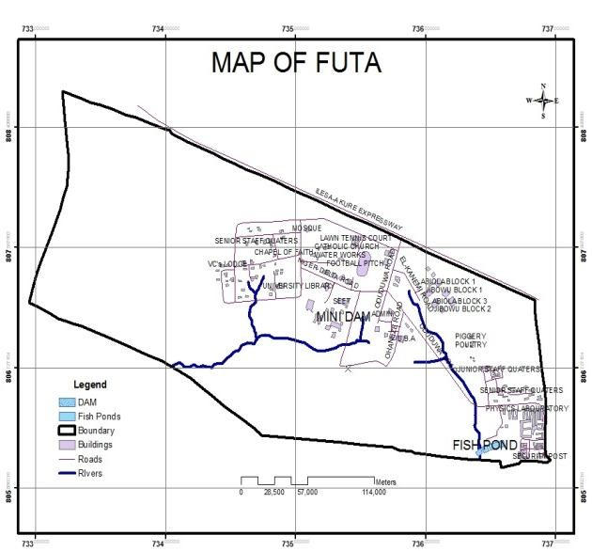
Figure 2: Digitized Map showing selected features

Estimation of Sewage Flow.
The estimation of sewage is obtained as a function of water use or water consumption per capita per day. This is taken here that the actual flow in each pipe is 85% of the water consumption and the peak flow is 120 l/c/d. Thus, the wastewater generated is represented as

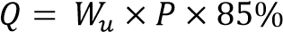 1
Where:

water use or water consumed per person (taken as 120 l/d = maximum daily consumption) P = number of population contributing to the sewer line, Discharge Q = wastewater generated peaking factor, Peaking factor, P.F = 3.0 for residential area and 1.5 for office area.

Sizing of Pipes.
Sanitary sewers were designed to flow through gravity. This eliminates the use of pump that requires high, costly and unavailable energy source for operation. Since the University is still strongly dependent on the use of energy source from the newly privatized Power Holding Company of Nigeria with epileptic power supply, it is therefore sustainable to design sewers to operate under gravity. The sanitary sewers were designed as a closed conduit but in actual sense, they operate as open channels because they are usually non-full flowing sewer. The Manning’s method of computation was used in this design because of its simplicity and appropriateness where limited data are available.
Outline of the procedure adopted in pipe sizing are as follows:
- Population data was obtained from appropriate authority and field work.
- 120 litre/capita/day was used for those living in the residential quarters
- 60 litre/capita/per day was used for those in the school and administrative areas
- Based on population of various units, the volume of water consumption were computed An assumption that 85% of the water consumed result in wastewater
- Based on assumption in v, the volume of wastewater generated was computed.
- Having known the discharge, the pipe sizes were determined using the derivation from Manning’s formula in Equation 2:

Manning’s formula: 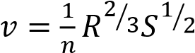 2
Discharge, 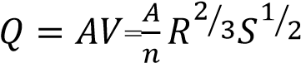 2a
Hydraulic radius: 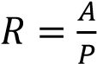 2b
Area of the pipe, 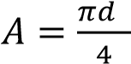 2c
Wetted perimeter, 2d
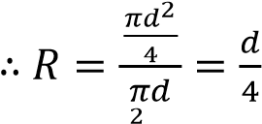 2e
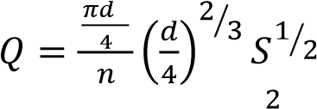 2f
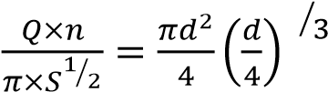 2g
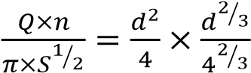 2h
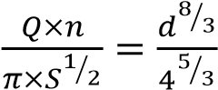 2i
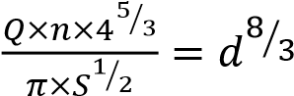 2j
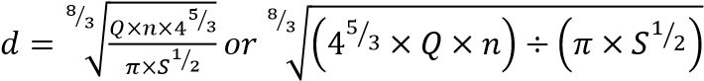 2k

The velocity of flow was determined from Equation 2a.

Proposed Treatment System.
The present wastewater treatment system in the university is the septic tank - soakaway system for each of the buildings in the institution. With the number of septic tanks, the level of ground water pollution becomes substantial and threatening to the groundwater supply and this has led to an improved and sustainable proposal for the centralized wastewater treatment system (anaerobic pond). Al-Hashimi and Hussain (2013) stated that the benefit of anaerobic digestion is that it can deal with highly concentrated wastewater and can achieve good purification results within short retention times. It is also very effective in tropical region like Nigeria with high BOD₅ removal of 80 – 90 percent while the maintenance is relatively cheap and uncomplicated.

Design principles of anaerobic ponds.
Volumetric organic loading.
An empirical approach is the recommended method for designing anaerobic ponds. Anaerobic ponds are normally designed based on permissible volumetric organic loading rate (λv) expressed in g/m³/day of BOD (Mara, 1976; Arthur, 1983; Mara and Pearson, 1986; Meiring et al., 1968). Volumetric organic loading rate and pond temperature have been observed to correlate satisfactorily on a full-scale anaerobic pond experiment. Meiring et al. (1968) proposed that permissible volumetric organic loading rates for designing anaerobic ponds should be within a range of 100 - 400 g/m³ day of BOD to ensure that anaerobic ponds function as intended. Such a range is thought to be safe for temperatures below 10ºC and above 20ºC. It is suggested that a volumetric organic loading rate of less than 100 g/m³/day can cause an anoxic reaction in anaerobic ponds. An anoxic pond is a slow rate reactor, which removes BOD relatively slower than an anaerobic pond. The upper limit of 400 g/m³ day is established to avoid the risk of odour produced by hydrogen sulphide gas (H₂S).
Mara and Pearson (1986) observed that a sulphate (SO₄) concentration of 500 mg/l in domestic wastewater is capable of producing odour if a volumetric organic loading rate of 400 g/m³ day is attained. They suggested that the volumetric organic loading rate should be reduced to 300 g/m³ day. This is thought to provide an adequate margin of safety against odour.
More recent research by Mara et. al. (1997) observed that a volumetric organic loading rate of 300 g /m³/day is in fact conservative and does not make the most economic use of the available land. They found that the volumetric organic loading rate could be increased to 350 g/m³/day as long as the sulphate (SO₄) concentration in domestic wastewater is less than 300 mg/l. This idea seemed logical as the WHO (1993) has recommended the maximum sulphate (SO₄) concentration in drinking water to be less than 250 mg/l. Table 1 lists the suitable design values of volumetric organic loading rates at various temperature ranges, the design temperature being the mean temperature of the coldest month.
Table 1: Design values of permissible volumetric BOD loading rate.
Temperature (ºC) | Volumetric BOD loading (g/m³ day)
< 10 | 100
10-20 | 20T* – 100
20- 25 | 10T + 100
> 25 | 350
T* = temperature Source: Mara and Pearson (1986) and Mara et al., (1997).
The process design of anaerobic pond volume is related to the BOD of the raw wastewater (Li, mg/l), the mean wastewater flow (Q, m³/day) and the volumetric organic loading rate () by Equation 4:
Traditional process design methods have considered the input design parameters of Equation 4 as deterministic single average values. Arthur (1983), Campos and Von Sperling (1996) and Mara et. al. (1992) have observed that such input design parameters increase when the level of income in a community improves. Traditional design of anaerobic ponds based on deterministic single values of the input design parameters is considered an unrealistic approach. It results in either overdesign or under design of anaerobic ponds such that the available land and project funds for procuring WSP are not used economically. Campos and Von Sperling (1996) suggested that input design parameters should be treated as a range due to uncertainty of their exact values. This was considered to be a more realistic approach. Furthermore, it has been suggested that designs based on a range of the input design parameters can also incorporate realistic safety factors.
The traditional method for process design establishes a factor of safety for anaerobic ponds based on the temperature in coldest month (Mara, 1976; Arthur, 1983). The resulting volumetric organic loading rate (Table 1) is expected to be low. This requires substantial land (Equation 4) for constructing anaerobic ponds. If the design temperature can be considered as a range with a minimum value during coldest month to a maximum value during hottest month, the volumetric organic loading rate can be manipulated to vary from 100 - 350 g/m /day during the design stage to follow the temperature pattern. Random values of the volumetric organic loading rate can be selected to design the anaerobic pond volume. The final area of the anaerobic pond can then be calculated based on the acceptable risk and available cost. This design approach is efficient and is based on realistic factors of safety.
BOD removal.
The design of an anaerobic pond for BOD removal is based on an empirical approach. Mara and Pearson (1986) and Mara et. al. (1997) have developed an empirical relationship between pond temperature and BOD removal in anaerobic ponds. It has been observed that BOD removal in an anaerobic pond is directly proportional to pond temperature. Marais (1970) showed that at a pond temperature of greater than 15ºC, methanogenesis is very efficient in removing BOD. Based on such knowledge, Mara and Pearson (1986) and Mara et. al. (1997) proposed the relationship of the design temperature and design BOD removal in anaerobic pond as shown in Table 2.
Table 2: Design of percentage BOD removal in anaerobic ponds at various temperatures.
Temperature ( ºC) | BOD removal (%)
< 10 | 40
10– 20 | 2T + 20
20 – 25 | 2T + 20
> 25 | 70
T = temperature Source: Mara and Pearson (1986) and Mara et al. (1997).

The traditional method for process design considers the percentage BOD removal and design temperature in the coldest month as deterministic average single values. This approach fails to take account of the efficient BOD removal that occurs in the hottest month of the summer season. In addition, traditional design methods treat the influent BOD as an exact single value. It has been argued by Campos and Von Sperling (1996) that BOD concentrations in raw wastewater vary significantly, with affluent communities producing more BOD than poor communities. This suggests that the influent BOD into facultative ponds should also be treated as a range and not a deterministic average single value.
BOD removal in anaerobic ponds depends on various environmental conditions, including the quality of the raw wastewater. If the pH of the raw wastewater is beyond the permissible range of ~6.6 - 7.8, BOD removal by methanogenic bacteria will be reduced significantly. This will consequently increase the influent BOD into the facultative pond. This presents a problem for traditional methods of process design, which treat input design parameters as deterministic single values. The best approach to manage the uncertainty of BOD removal in anaerobic ponds, as suggested by Campos and Von Sperling (1996), is to treat the design temperature as a range and this will provide a range of values for the percentage BOD removal, which in turn will result in a range of values for the influent BOD entering the facultative pond. The anaerobic ponds are designed on the basis of volumetric loading (λv, g/ m³/d), which is given by:
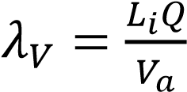 5
Where is influent BOD (mg/l), Q is flow rate
(m³/day), and is anaerobic pond volume (m³).
Meiring et. al., (1968) recommended that the loading should be between 100 – 400 g/ m³.day, in order to maintain anaerobic conditions. Once the organic loading is selected, the volume of the pond is then determined with the use of Equation 4. The hydraulic retention time is then calculated, using Equation 5, as follows:
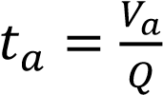 6
A retention time less than one day should not be used for anaerobic ponds; if it occurs, however, a retention time of one day should be used, and the volume of the pond should be recalculated. Table 1 above illustrates the permissible loadings to the anaerobic ponds.
Results and Discussion
Wastewater Quality Analysis.
Table 3: Wastewater Quality Analysis of Wastewater

S/N | Parameter | Unit | Wastewater  (Staff Quarters) | Wastewater (Office area)
1 | TDS | mg/l | 1266 | 1407
2 | Total Hardness (CaCO₃) | mg/l | 262 | 260
3 | Nitrate (NO₃) | mg/l | 37.2 | 31.6
4 | Alkalinity | mg/l | 914 | 720
5 | Ammonia (NH₄) | mg/l | 0.53 | 0.41
6 | Total Bacterial Count | Cfu/100ml | TNTC | TNTC
7 | E-coli | Cfu/100ml | TNTC | TNTC
8 | BOD | mg/l | 350 | 353
9 | Dissolved Oxygen | mg/l | 0.50 | 0.45
Source: Ajibade, 2013. Note: ND = Not Detected, TNTC = Too Numerous to Count, Cfu = Colony forming unit
Grab samples of the wastewater generated in the study area were obtained in the morning, afternoon and evening at the residential (staff quarters) and office areas. Summary of the results of the wastewater quality are shown in Table 3.

From Table 3, the characteristic of the domestic wastewater generated in the study area is classified as a medium strength wastewater (within 350 – 700 mg/l BOD) (Mara, 1984).

Population Data
The population of the study area was determined from the available records of students and staff obtained from Academic Office of the university is presented in Table 4. Also, the population in the Senior Staff Quarters was obtained through visitation to all 33 flats of 3 to 4 bedrooms and their boys quarter (Table 5).

Table 4: Total Staff and Students Population for 2001 – 2012 Academic Sessions of the university.

S/N | Session | Total  Number of  Students | Total Number of Staff  (Academic and non  Academic Staff)
1 | 2000/2001 | 8,586 | 1,499
2 | 2001/2002 | 9,209 | 1,506
3 | 2003/2004 | 11,661 | 1,446
4 | 2004/2005 | 12,147 | 1,562
5 | 2005/2006 | 12,696 | 1,548
6 | 2006/2007 | 12,325 | 1,635
7 | 2007/2008 | 14,767 | 1,700
8 | 2008/2009 | 16,034 | 1,768
9 | 2009/2010 | 16,669 | 1,833
10 | 2010/2011 | 19,277 | 1,861
11 | 2011/2012 | 23,894 | 1,907
(Source: Academic Planning Unit, FUTA, 2013). Note that 2002/2003 session was cancelled.
Table 5: Summary of the University Population
Dwelling Categories Population

Senior Quarters  Main flat  BQ | 264  66
Office Area  Students  Staff | 23,894  1,907
Grand Total | 26,131
BQ – Boys Quarter

Table 6: Estimation of Wastewater Production for the Location on the University Campus (Ajibade, 2013).

Dwelling Categories | Population | Discharge Volume  l/day | Peaking Factor | %  Contribution
Senior Quarters | 330 | 100,980 | 3.0 | 4.87
Office Areas | 25,801 | 1,973,777 | 1.5 | 95.13
 | 26,131 | 2,074,757 |  | 100.00

From Table 6, the wastewater generated from staff quarters and office areas in the study area was estimated to be 2,074,757 liters/day.

Determination of Pipe Sizes.
Typical analysis and design calculations for the school/administrative area using School of Agriculture and Agricultural Technology of FUTA as example are as shown in Tables 7 and 8. Also, a typical design parameter for senior staff quarter is shown in Tables 9 and 10.

Table 7: Design Data for the School of Agriculture and Agricultural Technology Sanitary Pipe Sizing (Ajibade, 2013).

Item | Value
Total population | 2365
Expected water consumption per design | 60 Litres per day
Total amount of water consumed | 60 2365 = 141,900 l/d
Wastewater produced (85% of water consumed becomes wastewater) | 0.85 141,900 = 120,615 l/d
Adopted Peaking Factor, P.F | 1.5
Discharge Q = wastewater produce P.F. | 120,615 1.5 = 180,923 l/d
Assuming 20% of the population contributes to the wastewater generated | 180,923 0.2 = 36,185 l/d

Table 8: The Pattern of Wastewater generated with respect to Time for School of Agriculture and Agricultural Technology, Building (Ajibade, 2013)
Time Range expressed in Percentage | Wastewater Generated
7:00am – 8:00am (45%) | 45% of 36,185 = 16,283 l/d
8:00am – 5:00pm (50%) | 50% of 36,185 = 18,093 l/d
5:00pm – 6:30pm (4%) | 4% of 36,185 = 1,447 l/d
6:30pm – 7:00am (1%) | 1% of 36,185 = 362 l/d

From the calculation of pipe size when flowing full for the agricultural building, the diameter was obtained to be 39 mm while the velocity is 0.48 m/s which is less than the value of the self-cleansing velocity (0.6 m/s). For the case of pipe flowing half-full, the diameter obtained was 50 mm and the velocity of 0.6 m/s which is higher than the value obtained for the pipe flowing full. Since the pipe will not be actually flowing full, it will be of great advantage to adopt the half-full pipe section whose velocity is the same as the self- cleansing velocity and a diameter of 50 mm. Though for optimum size solution, no public gravity sewer conveying raw wastewater shall be less than 8 inches (200 mm) in diameter. A reasonable size solution of 100 mm was selected for sanitary sewers which are suitable for wastewater flowing out of the buildings in the study area since it’s an academic environment and the contributory population is far less than a public gravity sewer, therefore the chance of blockage is minimized and the cleansing will be facilitated.

Table 9: Design Data of Sanitary Pipe Sizing for a Flat in Staff Quarter (Ajibade, 2013).

Item | Value
Total population | 10
Expected water consumption per design | 120 Litres per day
Total amount of water consumed | 120 x 10 = 1,200 l/d
Wastewater produced (85% of water consumed becomes wastewater) | 1200x 0.85= 1,020 l/d
Adopted Peaking Factor, P.F | 3.0
Discharge Q = wastewater produce x P.F. | 1,020 l/dx3 = 3,060 l/d
Assuming 80% of the population contributes to the wastewater generated | 3,060 x 0.8 = 2,448 l/d

Table 10: The Pattern of Wastewater Generated with respect to Time for a flat in staff quarter (Ajibade, 2013).

Time Range expressed in Percentage | Wastewater Generated
7:00am – 8:00am (15%) | 15% of 2,448 =367 l/d
8:00am – 5:00pm (5%) | 5% of 2,448 = 122 l/d
5:00pm – 6:30pm (20%) | 20% of 2,448 = 490 l/d
6:30pm – 7:00am (60%) | 60% of 2,448 = 1,469 l/d

velocity due to the contributory population while for the pipe flowing half full, the diameter obtained was 17.1 mm with velocity of 0.3 m/s which is slightly higher than the pipe flowing full and also lower than the selfFor pipe size of a pipe flowing full for a flat in cleansing velocity. the staff quarters, the diameter obtained was

Table 11: Calculated Diameter and Velocity for Pipe flowing full and Half-full (Ajibade, 2013).

S/N | DC* | P | Q (l/d) | Q (m³/s) | Slope | Pipe Flowing | Half-full | Pipe Half-Full Flowing
 |  |  |  |  |  | D | V | D | V
1 | SAAT | 2365 | 18,093 | 0.000558 | 0.0188 | 39.00 | 0.48 | 50 | 0.6
2 | SQ | 10 | 1,469 | 3.24x10⁻⁵ | 0.0200 | 13 | 0.24 | 17 | 0.30
* one residential and academic building was considered under dwelling category. Note: DC – Dwelling Category, SQ – Staff quarters, Q - Discharge, D - Diameter, P – Population, V - Velocity
Table 12: Calculated Diameter for the Assumed Velocities of 1 m/s and 1.5 m/s for Pipe Flowing full and Half-full (Ajibade, 2013).
S/N DC Pipe Full Pipe Full Pipe Half-full Pipe Half-full
Flowing Flowing Flowing Flowing
 | D V | D | V | D | V D | V
1 SAAT | 27 1.0 | 22 | 1.5 | 38 | 1.0 31 | 1.5
2 SQ | 6.4 1.0 | 5.3 | 1.5 | 9.1 | 1.0 7.4 | 1.5

Note: Notations are as explained in Table 11

Figure 4 shows the layout of the sanitary sewers for the sewerage system based on the preliminary design. This tentative layout of the sewers was made on the topographical map by drawing lines with arrows and locating manholes as shown in Figure 4. This allows flow under gravitation force. The manholes were placed at intervals, change in direction of sewer, change in pipe slope and change in pipe size. Manholes were labelled with an identification number for reference purposes.

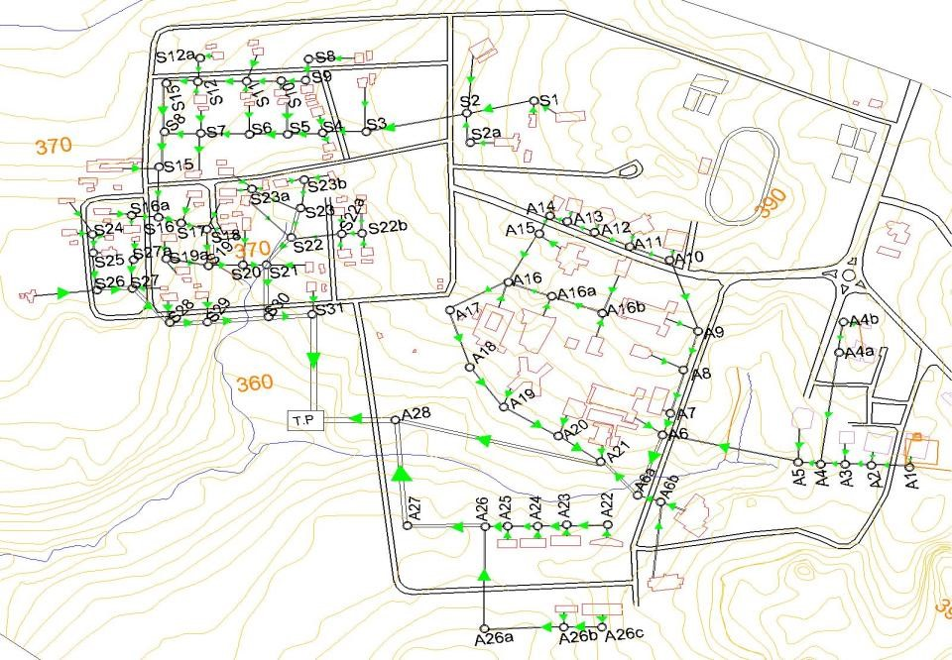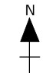

Figure 4: Sanitary Sewer Design Layout
Note: A represents Administrative/Office Sewer; S represents Staff Quarters Sewer and TP represents Central Treatment Plant).
Design of Anaerobic Ponds  Determination of Flow Rate, Q  Quantity of wastewater, Q is 2,074,757 l/day  Q = 2,074.757 m³/day  Q = 14,523.3 m³ per week 7 | Determination of Pond Volumetric Loading, λ_{v}  From Table 1, volumetric loading is a function of temperature, T, which is obtained from Table 13.

Table 13: Temperature and Precipitation per Month for Akure, Ondo State.

Temperatures |  |  |  | Precipitation
Months | Normal | Warmest | Coldest | Normal
January | 26.0 | 33.7 | 19.0 | 0
February | 28.1 | 35.8 | 21.6 | 1
March | 28.3 | 35.9 | 23.2 | 4
April | 28.1 | 34.2 | 21.1 | 8
May | 27.0 | 32.6 | 22.5 | 10
June | 25.5 | 30.9 | 21.6 | 13
July | 24.5 | 29.2 | 21.3 | 12
August | 24.5 | 28.8 | 21.2 | 11
September | 24.6 | 29.8 | 21.1 | 16
October | 25.6 | 31.3 | 21.3 | 10
November | 26.2 | 33.6 | 20.2 | 1
December | 25.7 | 33.6 | 18.7 | 0
(Source: NMI and NBC, 2011)

T = mean coldest temperature

= 19 + 21.6 + 23.2 + 21.1 + 22.5 +21.6 + 21.3 + 21.2 + 21.1 + 21.3 + 20.2 + 18.7

12
T = 21.1ºC

From Table 1, when T = 21.1ºC, λ_{v} = 10T + 100 λ_{v} = 311g/m³.day 8 Determination of BOD₅

From Table 3, BOD, L_{i} is 353 mg/l = 353 g/m³ 9

Determination of Pond Volume, Length and Width.

From Equation 5,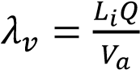
Therefore, 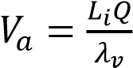 10
Substituting Equations 7, 8 and 9 into 10
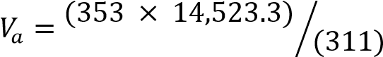
= 16,484.65 m³ (for a week)
= 2,354.95 m³ per day

In order to add flexibility to the operation, it will be best to have three ponds with a 3:1 length to width ratio. The recommended depth is between 2.5 and 6 metres. The cheapest and most effective is usually about 5 metres.

Area of each pond = 16,484.65 / (5m deep x 3 ponds) = 1098.98 m² for each pond
Area = width x length
Length = 3 x width
Area = width x (3 width) = 1098.98 m²
Width = (1098.98/3)^{0.5} = 19.14 m
Length = 3 x 19.14 = 57.42 m
So the anaerobic pond treatment of the 14,523.3 m³ and 352 mg/l wastewater can be accomplished using three ponds connected in series, each 19.14 metres wide, 57.42 metres long and 5 metres deep. Determination of Detention Time
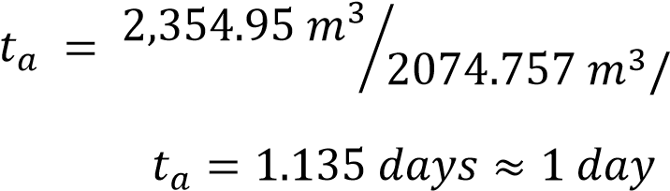
From Equation 6

Conclusion.
In the modern world, attention has been shifted from onsite wastewater disposal system and focuses on central sewerage system for residential areas especially estates, institutions, industrial areas, etc. Management of wastewater in semi urban area like Federal University of Technology, Akure should desist from the use of septic tanks and soakaway pits which have the potential to contaminate groundwater and surface water resources to a more robust and sustainable management approach. This paper presents a holistic approach to wastewater collection and disposal using appropriate modern methodology that is highly sustainable to improve environmental and sanitation quality in the institution. Daily wastewater generated from staff quarters and office areas in the study area of the institution was estimated to be 2,074,757 liters per day.

In selecting the pipe sizes for the sewers, the estimated discharge velocity for the office area is exactly the minimum allowed velocity, i.e., to be self-cleansing to prevent sedimentation in the pipes, and much less than the scouring velocity. Thus, a normal velocity of 1 m/s is adequate for the sewer flows but for the residential area (staff quarters), the calculated velocity is far below the self-cleansing velocity and much less than the scouring velocity due to the contributory population. Also, an available commercial pipe size like 100 mm was selected as appropriate as sewer pipes. Three anaerobic ponds connected in series are designed to cater for the treatment of the effluent. The dimensions of the ponds are
57.42 m 19.14 m 5 m each with detention period of 1.135 days.

Recommendations
From the outcome of this study, the following recommendations are therefore made:
- The current septic - soakaway system with the risk of overflow, creation of foul odour, and many health hazards will require full reclamation design and construction when the buildings are connected to the central wastewater system.
- The problem of groundwater contamination via septic tank is not an isolated problem of the area studied but rather a nationwide problem; hence precaution should be taken by siting of wells from septic tanks and treatment of well water before use.

References.
Adekunle, A. S. (2008). Impacts of industrial effluent on quality of well water within Asa Dam Industrial Estate, Ilorin, Nigeria. Nature and Science 6(3): 1-5.
Ajibade, F. O. (2013). Design of a Central Wastewater Disposal System for an Urban Area Using FUTA Campus as Case Study. Unpublished. M.Eng. Thesis, Department of Civil and Environmental Engineering, Federal University of Technology, Akure.
Alder, A.C., Golet, E., Ibric, S. and W. Giger (2000). Fate of Fluoroquinolone antibiotics during municipal wastewater treatment. The American chemical society, San Francisco, CA., 32, 219.
Al-Hashimi, M. A. I and H. T. Hussain (2013). Stabilization pond for wastewater treatment European Scientific Journal 9 (14):1857 – 7881.
Arthur, J. P. (1983). Notes on the Design and Operation of Waste Stabilization Ponds in Warm. Climates of Developing Countries. Technical Paper No.7. Washington, DC: The World Bank.
Campos, H.M. and M. Von Sperling (1996). Estimation of Domestic Wastewater Characteristics in a Developing Country based on Socioeconomic Variables. Water Science and Technology, 34 (3/4): 71-77.
Mara, D. D. (1976). Sewage Treatment in Hot Climates. Chichester, England: John Wiley and Sons.
Mara, D. D. (1984). Sewage Treatment in Hot Climates. ELBS/John Wiley and Sons Inc. London, England.
Mara, D.D. and H. W. Pearson (1986). Artificial freshwater environments: waste stabilization ponds. Biotechnology, 8: 177-206.
Mara, D. D., Alabaster, G. P., Pearson, H.W., and S. W. Mills (1992). Waste Stabilization Ponds: A Design Manual for Eastern Africa. Lagoon Technology
International Ltd, Leeds, England.
Mara, D. D., Pearson, H.W., Oragui, J. I., Arridge, H. and S. A. Silva (1997). Development of a New Approach to Waste Stabilization Pond Design. TPHE Research Monograph No.5. Leeds: University of Leeds, Department of Civil Engineering.
Marais, G.V.R. (1970). Dynamic Behaviour of Oxidation Ponds. In Proceedings of the 2nd International Symposium on Waste Treatment Lagoons (ed. R.E.
McKinney), pp. 15-46. Laurence, KS: University of Kansas.
McGhee, T.J. (1991). Water Supply and Sewerage. Sixth edition. McGraw-Hill Inc. New York.
Meiring, P.G., Drews, R.J., Vaneck, H. and G. J. Stander (1968). A Guide to the Use of Pond Systems in South Africa for the Purification of Raw and Partially Treated Sewage. CSIR Special Report WAT 34. Pretoria, South Africa: National Institute for Water Research.
Norwegian Meteorological Institute and Norwegian Broadcasting Corporation, NMI and NBC (2007-2011). Weather statistics for Akure, Ondo State, Nigeria
(http://www.yr.no/place/Nigeria/Ondo/Akure/statistics.html). Retrieved on 8th April, 2014.
Onunkwo A. and A. P. Uzoije (2011). Exploratory Survey of Geochemical Aspects of Underground Water in Ehime Mbano Area Se Nigeria. Global Journal of Research in Engineering. 11: 14-22.
Rahaman, M.A., (1989). Review of the basement geology of south-western Nigeria. In: Kogbe, C.A., (Ed) Geology of Nigeria, Rock View (Nig.) Limited, Jos, Nigeria, pp. 39-56.
Water Quality, (2013). How far should Private Water Wells be sited from Septic Tanks and Field Lines?
Http//www.freedrinkingwater.com/water purificationneed. accessed on 10th June, 2013.
WHO (1993). Guidelines for Drinking -Water Quality, 2nd edition. World Health Organization, Geneva and HMSO, London.
Wyasu, G., and O. A. Kure (2012). Determination of organic pollutants in hospital wastes water and food samples within Ahmadu Bello University Teaching Hospital (Abuth), Shika, Zaria, Nigeria. Advanced Applied Science Research 3(3):1691-1701.

