Name: OYEBOADE Rukayah Kiitan
Department: Biomedical Engineering
Matric number : 17/eng08/004
Course Code: ENG382
Course Title: Engineering Mathematics IV

- MATRIX INVERSE METHOD WITH THE AID OF MATHCAD

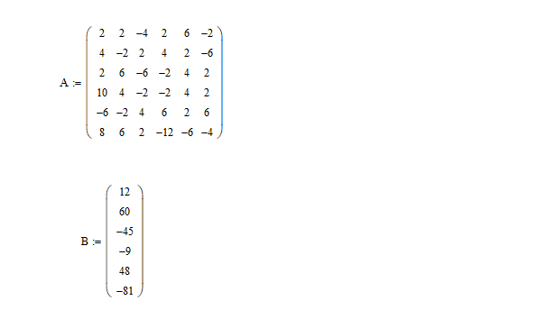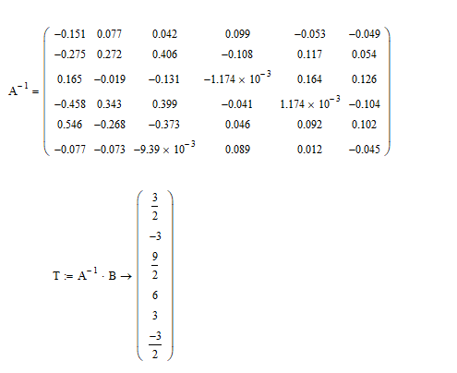

To covert to kelvin (K) we add 273 to each number, the new temperatures are ;

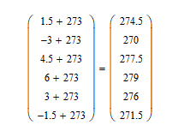

- GUASS ELIMINATION METHOD WITH THE AID OF MATHCAD
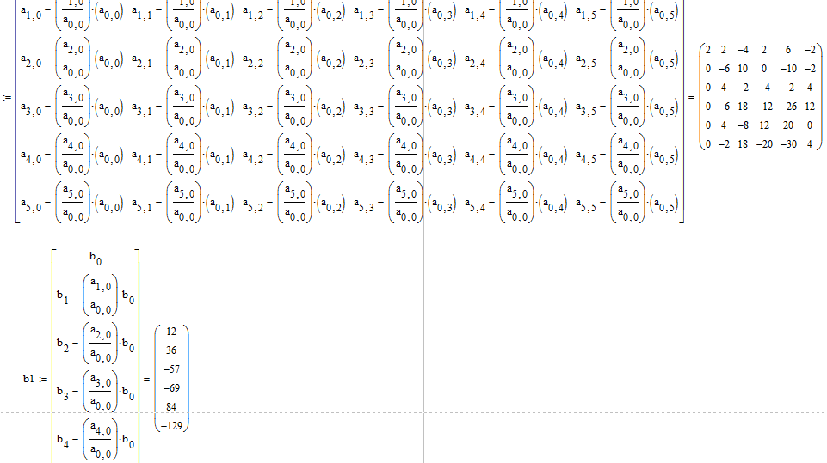
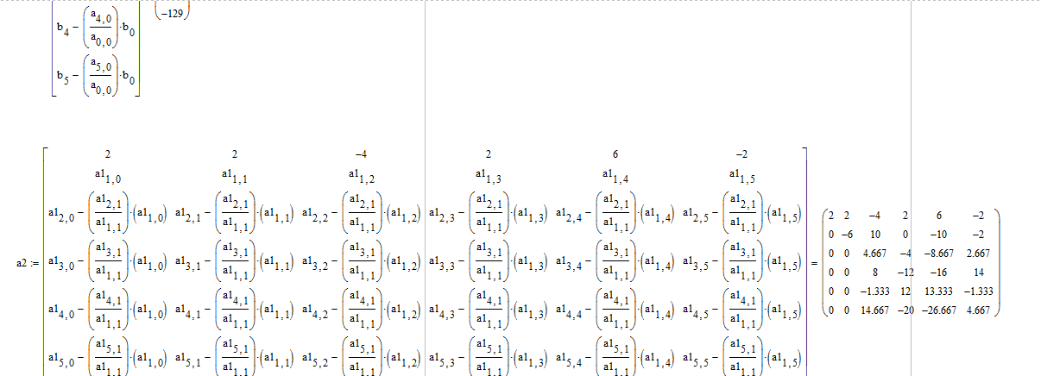
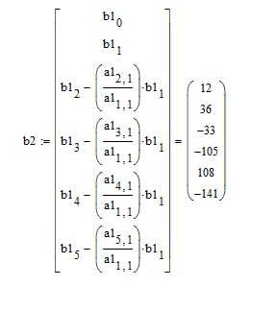
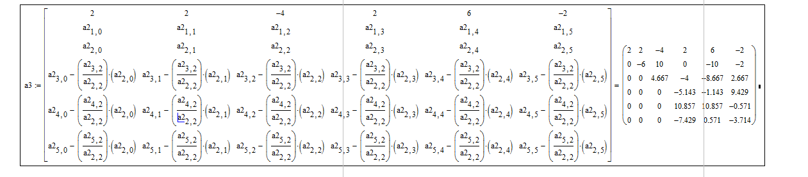

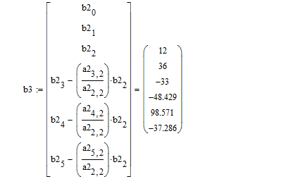

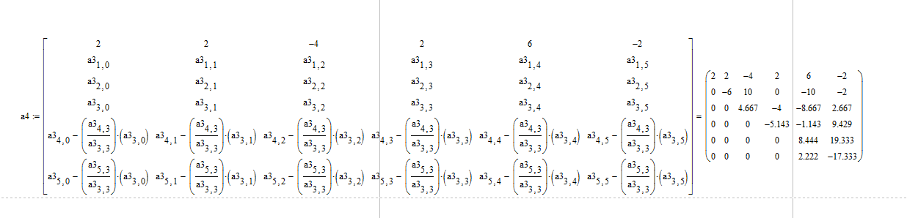

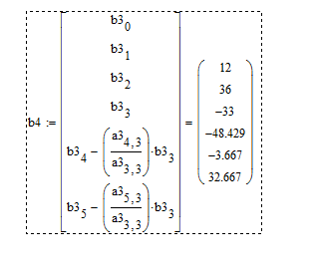

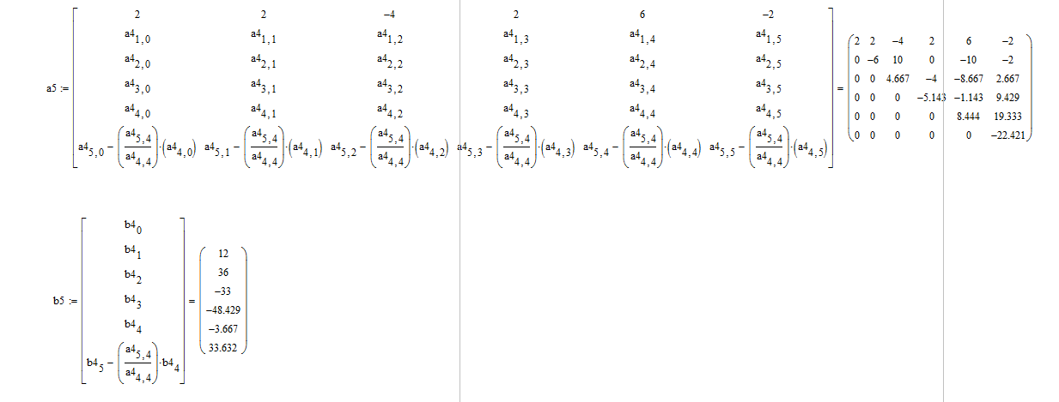

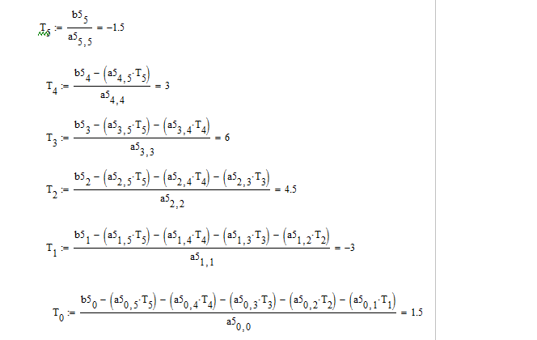

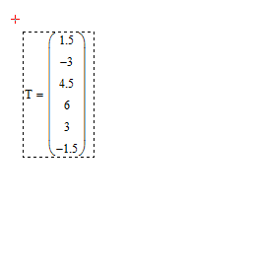

To convert to kelvin
274.5
270
277.5
279
276
271.5

