NAME: Ikebujo Delight Nkemjika
MATRIC NO.: 17/ENG06/043
DEPARTMENT: MECHANICAL ENGINEERING
ENGINEERING MATHS ASSIGNMENT 3
a)
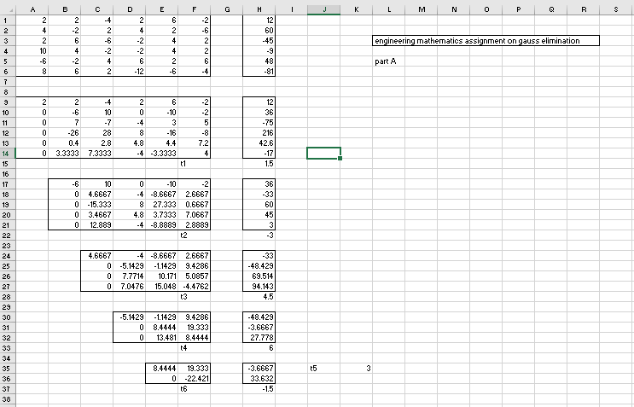

b)
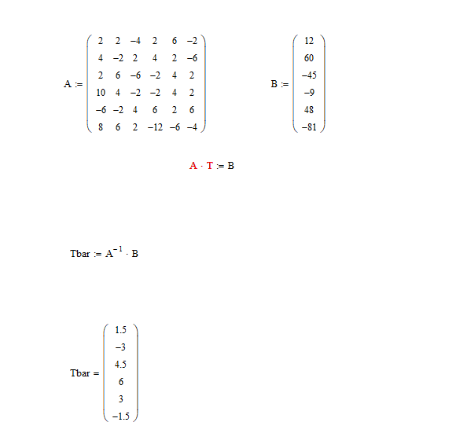

c) 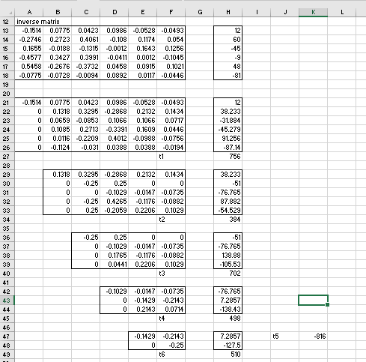
d) 