Engineering maths assignment 3
a)
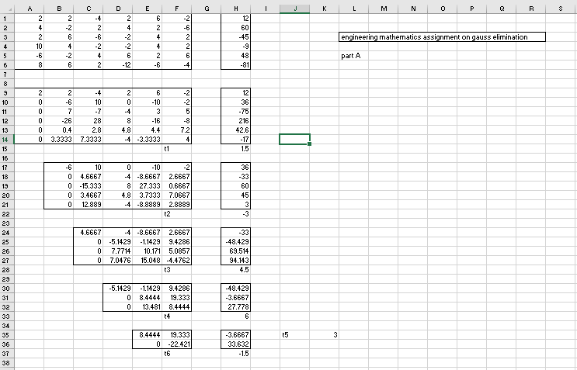

NAME: ADENIYI TOHEEB OPE
DEPARTMENT: COMPUTER ENGINEERING
MATRIC: 17/ENG02/006

b)
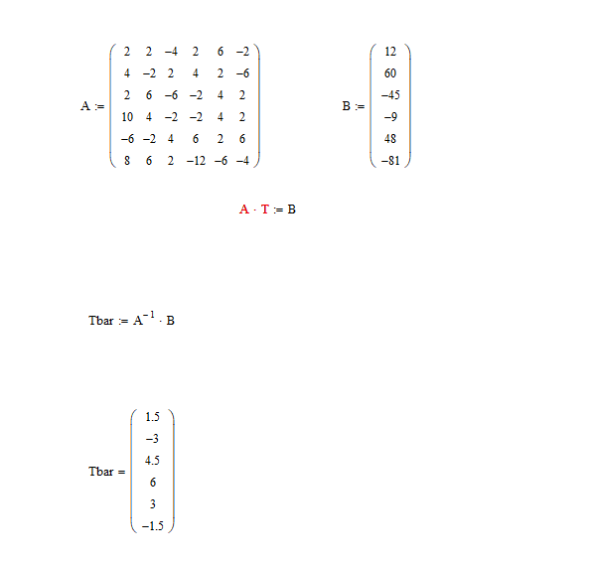

NAME: ADENIYI TOHEEB OPE
DEPARTMENT: COMPUTER ENGINEERING
MATRIC: 17/ENG02/006

c) 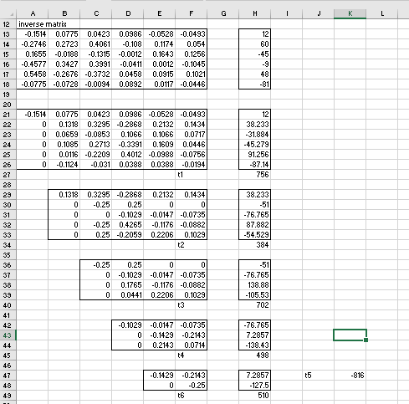

NAME: ADENIYI TOHEEB OPE
DEPARTMENT: COMPUTER ENGINEERING
MATRIC: 17/ENG02/006

d) 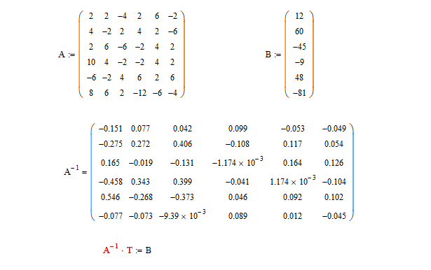
NAME: ADENIYI TOHEEB OPE
DEPARTMENT: COMPUTER ENGINEERING
MATRIC: 17/ENG02/006

