**EMEROLE CHINAEME IKENNA**

**17/ENG05/012**

**MECHATRONIC ENGINEERING**

ENG 382 : ENGINEERING MATH

1a)

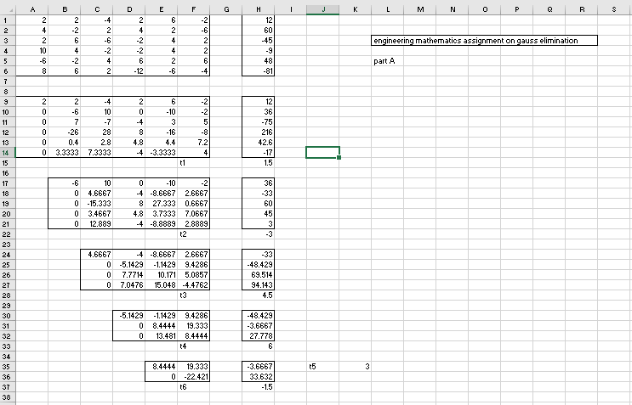

b)

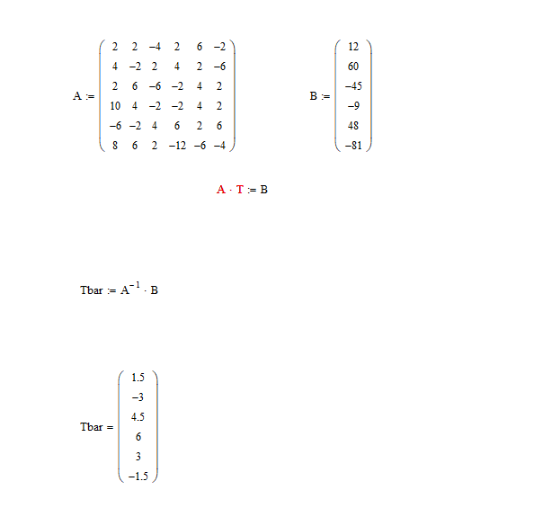

c) 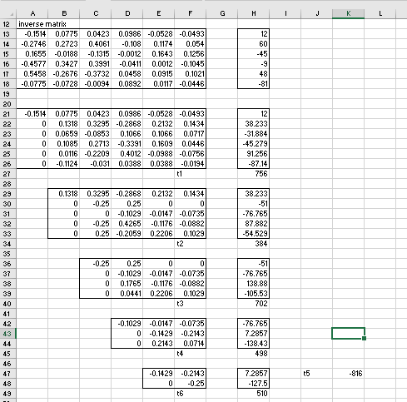

d) 