NAME: OKAFOR VICTOR CHIBUZOR
MATRIC NO: 17/ENG06/061
DEPARTMENT: MECHATRONICS ENGINEERING
ENGINEERING MATHS ASSIGNMENT 3
a)
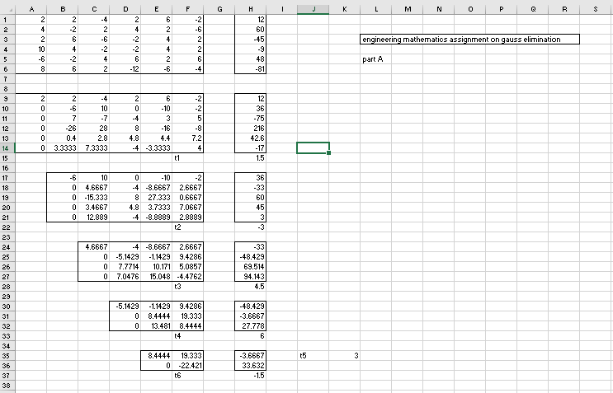

b)
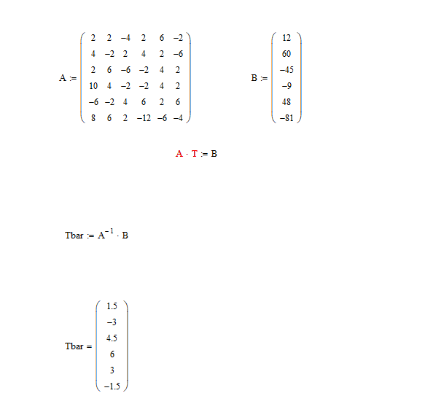

c) 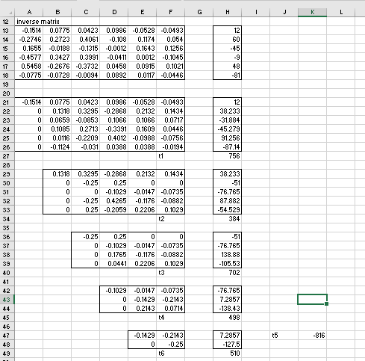
d) 