Name: Olagunju Joseph Olusegun Matric No: 17/ENG05/031
Department: Mechatronics Engineering
Engineering Maths Assignment 3
- For Gauss elimination

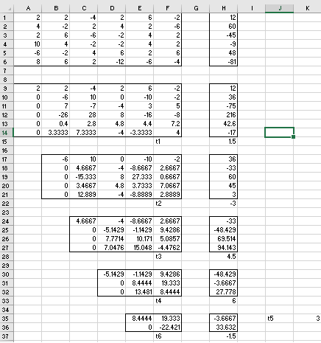
- A= 2 2 -4 2 6 -2
4 -2 2 4 2 -6
2 6 -6 -2 4 2
10 4 -2 -2 4 2
-6 -2 4 6 2 6
8 6 2 -12 -6 -4
B= 12
60
-45
-9
48
-81
A.T=B
T=BA⁻¹
T= 1.5
-3
4.5
6
3
-1.5
- 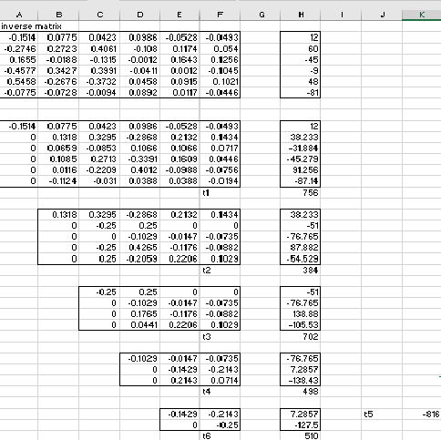
- A= 2 2 -4 2 6 -2
4 -2 2 4 2 -6
2 6 -6 -2 4 2
10 4 -2 -2 4 2
-6 -2 4 6 2 6
8 6 2 -12 -6 -4
B= 12
60
-45
-9
48
-81
A⁻¹= -0.151 0.077 0.042 0.099 -0.053 -0.049
-0.275 0.272 0.406 -0.108 0.117 0.054
0.165 -0.019 -0.131 -1.174x10⁻³ 0.164 0.126
-0.458 0.343 0.399 -0.041 1.174x10⁻³ -0.104
0.546 -0.268 -0.373 0.046 0.092 0.102
-0.077 -0.073 -9.39x10⁻³ 0.089 0.012 -0.045
A^{-1.}T=B
T=(A⁻¹)^{-1.}B

T= 756
384
702
498
-816
510

