A TERM PAPER ON
MANAGEMENT OF URBAN DRAINAGE: AN ESSENTIAL TOOL FOR DURABILITY HIGHWAY INFRASTRUCTURE IN NIGERIA
BY

OLAOYE ABASS AYODEJI
16/ENG03/061

COLLEGE OF ENGINEERING, DEPARTMENT OF CIVIL ENGINEERING
AFE BABALOLA UNIVERSITY, ADO EKITI.

IN PARTIAL FULFILMENT OF THE REQUIREMENT FOR THE AWARD OF BACHELOR OF ENGINEERING DEGREE (B.ENG) IN CIVIL ENGINEERING

February, 2020

Abstract
One of the observable impacts of rapidly growing urbanization and economic development in emerging cities of developing nations is witnessed in drainage problems connected to poor sanitation. The objectives of this research are to examine the management of urban drainage, the causes and extent of damage on drainage and poor sanitation systems in urban areas, highlight measures to improve health and living conditions of the residents, and propose measures to improve the economic functioning of the cities. Six (6) Local Government Areas (LGAs) in Lagos State, Southwest Nigeria were selected. The descriptive cross-sectional study identified 50 respondents from each LGA through careful selection. Data were collected through validated questionnaire, thorough observations and interviews with residents. The result of the investigation shows that ineffective drainage systems are basically associated with poor maintenance, indiscriminate dumping of refuse in drains, erection of building on drainage channels and alignments that inhibit the flow of water which leads to critical environmental hazards. The study suggests new approach that could be used to achieve sustainable and effective sanitation which would support government’s effort in upgrading urban services by preparing plans and feasibility studies, improving drainage maintenance procedures and effectively manage human waste disposal.

Introduction
The Rio declaration and the Agenda 21 from the early 1990’s introduced the concept of long-term sustainability of our environment. One important ingredient in the new approach is that technical, economic and social aspects of the development are handled carefully. There is today, a consensus that urban water systems should be approached in an integrated way. Surface water, groundwater, water quality, quantity, and ecology should be looked upon in relation to each other. Thus, the introduction of the concept of sustainability has, in the field of urban water systems among others, led to an increased interest for source control and open drainage of storm water within the urban environment (Geldof and Stahre, 2006).
Presently, about 2.6 billion people are living without proper sanitation, of which Africa is not exempted (Olukanni, 2013a; WHO/UNICEF, 2012). The need to provide proper drainage and sanitation facilities is essential to match up with the ever increasing population growth (Banerjee and Morella, 2011). The increase in the population of a settlement and the attendant growth of the needs of the residents in both quantity and variety, bring about intensive exploitation of the resources of the environment. Such exploitation might increase to a level that the resources would not be able to sustain the population, and in some cases the environment would collapse resulting in serious environmental problems (Asoegwu, 2009). This is further buttressed by Belete (2011) who expressed that high urban population growth rate also results in drainage system challenges because an increase in population requires a proportionate increase in infrastructure (roads and drainage systems) of which when not properly catered for, the facilities will be imperfect. Also, inadequate integration between road and urban storm water drainage can be attributed to natural causes such as intense rainfall, flat topography and poor soil infiltration or man-made causes such as improperly laid and graded street, poor and inefficient drainage facilities that aggravate the flooding problem (Jimoh, 2008).
Urban environments in Nigeria are faced with myriad of issues regarding poor drainage systems (Offiong et al., 2009) and water tight structures which are the major causes of flooding (Belete, 2011). Urban flooding which is the inundation of land or property in a built environment, particularly in more crowded areas are caused by rainfall overwhelming the capacity of drainage systems. Although this is sometimes caused by events such as flash flooding (Tucci, 2001).
Urban flooding is a condition characterized by its repetitive and systemic impacts on communities whether or not the affected communities are located within floodplains or near any body of water (CNT, 2013). Sule (2001) described Lagos, Calabar and Ibadan as cities where houses are constructed directly on drain channels and that this practice has resulted to blockage of storm drains and consequently leading to overflow and flooding of streets.
Also, poor drainage systems in Lagos State have caused tremendous environmental challenges. These challenges are basically associated with poor maintenance of drainage system and flood which eventually leads to environmental hazards. Some places were flooded, making the roads practically impassable for motorists. In many instances, torrential rainfall literally submerged the cities, halting human and vehicular activities thereby forcing residents to stay indoors as a pre-emptive measure against human disaster. Therefore, this study seeks to highlight the causes and environmental implications of bad drainage systems in the areas under study, highlights measures to improve health and living condition and make possible solutions and suggestions towards improving economic functions of the cities.
A. Study Area
Lagos State lies between the sedimentary belt of Southwestern Nigeria on longitude 2o 45'E and 4o 20'E and latitude 6o 2' N and 6o 4' N. It is the most urbanized State and its cities are ranked amongst the major growing cities in Nigeria (Mabogunje, 2002). It has a land area of 3577.28km2 and population density of 4906.78 persons per km2 (Source: Surveyor-General Office Secretariat, Ikeja) and has a population of about 17,552,942 (Census, 2006). Figure 1 shows the map of the study area.
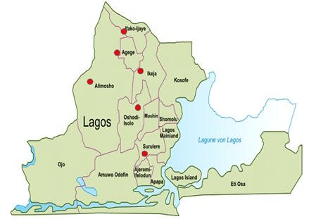
Figure 1. Lagos State Map showing the selected locations under study

Literature Review

Drainage
Drainage is the natural or artificial removal of a surface's water and sub-surface water from an area with excess of water. The internal drainage of most agricultural soils is good enough to prevent severe waterlogging (anaerobic conditions that harm root growth), but many soils need artificial drainage to improve production or to manage water supplies.

Drainage in the construction industry
The civil engineer is responsible for drainage in construction projects. They set out from the plans all the roads, street gutters, drainage, culverts and sewers involved in construction operations. During the construction process he/she will set out all the necessary levels for each of the previously mentioned factors.
Civil engineers and construction managers work alongside architects and supervisors, planners, quantity surveyors, the general workforce, as well as subcontractors. Typically, most jurisdictions have some body of drainage law to govern to what degree a landowner can alter the drainage from his parcel.
Drainage options for the construction industry include:
Point drainage, which intercepts water at gullies (points). Gullies connect to drainage pipes beneath the ground surface and deep excavation is required to facilitate this system. Support for deep trenches is required in the shape of planking, strutting or shoring.
Channel drainage, which intercepts water along the entire run of the channel. Channel drainage is typically manufactured from concrete, steel, polymer or composites. The interception rate of channel drainage is greater than point drainage and the excavation required is usually much less deep.
The surface opening of channel drainage usually comes in the form of gratings (polymer, plastic, steel or iron) or a single slot (slot drain) that runs along the ground surface (typically manufactured from steel or iron).

Drainage in retaining walls
Earth retaining structures such as retaining walls also need to consider groundwater drainage. Typical retaining walls are constructed of impermeable material which can block the path of groundwater. When groundwater flow is obstructed, hydrostatic water pressure buildups against the wall and may cause significant damage. If the water pressure is not drained appropriately, retaining walls can bow, move, fracture and seams separate. The water pressure can also erode soil particles leading to voids behind the wall and sinkholes in the above soil. Traditional retaining wall drainage systems can include, French Drains, drain pipes or weep holes. To prevent soil erosion, Geotextile filter fabrics are installed with the drainage system.

Methodology
For this study, information and data collection were obtained via two sources which include: Primary and secondary sources.
A. Primary sources
i) Administering of Questionnaires:
The questionnaires designed respects the rights and anonymity of the respondents thereby ensuring confidentiality of the respondents. A total of 300 copies of a well compiled questionnaire addressing the most likely causes, effect of water drainage challenges as well as environmental challenges relating to the improper utilization of the drainage systems in the chosen locations were used.
Table 1: Response on Drainage Challenges from Residents.
Percentage (%)
Location | Agege | Muhin | Ikeja | Alimosho | Apapa | Ifako Ijaye | Average  Percentage (%)
YES | 72 | 80 | 52 | 80 | 79.2 | 79.2 | 75
NO | 28 | 20 | 48 | 20 | 20.8 | 20.8 | 25

The lack of adequate waste collection and disposal system cause poor sanitation as it leads to the blockages of drains. Increased population, human activities and inflow materials into the area results in the generation of larger volumes of waste, coupled with irrepressible location of physical infrastructures such as offices, facilities, markets and residential structures which are located and built along natural erosion routes and drainage channels. From the results obtained in the study, 59.1%, 61.9%, 55 %, 44%, 80 %, 54.2% of the respondents in Agege, Mushin, Ikeja, Alimosho, Apapa and Afako Ijaye, respectively, agree that the abuse of drainage system is the most likely cause of drainage problems in all the local governments under study.
The drainages that were constructed in these areas lacked proper maintenance, as debris and waste materials were dumped into the drain thereby inhibiting flow of water in the drains. This indiscriminate attitude occurred majorly by road users who drop waste materials into the drains owing to insufficient waste bins around. Figure 2 shows the severity of the issues in each of the local government.
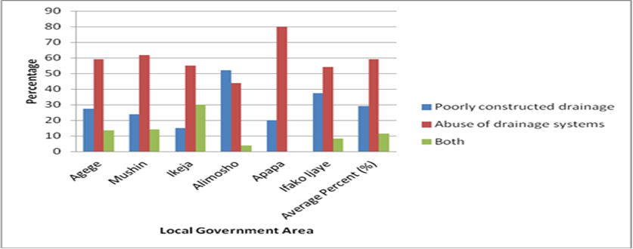
Figure 2: Showing the causes of flood in each of the Local Governments

A. Excess Sediments and Garbage
After each occurrence of flooding and storm, wastes are dumped in ditches and drainage channels. Theses drainage channels remains unattended to and thereby get clogged. This causes blockage of channels for the subsequent runoffs and other contents. Figure 3 shows the deterioration of the functionality of the drains in these areas of study.
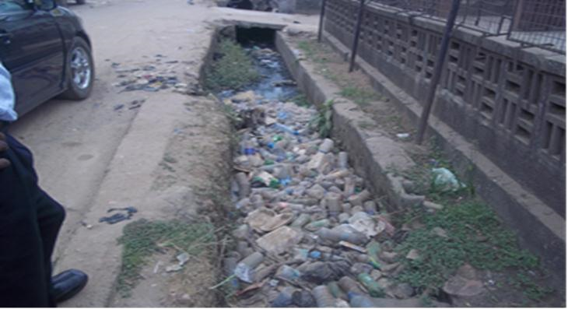
Figure 3: blocked drains as a result of abuse of drains with waste deposits
Also as this blockage exists, the road pavement attached to these drains is also under threat. Water builds up on the pavement (flood) thereby causing a wear and tear, with washing of bitumen and other road components into drains thereby causing further damage and leading to drain failures.

B. Effect of Poor Maintenance
The construction of drainages will be a waste when not properly maintained. The performance of a drain is attributed not only to how effective it is utilized, but also to the conditions therein. These conditions include the presence of waste, the presence of growing plants and leakages. These challenges do not only retard flow in the drain, but they also increase overflow conditions. It was clear that the drainage challenges within these areas were as a result of poor maintenance of the drains themselves. This has created habitats for growing weeds and stagnation of water. Figure 4 shows a collapsed drainage wall with weeds growing on it.

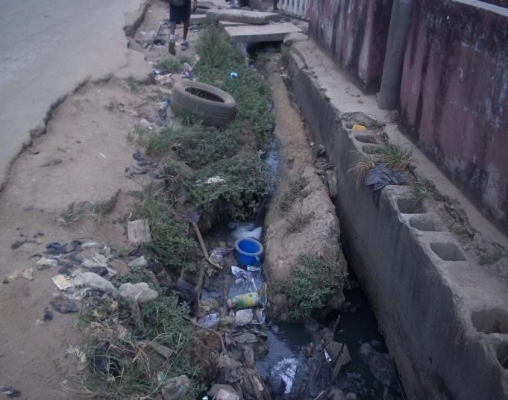
Figure 4: Showing a poorly maintained drain

C. Lack of Community Participation
One of the main obstructions preventing the successful control of storm runoff measures either by structural or non-structural measures is the absence of community participation in providing solutions to urban drainage problems. Community participation simply depends on the desire and ability to organize themselves, strict compliance to societal goals and rules, and providing medium of direct communication by the appropriate municipal administration. This provides linkages in which municipal authorities can pass useful information to residents, and vice versa. It can also develop into participatory function where well-defined priorities that pertain to urban drainage can be evaluated. As a result of compliance, the level of technical information as well as environmental education increases. The absence of community participation gives room for repetition of earlier errors in tackling drainage problems and also low investments in urban facilities
Silveira et al. (2001) identified the biggest difficulty in community participation which is the wide difference in socioeconomic levels amongst those living in the city (Table 2). Poor people living in areas with run-down public services inherently pay little attention to public utilities. It is no news anymore as people regard urban drainages as the place to dispose garbage. The establishment of garbage collection system may not bring change if other public services such as efficient and effective delivery of municipal waste to disposal areas do not exist.
However, environmental education programmes are necessary but not adequate in eradicating urban drainage problems.
In Lagos, the introduction of “Environmental Sanitation Day” which takes place every last Saturday of the month, adopts a systematic clean-up of urban waterways by residents thereby freeing drainages from subsequent blockage. With this participation, the problems of garbage and sediments in drainage channels remains, placing doubts on the effectiveness of such measures, at least in the short term. There is no objective measure to increase the effectiveness of such a programme, yet it cannot be abandoned. The efficacy in the long term would be on the increase when today’s children become adults tomorrow and are adequately taught how to participate in environmental preservation.

Table 2: Socio-Economic Factors In Developing Countries
Socio Economic Factor | Effect | Consequence
Insufficient environmental education of most of the population | Lack of knowledge and care about the impact of trash on streets and in watercourses | Discharge of refuse, sediments and excreta on streets and into watercourses
Social forces of the poorest segment of the population | Illegal occupancy of urban preserved areas | Deforestation, exposure of bare soil, impervious
 | Illegal occupancy of urban risk areas | Landslides, production and direct discharge of sediments and refuse into watercourses
 |  | Unacceptable exposure to major floods (life-risking floods)
Source: Silveira et al. (2001)
Community participation in terms of sanitation provides members of the community the opportunity to contribute in the policy and decision making process. In its contribution, the place of planning, implementation, monitoring and maintenance of drainage channels should be given its rightful place as regards to sustainability. Participation in its approach is seen as a means of ensuring augmented social accountability with the involvement of the citizens in decision making as well as creating a close relationship between the “governed” and the “governing”.
This could be achieved through public hearing, workshops, social surveys, reports, public meetings etc. This helps in development of local capabilities which its importance cannot be over emphasized.

D. Health Impacts
Flood related issues are experienced majorly during the raining seasons in Nigeria but they are very pronounced owing to poor sanitized environment during and after the raining seasons. Areas experiencing poor drainages like the areas under study allow runoff from these areas to have an interaction with black water from exposed or overflowing septic tank systems causing outbreak of water-borne related diseases and also, infiltration and percolation of this polluted water into the ground water will cause contamination. This is a conduit for gastro-intestinal diseases such as constipation, anal disorders, and structural disorders amongst others. To curb these hazards, proper cleaning of channels should be done on a regular basis and not only on sanitation days to reduce the habitation of pathogens responsible for these diseases. Also, more refuse dumps (collection points) be provided in this areas understudy and be visited by the agencies responsible on a regular basis to help reduce epidemics.

E. Drainage Designs Problems
Urban drainage system issues are also generated by improper design of these systems. This is attributed to the variance created in rainfall distribution patterns faced by the developing countries as a result of global warming (Silveira, 2001). Most of these drainages were designed with basic hydraulic formula without considering this variance thereby ending up not solving flood cases in these areas. More emphasis has to be made to producing homegrown methods that are related to these areas rather than depending on this formula or assumptions already in use in the developing countries because we have different catchment characteristics. Also, roof catchment methods of rain water collection should be encouraged to reduce peak flows of runoff that should have entered this drainage. There is so much reliance on hydrological data in determining the drainage challenges. Vital information and proper data collection such as water quality of runoff and sediments transport should not be neglected.. This could improve the design and sustainability of these drainage channels.

F. Drainage Designs Problems
Urban drainage system issues are also generated by improper design of these systems. This is attributed to the variance created in rainfall distribution patterns faced by the developing countries as a result of global warming (Silveira, 2001). Most of these drainages were designed with basic hydraulic formula without considering this variance thereby ending up not solving flood cases in these areas.
More emphasis has to be made to producing homegrown methods that are related to these areas rather than depending on this formula or assumptions already in use in the developing countries because we have different catchment characteristics. Also, roof catchment methods of rain water collection should be encouraged to reduce peak flows of runoff that should have entered this drainage. There is so much reliance on hydrological data in determining the drainage challenges. Vital information and proper data collection such as water quality of runoff and sediments transport should not be neglected. This could improve the design and sustainability of these drainage channels.

G. Urban Drainage Planning
In the study areas, the alteration in the planning has led to buildings being erected on drainage channel and path thereby increasing storm water problems. Also, it has left little or no escape routes for flood water thereby making these structures ineffective and insufficient. Drainage planning in the beginning is essentially a sure way to abate flooding issues. Secondly, due to alteration in urban planning, there is need for a review of the designs of the various drainage networks already in use. Thirdly, the government needs to urge relevant institution in-charge of housing and planning in Lagos and especially the areas underlisted in this research, to do a proper quality assurance in terms of urban planning. The policy should henceforth mandate that only houses which are in accordance with already laid policies which promote wellbeing and sustainability of the city be approved.

Conclusions and Recommendations
The state of urban drainage is of great concern because of the health implications and environmental dangers that it poses. Technical limitation to conventional urban drainage method is a predominant factor that decision makers and planners face. To overcome these limitations as well as preventing ecological problems in the future, there is need to measure today’s system. This can be achieved through sanitary approach which involves more of community involvement in actualizing the goals of proper and effective sanitation process. The processes aforementioned should be encouraged at all levels by the government through workshops, public hearings, and seminars for residents.
When policies are developed, the community should also ensure that there is a follow up or else it would be a complete waste. This will help in achieving a sustainable and effective sanitation that would support government’s effort in upgrading urban services, and improve drainage maintenance procedures.
Therefore, in order to ensure a sustainable and efficient drainage system, the following recommendations are made:
1. There should be policy development based on a renewed understanding of the environmental situation in Lagos.
2. Existing waste legislation should be enforced to promote education and awareness amongst the people toward waste disposal issues and its adverse impacts on health.
3. Necessary measures should be put in place to rehabilitate all the bad drainage systems.

REFERENCES
[1] Asoegwu, R. N. 2009. Enforcing Environmental Laws and Regulations: Levels of Responsibilities. Journal of Environmental Management and Safety, 26-31
[2] Banerjee, S. G and Morella, E. 2011. Africa’s Water and Sanitation Infrastructure: Access, Affordability and Alternatives. The International Bank for Reconstruction and Development/World Bank, Washington DC, U.S.A.
[3] Belete, D.A., 2011. Road and urban storm water drainage network integration in Addis Ababa: Addis Ketema Sub-city. Journal of Engineering and Technology Research. 3(7) Pp 217-225
[4] Centre for Neighbourhood Technology (CNT) 2013. The Prevalence and Cost of Urban Flooding. A case study of Cook County, IL.
[5] Falade, J. B. 2001. Amenity and Open Spaces Contents of Nigerian
Planning Legislation. A Paper Presented at the Policy Seminar on Environmental Issues and Management in Nigerian Development Held at the Department of Geography University of Benin.
[6] Geldof, G. D. and Stahre, P. 2006. On the road to a new storm water planning approach: from Model A to Model B (Water Practice and Technology Vol 1 No 1 © IWA Publishing
[7] Jimoh, H.I., 2008. Drainage Problems in a Tropical Environment: Perspectives on Urban Quality Management. Journal of human ecology; International interdisciplinary journal of man-environment relationship. 23(4) Pp 275-283
[8] Offiong, R.A., Atu, J.E., Njar, G.N. and Amuyou, U. A., 2008. Problems and prospects of poor drainage systems and urban sustainability in Calabar, Nigeria. Global journal of social sciences.7 (2), Pp121-127.
[9] Mabogunje, A. L. 2002. Land Management in Nigeria: Issues, Opportunities and Threats”, Paper presented at the National Conference on Land Management and Taxation, Department of Estate Management, University of Lagos. Available from: worldbank.org/EXTARD/Resources/1271205116054/mabogunje.pdf . Accessed 3/01/2013.
[10] Olukanni, D. O. and Akinyinka, M. O. 2012. Environment, Health and Wealth: Towards an Analysis of Municipal Solid Waste Management in Ota, Ogun State, Nigeria. Proc. ICCEM (2012) 138 – 145.
[11] Olukanni, D. O. 2013a. Assessment of WASH Program in Public Secondary Schools in South-Western Nigeria. ARPN Journal of Engineering and Applied Sciences Vol. 8 (3).
[12] Olukanni, D. O. 2013b. Analysis of Municipal Solid Waste Management in Ota, Ogun State, Nigeria: Potential for Wealth Generation. Proceeding of the 28th International Conference on Solid Waste Technology and Management March 10-13, 2013 Philadelphia, PA U.S.A.
[13] Offiong, R. A., Atu, J. E., Njar, G. N., & Iwara, A. I. 2009. Effects of Land Use Change on Soil Physico-Chemical Properties in a South-Southern Nigeria. African Journal of environment, Pollution and Health, 7(2), 47-51.
[14] Silveira, A. L. L., Goldenfum, J. A. and Fendrich, R., 2001. Urban drainage control measures, in : Urban Drainage in Humid Tropics, C. E. M. Tucci (ed.) , Urban Drainage in Specific Climates, C. Maksimovic (ch. ed.), UNESCO Technical Documents in
Hydrology, No. 40, Vol I, 125-154.

