AKWIDO OGHENEYOLE PRESLEY

ENGINEERING MATHS ASSIGNMENT

COMPUTER ENGINEERING

17/ENG02/010

a)

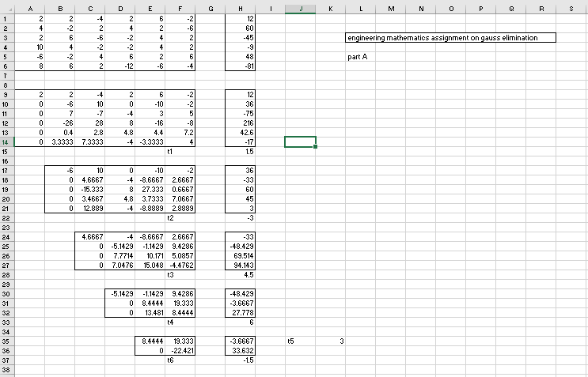

b)

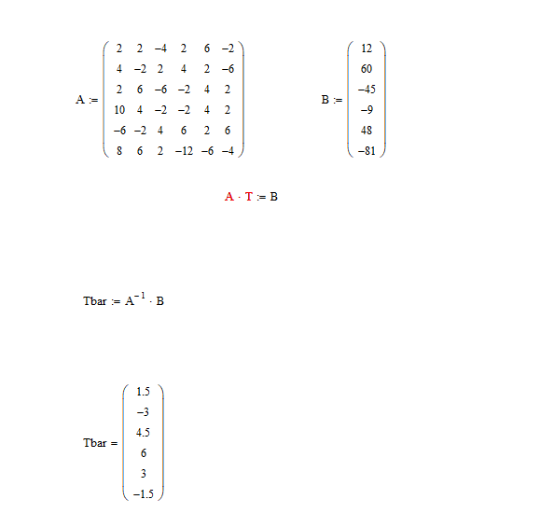

c) 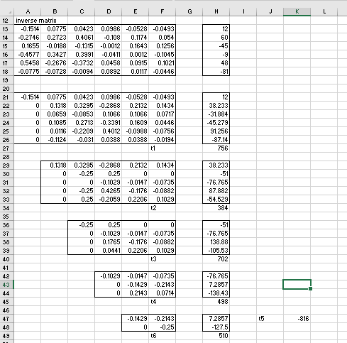

d) 