**ENGINEERING STRATEGIES FOR HANDLING COVID-19 FOR ENVIRONMENTAL HEALTH AND ECONOMIC STABILITY**

**PREPARED BY;**

**NAME: OBOT MKPOUTO OBOT**

**MATRICNUMBER: 17/ENG04/046**

**A TERM PAPER SUBMITTED TO**

**THE DEPARTMENT OF ELECTRICAL/COMPUTER ENGINEERING,**

**COLLEGE OF ENGINEERING,**

**AFEBABALOLA UNIVERSITY ADO-EKITI STATE, NIGERIA.**

**IN PARTIAL FUFILMENT OF ENG 384: ENGINEERING LAW AND MANAGERIAL ECONOMICS**

**ACKNOWLEDGEMENT**

I acknowledge the almighty God for giving me grace and the strength to carry out this project .I also acknowledge the school Afe Babalola University Ado-Ekiti (AB UAD) and its lecturers for devoting their energy resources time on this course.

ABSTRACT

The study is about finding engineering strategies to handle the virus known as Covid-19 popularly known as “corona virus” for economic and health stability .The data for the study were collected through various search engines such as Google, Wikipedia ,Quora and etc .The study shows how Nigeria as a country can handle the current pandemic through the use of one of its leading profession “The engineering Sector” and how it can help us battle the pandemic and also restore both our health and economic growth. Most data and findings made in this report are gotten from case studies and material from the UK.

**TABLE OF CONTENT**

|  |  |  |
| --- | --- | --- |
| CONTENT | PAGE | |
| TITLE | 1 | |
| COVERPAGE | 1 | |
| ACKNOWLEDGEMENTS | 2 | |
| ABSTRACT | 3 | |
| TABLE OF CONTENT | 4 | |
| Introduction to covid-19 | 8 | |
| Engineering strategies for handling covid-19 for environmental health and economic sustainability | 6-12 | |
| How digital transformation is advancing in the wake of the covid-19 pandemic | 13-15 | |
| METHODOLOGY | | 15 |
| CONCLUSION | | 15 |
| RECCOMENDATION | | 16 |

**INTRODUCTION**

**What Is Coronavirus?**

A corona virus is a kind of common virus that causes an infection in your nose, sinuses, or upper throat. They’re called coronaviruses because under a microscope, they look like a crown. Most corona viruses aren't dangerous. But in early 2020, after a December 2019 outbreak in China, the World Health Organization identified a new type of coronavirus. Officials named this new virus severe acute respiratory syndrome coronavirus 2 (SARS-CoV-2). This is the virus that causes COVID-19.

**What Is COVID-19?**

Coronavirus disease 2019, or COVID-19, is a disease that can cause what doctors call a respiratory tract infection. It can affect your upper respiratory tract (sinuses, nose, and throat) or lower respiratory tract (windpipe and lungs).The COVID-19 outbreak quickly spread around the world. It spreads the same way other coronaviruses do, mainly through person-to-person contact. Infections range from mild to serious, COVID-19 is one of seven types of coronavirus, including the ones that cause severe diseases like Middle East respiratory syndrome (MERS) and sudden acute respiratory syndrome (SARS). The other coronaviruses cause most of the colds that affect us during the year but aren’t a serious threat for otherwise healthy people.

SYMPTOMS OF COVID-19

* Trouble breathing
* Persistent pain or pressure in the chest
* New confusion or inability to arouse
* Bluish lips or face

PREVENTIVE MEASURES

* Wash your hands frequently with soap or any other alcohol-based hand sanitizer.
* When sneezing or coughing, cover your nose and mouth with tissues; dispose of the tissues immediately after use.
* Don’t come into close contact with an infected individual, anybody suffering from fever or exhibiting the typical symptoms.
* Cook your foods thoroughly, particularly meat and eggs, before consuming.

**Engineering strategies for handling covid-19 for environmental health and economic stability:**

* 1. MANUFACTURING MORE OPEN SOURCE VENTILATORS

# Corona virus: What are ventilators and why are they important?

OPEN SOURCE VENTILATOR:

Image copyrightDYSON

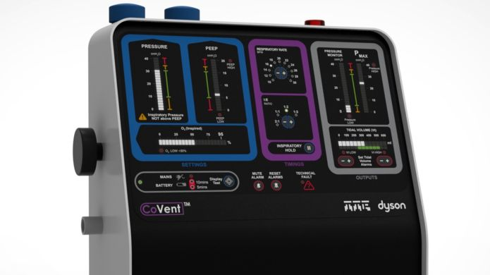

For patients with the worst effects of the infection, a ventilator offers the best chance of survival.

## What is a ventilator and what does it do?

Simply put, a ventilator takes over the body's breathing process when disease has caused the lungs to fail.

This gives the patient time to fight off the infection and recover.

Various types of medical ventilation can be used.

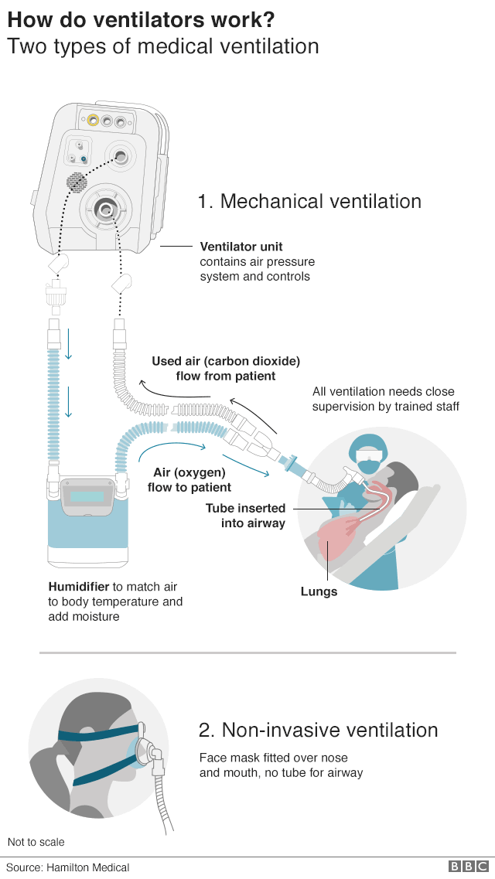

IMG_259

According to the World Health Organization (WHO), some 80% of people with Covid-19 - the disease caused by corona virus - recover without needing hospital treatment.

But one person in six becomes seriously ill and can develop breathing difficulties.

In these severe cases, the virus causes damage to the lungs. The body's immune system detects this and expands blood vessels so more immune cells enter.

But this can cause fluid to enter the lungs, making it harder to breathe, and causing the body's oxygen levels to drop.

To alleviate this, a machine ventilator is used to push air, with increased levels of oxygen, into the lungs.

The ventilator also has a humidifier, which modifies adds heat and moisture to the medical air so it matches the patient's body temperature.

Patients are given medication to relax the respiratory muscles so their breathing can be fully regulated by the machine.

Image copyrightGETTY IMAGES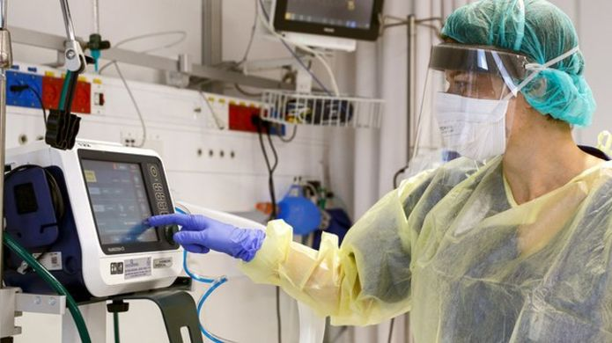

Image caption; All medical ventilation requires close supervision from trained staff

People with milder symptoms may be given ventilation using facemasks, nasal masks or mouthpieces which allow pressurized air or mixtures of gases to be pushed into the lungs.

University College London engineers have worked with clinicians at UCLH and Mercedes Formula One to build what is known as the [**Continuous Positive Airway Pressure (CPAP) device**](https://www.bbc.co.uk/news/health-52087002) . It is being trialed at several London hospitals and if all goes well, the Mercedes-AMG-HPP group can begin building up to 1,000 of the machines per day from next week (6 April).

The CPAP device has already got approval from the Medicines and Healthcare products Regulatory Agency.

Early reports from Lombardy in northern Italy suggest about 50% of patients given CPAP have avoided the need for invasive mechanical ventilation.

However, the use of CPAP machines in patients with contagious respiratory infections has raised some concern, as any small leaks around the mask could spray droplets on medical staff.

Hoods, where pressurised oxygen is pumped in via a valve, are also being commonly used to treat Covid-19 patients, partly because they reduce the risk of airborne transmission of the virus from droplets in the breath.

Image copyrightINTERSURGICAL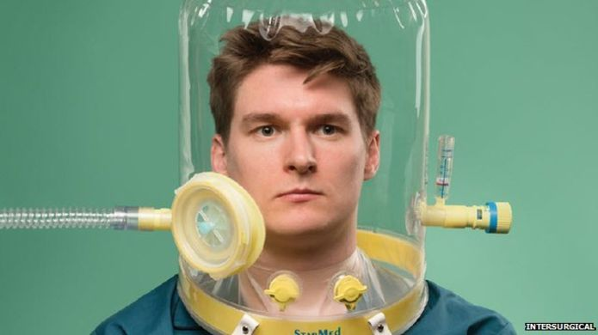

Image caption Oxygen hoods reduce the risk of disease transmission

These are known as "non-invasive" ventilation, as no internal tubes are required.

However, Intensive Care Units (ICUs) would generally put patients suffering acute respiratory distress on mechanical ventilation quickly, to ensure oxygen levels in the body stay normal.

Dr Shondipon Laha, from the Intensive Care Society, told the BBC most patients with Covid-19 would not need a mechanical ventilator and could be treated at home or with supplementary oxygen.

But although there were risks when using ventilators, such as not knowing who would suffer long-term effects, he said, sometimes a ventilator was "the only way of getting oxygen into the patient".

Another issue, Dr Laha explained, was having enough of the right staff in place to manage all the ventilators expected to be needed.

"A ventilator is a complex beast - it can cause a patient trauma if not set up properly," he said. "The technical aspects are challenging. People have knowledge on varying types of ventilator in other specialities, but may need support in using them in intensive care if they're unfamiliar with this."

Manufacturers are racing against time to build new ventilators for a predicted surge in the number of coronavirus patients.

Companies from across the engineering spectrum have offered their assistance, and [work is under way](https://www.theguardian.com/business/2020/mar/23/carmakers-make-nhs-ventilators-coronavirus-uk-government-nissan-rolls-royce)to build 30,000 devices. But what else can engineers do to help during this national and global crisis?

For some expert suggestions, we asked a group of Professional Engineering readers: “Apart from making ventilators, how could engineers help the fight against coronavirus?”

The answers are hugely encouraging, with many good ideas and willing helpers. They will hopefully provide inspiration for potential volunteers and maybe even guidance for under-pressure officials, who could use this engineering expertise to help minimise the worst of the virus’ impact.

Of course, everyone should follow social distancing and other temporary rules. But with potentially months of restrictions ahead and the possibility of the outbreak stretching on, here are another six ways that engineers could help.

## 2. Prevent the spread

With numbers of patients skyrocketing, stopping the spread of Covid-19 is an immediate concern. Multiple readers urged engineering companies to design, develop and manufacture more diagnostic kits, as well as improving logistics to distribute them quicker.

Following criticism of the government’s comparatively low level of testing, one member suggested engineers could install “intelligent body temperature detectors at schools, supermarkets, etc”.

Other cutting-edge engineering could help lower infection rates. “Cleaning solutions and material development with inbuilt anti-bacterial properties being developed into our design solutions would be positive,” said Daniel Marsh.

## 3. Support the NHS

More hospital spaces are needed for patients as the NHS comes under increasing strain. The ExCel Centre in East London is being co-opted as a field hospital and could reportedly hold up to 4,000 patients. Following similar measures in China, readers suggested engineers could help build new hospitals, including by designing and manufacturing buildings using offsite construction.

Improving Personal Protective Equipment (PPE) for NHS staff was a common suggestion. “NHS masks are ‘one size fits all’,” said William Richardson. “To state the obvious, everyone's face is slightly different.”

“Some of it looks quite rudimentary, and some needs very careful fitting to work properly,” said Simon Steven.

Member Caroline Rose suggested improvements could include atmosphere control and filtering, and decontamination. UV decontamination units could reduce waste – and therefore demand – on essential equipment, said one reader.

With multiple efforts ongoing to develop a vaccine, Paul Russenberger said companies should prepare for increased demand for injection needles.

## 4.Spread Stem knowledge

While pupils might have hoped for a break during school closures, teaching is ongoing. This could be a great opportunity to educate and inspire a future generation of engineers, said Dave Hughes.

“Help support education in Stem subjects to take the pressure from teachers, and provide some real-world examples to further engage our student population – of all ages – in what engineering can offer, and hopefully do something that is fun and real while they are learning in a virtual world,” he said.

## 5. ‘Strengthen home industry’

Other members hoped the crisis will be a wake-up call about over-reliance on foreign imports. “Long term, the UK needs to think about what is manufactured here. Importing all your critical supplies only works if there isn't a crisis,” said Richard Goodfellow.

“My hope is that we can strengthen home industry, leaving us less reliant on foreign imports when we have so many untapped skills and resources in the UK,” said Paul W.

## 6. Prevent future outbreaks

While the UK and countries around the world struggle with the current outbreak, several readers urged the industry to look ahead and plan for similar – or even worse – situations.

“We need to use our ingenuity to prevent the problem becoming worse, and avoiding or being prepared for future outbreaks,” said Richard Hulmes.

Engineers should carry out a full assessment of medical equipment that might be required in similar situations, said Rich Pearson, to ensure that designs can be open-sourced and shared with manufacturers when needed.

Industry itself should have a frank appraisal of its international activity to help prevent a repeat of this pandemic, said Paul Thurgood. Companies and employees might need to act differently in future.

“Hopefully this will be a wake-up call in many ways. This is an aggressive virus, but it could be that in future another one will show itself much more slowly, infecting many more people and with much more serious effects. Many of us engage far too much in international travel, with little regard for global warming. The virus is here in the UK solely because of this travel.”

The RT-PCR technique helps identify coronavirus infection accurately and within hours in both human and animal hosts. Using ionizing radiation, it identifies gene-expression during DNA repair and cell-cycle checkpoints like cell death (apoptosis). These data points tell scientists a lot about exposure and viral paths of transmission through populations

## 7.Run the country

For Justin Greenhalgh, the best way engineers could help is simple: “By being put in charge of the country and making long-term decisions!”

Others suggested practical ways of helping the government, including giving guidance on statistical modelling and risk assessment, managing supply chains and assisting planning.

“Whole-system thinking is something that is often lacking in central government – partly because it can be really hard,” said Grant Tuff. “Engineers can help with this, in terms of understanding the implications of different options and choices for handling many aspects of the current situation.”

**How digital transformation is advancing in the wake of the covid-19 pandemic**

[Enterprise Tech](https://www.forbes.com/enterprise-tech)

If “necessity is the mother of invention,” coronavirus (COVID-19) forced many around the world to rethink our daily lives from work to school to entertainment. In response to travel bans, school closures, and recommendations to not gather in large groups and keep our distance from fellow humans to limit the spread of the virus, many people turned to digital tools to keep some semblance of normality. It’s been imperative to digitally transform our places of work and education to be able to operate effectively. Those companies able to use technology well to keep going and rethink their business model for the future by fast-tracking digital transformation will be ones ahead of their competition.

**Ability to Work from Home**

Even companies that were resistant to the concept of a distributed workforce have been forced to allow working from home, so work can still be done while taking precautions to halt the spread of the virus. According to a survey by [Workhuman](https://www.cnbc.com/2020/03/06/the-coronavirus-could-actually-make-working-from-home-more-commonplace.html), only a third of people in the United States worked for home before the pandemic. Twitter and other large organizations encouraged their employees to work from home, and other companies such as Google and JPMorgan were building remote working policies in the event they needed to shift work home.

While the ability to work from home is a benefit many employees value, many companies lack the technology infrastructure structure to offer that capability without some sacrifices to “business as usual.” However, one unexpected outcome of COVID-19 is that companies realize the benefits of fast-tracking digital transformation.

When many Chinese cities went under lockdown as COVID-19 spread, government and many companies encouraged millions to stay at home, which had them experiencing the joys and turmoil of working from home. Generally, Chinese companies were set up with appropriate technology to allow working from home, but many company cultures were not.

While some companies will eventually go back to rigid work-in-office policies, it’s expected that some will realize the benefits to employees and that in fact, it can be done effectively. If nothing else, they will have valuable experience about what is needed and how to accommodate work-from-home needs in the future when it’s required again due to another outbreak or other reasons.

**Telehealth**

Before the COVID-19 outbreak, there was some progress made in[telemedicine](https://www.statnews.com/2020/02/28/coronavirus-telehealth-digital-health-us-hospitals-companies-face-challenges/); however, public health officials are pushing healthcare systems to expand their telemedicine through smartphones and other tools.

Technology can assist in triaging patients and in diagnosing those without the illness but are worried they might have it from seeking treatment at overcrowded facilities by talking to them through telehealth technology. And, using telemedicine limits human-to-human contact, critically important to slow the transmission. There are certainly many advantages to telehealth but also challenges that need to be overcome. Healthcare systems are being[forced to address them sooner rather than later](https://mhealthintelligence.com/news/coronavirus-scare-gives-telehealth-an-opening-to-redefine-healthcare) with COVID-19. In fact, a bill for coronavirus funding in the U.S. Congress waives the rules that usually restrict video services for people on Medicare, a move that really emphasizes the potential for telehealth in not only this current outbreak but in the future.

**Remote Learning**

As COVID-19 spread throughout countries, schools and[universities began to turn to virtual learning options](https://www.insidehighered.com/news/2020/03/09/colleges-move-classes-online-coronavirus-infects-more). Many universities decided to switch the rest of the semester’s work to online learning only and some closed campuses to contain spread of the virus. While many universities had experience with virtual learning such as[Harvard Business School Online](https://online.hbs.edu/learning-model/live) and were better prepared for the shift, the majority of education organizations are not really set up for online classes.

There are some [K-12 institutions](https://www.digitaltrends.com/features/coronavirus-digital-education-k12/) that are going virtual, leaving teachers and administrators to ensure that all kids have access to the technology and tools they need to keep learning from home. The transition to digital education is certainly disruptive as it wasn’t planned for in the timeline the coronavirus dictated, but the educators and educational institutions will be better prepared in the future.

In China[, New Oriental Educations & Technology Group and interactive streaming platform Agora.io](https://www.digitaltrends.com/features/coronavirus-digital-education-k12/) collaborated to quickly get digital platforms running in China under a tight timeline so education could continue as soon as possible.

**Events Going Virtual**

Along with many in-person conferences being canceled worldwide in response to the COVID-19 outbreak, some are[switching them to be virtual events.](https://www.marketwatch.com/story/tech-shows-go-digital-route-amid-coronavirus-risks-2020-03-04) The first conference to cancel due to safety concerns was Mobile World Congress, the annual gathering of electronics makers. Google Cloud Next ’20 became Digital Connect and promised that what once was a three-day conference to be a “free, global, digital-first, multi-day event” that would use the Next ’20 content. Collison, the fastest-growing tech conference in North America, was another conference that turned to virtual as Collison from Home—the in-person event got postponed to June 2021. I am currently making arrangements to film my keynote for the [SAS Global Forum](https://www.sas.com/en_us/events/sas-global-forum/announcement.html), which has gone virtual because of the coronavirus, so that people can watch it virtually.

[Conferences are a trillion-dollar industry](https://www.wired.com/story/amid-coronavirus-fears-startups-rethink-virtual-conference/) and have been a critical way to exchange ideas and build professional relationships. Some companies are trying to bridge the gap between in-person events and virtual ones with platforms that combines video, networking, and more to try to capture the benefits of networking at an in-person event and the content and tech of virtual tools.

The virus outbreak has pushed conference organizers and business owners to think outside the box to provide compelling alternative options in the interest of public safety. This push could also result in innovations for the future with how people meet and interact better virtually.

**Technology**

Remote working—and learning—is easier for all with cloud meeting and team collaboration tools such as Tencent’s WeChat Work or Alibaba-owned DingTalk. In response to the COVID-19 pandemic,[many technology companies are rolling out tools](https://www.nojitter.com/team-collaboration-tools-workspaces/coronavirus-boosts-cloud-meetings-team-collaboration) that can support companies and organizations when going remote for extended trial periods or for lower fees. Here are a few:

* [Google](https://cloud.google.com/blog/products/g-suite/helping-businesses-and-schools-stay-connected-in-response-to-coronavirus) is allowing free access to advanced features that normally have a fee every month for Hangouts Meet to all G Suite and G Suite Education customers for several months.
* [Microsoft](https://www.businessinsider.com/microsoft-teams-coronavirus-free-trial-remote-work-2020-3?utm_source=feedly&utm_medium=webfeeds) offered a free six-month trial of its top tier of Microsoft Teams to enable schools, hospitals, and businesses in China to keep operating even with the restrictions of coronavirus.
* U.S.-based video-conferencing provider[Zoom](https://blog.zoom.us/wordpress/2020/02/26/zoom-commitment-user-support-business-continuity-during-coronavirus-outbreak/) saw its stock price rise during the crisis; clearly people are seeing the value of remote-working tools. Zoom lifted the 40-minute limit from its free Basic plan for China when coronavirus hit the country. Doctors in China from more than 1,000 hospitals used the service for online consultations.
* [LogMeIn](https://www.gotomeeting.com/?clickid=2s%3AVXB3B2xyORsz0EHQlB1XYUknSVtXNpyL5XU0&irgwc=1&cid=g2m_noam_ir_aff_cm_pl_ct) is offering healthcare providers, educational institutions, non-profit organizations access to its video conferencing tools, including GoToMeeting and GoToWebinar.
* [Cisco is fortifying its Webex](https://blog.webex.com/video-conferencing/cisco-webex-supporting-customers-during-this-unprecedented-time/) tool to properly support companies during the coronavirus in the 44 countries its available in, including offering 24/7 assistance for businesses using the tool.

**Methology:**

Design of the study: the study adopted an online research design. Online research methods are ways in which researchers can collect data via the internet.

Area of study: England (where the research data was gathered)

**Conclusion:**

In conclusion in relation to the covid 19 pandemic, engineering could play a vital role in saving as much lives as possible. with more ventilators and masks being needed and have to be mass produced day by day, the engineering sector needs to work round the clock to provide the necessary numbers to make up for the current shortage. Also there reports of people using 3d printing technology to mass produce valve for ventilators, but manufacturing companies heavily warn against it for economical reasons. The is a possibility for 3d printing to be of major use here.