Briefly explain the following interconnection networks:
1. The Crossbar Network
2. Cube Interconnection Network
3. Fat Tree Connection
Solution
Crossbar network: A crossbar is a non-blocking switching element with N inputs and M outputs used for connecting multiple components of a computer where, typically, N = M. The crossbar can simultaneously transport signals on any of the N inputs to any of the M outputs as long as multiple signals do not compete for the same input or output port. Crossbars are commonly used as basic switching elements in switched-media network.
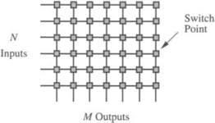
Cube interconnection network: An cube network, also called hypercube, consists of N=2n nodes; n is called the dimension of the n-cube network. When the node addresses are considered as the corners of an n-dimensional cube, the network connects each node to its n neighbors. In an n-cube, individual nodes are uniquely identified by n-bit addresses ranging from 0 to N-1. Given a node with binary address d, this node is connected to all nodes whose binary addresses differ from d in exactly 1 bit. For example, in a 3- cube, in which there are eight nodes, node 7 (111) is connected to nodes 6 (110), 5 (101), and 3 (011).
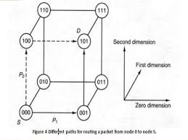

Fat tree connection: The fat tree network is a universal network for provably efficient communication. It was invented by Charles E. Leiserson of the Massachusetts Institute of Technology in 1985. In a tree data structure, every branch has the same thickness, regardless of their place in the hierarchy—they are all "skinny" (skinny in this context means low-bandwidth). In a fat tree, branches nearer the top of the hierarchy are "fatter" (thicker) than branches further down the hierarchy. In a telecommunications network, the branches are data links; the varied thickness (bandwidth) of the data links allows for more efficient and technology-specific use.
