Name : Ayodele Victoria Jesuseun
Course : MAT204
Matric NO :19/sci01/093
QUESTIONS

1. Define the following (i) linear transformation (ii) Rank of a matrix.

2. Given a matrix X where the first column is 1, 4, 9, the second column is 2, 7 5 and the third column is

8, 6, 3. Determine whether is singular or non-singular.

3. Let T maps X to Y be a linear transformation. Let the elements in domain X be e, f, g, h, I, j, k and let the elements in co-domain Y be 2, 4, 6, 8, 10. Transform 5 elements in domain X to 5 elements in co-domaim Y.

Answer
1i) A linear transformation is a function from one vector space to another that respects the underlying (linear) structure of each vector space.
1ii) The rank of a matrix is the dimension of the vector space generated by its columns.
2) 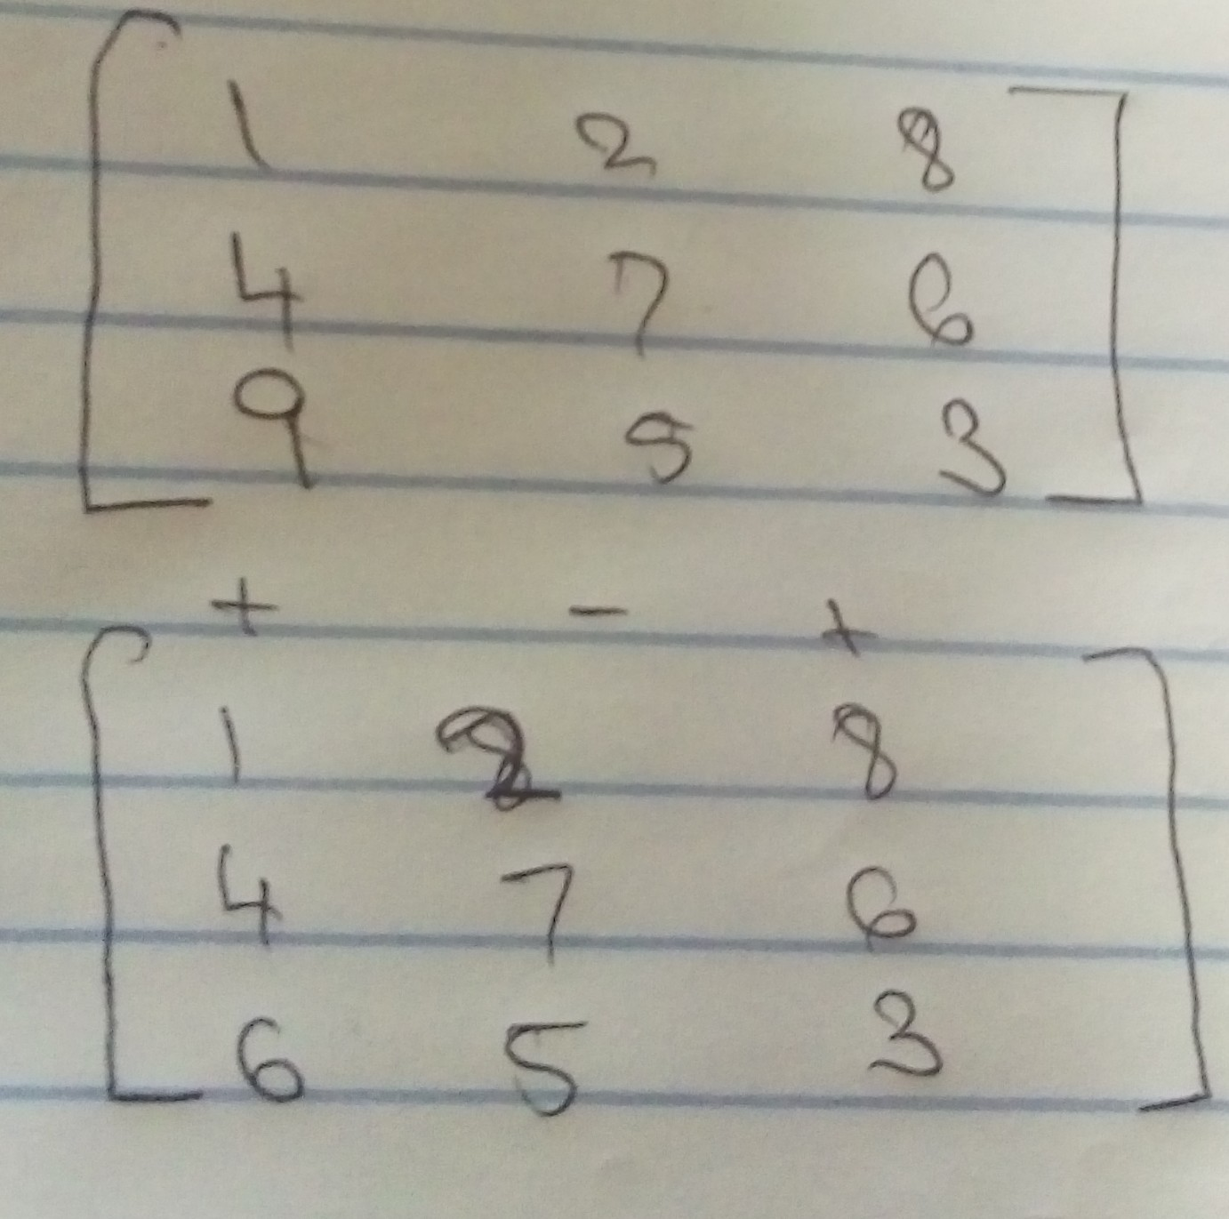
Solution
1((7x3) (5x6)) - 2((4x3)-(9x6)) + 8((4x5)-(7x9))
=1(21 - 30) - 2(12 - 54) + 8 (20 - 63)
=1(-9) - 2(-42) + 8(-43)
=-9 + 84 - 344
= -269
Therefore matrix is non-singular since determinant is not zero
3)


