NAME: OMOLADE BRIGHT AYOMIDE
DEPARTMENT: COMPUTER SCIENCE
MATRIC NO : 19/SCI01/078
TABLE

NUMBER 1 AND TABLE CONTINUATION
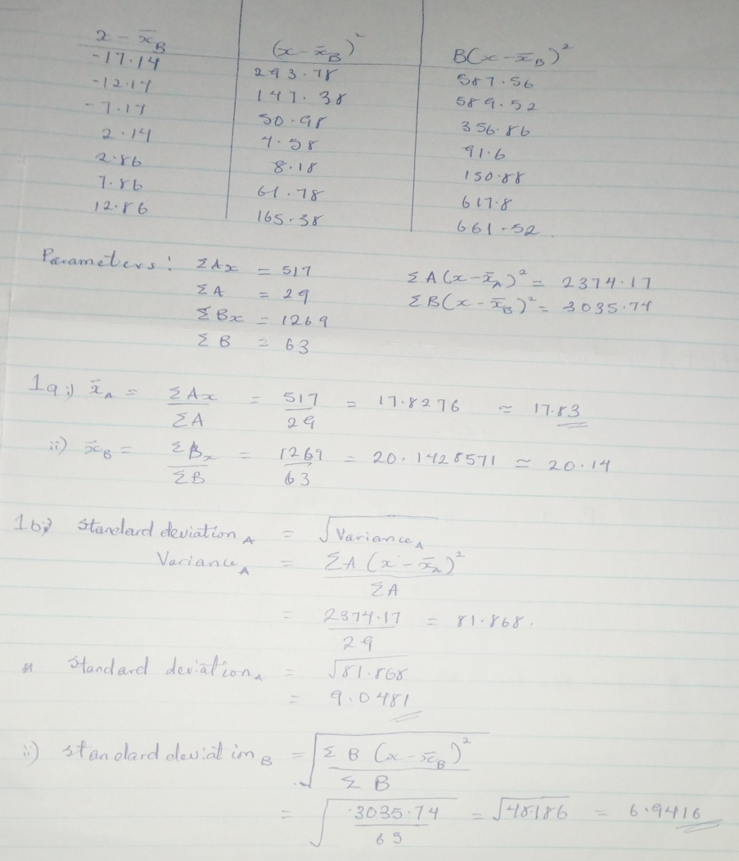

NUMBER 2

