Name: OMOSEEBI OLUWANIFEMI AUSTINE
Department: Dentistry
Matric No: 19/MHS09/018
Course code: Chem 102

Assignment
1. Discuss the 2 major classification of alkanol and give 2 example each for each class
Solution
- Classification based on the number of hydrogen atoms attached to the carbon atom containing the hydroxyl group: if the number of hydrogen atom attached to a carbon atom bearing the hydroxyl group are three or two it is called primary alcohol (1°), it is called secondary alcohol(2°) if it has one hydrogen atom attached to the carbon atom containing the hydroxyl group and if there is no hydrogen atom attached to the carbon atom bearing the hydroxyl group it is called a tertiary alcohol (3°). Examples are Methanol CH3OH (1°), Propan-2-ol CH3CH(OH)CH3 (2°)

- Classification based on the number of hydroxyl group they possess: Monohydric alcohol have one hydroxyl group present in the alcohol structure. Dihydric alcohol have two hydroxyl group present in the alcohol structure, they are also called Glycol. Trihydric alcohol have three hydroxyl group present in the structure of the alcohol while polyhydric alcohol have more than 3 hydroxyl group. Examples are Ethane-1,2-diol HOCH2CH2OH, Propane-1,2,3-triol OHCH2CH(OH)CH2OH

2. In grignard synthesis of alkanol react a named grignard reagent with CH3CH2CH2CH2C=OCH2CH2CH3
Solution
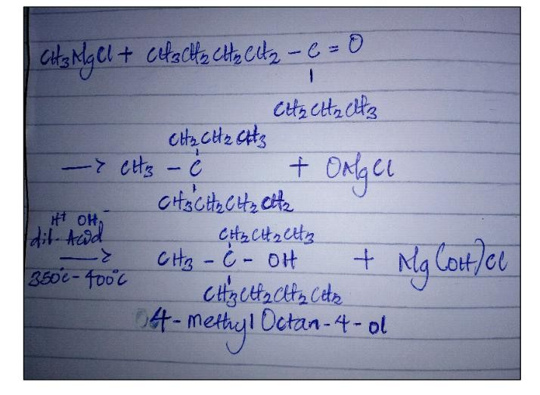
3. Discuss the industrial manufacture of ethanol showing all reaction equations and necessary enzymes and temperature of the reaction
Solution
Ethanol is produced from the biological process of fermentation of carbohydrate. The biological catalyst enzymes found in yeast break down the carbohydrate molecules into ethanol to give a yield of 95%. First the carbohydrate is broken down into maltose by the enzyme called Diastase at a 60°C
2(C6H10O5)n + nH2O. nC12H22O11
60°C/ Diastase
The maltose is further broken down into glucose on the addition of yeast which contains the enzyme maltase at a temperature of 15°C
C12H22O11 + H2O 15°/maltase 2C6H12O6
The glucose at a constant temperature of 15°C is them converted to ethanol by the enzyme called zymase
C6H12O6. 2CH3CH2OH + 2CO2
15°C/Zymase

4. Determine the product obtained in the reduction of alkanone and alkanal use a specific example for each and show the equation of the reaction
Solution
In the reduction of alkanone with a reducing agent such as lithiumtetrahydridoaluminate(III) in ethyoxyethane gives a secondary alcohol as the end product
RR'C =O. RR'CHOH
LiAlH4/(C2H5)2O
In the reduction of alkanal with the reducing agent such as lithiumtetrahydridoalumimate(III) in ethyoxyethane gives a primary alcohol as the end product
RCHO. RCH2OH
LiAlH4/(C2H5)2O

