NAME: IGE .A. SAMUEL
MATRIC N0: 17/SCI01/039
COURSE: CSC 310(COMPUTER ARCHITECTURE and ORGANISATION).
ASSIGNMENT.
Briefly explain the following interconnection networks:
1. The Crossbar Network
2. Cube Interconnection Network
3. Fat Tree Connection
SOLUTION.
- The Crossbar Network:
Crossbar networks allow any processor in the system to connect to any other processor or memory
unit so that many processors can communicate simultaneously without contention. Crossbar networks are used in the design of high-performance small-scale multiprocessors, in the design of routers for direct networks, and as basic components in the design of large-scale indirect networks. A crossbar can be defined as a switching network with N inputs and M outputs, which allows up to min{N, M} one-to-one interconnections without contention.
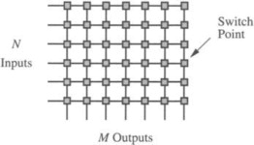
Fig1: How the crossbar works.

- Cube Interconnection Network:
The Cube Interconnection networks are a type of network topology used to connect multiple processors with memory modules and accurately route data. Hypercube networks consist of 2^{m} nodes. These nodes form the vertices of squares to create an internetwork connection. A hypercube is basically a multidimensional mesh network with two nodes in each dimension. Due to similarity, such topologies are usually grouped into a k-array d-dimensional mesh topology family where d represents the number of dimensions and k represents the number of nodes in each dimension.

- Fat Tree Connection:
The fat tree network is a special instance of the Clos topology, fat-trees are optimal interconnects for large-scale clusters and, by extension, for WSCs. When using a fat-tree interconnect servers are placed at the leafs of the tree, while switches populate the root and the internal nodes of the tree. Fat-trees have additional links to increase the bandwidth near the root of the tree. Some set of paths in a fat-tree will saturate all bandwidth available to the end hosts for arbitrary communication patterns. A fat-tree communication architecture can be built with cheap commodity parts as all switching elements of a fat-tree are identical.

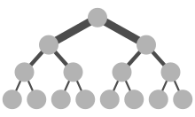
Fig2: Diagram of a Fat Tree Network.

