EDIDIONG IME- ESSIEN
17/SCI01/041
CSC310
Question : Explain the following interconnection networks:
1. The Crossbar Network
2. Cube Interconnection Network
3. Fat Tree Connection

Answers
1.Crossbar networks allow any processor in the system to connect to any other processor or memory unit so that many processors can communicate simultaneously without contention. Crossbar networks are used in the design of high-performance small scale multiprocessors, in the design of routers for direct networks, and as basic components in the design of large-scale indirect networks.

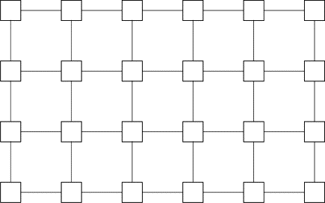

2. Cube interconnection network: It is a 3 dimensional interconnection network. The minimum distance between a pair of nodes is the minimum number of communication links (hops) that data from one of the nodes must traverse in order to reach the other node.

3. Fat tree network topology looks like a tree topology like below example. In tree topology, we have same terminologies like Root, parent, child etc. This is mainly used to connect a large number of physical servers/ computers in a large data center. Fat tree topology is based on the complete binary tree. Below is an example of 3 layer Fat tree topology. The top layer (level-0) of switches is called Core layer. The second layer of switches is called Aggregation layer. And the third layer of switches is called Edge layer. The number of ports in each switch is same.
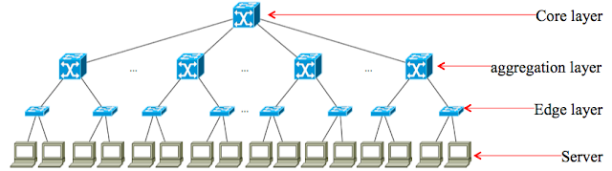
Fig-2. An example of 3 layer Fat tree topology.

