EDE ADE EDWINA

16/SCI05/003

MCB408

QUESTION: In not more than three pages write on the virology, epidemiology, pathogenesis and control of COVID-19

VIROLOGY OF COVID-19

Origin, Classification, and Genome
At the end of 2019, COVID-19 emerged in several local hospitals of Wuhan, Hubei Province, China (Figure 1). Based on clinical manifestations, blood tests, and chest radiographs, this disease was diagnosed as virus-induced pneumonia by clinicians. Initial epidemiological investigation suggested that a majority of suspected cases were associated with their presence (exposure) in a local Huanan seafood market. Notably, not just seafood, but many kinds of live wild animals were available for sale in this market all year round before it was forced to close on January 1, 2020. As expected, SARS-CoV-2 was isolated in environmental samples of the Huanan Seafood Market by China Center for Disease Control and Prevention (CDC), implying the origin of the outbreak. However, such a decisive conclusion was disputed because the earliest case had had no reported link connection to the mentioned market In addition, it was found that at least two different strains of SARS-CoV-2 had occurred a few months earlier before COVID-19 was officially reported . A recently phyloepidemiologic analysis suggests that SARS-CoV-2 at the Huanan Seafood Market could have been imported from other places . To date, it remains inconsistent with regard to the origin of SARS-CoV-2, and epidemiologic and etiologic investigations are being conducted by Chinese health authorities ( Wilde et al., 2018 )

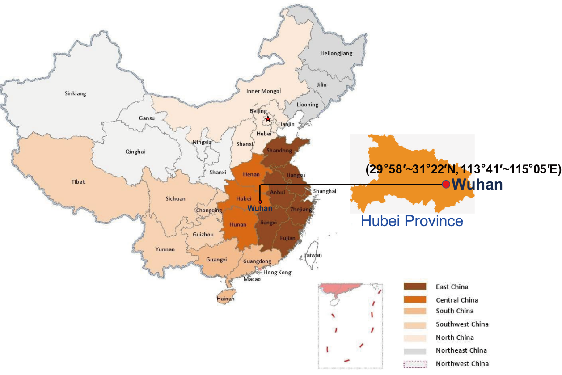
Figure 1. Geographic location of Wuhan, Hubei Province in China. Hubei Province is located in the central area of China, and the provincial capital is Wuhan.

SARS-CoV-2 was first isolated in the bronchoalveolar lavage fluid (BALF) of three COVID-19 patients from Wuhan Jinyintan Hospital on December 30, 2019 . After sequence and evolutionary tree analysis, SARS-CoV-2 was considered as a member of β-CoVs. The CoVs family is a class of enveloped, positive-sense single-stranded RNA viruses having an extensive range of natural roots. These viruses can cause respiratory, enteric, hepatic, and neurologic diseases]. The CoVs are genotypically and serologically divided into four subfamilies: α, β, γ, and δ-CoVs. Human CoV infections are caused by α- and β-CoVs SARS coronavirus (SARS-CoV) and MERS coronavirus (MERS-CoV) are members of β-CoVs . Genome-wide phylogenetic analysis indicates that SARS-CoV-2 shares 79.5% and 50% sequence identity to SARS-CoV and MERS-CoV, respectively . However, there is 94.6% sequence identity between the seven conserved replicase domains in ORF1ab of SARS-CoV-2 and SARS-CoV, and less than 90% sequence identity between those of SARS-CoV-2 and other β-CoVs implying that SARS-CoV-2 belongs to the lineage B (Sarbecovirus) of β-CoVs .
As shown in figure 1, similar to other β-CoVs, the SARS-CoV-2 virion with a genome size of 29.9 kb possesses a nucleocapsid composed of genomic RNA and phosphorylated nucleocapsid (N) protein. The nucleocapsid is buried inside phospholipid bilayers and covered by two different types of spike proteins: the spike glycoprotein trimmer (S) that exists in all CoVs, and the hemagglutinin-esterase (HE) only shared among some CoVs. The membrane (M) protein and the envelope (E) protein are located among the S proteins in the viral envelope . The SARS-CoV-2 genome has 5′ and 3′ terminal sequences (265 nt at the 5′ terminal and 229 nt at the 3′ terminal region), which is typical of β-CoVs, with a gene order 5′-replicase open reading frame (ORF) 1ab-S-envelope(E)-membrane(M)-N-3′ . The predicted S, ORF3a, E, M, and N genes of SARS-CoV-2 are 3822, 828, 228, 669, and 1260 nt in length, respectively. Similar to SARS-CoV, SARS-CoV-2 carries a predicted ORF8 gene (366 nt in length) located between the M and N ORF genes.

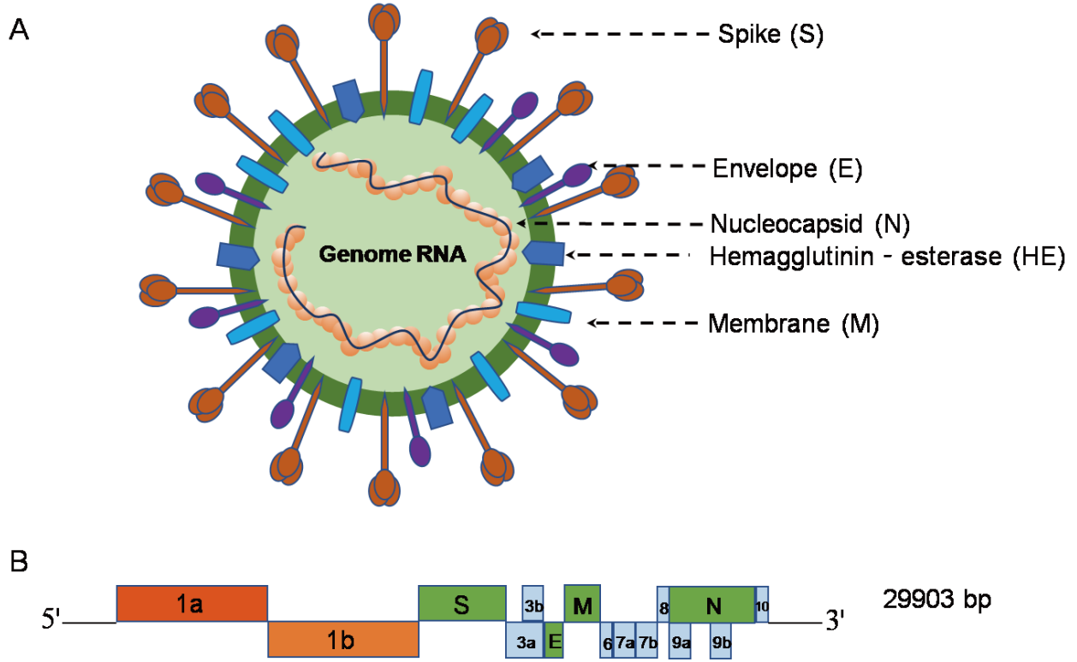

Figure 2. β-coronavirus particle and genome [9] (A) The β-coronavirus particle. β-coronavirus is an enveloped, nonsegmented, positive-sense single-stranded RNA virus genome in a size ranging from 29.9 kb. The virion has a nucleocapsid composed of genomic RNA and phosphorylated nucleocapsid (N) protein, which is buried inside phospholipid bilayers and covered by the spike glycoprotein trimmer (S). The membrane (M) protein hemagglutinin-esterase (HE) and the envelope (E) protein are located among the S proteins in the virus envelope. (B) 5′ and 3′ terminal sequences of the SARS-CoV-2 genome. The gene order is 5′-replicase ORF1ab-S-envelope(E)-membrane(M)-N-3′. ORF3ab, ORF6, ORF7ab, ORF8, ORF9ab, and ORF10 are located at the predicted positions shown in the picture. 1a, 1b, 3a, 3b, 6, 7a, 7b, 8, 9a, 9b, 10 in the picture represent different ORF genes.

Epidemiology

Source of Infection
Currently, COVID-19 patients are the main source of infection, and severe patients are considered to be more contagious than mild ones. Asymptomatically infected persons or patients in incubation who show no signs or symptoms of respiratory infection proven to shed infectious virus, may also be potential sources of infection . Additionally, samples taken from patients recovered from COVID-19 continuously show a positive RT-PCR test which has never been seen in the history of human infectious diseases. In other words, asymptomatically infected persons and patients in incubation or recovered from COVID-19 may pose serious challenges for disease prevention and control ( Zhao et al., 2019 ).

Epidemiological Characteristics in Mainland China
Spatiotemporal distribution. The initial outbreak (8 December 2020) only occurred in Wuhan and its surroundings inHubei Province before an imported case was first reported in Guangdong Province on January 19, 2020 . As of January 30, 2020, when the first imported case in Tibet Province was reported, COVID-19 had spread to all 31 provinces in mainland China. Until 11 February2020, 44,672 cases were reported in all 31 provinces of mainland China (74.7% in Hubei). Among them, 0.2% (100% in Hubei), 1.7% (88.5% in Hubei), 13.8% (77.6% in Hubei), and 73.1% (74.7% in Hubei) of cases were onset before 31 December 2019, 10 January 2020, 20 January 2020, and 31 January 2020, respectively . The number of reported cases rose rapidly after 10 January 2020, and reached a peak on 12 February 2020 . Through the analysis of 1688 healthcare confirmed cases with severe symptoms, there were 1080 cases in Wuhan, accounting for 64.0% of the total incidence, 394 cases (23.3%) in Hubei except Wuhan, and 214 cases (12.7%) nationwide, except for Hubei. Tibet and Qinghai Provinces have had no confirmed cases since 21 February 2020 and 24 February 2020, respectively . On 18 March 2020, “0” new confirmed cases was first reported in Hubei Province, and a total of 24 provinces in mainland China had consecutively reported “0” new confirmed cases. Until 23 March 2020, 81,773 cases (427 imported cases from abroad) were cumulative reported in 31 provinces of mainland China, and the number of new confirmed cases have mainly come from abroad and eight provinces have had no confirmed cases.

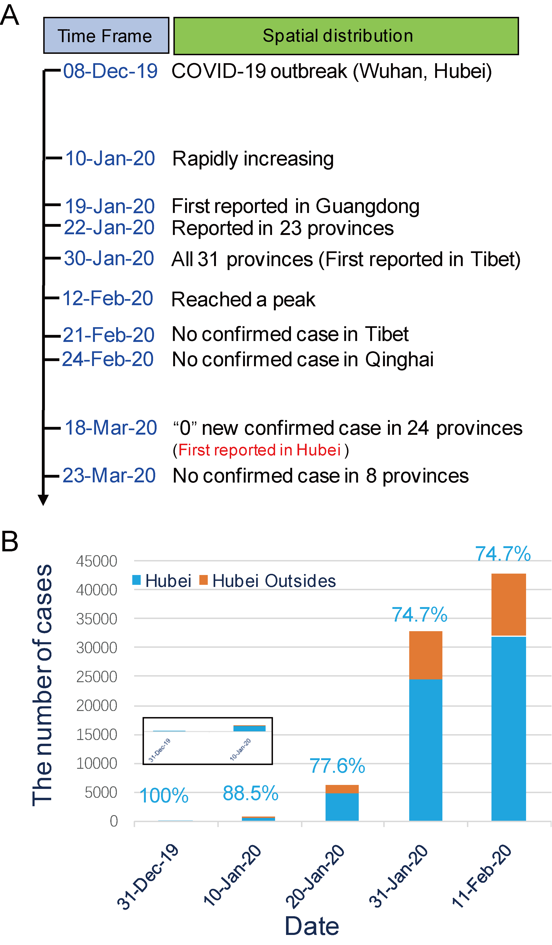

Figure 3. Spatiotemporal distribution of COVID-19. (A) The spread and decline of COVID-19 in mainland China over time. The time point (red words) of “0” new confirmed case first reported in Hubei Province was 18 March, 2020. (B) Distribution of cases with different onset times before 11 February 2020.

Population distribution. China CDC data showed that patients were mainly concentrated at the age of 30–79, accounting for 89.8%, 88.6%, and 86.6% of confirmed cases in Wuhan, Hubei, and mainland China, respectively. The gender ratio (male/female) of confirmed cases in Wuhan, Hubei, and mainland China was 0.99:1, 1.04:1, and 1.06:1, respectively. The proportion of infected healthcare workers and farmers was 2.09% and 22%, respectively .
Case-fatality rate. The total case-fatality rate was 2.3% of 44,672 confirmed cases, while the total case-fatality rate in Hubei and its surroundings was 2.9% and 0.4%, respectively . In contrast, the total case-fatality rate of SARS and MERS was 9.6% ] and 34%, respectively. all COVID-19 patients over 80-years old, the case-fatality rate wasas high as 14.8%. The case-fatality rate of males and femaleswas2.8% and 1.7%, respectively . Patients with underlying basic disorders showed poor prognosis. The case-fatality rate of cases without basic disorders was as low as 0.9%, while the case-fatality rate of cases with cardiovascular disease, diabetes, chronic respiratory disease, hypertension, and cancer was10.5%, 7.3%, 6.3%, 6.0%, and 5.6%, respectively . Notably, critical cases had the highest case-fatality rate of 49% . As for healthcare workers, the case-fatality rate was approximately 0.17% of 3019 cases .

Pathogenesis

Virus Entry and Spread
SARS-CoV-2 is transmitted predominantly via respiratory droplet, contact, and potential in fecal-oral . Primary viral replication is presumed to occur in mucosal epithelium of upper respiratory tract (nasal cavity and pharynx), with further multiplication in lower respiratory tract and gastrointestinal mucosa , giving rise to a mild viremia. Few infections are controlled at this point and remain asymptomatic. Some patients have also exhibited non-respiratory symptoms such as acute liver and heart injury, kidney failure, diarrhea , implying multiple organ involvement. ACE2 is broadly expressed in nasal mucosa, bronchus, lung, heart, esophagus, kidney, stomach, bladder, and ileum, and these human organs are all vulnerable to SARS-CoV-2 . Recently, potential pathogenicity of the SARS-CoV-2 to testicular tissues hasalso been proposed by clinicians, implying fertility concerns in young patients (Wu et al., 2020).

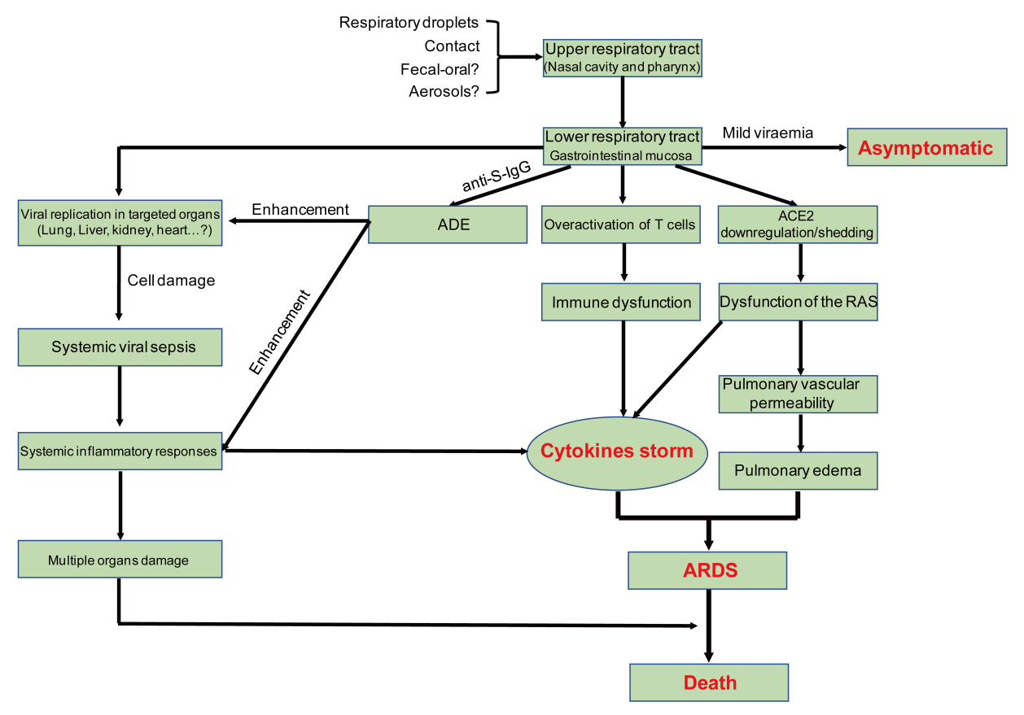
Figure 5. Postulated pathogenesis of SARS-CoV-2 infection. Antibody-dependent enhancement (ADE); ACE2: angiotensin-converting enzyme 2; RAS: renin-angiotensin system; ARDS: acute respiratory distress syndrome. Red words represent the important turning points in SARS-CoV-2 infection.

Pathological Findings
The first report of pathological findings from a severe COVID-19 showed pulmonary bilateral diffuse alveolar damage with cellular fibromyxoid exudates. The right lung showed evident desquamation of pneumocytes and hyaline membrane formation, indicating acute respiratory distress syndrome. The left lung tissue displayed pulmonary edema with hyaline membrane formation, suggestive of early-phase acute respiratory distress syndrome (ARDS) (National Microbiology Data Center , 2020 ).

Acute Respiratory Distress Syndrome (ARDS)
ARDS is a life-threatening lung condition that prevents enough oxygen from getting to the lungs and into the circulation, accounting for mortality of most respiratory disorders and acute lung injury . In fatal cases of human SARS-CoV, MERS-CoV, and SARS-CoV-2 infections, individuals exhibit severe respiratory distress requiring mechanical ventilation, and the histopathology findings also support ARDS . Previous studies have found that genetic susceptibility, and inflammatory cytokines were closely related to the occurrence of ARDS. More than 40 candidate genes including ACE2, interleukin 10 (IL-10), tumor necrosis factor (TNF), and vascular endothelial growth factor (VEGF) among others have been considered to be associated with the development or outcome of ARDS ( Doremalen et al., 2020 ) .

Cytokine Storm
Clinical findings showed exuberant inflammatory responses during SARS-CoV-2 infection, further resulting in uncontrolled pulmonary inflammation, likely a leading cause of case fatality. Rapid viral replication and cellular damage, virus-induced ACE2 downregulation and shedding, and antibody dependent enhancement (ADE) are responsible for aggressive inflammation caused by SARS-CoV-2, as concluded in a recently published review article .SARS-CoV-2 hijacks the same entry receptor, ACE2, as SARS-CoV for infection, suggesting the likelihood of the same population of cells being targeted and infected . The initial onset of rapid viral replication may cause massive epithelial and endothelial cell death and vascular leakage, triggering the production of exuberant pro-inflammatory cytokines and chemokines ( Li et al., 2003 ).

CONTROL
Vaccination probably offers the best option for COVID-19 control. Epitopes, mRNA, and S protein-RBD structure-based vaccines have been widely proposed and started . Rapid reconstruction of SARS-CoV-2 using a synthetic genomics platform has been reported, and this technical advance is helpful for vaccine development . Human ACE2 transgenic mouse and rhesus monkey models of COVID-19 have been well established for vaccine development , and someSARS-CoV-2 vaccines are already under clinical trial ( Wrapp et al., 2020 ) .

REFERENCES
De Wilde, A.H.; Snijder, E.J.; Kikkert, M.; van Hemert, M.J. Host Factors in Coronavirus Replication. In Roles of Host Gene and Non-Coding RNA Expression in Virus Infection; Tripp, R.A., Tompkins, S.M., Eds.; Springer International Publishing: Cham, Switzerland, 2018; pp. 1–42.
Lu, R.; Zhao, X.; Li, J.; Niu, P.; Yang, B.; Wu, H.; Wang, W.; Song, H.; Huang, B.; Zhu, N.; et al. Genomic characterisation and epidemiology of 2019 novel coronavirus: Implications for virus origins and receptor binding. Lancet (Lond. Engl.) 2020, 395, 565–574.
Wu, F.; Zhao, S.; Yu, B.; Chen, Y.-M.; Wang, W.; Hu, Y.; Song, Z.-G.; Tao, Z.-W.; Tian, J.-H.; Pei, Y.-Y.; et al. Complete genome characterisation of a novel coronavirus associated with severe human respiratory disease in Wuhan, China. bioRxiv 2020.
National Microbiology Data Center. Available online: http://nmdc.cn/coronavirus (accessed on 26 March 2020).
General Office of National Health Commission; General Office of National Administration of Traditional Chinese Medicine. Diagnostic and treatment protocol for Novel Coronavirus Pneumonia; (Trial version 6). Available online: http://www.nhc.gov.cn/yzygj/s7653p/202002/8334a8326dd94d329df351d7da8aefc2.shtml: (accessed on 20 February 2020).
Van Doremalen, N.; Bushmaker, T.; Morris, D.H.; Holbrook, M.G.; Gamble, A.; Williamson, B.N.; Tamin, A.; Harcourt, J.L.; Thornburg, N.J.; Gerber, S.I.; et al. Aerosol and Surface Stability of SARS-CoV-2 as Compared with SARS-CoV-1. N. Engl. J. Med. 2020.
Li, W.; Moore, M.J.; Vasilieva, N.; Sui, J.; Wong, S.K.; Berne, M.A.; Somasundaran, M.; Sullivan, J.L.; Luzuriaga, K.; Greenough, T.C.; et al. Angiotensin-converting enzyme 2 is a functional receptor for the SARS coronavirus. Nature 2003, 426, 450–454.
Donoghue, M.; Hsieh, F.; Baronas, E.; Godbout, K.; Gosselin, M.; Stagliano, N.; Donovan, M.; Woolf, B.; Robison, K.; Jeyaseelan, R.; et al. A novel angiotensin-converting enzyme-related carboxypeptidase (ACE2) converts angiotensin I to angiotensin 1-9. Circ. Res. 2000, 87, E1–E9.
Li, F. Structure, Function, and Evolution of Coronavirus Spike Proteins. Annu. Rev. Virol. 2016, 3, 237–261.
Wrapp, D.; Wang, N.; Corbett, K.S.; Goldsmith, J.A.; Hsieh, C.-L.; Abiona, O.; Graham, B.S.; McLellan, J.S. Cryo-EM Structure of the 2019-nCoV Spike in the Prefusion Conformation. bioRxiv 2020.
Zhou, Q.; Yan, R.; Zhang, Y.; Li, Y.; Xia, L. Structure of dimeric full-length human ACE2 in complex with B0AT1. bioRxiv 2020.
Vijaykrishna, D.; Smith, G.J.; Zhang, J.X.; Peiris, J.S.; Chen, H.; Guan, Y. Evolutionary insights into the ecology of coronaviruses. J. Virol. 2007, 81, 4012–4020.

