A TERM PAPER ON
DESIGN AND OPTIMISATION OF WATER TREATMENT PLANT FOR ADO-EKITI FOR ECONOMIC AND SOCIAL IMPACT

PREPARED BY
ELIJAH NSIKAK-ABASI DAVID
15/ENG03/011

SUBMITTED TO
ENGR.O.J.OYEBODE

THE DEPARTMENT OF CIVIL ENGINEERING,
COLLEGE OF ENGINEERING, AFE BABALOLA UNIVERSITY
ADO-EKITI, NIGERIA

IN PARTIAL FULFILMENT OF REQUIREMENT FOR THE AWARD OF BACHELOR OF ENGINEERING (B.ENG) DEGREE IN CIVIL ENGINEERING

MARCH 2020

INTRODUCTION
The design of a water treatment system represents a decision about how limited resources should be used to achieve specific objective, and the final design is selected from various proposals that would accomplish the same objectives [1].
A design must satisfy a number of technical considerations thus of a good design for a water requires technical competence in the related areas. While engineers may take this fact to be self-evident, it often needs to be stressed to industrial or political leaders motivated by their hopes for what a proposed water treatment system might accomplish, rather than what is possible with the resources available [2]. Moreover, economics and other values must also be considered in the choice of a design, which cannot be determined by technical considerations alone. Moreover, these non-technical issues tend to dominate the final choice of a design for a water treatment system.
The traditional approach to designing water treatment systems uses the average (mode or median) of water quality data.
However, the operation of such water treatment plants may lead to a number of significant dangers [3], as the input water quality is usually not at a constant level. This leads to uncertainties that can only be addressed using a stochastic optimal design model. In the stochastic model [4], a small probability (α) leads to lower risk and higher reliability, with the α-value being chose by a decision maker.
The objective of this paper is to demonstrate how to apply systems analysis to the design of a water treatment system based on the concept and practice of optimization theory.
Models for solving environmental system problems are generally nonlinear, including objective functions and constraints. Such the models should thus be solved using nonlinear methods, although NLP problems are more difficult to solve, as they have been studied by researchers for more than 20 years, no ideal solutions have yet been found.
This is mainly because many certain factors cause the solution to stop at a non-optimal point. The rest of this paper is organized as follows. Section 2 examines the mathematical theory underlying the concept of flexible tolerance, which forms the basis for all that follows. Section 3 applies the model a case study of an existing water treatment plant, while Section 4 describes the system optimization procedure. Section 5 gives the results of a sensitivity analysis, an essential part of any practical optimization approach, since mathematical descriptions of reality are inherently in exact. Finally, Section 6 presents the suggestions for academics and practitioners, and the conclusions of this work

LITERATURE REVIEW
2 Flexible tolerance concept
2.1 Concept of tolerance
While using the concept of tolerance in a flexible simplex method to solve NLP problems is theoretically feasible, when the number of variables exceeds seven or eight, the simplex deteriorates and becomes much less efficient [5, 6]. Therefore, methods based on the concept of flexible tolerance have not been proposed in the literature on NLP.
2.2 The concept of flexible tolerance
Kao et al. proposed the concept of flexible tolerance, in which the tolerance is gradually reduced in the process of calculations, and approaches zero when the optimal solution is reached. Using this method, many pull-in operations are not needed [7], and thus intuitively this is a feasible approach.

METHODOLOGY
3 The multiplier method with flexible tolerance
This study uses the following four methods: the feasible directions method, flexible simplex method, quadratic approximation method, and multipliers method, which are all implemented to cope with the concept of flexible tolerance. A computer program is developed in this work that makes use of these approaches based on factors such as convergence, rate of convergence, accuracy, core memory needed, and the ease of use. Of all four methods, the multipliers approach has been shown to have the best performance with regard to all these factors [7].
Due to space limitations, this paper only presents the basic theory of the multipliers method and the procedure used to apply it, based on concept of flexible tolerance, in order to solve NLP problems.
There are two types of difficulty that arise when solving NLP problems. First, in the process of calculation, the constraints are often difficult to satisfy in order to reach the optimal solution. Next, even if the optimal solution is obtained, many pull-in operations are required to meet all the constraints at all times. Therefore, the concept of flexible tolerance is proposed in this work to allow a tolerance for each constraint. In the process of calculation, the tolerance is gradually reached. And then approaches zero when the optimal solution is obtained. The problem is as follows:

$$min-x_{1}-x_{2}$$
$$s.t. {-x}_{1}^{2} {-x}_{2}^{2}+4=0,$$
$$x_{1}≥0$$
$$x_{2}≥0$$

As shown in Fig. 1, the feasible region is an arc. If the initial point is X=(2, 0), then it needs to move through the arc −X −X −X +4=0, and finally converges at the optimal point X∗=(2/√2,2/√2). The point moves along the line and travels a very short way at first and must enter the feasible region. In the next step, the point moves forward in a straight-line direction and repeats the same pull-in operations. However, this process wastes much computational time, because the convergence rate is too slow. Therefore, a new concept of tolerance based on the work of Paviani and Himmeblau is proposed in this study [7,8].
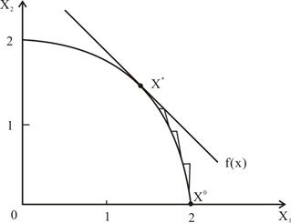
Figure 1. Model solution when the constraint is curved.
At the beginning of the solving procedure, a tolerance range is introduced for every constraint, and the constraint is assumed to be satisfied within this. There are three cases to be considered:
- h(x)=0, then it is feasible.
- 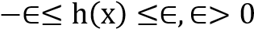is tolerance, it is near feasible.
- 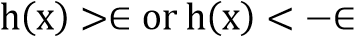, it is infeasible.
Where h(x) is the constraint.
In each step, the tolerance is gradually reduced so that it can finally approach zero when the optimal solution is reached. Figure 2 shows the geometry of the concept of tolerance. When the problem has more than one constraint, as shown by Equation (2), all the constraints can be combined to consider their overall tolerance, which is presented as follows:
$$min.f(x)$$
$$s.t.g_{i}\left(x\right)≥0,i=1,2,….I$$
$$h_{i}\left(x\right)=0,j=1,2,….J$$
Suppose that Ui is a Heaviside operator,
$$U_{i}\left\{\begin{aligned}0, if g_{i}(x)≥0 \\ 1, if g_{i}\left(x\right)<0\end{aligned}\right.$$
T(X), which is always positive, is defined as follows:
$$T\left(X\right)=\sum_{i-1}^{I}{U_{i}g_{i}^{2}\left(x\right)+}\sum_{j-1}^{I}{h_{j}^{2}\left(x\right)}$$
which means that all constraints should be satisfied. When T(X)=0, all constraints are satisfied, and is a feasible solution. When 0≤T(X)≤∈ X is almost feasible; when T(X)>∈, X is infeasible so it should move toward the feasible region.
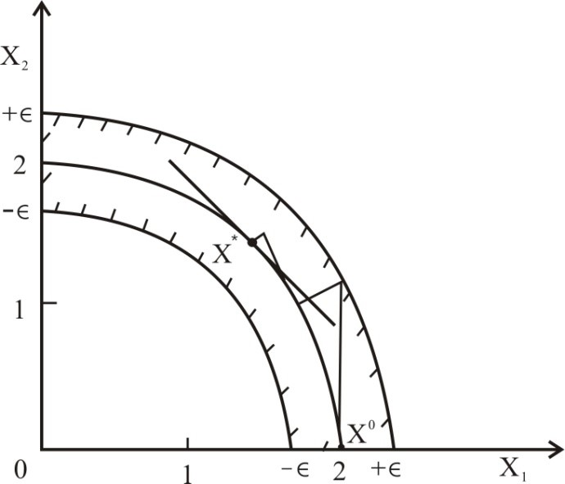
Figure 2. Geometry of the tolerance concept

When the problem is presented in the form of equation (1) with ∈=1/3, Fig. 3 represents the near feasible region. The two semicircles are the tolerance for $X_{1}$≥0 and $X_{2}$≥0
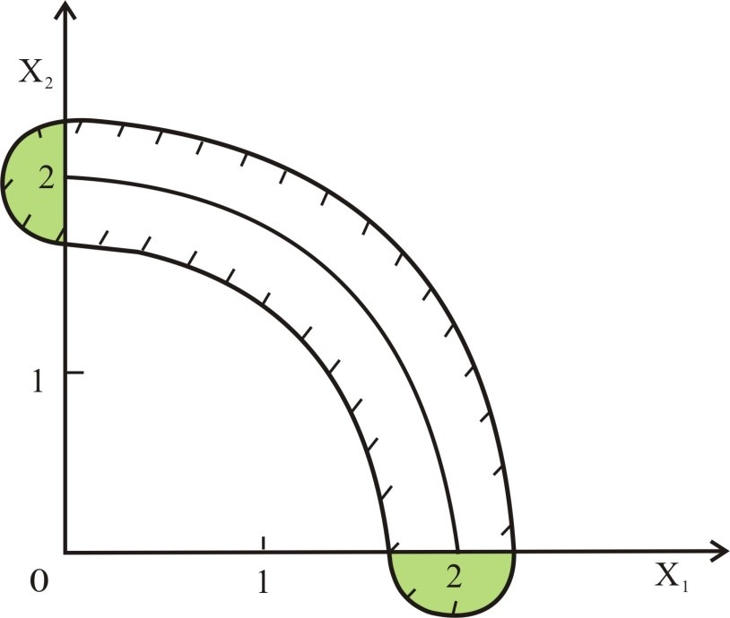
Figure 3. The quasi-feasible region obtained by combining all the constraints.

4. Systems optimization procedure
4.1. The problem
No single procedure can deal completely with all aspects of a system, and systems analyst, with the responsibility to carefully investigate the entire situation, we must incorporate all the important elements. The question thus arises, how can this be done efficiently? This section presents a procedure for using all the optimization elements to achieve the best design.

4.2. Design procedure
There are four main steps for systems, as follows.
4.2.1. Screening
Screening of the feasible solutions to obtain a small set of non-inferior ones, using a screening model [16]. The screening process in effect defines regions of optimality, and the results are best interpreted as first-order estimates or the nature of the actual best designs for a system.

4.2.2. Sensitivity analysis
Sensitivity analysis of these best solutions is then carried out, to determine their performance in realistic situations. In the formal process, a specific sensitivity analysis should be conducted to determine how the optimum design would change if the problem were formulated differently. Similarity, the opportunity costs should be examined to see if the optimum design is likely to change, given the known or anticipated changes in the parameters of the objective function. Overall, the sensitivity analysis general reveals many ways in which the “optimum” solutions derived in the screening process can be improved, demonstrating that some designs perform better over a wide range of likely conditions. The analysis may also indicate the importance of certain factors that are otherwise assumed away.

4.2.3. Dynamic analysis
Dynamic analysis is used to establish the optimal pattern of development over time, and can be done reasonably easily after the screening and sensitivity analysis. Dynamic programming is typically best suited for this analysis, as it deals effectively with nonconvex feasible regions such as those generated by exponential growth and economies of scale.
4.2.4. Presentation
Presentation is the organization of the final results in a way that makes sense to the client, as the client needs to see why the proposed plan is preferable to alternative, to the appreciates, and that the trade-offs between objectives are reasonable.

5 Sensitivity analysis
5.1. Concept
Sensitivity analysis is the process of investigating the dependence of an optimal solution to changes in the way a problem is formulated. Doing a sensitivity analysis is a key part of the design process, equal in importance to the optimization of the process itself.
The significance of sensitivity analysis stems from the fact that the mathematical problem solved in any optimization is only an approximation of the real problem, and no mathematical models will ever represent systems exactly, each differing from reality in any or all of the following ways:
- Structurally, because the overall nature of the equations does not correspond precisely to the actual situation.
- Parametrically, as we are not able to determine all coefficients precisely.
- Probabilistically, in that we typically assume that the situation is deterministic when it is generally variable. In this work, the author has used a stochastic model to solve the problem of uncertainty.

This section presents the sensitivity analysis principally in the context of linear programming. This is because the solutions to linear programming problems automatically include most of the sensitivity information a designer needs, and thus linear programming is the main basis for sensitivity analysis. In addition the linearity of linear programming makes it easier to explain key concepts, which the reader can then extend to other forms of optimization.
Most of this section is devoted to the two most important aspects of sensitivity analysis, the concept and use of:
- shadow prices.
- opportunity costs.

5.2. Shadow prices
A shadow price is the rate of change of the objective function with respect to a particular constraint, an essentially equivalent to the Lagrangian multiplier. The shadow price has no necessary connection with money, despite its name, and its units are those of the objective function divided by the constraint. The shadow price is expressed in dollars only when the objective function is also expressed in dollars or profit.

5.2.1. Use of shadow price
Shadow prices enable the designer to:
- identify which constraints might most beneficially be changed, and to initiate these changes as fundamental ways to improve the design.
- react appropriately when external circumstances create opportunities or threats to change the constraints.
5.2.2. Sign of shadow prices
A key practical question with regard to shadow prices is: what is the sign of the shadow price, and in which direction can one change a constraint to improve the design? The relationship between the nature of the shadow prices and the changes in constraints is that:
- Relaxing the constraints leads to improvements in the optimum design, either increasing a maximum or decreasing a minimum.
- Changes in constraints that “raise the roof” or “lower the floor” will tend to improve the optimum design.
A constraint is relaxed if it is changed so as increase the size of the feasible region, that is, if an upper bound is increased or a lower bound is decreased. It is important to note that there is no simple relationship between the sign of the change in constraint and the sign of the shadow price. This is because an increase in the constraint can either relax or tighten a constraint, depending on whether it is an upper or lower bound and if the constraint is a maximizing or minimizing one.

5.2.3. Range of shadow prices
In general, the shadow price is the instantaneous change in the objective function with respect to a specific constraint, ∂Y/∂bj (Y=g(x), b is the r.h.s of the j-th constraint).
This rate can vary with the decision variables and normally will when the constraints are nonlinear.
The peculiarity of linear programming in this regard is that the shadow prices are constant over a range, rather than varying continuously. If we really describe the problem accurately with the appropriate nonlinear equations, the shadow prices will usually vary instantaneously. Even though the range of constancy of the shadow prices is thus an artificial result, the concept is very useful in practice, because it indicates how sensitive the optimum solution is to the constraint. Indeed, if the range is narrow, this means that even small changes in the constraint could lead to quite different shadow prices, thus that the shadow prices may change rapidly. The range of the shadow price is defined by the intersections of the constraints adjacent to the one that defines the optimum solution of the linear program. In general, there can be a limit to the range of a shadow price for both increases or decreases.

5.3. Opportunity costs
5.3.1. Definition of opportunity cost
Opportunity costs, in the context of sensitivity analysis, are related to the coefficients of the decision variables in the objective function. In general terms they define the “cost” of using decision variables that are not part of the optimal design. In general, the set of optimal decision variables, X∗, can be divided into two categories. The two categories for the optimum set of the decision variables, X∗ are thus the
- optimal variables those with nonzero values at the optimum(X∗≠0). These are said to be “in the solution”.
- non-optimal variables, those equal to zero at the optimum (X ∗=0). These are said to be “not in the solution”.
With this distinction in mind, we can now formally define opportunity costs in the sensitivity analysis: The opportunity cost is the rate of the degradation of the optimum per unit use of a non-optimal variable in the design. The notion of degradation here is important, as it refers to the worsening of an optimum solution. This may either be a decrease, if we are trying to maximize, or an increase, if we are trying to minimize.
5.3.2. Use of opportunity costs Opportunity costs are thus used to define the coefficient of the decision variables which would lead to a change in design. The designer, having defined the optimum design, then continuously monitors the situation to determine when it has changed enough so that a new design ought to be used.

6. Conclusion
This study was presented under the assumptions that readers have some knowledge of and experience with the following: (1) mathematical models for systems optimization, (2) engineering economics, (3) cost-benefit analyses, and (4) water supply engineering, especially the functional design of water treatment systems. This work proposes a new method based on the concept of flexible tolerance to solve problems involving nonlinear conditions that unavoidably arise when mathematical models for optimizing water treatment plant design are implemented. The significant contribution of this paper is that the proposed method can be used to obtain optimal solutions rapidly and accurately by allowing approximate solutions to approach exact ones. Additionally, this work also proposed proactive and improved concepts for the sensitivity analysis and systems optimization procedures, which can help that enable readers to implement the method presented in this work and thus optimize water treatment design by drawing inferences about their use from the examples given in earlier sections.

REFERENCE
[1] Li, K.C. and Wu, E. M., (1988). Application of stochastic NLP model on the optimal design of the water treatment facilities. J. Water Supply 6, 137.
[2] Dykstra, D.P. (1984). Mathematical Programming for Natural Resource Management. New York: McGraw-Hill.
[3] Wu, E.M. and Chu, W.S. (1991). System analysis of water treatment plant in Taiwan. J. Water Resour. Plann. Manag. 117, 536.
[4] Fletcher, R. (1981). Practical Methods of Optimization, Vol. 2, Constrained Optimization. New York: John Willey & Sons.
[5] Paviani, D. and Himmelban, D.M. (1969). Constrained nonlinear optimization by heuristic programming. J. Oper. Res. 17, 872.
[6] Himmeblau, D.M. (1972). Applied Nonlinear Programming. New York: McGraw-Hill.
[7] Kao, C., Chiou, S.T. and Wu, E.M. (2005). Some flexible tolerance methods for solving NLP; Research Report of National Cheng-Kung University, Taiwan, R.O.C.
[8] Bett, J.T. (1975). An improved penalty function method for solving constrained parameter optimization problems. JOTA 16, 1.
[9] Hwang, F.A. (1993). Using the penalty function method to solve the NLP; master thesis of National Cheng-Kung University. Department of Mathematics Science, Taiwan, R.O.C.
[10] Martinez, J.M. and Svaiter, B.F. (2003). A practical optimality condition without constraint qualifications for nonlinear programming. J. Optimization Theory Appl. 118, 117.
[11] Clark, R. M. (1982), Cost estimating for conventional water treatment. J. Environ. Engrg. Div., ASCE, 108(5), 819.
[12] Wiesner, M. R., O’Melia, C. R., and Cohon, J. L. (1987), Optimal water treatment plant design. J. Environ. Engrg. Div., ASCE, 113(3), 567.
[13] Lee, K. C., Wu, E. M., (1980). Research on the construction cost for sanitary system in Taiwan, Report No. 16, Grduate School of Environmental Engineering, National Taiwan University, Taiwan.
[14] Taiwan Water Supply Company, (1985). Water supply engineering construction and operation cost estimates.
[15] Xu, Y., Huang, G.H., and Qin, X. (2009). Inexact two-stage stochastic robust optimization model for water resources management under uncertainty. Environ. Eng. Sci. 26, 1765.
[16] Neufville, D.R. (1990). Applied systems Analysis-Engineering Planning and Technology Management, Singarpore, Mc-Graw-Hill.

