CSC 202
YAKUBU UMAR SANDA
18/sci14/026
A computer keyboard is one of the primary input devices used with a computer. Similar to an electric typewriter, a keyboard is composed of buttons that create letters, numbers, and symbols, as well as perform other functions. The following sections provide more in-depth information and answers to some of the more frequently asked questions about the keyboard.
Types of KEYBOARD
There are two major types of keyboards
- BASIC KEYBOARD
The Basic keyboard contains at most, 110 keys and is enough to perform all the functions that can be done on a Windows PC. They range from 80-110 keys which include;
- Typing keys
- A numeric keypad
- Function keys
- Control keys
The typing keys include the letters of the alphabet, generally laid out in the same pattern used for typewriters. According to legend, this layout, known as QWERTY for its first six letters, helped keep mechanical typewriters' metal arms from colliding and jamming as people typed. Some people question this story -- whether it's true or not, the QWERTY pattern had long been a standard by the time computer keyboards came around.
The numeric keypad is a more recent addition to the computer keyboard. As the use of computers in business environments increased, so did the need for speedy data entry. Since a large part of the data was numbers, a set of 17 keys, arranged in the same configuration found on adding machines and calculators, was added to the keyboard.
In 1986, IBM further extended the basic keyboard with the addition of function and control keys. Applications and operating systems can assign specific commands to the function keys. Control keys provide cursor and screen control. Four arrow keys arranged in an inverted T formation between the typing keys and numeric keypad move the cursor on the screen in small increments.
- EXTENDED KEYBOARD
The Extended keyboard may have additional keys, and the design varies among the companies manufacturing them. These are usually customized keyboards that are specific to certain operating systems or applications. The best example I can think of, for extended keyboards, is the Windows 8 keyboard designed by Microsoft for use with its first “start screen” operating system. It is also a larger version of a basic computer keyboard that has additional function keys which can be assigned to trigger regular actions such as printing, connecting to the internet and file saving.
Under the extended we have various designs of keyboards;

1. Flexible Keyboard
These keyboards work just the same as standard keyboards but are meant for people on the move. They are typically made of silicon, which is water and dust-resistant and don’t require constant cleaning.
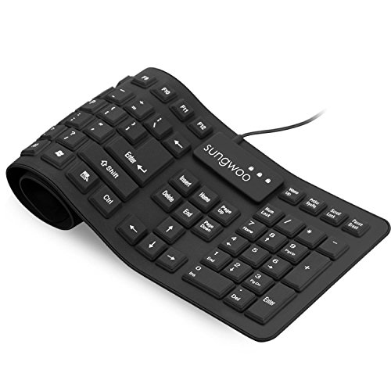

2. Ergonomic Keyboard
The ergonomic keyboard is designed to reduce the strain of constant typing on the wrist and other problems that stem from that.
These keyboards prevent musculoskeletal problems such as Repetitive Strain Syndrome (RSI), something that can be caused by long hours of using keyboards.
Ergonomic keyboards are designed to angle the hands the way they would naturally fall and typically feature padding for the wrists to rest on.
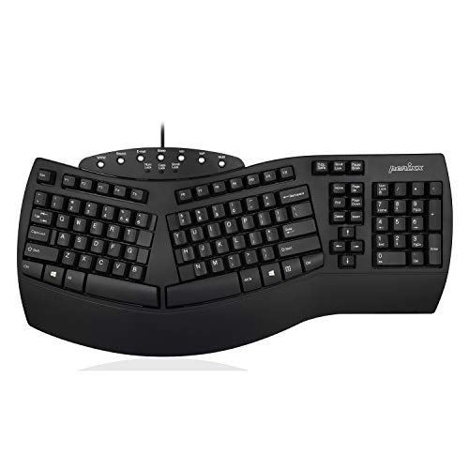

3. Gaming Keyboard
Gaming keyboards are created for use for long periods of time, often adopting ergonomic designs for comfort and also lighted keys for playing in the night.
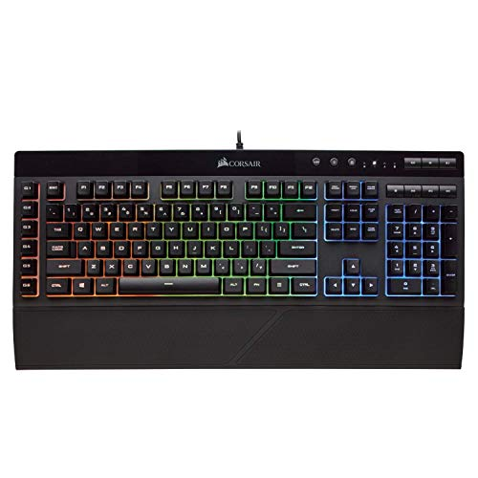

4. Wireless Keyboard
The wireless keyboard is exactly what it’s called; a keyboard without a wire. It is connected to your computer with infrared, 2.4 GHz WiFi or more often through Bluetooth.
Sale
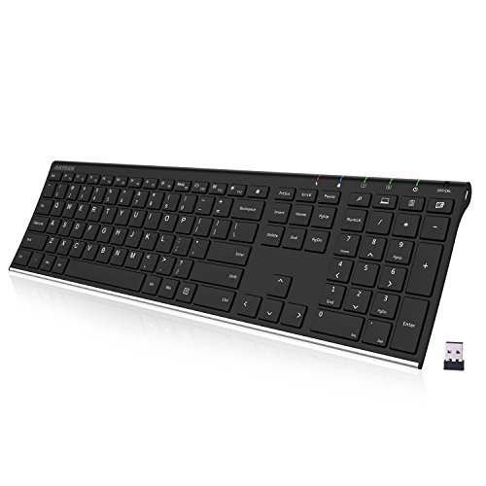

5. Multimedia/Internet Keyboard
Both multimedia and internet keyboards are just regular keyboards with a few extra options. For multimedia designers, the keyboards feature volume control and media application launch buttons.
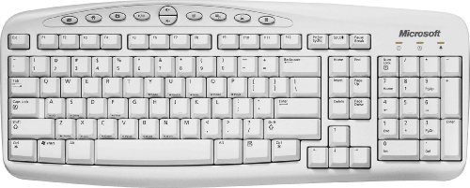
8 Reviews

6. Membrane Keyboard
Unlike the majority of keyboards, membrane keyboards don’t have space between the individual keys. These keys are pressure sensitive and are divided by an outline for each symbol, letter or number. The keys lay flat on a flexible surface.

7. Mechanical Keyboard
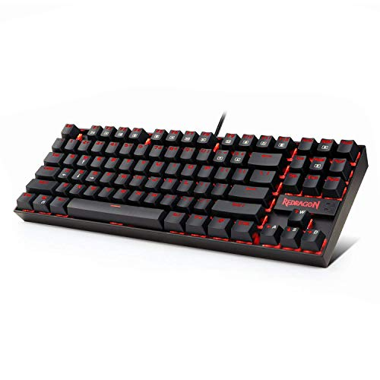

8. Virtual Keyboard
A virtual keyboard is essentially just software that allows you to type without the need for actual physical keys. The way you to use this keyboard is with the use of a touch screen featured in newer laptop releases and tablet computers.

9. Laptop Keyboard
Laptop keyboards have what we call “chiclet style” keys, which are sleeker than traditional keys to fit in thinner design laptops.
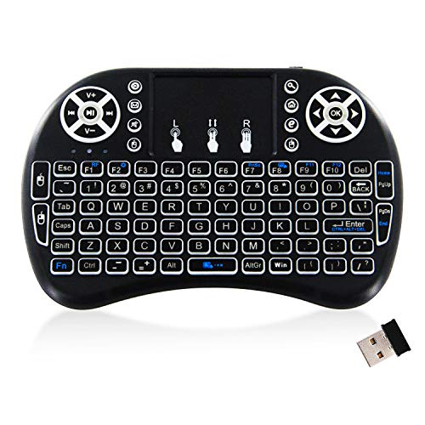

10. Projection Keyboard
Finally, probably the coolest keyboard of the lot is the projection keyboard. This is a device that can be connected through Bluetooth to your mini PC, tablet computer or even smartphone.
It shows the laser projection of a keyboard on any plain surface that you choose. You type on the holograph of the keys and the device records your key strokes and responds accordingly. Welcome to the future!
The Major Differences between Basic and Extended Keyboards
BASIC KEYBOARD | EXTENDED KEYBOARD
It contains only 110 keys. | It contains the basic keys (110 keys) and more.
It is not customized for other operating systems, it is only functional for the windows operating system. | It is designed and customized to perform on different operating systems
It performs the basic operations of a computer system. | It performs more complicated operations.
It requires little or no training to use. | It requires training to use
It is less expensive | It is expensive

