NAME: ASIDERE ISRAEL OLUKOME
MATRIC NUMBER: 17/SCI01/017
COURSE CODE: CSC310
COURSE TITLE: Computer Architecture and Organisation II
ASSIGNMENT
Question
Briefly explain the following interconnection networks:
1. The Crossbar Network
2. Cube Interconnection Network
3. Fat Tree Connection

- THE CROSSBAR NETWORK
The Crossbar exchanges were developed during 1940s. They achieve full access and non-blocking capabilities with the Crossbar switches and common control equipment, used in the Crossbar exchanges. The active elements called Crosspoints are placed between the input and the output lines. In the common control switching systems, the separation between switching and control operations allows the usage of switching networks by a group of common control switches to establish many calls at the same time on a shared basis.
The features are described in brief below −
While processing a call, the common control system helps in the sharing of resources.
The specific route functions of call processing are hardwired because of the Wire logic computers.
The flexible system design helps in the appropriate ratio selection is allowed for a specific switch.
Fewer moving parts ease the maintenance of Crossbar switching systems.
The Crossbar switching system uses the common control networks which enable the switching network to perform event monitoring, call processing, charging, operation and maintenance as discussed previously. The common control also provides uniform numbering of subscribers in a multi-exchange area like big cities and routing of calls from one exchange to another using the same intermediate exchanges. This method helps to avoid the disadvantages associated with the step-by-step switching method through its unique process of receiving and storing the complete number to establish a call connection.
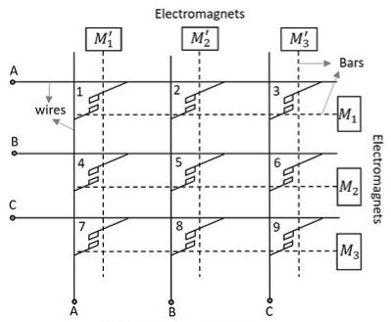
Figure 1 3×3 Crossbar Switch

- CUBE INTERCONNECTION NETWORK
Hypercube networks are a type of network topology used to connect multiple processors with memory modules and accurately route data. Hypercube networks consist of 2m nodes. These nodes form the vertices of squares to create an internetwork connection. A hypercube is basically a multidimensional mesh network with two nodes in each dimension. Due to similarity, such topologies are usually grouped into a k-ary d-dimensional mesh topology family where d represents the number of dimensions and k represents the number of nodes in each dimension.
Given a node with binary address d, this node is connected to all nodes whose binary addresses differ from d in exactly 1 bit. For example, in a 3-cube, in which there are eight nodes, node 7 (111) is connected to nodes 6 (110), 5 (101), and 3 (011). The Figure demonstrates all the connections between the nodes.

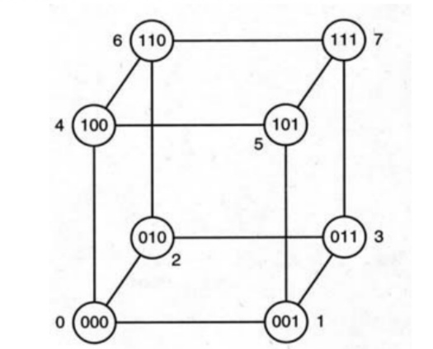
Figure 2 A three dimensional Cube

- FAT TREE CONNECTION

The fat tree network is a universal network for provably efficient communication. It was invented by Charles E. Leiserson of the Massachusetts Institute of Technology in 1985. The structure of the fat tree is based on a binary tree. Each edge of the binary tree corresponds to two channels of the fat tree. One of the channels is from parent to child, and the other is from child to parent. The number of communication links in each channel increases as we go up the tree from the leaves and is determined by the amount of hardware available.

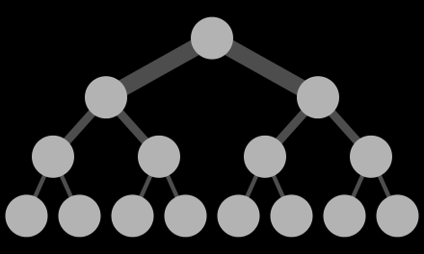

Figure 3 A Fat Tree

