ENGINEERING MATHEMATICS ASSIGNMENT
EKOK NZIE OKPOKAM
18/ENG05/045
MECHATRONICS
MATHCAD

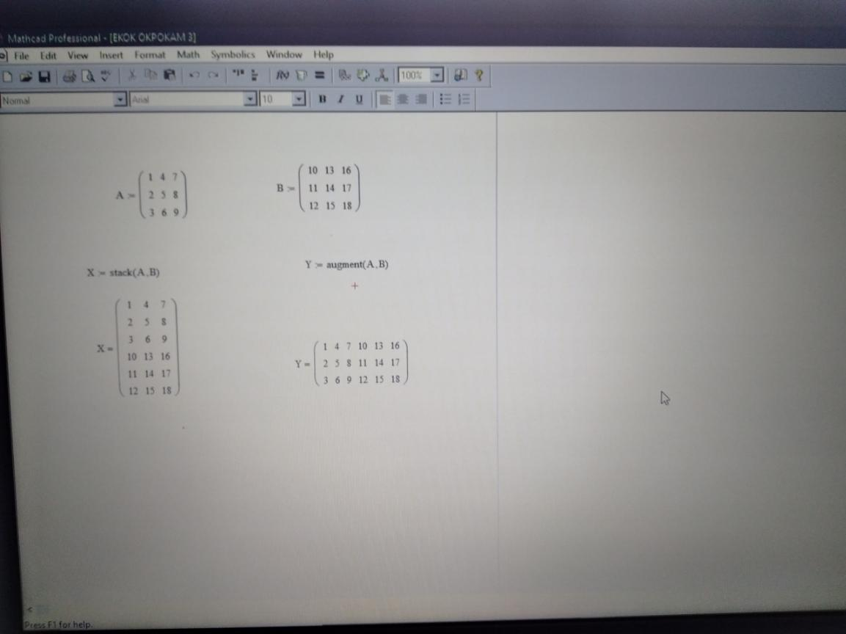

MATLAB

