NAME: Wonderful Oweifie
DEPARTMENT: PHARMACOLOGY
MATRIC NUMBER : 17/MHS07/027
COURSE CODE: PHA 312

Questions
- Draw and explain the life cycle of the malaria parasite.
- Mention two major classification of antiamoebic drugs
- Highlight the name of the drugs used under each group and give appropriate examples.
- Explain vividly the mechanism of action of Metronidazole
ANSWERS
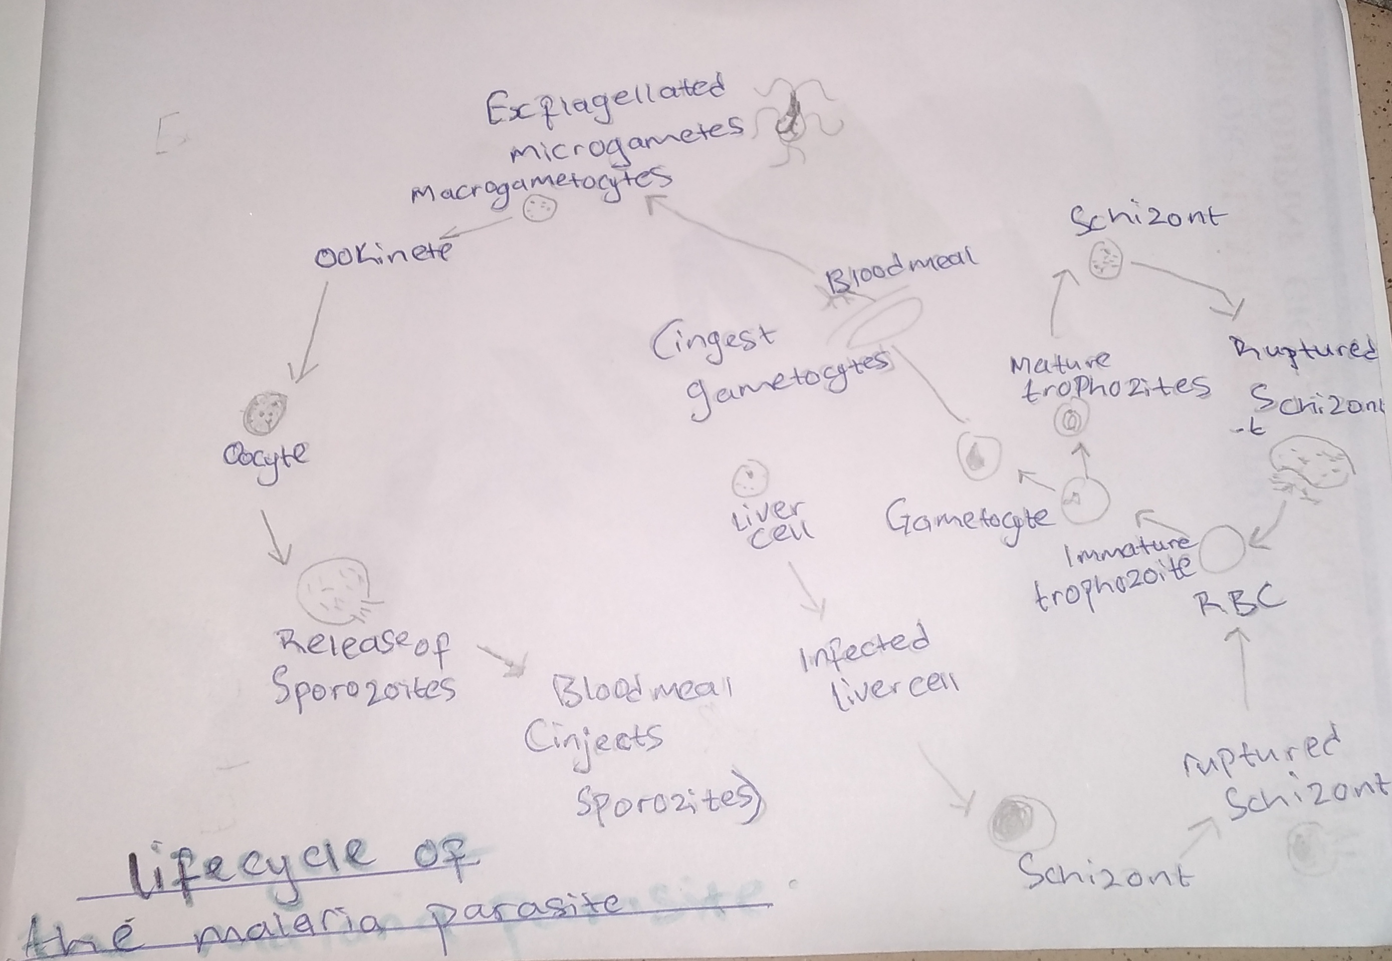
- The above is a diagram of the life cycle of the malaria parasite
The malaria parasite life cycle involves two hosts.
During a blood meal, a malaria-infected female Anopheles mosquito inoculates sporozoites into the human host . Sporozoites infect liver cells and mature into schizonts , which rupture and release merozoites . (Of note, in P. vivax and P. ovale a dormant stage [hypnozoites] can persist in the liver (if untreated) and cause relapses by invading the bloodstream weeks, or even years later.) After this initial replication in the liver (exo-erythrocytic schizogony ), the parasites undergo asexual multiplication in the erythrocytes (erythrocytic schizogony ). Merozoites infect red blood cells . The ring stage trophozoites mature into schizonts, which rupture releasing merozoites . Some parasites differentiate into sexual erythrocytic stages (gametocytes) . Blood stage parasites are responsible for the clinical manifestations of the disease. The gametocytes, male (microgametocytes) and female (macrogametocytes), are ingested by an Anopheles mosquito during a blood meal .
The parasites’ multiplication in the mosquito is known as the sporogonic cycle . While in the mosquito’s stomach, the microgametes penetrate the macrogametes generating zygotes . The zygotes in turn become motile and elongated (ookinetes) which invade the midgut wall of the mosquito where they develop into oocysts . The oocysts grow, rupture, and release sporozoites, which make their way to the mosquito’s salivary glands. Inoculation of the sporozoites into a new human host perpetuates the malaria life cycle.
2. Classification of antiamoebic drugs:
- Drugs effective in luminal infection only (some also have actions against cysts, so helpful in elimination of carrier state):Diloxanide furoate, Diiodohydroxyquin, Tetracyclines, Paromomycin
- Drugs effective in hepatic and tissue amoebiasis only :Chloroquine, Emetine, Dehydroemetine
3. Examples under the classifications of antiamoebic drugs
Drugs effective in luminal infection only:
- Diloxanide furoate
- Diiodohydroxyquin
- Tetracyclines,
- Paromomycin
Drugs effective in hepatic and tissue amoebiasis only
- Chloroquine,
- Emetine,
- Dehydroemetine
Drugs effective in luminal & tissue amoebiasis (though less in lumen)
Not effective against cysts

- Metronidazole,
- Tinidazole,
- Secnidazole,
- Ornidazole
Usually combined with luminal agents.
Tinidazole, Secnidazole and Ornidazole.
4. Mechanism of action of Metronidazole :
Metronidazole is of the nitroimidazole class. It inhibits nucleic acid synthesis by disrupting the DNA of microbial cells. This function only occurs when metronidazole is partially reduced, and because this reduction usually happens only in anaerobic bacteria and protozoans, it has relatively little effect upon human cells or aerobic bacteria.

