ASSIGNMENT ON INTERCONNECTION NETWORKS
- THE CROSS BAR NETWORK
Crossbar networks allow any processor in the system to connect to any other processor or memory unit so that many processors can communicate simultaneously without contention. A new connection can be established at any time as long as the requested input and output ports are free. Crossbar networks are used in the design of high-performance small-scale multiprocessors, in the design of routers for direct networks, and as basic components in the design of large-scale indirect networks. A crossbar can be defined as a switching network with N inputs and M outputs, which allows up to min{N, M} one-to-one interconnections without contention. Figure 1.9 shows an N × M crossbar network. Usually, M = N except for crossbars connecting processors and memory modules.

- CUBE INTERCONNECTION NETWORK
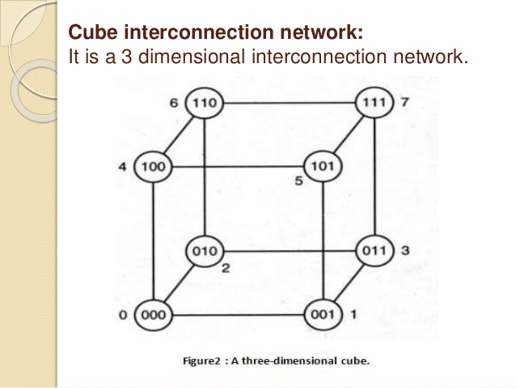

- FAT TREE CONNECTION NETWORK
The fat tree network is a universal network for provably efficient communication. It was invented by Charles E. Leiserson of the Massachusetts Institute of Technology in 1985.
In a tree data structure, every branch has the same thickness, regardless of their place in the hierarchy—they are all "skinny" (skinny in this context means low-bandwith). In a fat tree, branches near the top of the hierarchy are "fatter" (thicker) than branches further down the hierarchy. In a telecommunications network, the branches are data links; the varied thickness (bandwidth) of the data links allows for more efficient and technology-specific use.
Mesh and hypercube topologies have communication requirements that follow a rigid algorithm, and cannot be tailored to specific packaging technologies.

