NAME: OMISORE DAMILOLA OLUWASENI
MATRIC NO: 17/SCI01/068
COURSE CODE: CSC 310

ASSIGNMENT ANSWER:
- THE CROSSBAR NETWORK:
Crossbar networks allow any processor in the system to connect to any other processor or memory unit so that many processors can communicate simultaneously without contention. A new connection can be established at any time as long as the requested input and output ports are free. Crossbar networks are used in the design of high-performance small-scale multiprocessors, in the design of routers for direct networks, and as basic components in the design of large-scale indirect networks. A crossbar can be defined as a switching network with N inputs and M outputs, which allows up to min{N, M} one-to-one interconnections without contention. Crossbar networks have been traditionally used in small-scale shared-memory multiprocessors, where all processors are allowed to access memories simultaneously as long as each processor reads from, or writes to, a different memory. When two or more processors contend for the same memory module, arbitration lets one processor proceed while the others wait. The arbiter in a crossbar is distributed among all the switch points connected to the same output. However, the arbitration scheme can be less complex than the one for a bus because conflicts in crossbar are the exception rather than the rule, and therefore easier to resolve.

- CUBE INTERCONNECTION NETWORK:
An n-cube network, also called hypercube, consists of N=2n nodes; n is called the dimension of the n-cube network. When the node addresses are considered as the corners of an n-dimensional cube, the network connects each node to its n neighbors. In an n-cube, individual nodes are uniquely identified by n-bit addresses ranging from 0 to N-1. Given a node with binary address d, this node is connected to all nodes whose binary addresses differ from d in exactly 1 bit. For example, in a 3-cube, in which there are eight nodes, node 7 (111) is connected to nodes 6 (110), 5 (101), and 3 (011). The figure below demonstrates all the connections between the nodes.
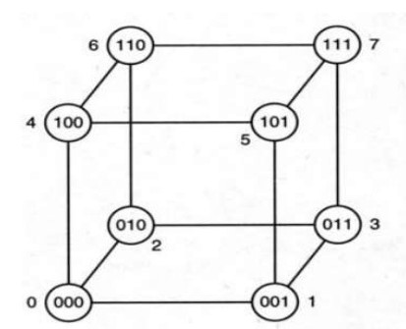
Figure 1: A three-dimensional cube.

- FAT TREE CONNECTION:
The fat tree network is a universal network for provably efficient communication. In a tree data structure, every branch has the same thickness, regardless of their place in the hierarchy—they are all "skinny" (skinny in this context means low-bandwidth). In a fat tree, branches nearer the top of the hierarchy are "fatter" (thicker) than branches further down the hierarchy. In a telecommunications network, the branches are data links; the varied thickness (bandwidth) of the data links allows for more efficient and technology-specific use. Fat-trees are optimal interconnects for large-scale clusters and, by extension, for WSCs. When using a fat-tree interconnect servers are placed at the leafs of the tree, while switches populate the root and the internal nodes of the tree. Fat-trees have additional links to increase the bandwidth near the root of the tree. Some set of paths in a fat-tree will saturate all bandwidth available to the end hosts for arbitrary communication patterns. A fat-tree communication architecture can be built with cheap commodity parts as all switching elements of a fat-tree are identical.

