NAME: OFODI CHRISTABEL
MATRIC NUMBER: 19/sci01/070
Number 1:
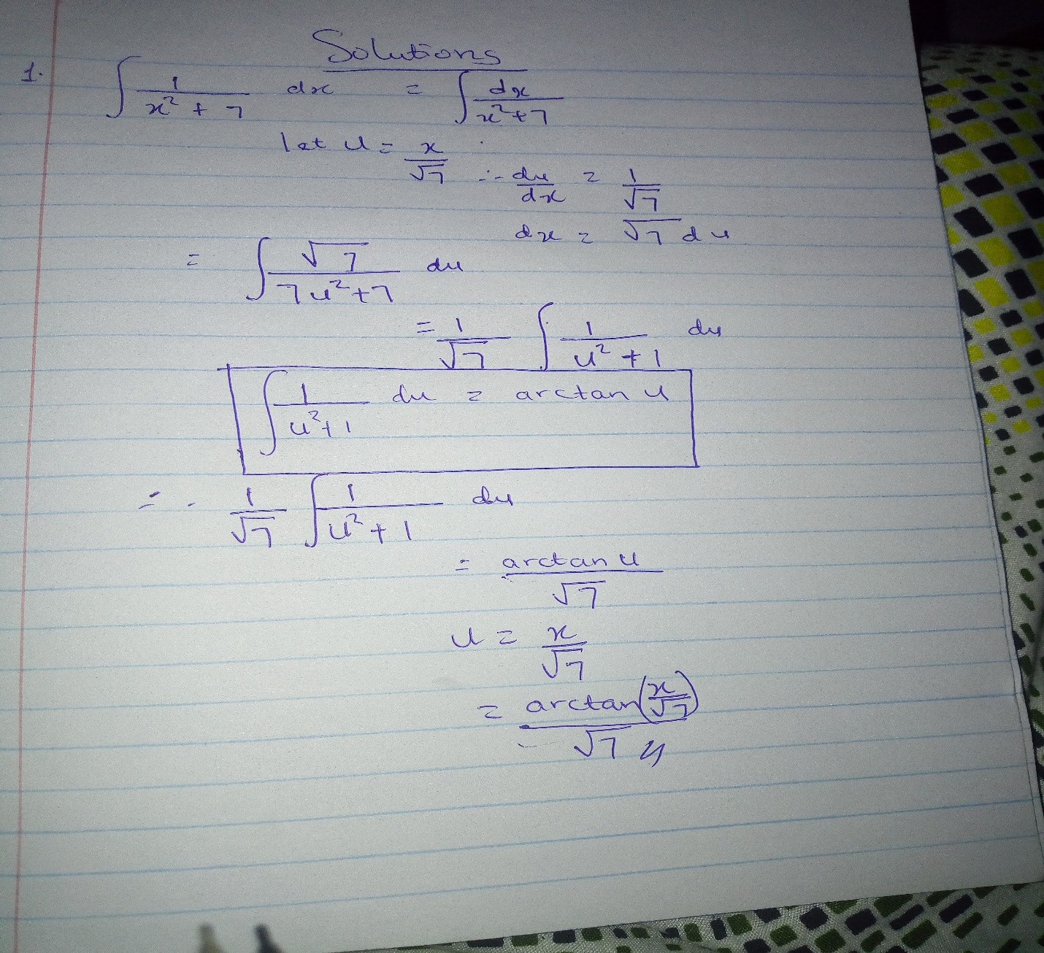

Number 2: