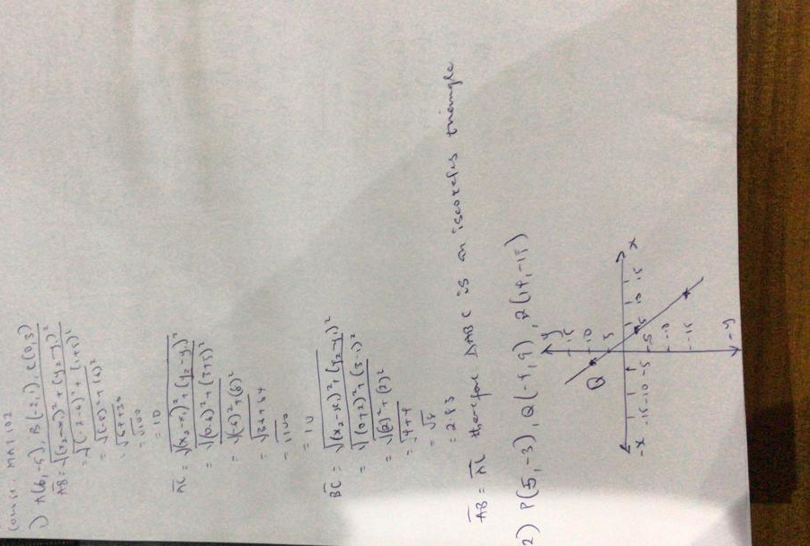Amadi Ekenedilichukwu Anthony Mechatronics Engineering 19/ENG05/009 