Name; Saidu Maryam

Department; Pharmacy

Matric Number; 19/MHS11/130

Course; Chem102

ASSIGNMENT

- Classification Of Alkanol

- It can be classified based on the number of hydrogen atons attached to the carbon atom containing the hydroxyl group. If the number of hydrogen atoms attached to the carbon atom bearing the hydroxyl group are three or two, it is called a primary alcohol (1°). if it is one hydrogen atom it is called secondary alcohol (2°) and if no hydeogen atom is attached to the carbon atom bearing the hydroxyl group. It is called a tertiary alcohol (3°)
Example; CH3CH2OH Ethanol 2H(primary 1°)
(CH3)3C-OH 2-Methylpropan-2-ol 0H(3°)

- It is classified based on the number of hydroxyl groups they possess when there is presence of one hydroxyl group is called Monohydric alcohol.
Dihydric/glycol alcohol- presence of two hydroxyl group
Trihydric/tricol alcohol- presence of three hydroxyl group
Polyhydric/polyol alcohol- moore than three hydrolic group
Examples; CH3CH2CH2OH propanol(monohydric alcohol)
HOCH2CH2OH ehane-1,2-diol(dihydric alcohol.

- CH3CH2CH2CH2-C-OCH2CH2CH3 + C2H5MgBr

C4H9C3H7C2H5-C-OMgBr→C4H9C3H7C2H5-C-OH+Mg(OH)Br
Grignard agent; CH3MgBr(methyl magnesium bromide).

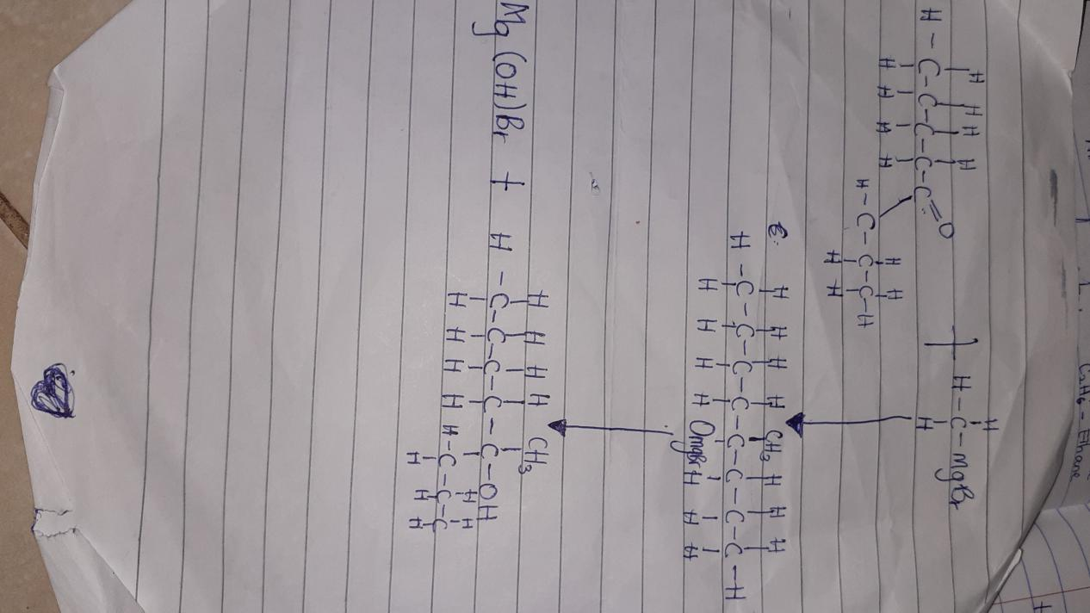

- Starchy foodstuff like potatoes and cereals e.g (rice, maize, guinea corn, millet and barley are the main source of ethanal in many countries. The starch granules are first extracted by crushing and pressure cooking the material. They are then treated with malt at 50° to 60° for an hour. Malt is partially geminated barley, which contain the enzyme diastase. The starch is converted by this enzyme into maltose.
2(C6H10O5)n(s) + nH2O(1)→nC12H22O11
Starch maltose

Yeast is then added at room temperature, yeast contains two enzymes, namely maltose which converts the maltose to glucose and zymase which the decomposes the glucose into ethanol and carbon(iv)oxide.
C12H22O11(aq) + H2O → 2C6H12O6(aq)
Maltose maltase glucose
C6H12O6(aq) → 2C2H5OH(aq) +2CO2(g)
Glucose zymase ethanol

- Alkanone and alkanal are reduced to primary and secondary alcohol respectively by reaction with hydrogen in the presence of a platinum or nickel catalyst or with aluminium is a propoxide or with complex metal hydride such as lithium tetrahydridoaluminate(iii)(LiAlH4) or sodium tetrahydridoborate(iii)(NaBH4).
Alkanone; CH3C2H5-C=O→CH3C2H5CHOH
LiAlH4
Alkanal; CH3CH2CH=O→ CH3CH2CH2OH
LiAlH4/H2O

