NAME: OMOLADE BRIGHT AYOMIDE
DEPARTMENT: COMPUTER SCIENCE
MATRIC NO: 19/SCI01/078
NUMBER 1
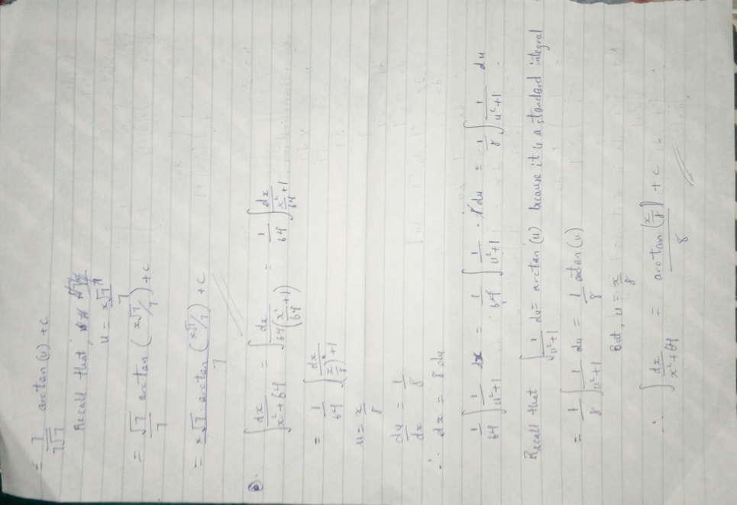

NUMBER 1 CONTINUATION AND NUMBER 2
