NAME: ANELE JEFF
DEPARTMENT: COMPUTER SCIENCE
MATRIC NO : 19/sci01/018
TABLE

NUMBER 1 AND TABLE CONTINUATION
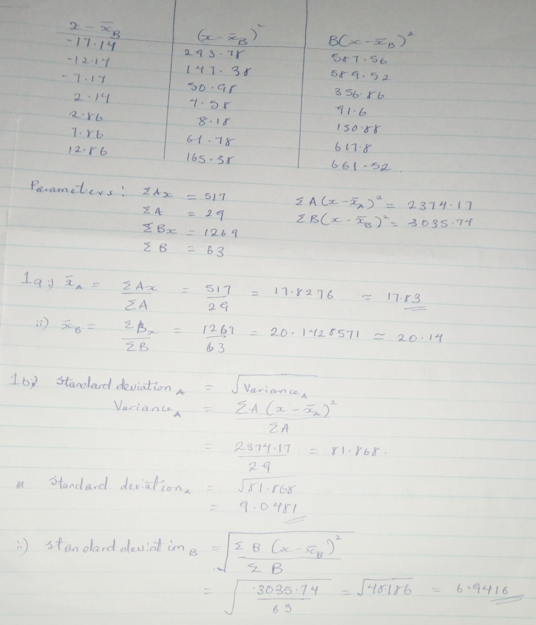

NUMBER 2

