TERM PAPER

ON

RESCUE MISSION OF CIVIL ENGINEERS IN THE MANAGEMENT OF DRAINAGE FACILITIES IN NIGERIAN.

BY

YUSUF YATAKIR MALGWI

15/ENG03/036

DEPARTMENT OF CIVILNAND ENVIRONMENTAL ENGINEERING.

SUBMITTED TO

ENGR. OYEBODE. D. O

CVE 518 ASSIGNMENT

ABSTRACT
Drainage is the natural or artificial removal of a surface's water and sub-surface water from an area with excess of water. Furthermore, these drains must be managed in other to create an appropriate path for the water to flow without destroying land (farms) or property. The construction of reinforced concrete drainage systems is a major area in drainage system. However, without well design and constructed drains, water causes a lot of problems to the environment.

INTRODUCTION
Drainage is the removal of excess from land surface or sub-surface using either artificial or natural means. Naturally, water flow through paths that are created over time from water sources which gather together to create a water basin where water is trapped.
However, civil engineers are responsible for drainage in construction projects. They set out from the plans all the roads, street gutters, drainage, culverts and sewers involved in construction operations.
Civil engineers and construction managers work alongside architects and supervisors, planners, quantity surveyors, the general workforce, as well as subcontractors. Typically, most jurisdictions have some body of drainage law to govern to what degree a landowner can alter the drainage from his parcel.

CHAPTER ONE
Roads will affect the natural surface and subsurface drainage pattern of a watershed or individual hillslope. Road drainage design has as its basic objective the reduction and/or elimination of energy generated by flowing water. The destructive power of flowing water increases exponentially as its velocity increases. Therefore, water must not be allowed to develop sufficient volume or velocity so as to cause excessive wear along ditches, below culverts, or along exposed running surfaces, cuts, or fills.
Provision for adequate drainage is of paramount importance in road design and cannot be overemphasized. The presence of excess water or moisture within the roadway will adversely affect the engineering properties of the materials with which it was constructed. Cut or fill failures, road surface erosion, and weakened subgrades followed by a mass failure are all products of inadequate or poorly designed drainage. As has been stated previously, many drainage problems can be avoided in the location and design of the road: Drainage design is most appropriately included in alignment and gradient planning.
Hillslope geomorphology and hydrologic factors are important considerations in the location, design, and construction of a road. Slope morphology impacts road drainage and ultimately road stability. Important factors are slope shape (uniform, convex, concave), slope gradient, slope length, stream drainage characteristics (e.g., braided, dendritic), depth to bedrock, bedrock characteristics (e.g., fractured, hardness, bedding), and soil texture and permeability. Slope shape (Figure 1) gives an indication of surface and subsurface water concentration or dispersion. Convex slopes (e.g., wide ridges) will tend to disperse water as it moves downhill. Straight slopes concentrate water on the lower slopes and contribute to the buildup of hydrostatic pressure. Concave slopes typically exhibit swales and draws. Water in these areas is concentrated at the lowest point on the slope and therefore represent the least desirable location for a road.
Hydrologic factors to consider in locating roads are number of stream crossings, side slope, and moisture regime. For example, at the lowest point on the slope, only one or two stream crossings may be required. Likewise, side slopes generally are not as steep, thereby reducing the amount of excavation. However, side cast fills and drainage requirements will need careful attention since water collected from upper positions on the slope will concentrate in the lower positions. In general, roads built on the upper one-third of a slope have better soil moisture conditions and, therefore, tend to be more stable than roads built on lower positions on the slope.
Natural drainage characteristics of a hillslope, as a rule, should not be changed. For example, a drainage network will expand during a storm to include the smallest depression and draw in order to collect and transport runoff. Therefore, a culvert should be placed in each draw so as not to impede the natural disposition of stormflow. Culverts should be placed at grade and in line with the centerline of the channel. Failure to do this often results in excessive erosion of soils above and below the culvert. Also, debris cannot pass freely through the culvert causing plugging and oftentimes complete destruction of the road prism. Headwater streams are of particular concern (point A, Figure 2) since it is common to perceive that measurable flows cannot be generated from the moisture collection area above the crossings. However, little or no drainage on road crossings in these areas is notorious for causing major slide and debris torrents, especially if they are located on convex slope breaks.
Increased risks of road failures are created at points A and B. At point A, water will pond above the road fill or flow downslope through the roadside ditch to point B. Ponding at A may cause weakening and/or erosion of the subgrade. If the culvert on Stream 1 plugs, water and debris will flow to point A and from A to B. Hence, the culvert at B is handling discharge from all three streams. If designed to minimum specifications, it is unlikely that either the ditch or the culvert at B will be able to efficiently discharge flow and debris from all three streams resulting in overflow and possible failure of the road at point B.
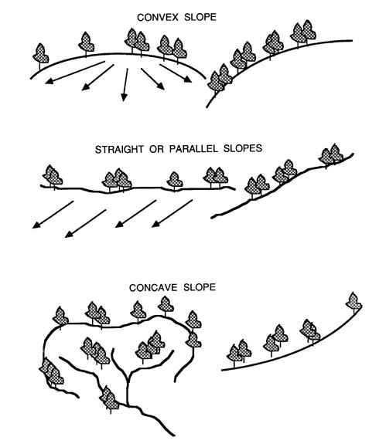
Figure 1: Slope shape and its impact on slope hydrology

A road drainage system must satisfy two main criteria if it is to be effective throughout its design life:
- It must allow for a minimum of disturbance of the natural drainage pattern.
- It must drain surface and subsurface water away from the roadway and dissipate it in a way that prevents excessive collection of water in unstable areas and subsequent downstream erosion.
The design of drainage structures is based on the sciences of hydrology and hydraulics-the former deals with the occurrence and form of water in the natural environment (precipitation, streamflow, soil moisture, etc.) while the latter deals with the engineering properties of fluids in motion.
Figure 2 Culvert and road locations have modified drainage patterns of ephemeral streams 2 and 3. Locations A and B become potential failure sites. Stream 3 is forced to accept more water below B due to inadequate drainage at A.
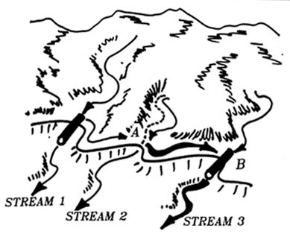
Figure 2 Culvert and road locations have modified drainage patterns

Recommendation and Conclusion
Recommendation
- The path ways for water should not be blocked rather it should the utilised for drainage construction.
- Suitable drains should be constructed using the result obtained from survey
- Professionals how be employed for the design of drains.
- Timely maintenance should be carried out.
Conclusion
The constructions and maintenance of drains in Nigeria should be taken seriously.

