A
Term Paper
On
ROLES OF MICROBES IN NUTRIENT CYCLING AND FOOD CHAIN
By
OLAOYE, OLUFUNBI JOSEPHINE
17/SCI05/009
Department of Microbiology
To
DR. ISITUA

MCB 308: Microbial Ecology
Afe Babalola University Ado-Ekiti
Ekiti State

APRIL 2020

Contents
ABSTRACT 3
Microorganisms abound in the ecosystem and are critical to recycling nutrients and in food chains which are essential for the majority of the ecosystem’s functions and services. 3
CHAPTER ONE 4
INTRODUCTION 4
1.1 NUTRIENT CYCLING 4
1.2 FOOD CHAINS 4
CHAPTER TWO 7
ROLES OF MICROBES IN NUTRIENT CYCLING 7
2.1 ROLES OF MICROBES IN NITROGEN CYCLE 7
2.2 ROLES OF MICROBES IN CARBON CYCLE 8
2.3 ROLES OF MICROBES IN SULPHUR CYCLE 9
CHAPTER THREE 11
ROLES OF MICROBES IN FOOD CHAINS 11
3.1 ROLES OF MICROBES AS PRODUCERS 11
3.2 ROLES OF MICROBES AS CONSUMERS 11
3.3 ROLES OF MICROBES AS DECOMPOSERS 11
CONCLUSION 13
REFERENCES 15

ABSTRACT

Microorganisms abound in the ecosystem and are critical to recycling nutrients and in food chains which are essential for the majority of the ecosystem’s functions and services.
Flows of nutrients from living to non-living components of the Earth are called biogeochemical cycles. Ecosystems hinge on biogeochemical cycles. The nitrogen cycle, the phosphorous cycle, the sulfur cycle, and the carbon cycle all involve assimilation of these nutrients into living things. These elements are transferred among living things through food webs and food chains, until organisms ultimately die and release them back into the ecosystem.
This report presents details on the roles of microorganisms in nutrient cycling and food chains. system services

CHAPTER ONE

INTRODUCTION

1.1 NUTRIENT CYCLING

Nutrient cycling is one of the most important processes that occur in an ecosystem. The nutrient cycle describes the use, movement, and recycling of nutrients in the environment. Valuable elements such as carbon, oxygen, hydrogen, phosphorus, and nitrogen are essential to life and must be recycled in order for organisms to exist. Nutrient cycles are inclusive of both living and nonliving components and involve biological, geological, and chemical processes. For this reason, these nutrient circuits are known as biogeochemical cycles.
Biogeochemical cycles can be categorized into two main types: global cycles and local cycles. Elements such as carbon, nitrogen, oxygen, and hydrogen are recycled through abiotic environments including the atmosphere, water, and soil. Since the atmosphere is the main abiotic environment from which these elements are harvested, their cycles are of a global nature. These elements may travel over large distances before they are taken up by biological organisms. The soil is the main abiotic environment for the recycling of elements such as phosphorus, calcium, and potassium. As such, their movement is typically over a local region.

1.2 FOOD CHAINS
A food chain is a linear sequence of organisms through which nutrients and energy pass: primary producers, primary consumers, and higher-level consumers are used to describe ecosystem structure and dynamics. There is a single path through the chain. Each organism in a food chain occupies what is called a trophic level. Depending on their role as producers or consumers, species or groups of species can be assigned to various trophic levels.
All life forms in an ecosystem can be broadly grouped into one of two categories (called trophic levels): Autotrophs, which produce organic matter (food) from inorganic substances; and Heterotrophs, which must feed on other organisms in order to obtain organic matter. In general, trophic levels are used to describe the way in which a particular organism within an ecosystem gets its food. Using this description, we can restate and reorganize the categories above to define the three basic ways organisms acquire their food:
Producers (autotrophs) do not usually eat other organisms but pull nutrients from the soil or the ocean and manufacture their own food using photosynthesis. It is the energy from the sun that usually powers the base of the food chain.
Consumers (heterotrophs) cannot manufacture their own food and need to consume other organisms.
Decomposers break down dead plant and animal material and wastes and release them into the ecosystem as energy and nutrients for recycling.
Microorganisms play a vital role in every ecological community by serving both as producers and as decomposers

CHAPTER TWO

ROLES OF MICROBES IN NUTRIENT CYCLING

2.1 ROLES OF MICROBES IN NITROGEN CYCLE
Nitrogen is a necessary component of biological molecules. Some of these molecules include amino acids and nucleic acids. Although nitrogen (N2) is abundant in the atmosphere, most living organisms can not use nitrogen in this form to synthesize organic compounds. Atmospheric nitrogen must first be fixed, or converted to ammonia (NH3) by certain bacteria
The nitrogen cycle is the process by which nitrogen is converted from organic to inorganic forms; many steps are performed by microbes.
Fixation: In order for organisms to use atmospheric nitrogen (N2), it must be “fixed” or converted into ammonia (NH3). This can happen occasionally through a lightning strike, but the bulk of nitrogen fixation is done by free living or symbiotic bacteria such as Azotobacter, Beijerinckia, and Clostridium) . These bacteria have the nitrogenase enzyme that combines gaseous nitrogen with hydrogen to produce ammonia. It is then further converted by the bacteria to make their own organic compounds. Some nitrogen fixing bacteria live in the root nodules of legumes where they produce ammonia in exchange for sugars.
Nitrificaton: Nitrification is the conversion of ammonia (NH3) to nitrate (NO3–). It is usually performed by soil living bacteria, such asNitrobacter. This is important because plants can assimilate nitrate into their tissues, and they rely on bacteria to convert it from ammonia to a usable form.
Ammonification /Mineralization: In ammonification, bacteria or fungi convert the organic nitrogen from dead organisms back into ammonium (NH4+). Nitrification can also work on ammonium. It can either be cycled back into a plant usable form through nitrification or returned to the atmosphere through denitrification.
De-Nitrification: Nitrogen in its nitrate form (NO3–) is converted back into atmospheric nitrogen gas (N2) by bacterial species such as Pseudomonas and Clostridium, usually in anaerobic conditions. These bacteria use nitrate as an electron acceptor instead of oxygen during respiration.

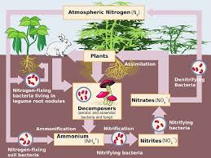
Figure 1: Nitrogen cycle
Source: https://courses.lumenlearning.com/trident-boundless-microbiology/chapter/nutrient-cycles/

2.2 ROLES OF MICROBES IN CARBON CYCLE
Carbon is essential to all life as it is the main constituent of living organisms. It serves as the backbone component for all organic polymers, including carbohydrates, proteins, and lipids. Carbon compounds, such as carbon dioxide (CO2) and methane (CH4), circulate in the atmosphere and influence global climates. Carbon is circulated between living and nonliving components of the ecosystem primarily through the processes of photosynthesis and respiration. Plants and other photosynthetic organisms obtain CO2 from their environment and use it to build biological materials. Plants, animals, and decomposers (bacteria and fungi) return CO2 to the atmosphere through respiration. The movement of carbon through biotic components of the environment is known as the fast carbon cycle. It takes considerably less time for carbon to move through the biotic elements of the cycle than it takes for it to move through the abiotic elements. It can take as long as 200 million years for carbon to move through abiotic elements such as rocks, soil, and oceans. Thus, this circulation of carbon is known as the slow carbon cycle.
Steps of the Carbon Cycle
- CO2 is removed from the atmosphere by photosynthetic organisms (plants, cyanobacteria, etc.) and used to generate organic molecules and build biological mass.
- Animals consume the photosynthetic organisms and acquire the carbon stored within the producers.
- CO2 is returned to the atmosphere via respiration in all living organisms.
- Decomposers break down dead and decaying organic matter and release CO2.
- Some CO2 is returned to the atmosphere via the burning of organic matter (forest fires).
- CO2 trapped in rock or fossil fuels can be returned to the atmosphere via erosion, volcanic eruptions, or fossil fuel combustion.
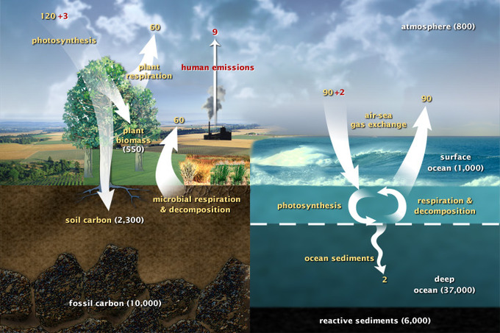
Figure 2: carbon cycle
Source: https://courses.lumenlearning.com/trident-boundless-microbiology/chapter/nutrient-cycles/

2.3 ROLES OF MICROBES IN SULPHUR CYCLE
Many bacteria can reduce sulfur in small amounts, but some bacteria can reduce sulfur in large amounts, in essence, breathing sulfur. The sulfur cycle describes the movement of sulfur through the atmosphere, mineral forms, and through living things. Although sulfur is primarily found in sedimentary rocks or sea water, it is particularly important to living things because it is a component of many proteins.
Sulfur is released from geologic sources through the weathering of rocks. Once sulfur is exposed to the air, it combines with oxygen, and becomes sulfate SO4. Plants and microbes assimilate sulfate and convert it into organic forms. As animals consume plants, the sulfur is moved through the food chain and released when organisms die and decompose.
Some bacteria – for example Proteus, Campylobacter, Pseudomonas and Salmonella – have the ability to reduce sulfur, but can also use oxygen and other terminal electron acceptors. Others, such as Desulfuromonas, use only sulfur. These bacteria get their energy by reducing elemental sulfur to hydrogen sulfide. They may combine this reaction with the oxidation of acetate, succinate, or other organic compounds.
The most well-known sulfur reducing bacteria are those in the domain Archea, which are some of the oldest forms of life on Earth. They are often extremophiles, living in hot springs and thermal vents where other organisms cannot live. Lots of bacteria reduce small amounts of sulfates to synthesize sulfur-containing cell components; this is known as assimilatory sulfate reduction. By contrast, the sulfate-reducing bacteria considered here reduce sulfate in large amounts to obtain energy and expel the resulting sulfide as waste. This process is known as dissimilatory sulfate reduction. In a sense, they breathe sulfate.
Sulfur metabolic pathways for bacteria have important medical implications. For example, Mycobacterium tuberculosis (the bacteria causing tuberculosis) and Mycobacterium leprae (which causes leoprosy) both utilize sulfur, so the sulfur pathway is a target of drug development to control these bacteria.
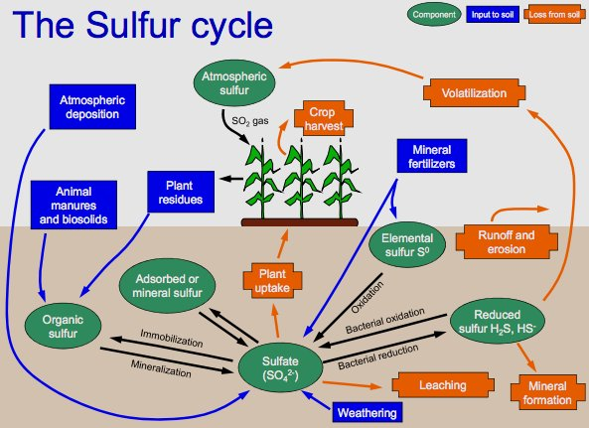
Figure 3: Sulphur cycle
Source : wikipedia

CHAPTER THREE

ROLES OF MICROBES IN FOOD CHAINS

3.1 ROLES OF MICROBES AS PRODUCERS
Autotrophs or primary producers are organisms that acquire their energy from sunlight and materials from nonliving sources. Algae, higher plants, and some bacteria and protists are important autotrophs in running waters. A primary producer converts an abiotic source of energy (e.g. light) into energy stored in organic compounds, which can be used by other organisms (e.g. heterotrophs). The primary producers can convert the energy in the light (phototroph and photoautotroph) or the energy in inorganic chemical compounds (chemolithotrophs) to build organic molecules, which is usually accumulated in the form of biomass and will be used as carbon and energy source by other organisms (e.g. heterotrophs and mixotrophs). The photoautotrophs are the main primary producers, converting the energy of the light into chemical energy through photosynthesis, ultimately building organic molecules from carbon dioxide, an inorganic carbon source.^{[1]} Examples of chemolithotrophs are some archaea and bacteria (unicellular organisms) that produce biomass from the oxidation of inorganic chemical compounds, these organisms are called chemoautotrophs, and are frequently found in hydrothermal vents in the deep ocean. Primary producers are at the lowest trophic level, and are the reasons why Earth is sustainable for life to this day. There are many different types of primary producers out in the Earth's ecosystem at different states. Fungi and other organisms that gain their biomass from oxidizing organic materials are called decomposers and are not primary producers. However, lichens located in tundra climates are an exceptional example of a primary producer that, by mutualistic symbiosis, combine photosynthesis by algae (or additionally nitrogen fixation by cyanobacteria) with the protection of a decomposer fungus. Also, plant-like primary producers (trees, algae) use the sun as a form of energy and put it into the air for other organisms.There are of course H2O primary producers, including a form of bacteria, and phytoplankton. As there are many examples of primary producers, two dominant types are coral and one of the many types of brown algae, kelp.

3.2 ROLES OF MICROBES AS CONSUMERS
Protozoa and nematodes consume other microbes. After the protozoa and nematodes consume the bacteria or other microbes (which are high in nitrogen), they release nitrogen in the form of ammonium (see the graph on net mineralization). Ammonium (NH₄+) and nitrates (NO₃-) are easily converted back and forth in the soil. Plants absorb ammonium and soil nitrates for food with the help of the fungi mycorrhizal network.

3.3 ROLES OF MICROBES AS DECOMPOSERS
Decomposition releases the mineral nutrients (e.g., N, P, K ) bound up in dead organic matter in an inorganic form that is available for primary producers to use. Without this recycling of inorganic nutrients, primary productivity in th ecosystem would stop.
On land, most of the decomposition (also called "mineralization") of dead organic matter occurs at the soil surface, and the rate of decomposition is a function of moisture and temperature (too little or too much of either reduces the rate of decomposition). Fungi are important in terrestrial systems, but not in aquatic. They are present even before the leaves and twigs enter the soil and so decomposition starts in the living or senescent plant material. Fungi are the most important decomposers of structural plant compounds (cellulose and lignin – but note that lignin is not broken down when oxygen is absent). The fungi invade the organic matter in soils first and are then followed by bacteria.
In water, the decomposition of organic matter is mostly toxic in streams and in the ocean and anoxic in the bottoms of lakes or in swamps.
Stages of Decomposition
When an organism dies and decomposers do the work of decomposition, the organism’s remains go through five stages of decomposition: fresh, bloat, active decay, advanced decay, and dry/remains. There are two main processes that occur in a decomposing organism: autolysis and putrefaction. Autolysis is when cellular enzymes in the dead organism’s own body break down cells and tissues, while putrefaction is when microbes grow and reproduce throughout the body after death. Here is a brief summary of the five stages.
Fresh
Putrefaction also begins to occur.
Bloat
Due to putrefaction, a buildup of gases occurs and the organism’s remains appear bloated in what is known as the bloat stage. Some gases and fluids are purged out.
Active Decay
The remains lose mass, and liquefaction and disintegration of tissues begins to occur. Bacteria produce chemicals such as ammonia, hydrogen sulfide, and methane, which cause strong odors.
Advanced Decay
The organism has lost a lot of mass, so there is not much left to be decomposed. If the organism is on or in soil, the surrounding soil will show an increase in nitrogen, an important nutrient for plants.
Dry/Remains
In this stage, only dry skin, cartilage, and bones are left. Plant growth may occur around the remains because of the increased nutrient levels in the soil. Eventually, only the bones of the organism will remain.

CONCLUSION
Microorganisms are essential for the majority of soil ecosystem functions and services. They play a central and essential role in the biogeochemical cycling of soil nutrients. This ensures the turnover and supply of nutrients that are essential for plant and crop growth, through the inter-conversion of different forms of nitrogen, sulphur and interlinked with the carbon cycle. Thus all microbiological activity in soil contributes to cycling of nutrients and other ecosystem functions and all soil functions contribute to ecosystem services.

REFERENCES
- Alexander, Martin. 2006. Introduction to Soil Microbiology, 2nd Edition. Malabar, FL: Krieger Publishing Company.
- Biologydictionary.net Editors. “Decomposer.” Biology Dictionary, Biologydictionary.net, 21 Dec. 2016, https://biologydictionary.net/decomposer/.

- Brock et. al. 2009. Biology of Microorganisms. 12th edition, Pearson, 1061 pp.

- Dusenbery, D. B. 2006. Life at Small Scale - the Behavior of Microbes. Scientific American Library, W. H. Freeman and Company, New York. 214 pp.
- Fenchel, T., G. M. King, and T. H. Blackburn. 2008. Bacterial Biogeochemistry: The Ecophysiology of Mineral Cycling. Academic Press, London. 307 pp.
- Ingham, E.L. Soil Biology, The Soil Biology Primer, Chapter 3–Chapter 6. Natural Resource Conservation Service. SeAlexander, Martin. 2001. Introduction to Soil Microbiology, 2nd Edition. Malabar, FL: Krieger Publishing Company.
- https://courses.lumenlearning.com/trident-boundless-microbiology/chapter/nutrient-cycles/ retrieved on 8/10/2020 by 11:50pm

