NAME: ERETAN OLUFEMI PAUL
MATRIC NO: 18/LAW01/094
COURSE CODE: BUS 208
COURSE TITLE: CONSUMER BEHAVIOUR II

QUESTION
In not less than 2000 words, explain explicitly how the pandemic, COVID-19 has affected consumer buying behavior

PANDEMICS AND THEIR RELATIONSHIP WITH CONSUMERS
A pandemic, derived from the Greek words pan meaning all and demos meaning people, is an epidemic of disease that has spread across a large region, for instance multiple continents or worldwide. It can also be defined as an epidemic occurring on a scale that crosses international borders, usually affecting people on a worldwide scale. They also occur in important agricultural organisms such as livestock or in other organisms. A disease or condition is not a pandemic merely because it is widespread or kills many people; it must also be infectious and easily transmitted. Throughout history, there have been a number of devastating pandemics such as smallpox and tuberculosis and the most notable being the Black Death or the Plague which killed an estimated 75-200 million people in the 14th Century. Current pandemics include HIV/AIDS and the 2019-20 coronavirus epidemic.
Coronavirus disease 2019 or COVID-19, is a new strain of coronavirus which originated in Wuhan, Hubei province, China, in late December 2019. According to media reports, more than 200 countries and territories have been affected by COVID-19, because major outbreaks of it have occurred in the United States, central China, Western Europe and Iran. COVID-19 was categorized by the World Health Organization as a pandemic on the 11th of March 2020. As of 6 April 2020, the number of infected people reached 1.31 million, the death toll was 77,200 and the number of patients recovered was 276,189. A pandemic such as COVID-19 has its effects on various aspects of human society such as economic damage through multiple channels, social and economic disruption, individual behavioral changes which cause of negative shocks to economic growth and in countries with legacies of political instability, an increase in political stress and tensions. In 2016, the Commission on a Global Health Risk Framework for the Future estimated that pandemic disease events would cost the global economy over 6 trillion dollars in the 21st century-over 60 billion dollars per year. The reality is that the coronavirus took the world by surprise. Coronavirus is shaking up business and consumer behavior on a massive scale. Both the public and private sectors are scrambling to slow the spread of illness and contain COVID-19 infections. While the full economic consequences of this black swan event are still unclear, we know that the effects that the virus-and the drastic measures being taken to contain it-are already precipitating change across industries. COVID-19 has caused a movement of social distancing and nationwide shutdowns of major cities. People in grossly affected countries worldwide are still trying adapt to the idea of prolonged indoor stays. Amid this period, some industries will be more grossly affected than others. Businesses such as restaurants and bars are particularly vulnerable, as well as event spaces and retail stores and due this the consumer’s buying behavior is greatly altered. Consumer behavior can be defined as the study of how individual customers, groups or organizations select, buy, use, and dispose ideas, goods, and services to satisfy their needs and wants. It refers to the actions of the consumers in the marketplace and the underlying motives for those actions. Consumer behavior is an inter-disciplinary social science that blends elements from psychology, sociology, social anthropology, anthropology, ethnography, marketing and economics, especially behavioral economics. It examines how emotions, attitudes and preferences affect buying behavior. Characteristics of individual consumers such as demographics, personality lifestyles and behavioral variables such as usage rates, usage occasion, loyalty, brand advocacy, willingness to provide referrals, in an attempt to understand people's wants and consumption are all investigated in formal studies of consumer behavior. The study of consumer behavior also investigates the influences, on the consumer, from groups such as family, friends, sports, reference groups, and society in general. The study of consumer behavior not only helps to understand the past but even predict the future. The below underlined factors pertaining to the tendencies, attitude and priorities of people must be given due importance to have a fairly good understanding of the purchasing patterns of consumers.
5. Marketing Campaigns
Advertisement plays a greater role in influencing the purchasing decisions made by consumers. They are even known to bring about a great shift in market shares of competitive industries by influencing the purchasing decisions of consumers. The Marketing campaigns done on regular basis can influence the consumer purchasing decision to such an extent that they may opt for one brand over another or indulge in indulgent or frivolous shopping. Marketing campaigns if undertaken at regular intervals even help to remind consumers to shop for not so exciting products such as health products or insurance policies.
4. Economic Conditions
Consumer spending decisions are known to be greatly influenced by the economic situation prevailing in the market. This holds true especially for purchases made of vehicles, houses and other household appliances. A positive economic environment is known to make consumers more confident and willing to indulge in purchases irrespective of their personal financial liabilities.
3. Personal Preferences
At the personal level, consumer behavior is influenced by various shades of likes, dislikes, priorities, morals and values. In certain dynamic industries such as fashion, food and personal care, the personal view and opinion of the consumer pertaining to style and fun can become the dominant influencing factor. Though advertisement can help in influencing these factors to some extent, the personal consumer likes and dislikes exert greater influence on the end purchase made by a consumer.
2. Group Influence
Group influence is also seen to affect the decisions made by a consumer. The primary influential group consisting of family members, classmates, immediate relatives and the secondary influential group consisting of neighbors and acquaintances are seen have greater influence on the purchasing decisions of a consumer. Say for instance, the mass liking for fast food over home cooked food or the craze for the SUV’s against small utility vehicle are glaring examples of the same.
1. Purchasing Power
Purchasing power of a consumer plays an important role in influencing the consumer behavior. The consumers generally analyze their purchasing capacity before making a decision to buy and products or services. The product may be excellent, but if it fails to meet the buyers purchasing ability, it will have high impact on it its sales. Segmenting consumers based on their buying capacity would help in determining eligible consumers to achieve better results.
Consumer Buying Behavior refers to the actions taken (both on and offline) by consumers before buying a product or service. This process may include consulting search engines, engaging with social media posts, or a variety of other actions.
Consumer behavior has been forced to immediately change, and change on a massive scale. Those in isolation or under lockdown can’t perform their usual routines, especially since many local shops have been forced to close their doors for safety reasons. Financial uncertainty and the prospect of a severe and long-term recession make for a stark backdrop which has led to an impact on consumer outlook, perceptions and behaviors. Coronavirus has greatly altered the factors involved in a consumer’s behavior in a number of ways for a number of reasons which can be seen as a preventive or reactive measure towards the coronavirus epidemic.
To identify ways the coronavirus is affecting consumer behavior is by monitoring locations struck with a high rate of the virus, it is found that consumers go through behavioral reaction stages based on their awareness of the COVID-19 spread in their communities:
1. Grocery sales are going up.
In the US online purchases of shelf-stable grocery items have grown substantially in the last few days, including Rice (+432%), Flour (+423%), Canned & Jarred Vegetables (+337%), Canned & Prepared Beans (+433%), and Canned & Dry Milk (+378%) compared to the first four weeks of January.
And it makes sense: These items are made for tough times when people may need to hunker down. They have a long shelf life, are versatile, and are frequently offered in large formats, making it easy to stock up on ingredients that last.
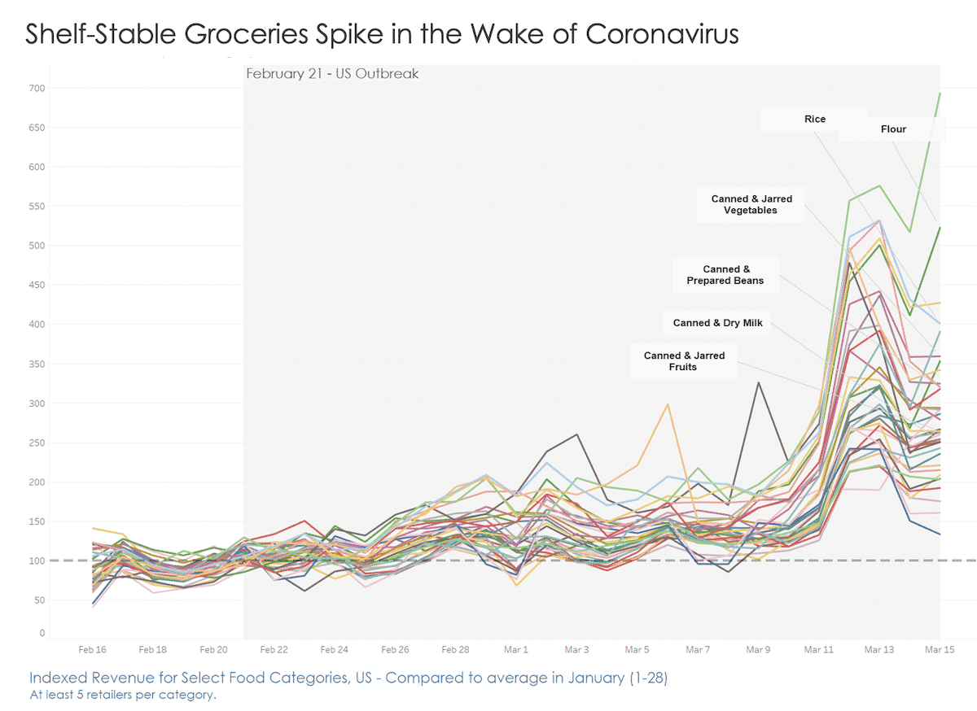

2. Sales of medical supplies are soaring.
In Italy, people prepared to take good care of themselves at home after a partial lockdown on February 25th. Sales of Medical Supplies spiked by +286% in early March. COVID-19 will further accentuate this dynamic, and health and wellness products have been growing abnormally fast since the outbreak. Before the outbreak, there was already a long-term shift towards healthier products and categories. Even as COVID-19 continues or subsides, consumers are expected to continue to look after their health and wellbeing.
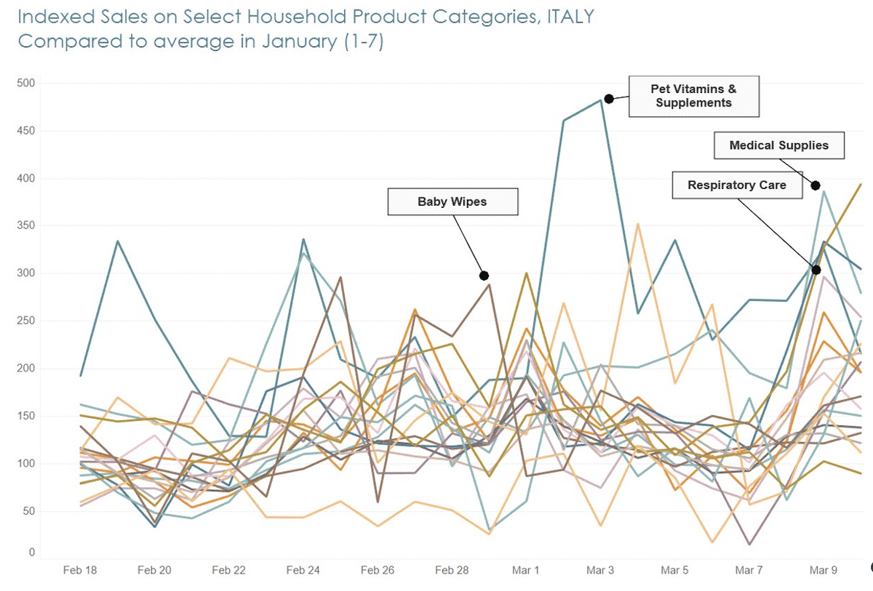

3. Price won’t matter that much
In the last two months, shoppers have been buying what they need and what they can get. Price remains a key driver in their decision-making, but quality has recently stepped up too. Given the climate, consumers may reprioritize health, safety, and availability in their consideration of a product. Brands and retailers can deliver these quality and safety assurances by communicating, or highlighting, the steps that were taken to ensure healthy, hygienic, and safe provision of products, especially fresh ones. Nonetheless, this doesn’t mean continued long term decline for categories that were impacted negatively by COVID-19. Though only time can tell how long COVID-19 will last, these consumer behavior patterns can help provide leading and trailing indicators to those who want to understand how people will respond as developments continue to play out during this outbreak.

HOW CORONOVIRUS AFFECTS NIGERIA
Since the onset of the first case discovered in Nigeria, the nation has been in state of tensed breath and after the advance of the disease to other states of the country, in a state of suppressed panic. Nigeria announced a lockdown of major cities to curb coronavirus. Nigeria implemented a sweeping quarantine for three major states that are home to almost 30 million people in a bid to slow the spread of the new coronavirus in Africa's most populous country. The lockdown in Lagos, Abuja and Ogun kicked in at 11pm local time (22:00 GMT) on Monday and will stay in place for at least two weeks, President Muhammadu Buhari announced on Sunday, a little over a month after Nigeria confirmed its first case.
The announcement triggered panic among many in Lagos, the epicenter of the coronavirus outbreak in the country which has so far infected a large number of people and caused death. Residents in Lagos flooded markets and stores to buy food and other items. Bose Odumosu, a mother of five, told Al Jazeera that she will use the next hours to stock up on food for her family.
"I was expecting the government to give us a few days to sort out our domestic needs before the announcement. I feel the sudden restriction will cause the price of commodities to increase," Odumosu said.
Buhari said all branches of government have been mobilized "to confront what has now become both a health emergency and an economic crisis", but the lockdown means additional financial pain for millions of informal laborers who rely heavily on their daily earnings to survive. Across the world, the outbreak of the new coronavirus has strained healthcare systems and hit economies hard, with few countries expected to emerge unscathed by the pandemic's financial effect. Nigeria is already feeling the pinch with oil prices plunging. The country is the world's eighth-largest oil exporter, and almost 90 percent of its export earnings are tied to oil. Shutting down the country's financial capital, Lagos, is expected to further add to an impending economic crisis. Meanwhile, electricity remains a major challenge in the country. Most people rely on costly diesel-powered generators to power their homes and keep businesses afloat. Families are also hoping for regular power supply during the period of quarantine.
CONCLUSION
COVID-19 epidemic is unprecedented, a never seen before disease and countries around the world are scrambling to bring up a vaccine or cure. Nigeria can benefit by learning from countries like China who were successful in containing the virus and other countries can learn from this pandemic by setting up safeguards to avoid another disease of this magnitude ensuring that consumers do not suffer again to such a dilemma.

REFRENCES
- CRITEO, 5 Ways the Coronavirus is Affecting Consumer Behavior, US, March 2020, viewed April 8, 2020, https://www.criteo.com/insights/coronavirus-consumer-behavior/
- Research Services Blog, 5 Common Factors Influencing Consumer Behavior, viewed April 8, 2020, https://www.iresearchservices.com/5-common-factors-influencing-consumer-behavior/
- Aljazeera News, Nigeria announces lockdown of major cities to curb coronavirus, by Fidelis Mbah, 30 March 2020, viewed April 8, 2020, https://www.aljazeera.com/news/2020/03/nigeria-announces-lockdown-major-cities-curb-coronavirus-200330095100706.html
- CONTENTSERV, How the COVID-19 Pandemic is Influencing Consumer Behavior, viewed on April 8, 2020, https://www.contentserv.com/en/blog/how-covid-19-pandemic-is-influencing-consumer-behavior/
- Wikipedia, Consumer Behaviour, Pandemic, viewed April 8, 2020, https://en.wikipedia.org/wiki/Consumer_behaviour
- DemandJump, What is Consumer Buying Behaviour, by Jordan Ehrlich, published on January 20 2020, viewed on April 8, 2020, https://www.demandjump.com/blog/what-is-consumer-buying-behavior

