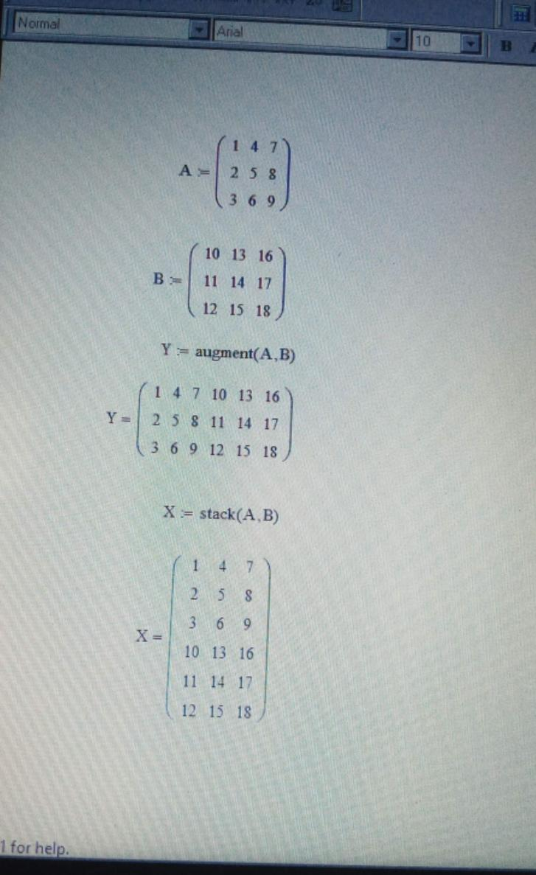
OKEKE CHIDERA SAMUELLA 18/ENG08/014,,,,,,,,, BIOMEDICAL ENGINEERING

