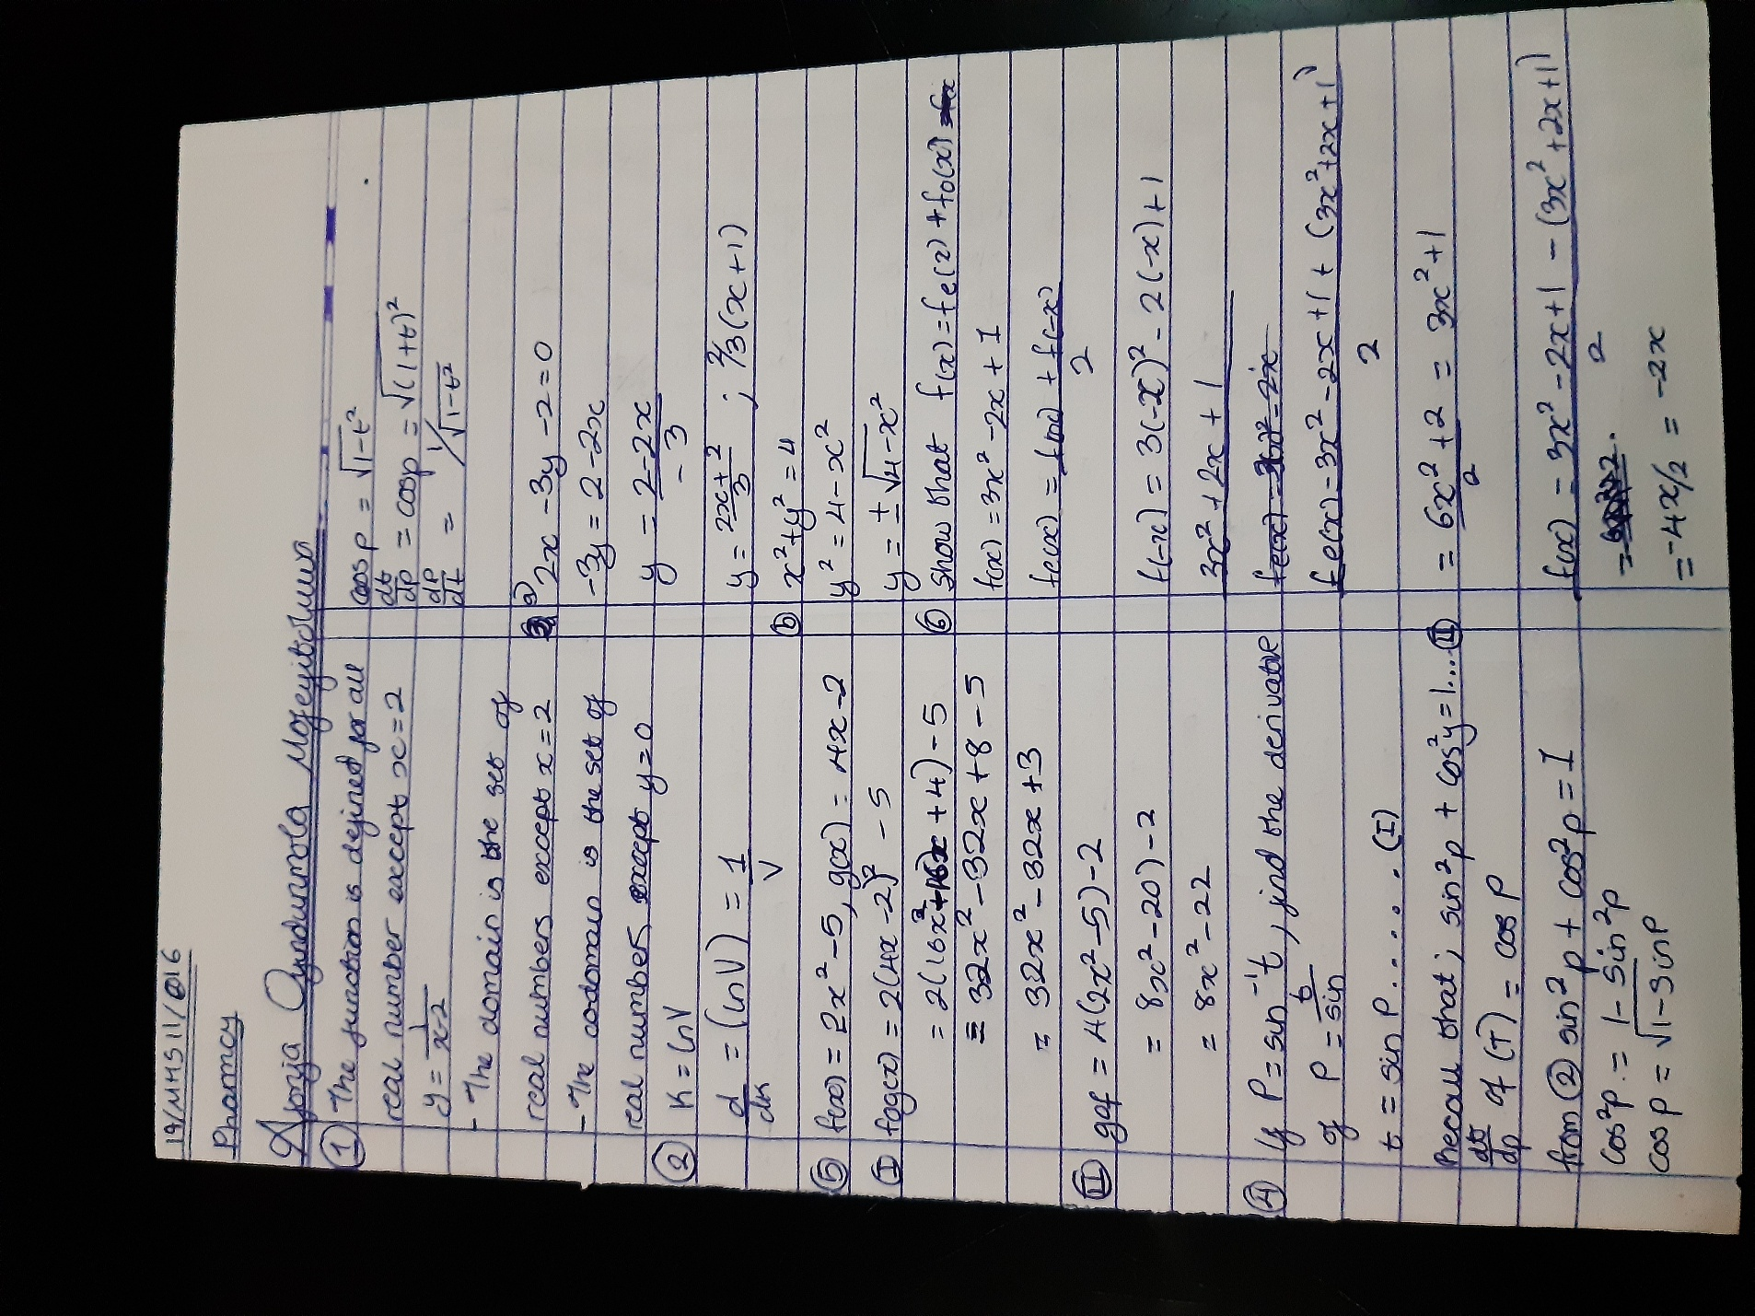 ***AFONJA OYINDUNMOLA MOFEYITOLUWA PHARMACY 19/MHS11/016***

