IGBA TISHA EMUOBOSA
COLLEGE OF ENGINEERING
ELECTRICAL AND ELECTRONICS ENGINEERING
19/ENG04 /025
STAT 132
Assignment
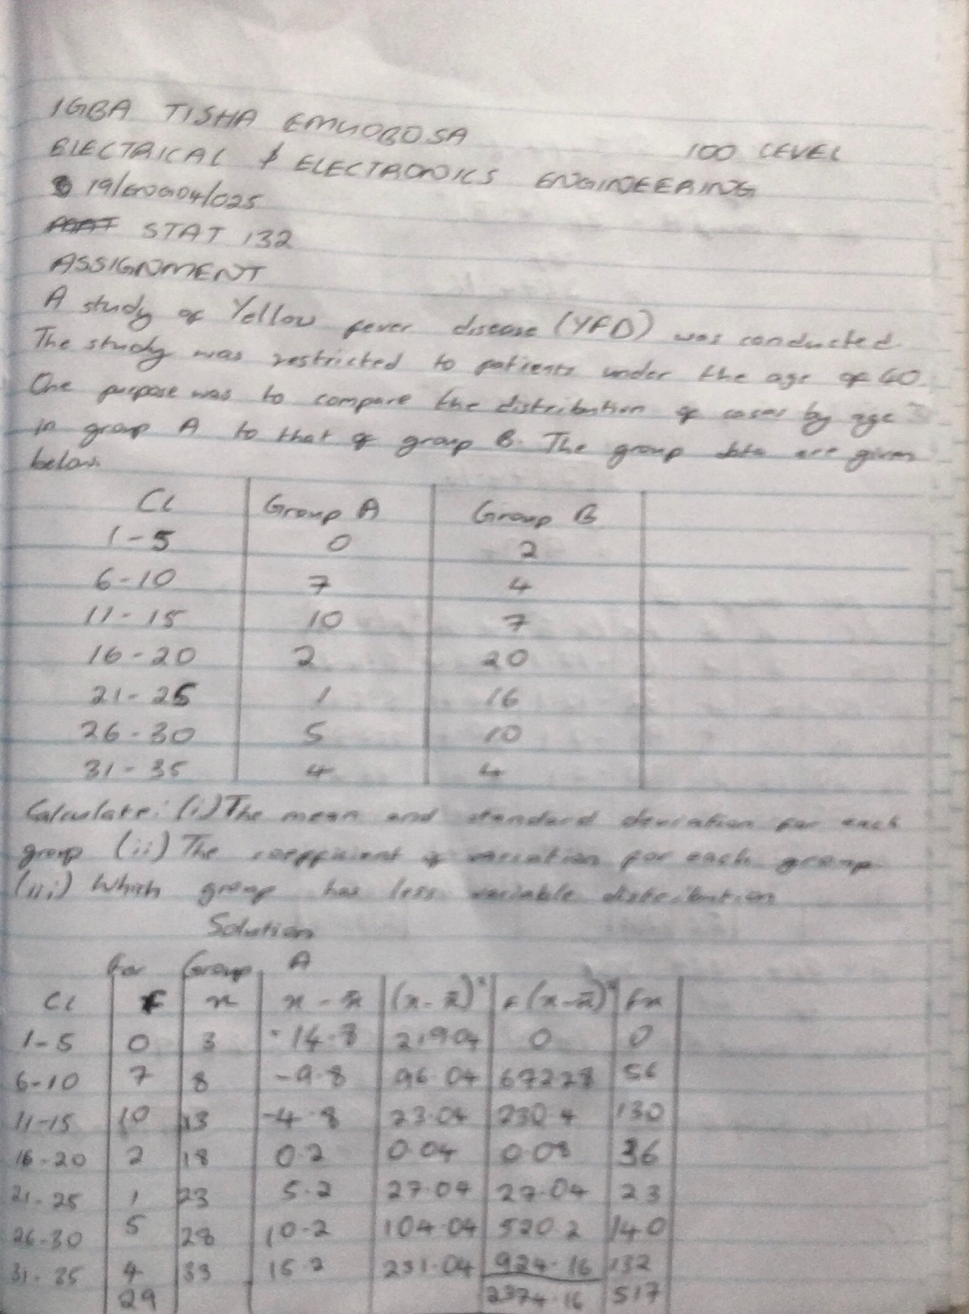
Due : 8th April, 2020
