NAME: OMOLADE BRIGHT AYOMIDE
MATRIC NO: 19/SCI01/078
DEPARTMENT: COMPUTER SCIENCE
Number 1
Number 2 and 3
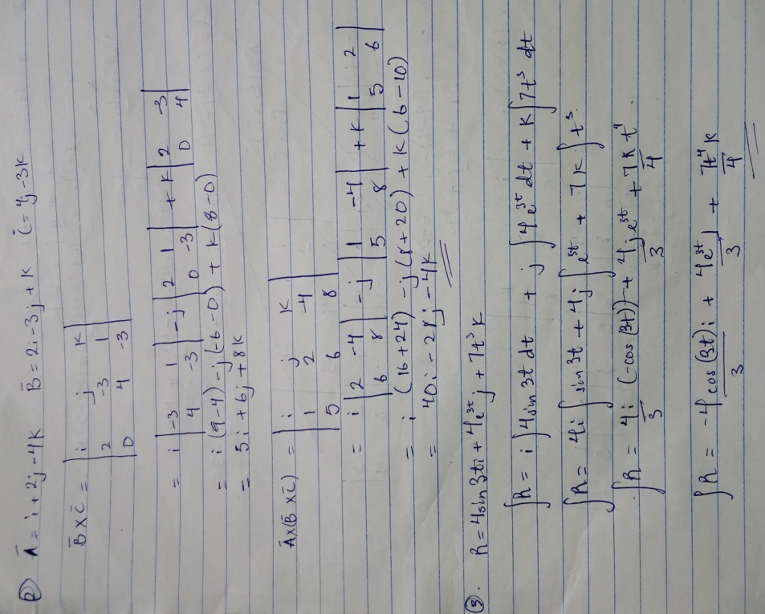

Number 4 and 5

