ENGINEERING STRATEGIES FOR HANDLING COVID-19 FOR ENVIRONMENTAL HEALTH AND ECONOMIC STABILITY
PREPARED BY;
NAME: OJEME SELBY UDUEHI
MATRICNUMBER:17/ENG04/052
A TERM PAPER SUBMITTED TO
THE DEPARTMENT OF ELECTRICAL/COMPUTER ENGINEERING,
COLLEGE OF ENGINEERING,
AFEBABALOLA UNIVERSITY ADO-EKITI STATE, NIGERIA.
IN PARTIAL FUFILMENT OF ENG 384: ENGINEERING LAW AND MANAGERIAL ECONOMICS

ACKNOWLEDGEMENT
I acknowledge the almighty God for giving me grace and the strength to carry out this project.I also acknowledge the school AfeBabalola University Ado-Ekiti(ABUAD) and its lecturers for devoting their energy and time on this course.
ABSTRACT
The study is about finding engineering strategies to handle the virus known as Covid-19 popularly known as “corona virus” for economic and health stability .The data for the study were collected through various search engines such as Google, Wikipedia ,Bling and etc .The study shows how Nigeria as a country can handle the current pandemic through the use of one of its leading profession “The engineering Sector” and how it can help us battle the pandemic and also restore both our health and economic growth.

TABLE OF CONTENT
CONTENT | PAGE
TITLE | I
COVERPAGE | I
ACKNOWLEDGEMENTS | II
ABSTRACT | Iii
TABLE OF CONTENT | 1
LIST OF TABLES | 2
LIST OF FIGIURES | 2
INTRODUCTION | 6
LITERATURE REVIEW  1.WHAT IS CORONAVIRUS  Ii WHAT IS COVID-19  Iii SYMPTOMS OF COVID-19  IV PREVENTIVE MEASURES  2 MANUFACTURING MORE OPEN SOURCE VENTILLATORS  IOPEN SOURCE VENTILLATOR MEANING  IIPICTORIAL DESCRIPTION OF OPEN SOURCE VENTILLATORS | 8  10

2 INTRODUCTION OF THE USE OF ONLINE NARRATIVES TO CURB THE SPREAD OF COVID-19  I 10 STRATEGIES IN CURBING THE SPREAD OF COVID-19  3 TECHNOLOGICAL MEASURES  I World health organization declares covid-19 a global state of emergency  II TYPES OF TECHNOLOGICAL MEASURES USED  I MEDEVAIL MEASURES  IIDETECTION TECHNOLOGY  III PREDICTIVE TECHNOLOGY  IV CROWDSOURCING DISEASE TRACKING  V CONNECTED WORLD  . | 12  20
METHODOLOGY | 24
ANALYSISOFREPORT | 24
CONCLUSION | 24

INTRODUCTION
What Is Coronavirus?
A coronavirus is a kind of common virus that causes an infection in your nose, sinuses, or upper throat. They’re called coronaviruses because under a microscope, they look like a crown.Most coronaviruses aren't dangerous. But in early 2020, after a December 2019 outbreak in China, the World Health Organization identified a new type of coronavirus. Officials named this new virus severe acute respiratory syndrome coronavirus 2 (SARS-CoV-2). This is the virus that causes COVID-19.
What Is COVID-19?
Coronavirus disease 2019, or COVID-19, is a disease that can cause what doctors call a respiratory tract infection. It can affect your upper respiratory tract (sinuses, nose, and throat) or lower respiratory tract (windpipe and lungs). The COVID-19 outbreak quickly spread around the world. It spreads the same way other coronaviruses do, mainly through person-to-person contact. Infections range from mild to serious, COVID-19 is one of seven types of coronavirus, including the ones that cause severe diseases like Middle East respiratory syndrome (MERS) and sudden acute respiratory syndrome (SARS). The other coronaviruses cause most of the colds that affect us during the year but aren’t a serious threat for otherwise healthy people.

SYMPTOMS OF COVID-19

- Trouble breathing
- Persistent pain or pressure in the chest
- New confusion or inability to arouse
- Bluish lips or face

PREVENTIVE MEASURES
- Wash your hands frequently with soap or any other alcohol-based hand sanitizer
- When sneezing or coughing, cover your nose and mouth with tissues; dispose of the tissues immediately after use
- Don’t come into close contact with an infected individual, anybody suffering from fever or exhibiting the typical symptoms
- Cook your foods thoroughly, particularly meat and eggs, before consuming
MANUFACTURING MORE OPEN SOURCE VENTILATORS
An open-source ventilator is a disaster-situation ventilator made using a freely-licensed (open source) design, and ideally, freely-available components and parts. Designs, components, and parts may be anywhere from completely reverse engineered or completely new creations, components may be adaptations of various inexpensive existing products, and special hard-to-find and/or expensive parts may be 3D printed instead of purchased.^{[2][3]}
One small, early prototype effort was the Pandemic Ventilator created somewhere back in 2008 (per oldest comments) during the resurgence of H5N1 avian influenza that began in 2003, and so named "because it is meant to be used as a ventilator of last resort during a possible avian (bird) flu pandemic."
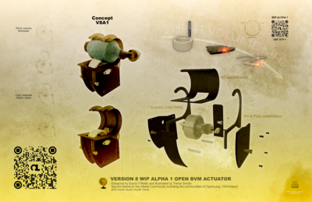
The Open Source Ventilator's Open Lung project, an open source, low resource, quick deployment mechanical ventilator design utilizes a bag valve mask (BVM or Ambu-bag) as a core component.^{[1]}

One of the major strategies in battling this virus is the manufacturement of open source ventilators One of the biggest challenges faced by health workers around the world amid the coronavirus pandemic is trying to save lives when the number of patients needing critical care overtakes the available medical infrastructure.
Countries with a large number of cases are struggling to meet the demand for supplies and equipment needed to arm those on the front lines against COVID-19, the highly infectious respiratory disease caused by the virus. Ventilators - mechanical breathing devices - are crucial in the fight to save patients whose lungs are assailed by the virus.
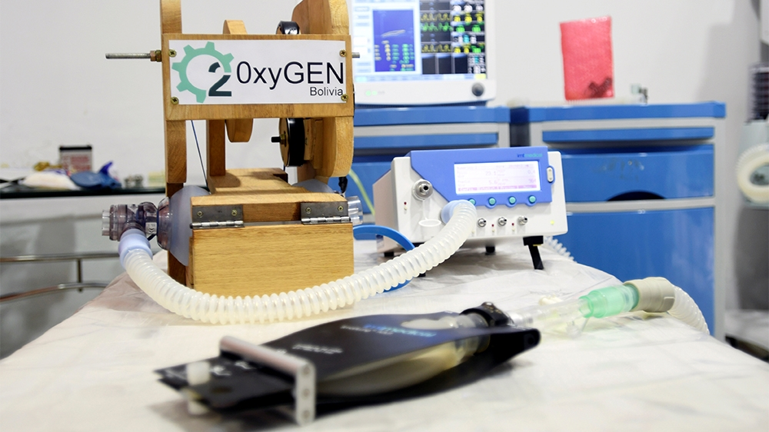
A ventilator for use during the coronavirus outbreak in Santa Cruz, Bolivia [Rodrigo Urzagasti/Reuters].According to the World Health Organization, one in six COVID-19 patients becomes seriously ill and can develop breathing difficulties, Ventilators are a key part in combating this pandemic so I for one believe that as a country we should task our engineering sector to be able to build more open source ventilators in order to be able to provide to the needs of those who have been infected with the corona virus,we can use the ventilators we have now and modify them into open source, we can even enlist the use of 3D printers to meet up with the demand rate,This strategy will definetly improve and stabilize economic growth.
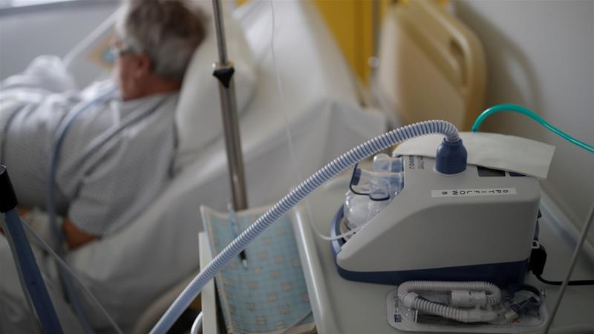
Non-invasive ventilation uses face masks, nasal masks or mouthpieces
INTRODUCTION OF THE USE OF ONLINE NARRATIVES TO CURB THE SPREAD OF COVID-19
As the COVID-19 coronavirus continues to spread, schools around the globe are shifting to online learning in an effort to slow the spread of the disease.Members of ISTE’s professional learning networks have been hard at work identifying key practices for successful online learning. Here are some of the best ideas from educators from around the world, many of whom have already been teaching during coronavirus closures.
Prepare and practice
1. Ensure digital equity.
Equity is the biggest obstacle in preparing for online learning, and the first thing you should be thinking about. If your district is not 1:1 and does not have devices to send home with everyone, survey teachers and families ahead of time to figure out who will need devices and bandwidth.
Jenna Conan, technology integration specialist at All Saints' Episcopal School in Fort Worth, Texas, points out that most families don't have one computer per person. During a school shutdown, parents may also be working from home, meaning several people could be competing for one or two computers. Therefore, make sure all online apps work on mobile devices in case a laptop is not available.
For teachers or students who don't have Wi-Fi at home, districts must figure out how to buy or rent Wi-Fi hotspots and then have a plan for distributing both devices and hotspots. If you have advance warning that a shutdown is imminent, districts can send devices and hotspots home with students before the closure. If a shutdown happens abruptly, plan a pick-up time and location, and arrange to deliver devices and hotspots to those who cannot pick them up.
Keep in mind that students who have individual education plans (IEPs) need to have access to their specific accommodations during the closure, including video access to aides and logins for apps.
2. Practice.
Schools that regularly have digital learning days – and have worked through home-connectivity and device issues – are already ahead of the game, says Michael Flood, ISTE Digital Equity PLN Leader. But if your school has not laid the groundwork, consider this to be an opportunity.
Teachers not already using a learning management system regularly, need to dive in now so that there will be no interruption in communication in the wake of a sudden closure. Teachers should train themselves and their students on the apps and technology tools they may need to use in the event of closure. Practice in the classroom and then send students off to try using the tools from home, says Sandra Chow, director of innovation and digital learning at Keystone Academy in Beijing.
Chow, who has been teaching online since coronavirus shut down her school in early February, says educators won’t regret spending time on this.
"None of this learning will go to waste moving forward," she says, "as many of the skills learned during the online learning period will be equally beneficial in a regular classroom.”
3. Provide clear expectations to staff and parents.
During a closure, communication between administrators, staff, parents and students is more important than ever.
"In an online environment, everyone's anxiety is high and channels of communication need to be frequent, clear and succinct," Chow says.
For big-picture communications, prepare an FAQ outlining all the details of how the school will operate during a closure so staff and parents are on the same page.
David Lowe, a parent and former assistant principal whose children's district in Washington state switched to remote learning on March 9, recommends the FAQ include where to find the daily assignments; a list of sites and tools the students will need, how to log in and what to do if the technology doesn’t work; and, finally, the expectations of parents. “There’s a lot of information to sift through and parents are working hard to make sure they’re clear on what they should be doing to best support their students.”
In addition to posting and distributing FAQs, schools should set up communitywide texting to communicate quickly and then advise people where to find follow-up messages via email or on your website.
Next, prepare a step-by-step guide on how to access and use online learning tools and curriculum. Make sure you present this information in various formats including video and text and include screenshots and screen-casting tutorials.
Ask families to make sure all students – especially the youngest learners – know how to log in to the apps and know their passwords. Teachers need to know how to take attendance. Provide extra tech support and make sure parents and teachers know how to ask for help.
4. Take time to plan.
If a shutdown occurs before your staff is ready to teach online, invest some time – even if it’s just a day or two – to prepare before rolling out online learning with the students. The brief delay in starting online lessons will pay off in the long run. In the Washington district where Lowe’s three children attend, staff spent time getting ready for an impending closure. “The district took a whole day for all the teams to get together to create a plan for online learning,” he said. “It was a really smart move.”
Teams divided up and tackled everything from logistical issues, like the setup of Zoom meetings, to instructional ones, like different home support models, and then reported out to the larger group. When the district shut down two days later, teachers got two planning days before fully jumping into online learning with the students. The team and individual planning days helped smooth implementation. Even if a closure is sudden and offers no time to plan before schools are shuttered, it is still prudent to plan before beginning online lessons.
5. Pack your bag.
Make sure you have access to everything you need from home in case you are not able to return to school or bring home your school computer and move your files into the cloud.
Implementation
6. Establish daily schedules.
Expectations should be clear about when teachers and students need to be logged on. A full day in front of a screen is a lot for kids and teachers, especially for families who may be sharing one device. Many schools are choosing two check-in times – a morning meeting and an afternoon check-in – and then allowing families flexibility about how they organize the at-home school schedule.
Other schools are reorganizing the school schedule, by spreading one school day over two days. Students attend three classes in the morning and have the afternoons to work independently and interact with those teachers during “office hours.” The next day, they attend the rest of their classes online in the morning and then have office hours with those teachers in the afternoons. Sometimes it can be difficult to anticipate the roadblocks that students might face while navigating this new territory. Nadine Bailey, teacher librarian and technology integrator at the Western Academy of Beijing, suggests picking one student per grade and monitoring their "expected" path throughout the day from tool to tool to make sure everything is working as it should. If not, be flexible and make changes along the way.
It can be trickier handling specialty classes like PE, robotics or art. Adam Hill is a blogger and teacher at Victoria Shanghai Academy in Hong Kong, which has been closed since Jan. 22 and began offering remote learning on Feb. 5.
Hill's school found that students were struggling to make time each day for specialist instruction so they decided to allocate one day per week for all elective activities.
7. Provide robust learning.
In extreme circumstances like an impromptu closure, it’s tempting for teachers to upload worksheets for students to complete and return. But online earning during a closure – especially during extended closures – should be at least as engaging as the classroom experience (if not more) or students will suffer.
Educator Alison Yang developed an online learning guide, which stresses that online learning should never be an excuse to assign busy work, but rather to address clear engaging learning objectives. Bailey, the Beijing teacher-librarian, adapted Yang's guide into one for parents to help them understand the objectives.
For key principals that ISTE recommends are:
Break learning into smaller chunks.
Be clear about expectations for online participation.
Provide immediate (or at least frequent) feedback through online knowledge checks, comments on collaborative documents and chat to keep students motivated and moving forward.
Include virtual meetings, live chats or video tutorials to maintain a human connection.
Chow's leadership team in Beijing met virtually to design an online learning plan, which included training for video production and other tools, online learning pedagogy as well as social-emotional training.
She stressed that the community will need time to adjust. Provide manageable and achievable goals to work on each week, listen to feedback and communicate frequently, she says.
8. Design independent learning.
Keep in mind that parents might either be at work or working from home and unable to help much. It’s important to design learning that does not require a lot of support from parents who might already be overwhelmed. Lowe, the parent from Washington state, said expectations about parental support might be the biggest issue for him and his wife. Providing guidance for parents on how they can be supporting their kids in an online learning model is also helpful.
“It feels similar to homeschooling right now,” Lowe said. “The biggest challenge is parents supervising what their kids are supposed to be doing and at what time.”
Lowe acknowledges that his family is lucky. He’s a consultant who can work from home and his wife is a teacher, so they are available to pitch in. Not all parents will be able to cope as easily, especially those with small children who can’t work from home.
“One of the best things our schools have done to support parents is streamlining information by creating one place for all the assignments, schedules and expectations,” he said. “The closer to a checklist you can make these resources, the better.”
9. Address the emotional toll.
Check in with students and coworkers, especially those who are less comfortable with digital tools to see if they need any help or someone to talk to. Being sequestered at home can be isolating and exacerbate the fear of dealing with a global crisis. Taking time to check in about feelings of anxiety is just as important as checking on academics.
In his guide to online learning, Rushton Hurley, an ISTE member and founder of Next Vista for Learning, shares a story from expat teachers in Wuhan, China, the epicenter of the coronavirus. After weeks of largely being confined to their apartments, teachers began calling each other and leaving the lines open, even if they weren't talking. They simply wanted the comfort of being able to speak up and have someone hear their voices. If a closure lasts for a long time, you will miss your students, and they will miss you and each other, Hurley said.
While it may seem fun to work from home, it can be challenging to keep to a regular schedule. Some things that can help include:
Take regular breaks.
Making time to exercise.
Keep to a regular sleep schedule.
Limit distractions when possible (turn off social media notifications, for example).
Set daily and weekly goals.
Make time to socialize, even if it’s virtually.
10. Choose the right tools and stick with them.
A wide variety of technology tools, many free, are available to help. Jason Reagin, edtech consultant and teacher in Incheon, South Korea, has put together a Wakelet of apps offering free upgrades during the global crisis.
With so much out there, it can be tempting to try to use everything. Instead, limit the number of tools, apps and platforms so students and their parents are not overwhelmed.
It may be a little harder for students to follow classroom assignments when you are not there face to face. Some ideas from Arizona State University for helping kids focus are using different colored fonts on-screen to help learners distinguish important ideas. Try to keep online instructions short, simple and clear. Consider making video instructions instead of text.
Videoconferencing will take you and your students into each other's homes so it's important to consider privacy. Some programs let users blur your background. Dress as you would for attending school and expect students to do the same.
Online learning also presents a great opportunity to review digital etiquette and embed digital citizenship into online collaboration activities.

TECHNOLOGICAL MEASURES
The World Health Organization declared the coronavirus a global health emergency in recognition that the disease risk no longer is confined to China.
United Nations member countries may decide to close their borders, cancel flights, implement special screenings at airports, or take other steps in response to the notice.
U.S. health officials march ending announced they would fast-track work on a coronavirus vaccine, with the goal to have an early-stage trial within three months. That timeline is considered optimistic, and even if the work proceeds apace, a phase 1 trial is still a long way from a vaccine ready for mass deployment, the National Institute of Allergy and Infectious Diseases, an agency within the Department of Health and Human Services, has emphasized.
It could take a year or even longer before any vaccine is released for widespread use.
That is likely of little comfort to those in the Chinese city of Wuhan, which is ground zero for the coronavirus outbreak and essentially has been quarantined. As of this week, the virus has killed 106 people in mainland China, and it has infected nearly 4,700 people worldwide, including in the United States.
The Chinese government rapidly constructed a 1,000-bed hospital in Wuhan as a way to contain and treat patients suspected of contracting the virus. Named the "Wuhan Huoshenshan Hospital," it reportedly is a 25,000-square-meter facility purpose-built to address this outbreak. The goal of the Chinese was to have the hospital finished and operational in just 10 days.
A second and even larger facility, the Leishenshan Hospital, also is under construction, and the goal is to have that building finished in just 15 days.
Medieval Measures
Essentially locking down an entire city or region isn't exactly a new tactic, and it certainly is not effective. When the "Black Death" spread during the Middle Ages, it was commonplace for port cities to be closed to ships suspected of coming from infected areas.
In the 14th century, Venice was among the first cities to formalize such measures, closing the city's waters to suspected vessels, and even subjecting travelers and nearly all ships to 30 days of isolation.
The period was extended to 40 days, which led to the term "quarantine."
Sadly, those efforts generally were unsuccessful, and it is unclear if a modern quarantine would have any better success. However, this week the Centers for Disease Control and Prevention told Americans to avoid all nonessential travel to China and extended its travel warning from Wuhan to the entire country.
The effectiveness of this move currently is being debated, said Mariea Snell, assistant director of Doctor of Nursing Practice programs at Maryville University.
"At this point, the recommendation is that travel be limited, as the risk is considered to not outweigh the benefit at this point," she told TechNewsWorld.
Modern air travel exponentially increased the spread of influenza each year, based on a study by Chong and Chung, originally conducted in 2012 and updated in 2017.
Air travel restrictions should become a priority when flu or other potential pandemic could occur, the researchers recommended.
Some companies are heeding such advice. Apple CEO Tim Cook on Tuesday announced restrictions on employee travel and even took the drastic measure of shutting down one store in China.
The question is whether restricting travel and utilizing quarantine practices be effective at curbing the spread of infection.
"Recent studies indicate that it may not be as beneficial as originally thought to be," Snell said.
"We learned a lot from the SARS and Ebola outbreak in this regard. While it may slow it down, it will not eliminate it," she noted.
"The best way to prevent the spread of illness is to wash your hands, and stay home if you are sick," Snell said.
Detection Technology
Aside from quarantines, efforts to halt the spread of disease include screenings. It has gotten far easier to determine if someone is contagious and carrying an illness through various methods of detection, which can be as simple as taking temperatures and observing individuals for symptoms.
"A helpful way that technology can and is being used to stop the spread of illness is the use of public health surveillance data," noted Snell.
The effectiveness can be hit or miss, however, largely depending on the virus.
"In the case of the coronavirus, scientists say that the viral shedding period -- period when you are contagious -- can occur up to a week before you start to show symptoms," Snell explained.
"Given this, using technology to detect infection -- like fever -- would not be very effective at preventing the spread," she noted. "This can be helpful during acute illness, but it would not catch all infected people."
Predictive Technology
Technology isn't just used just to determine if someone is ill, however. Advances in artificial intelligence and machine learning now are being used to predict where an outbreak might occur -- or even more importantly, where it might spread.
One such effort is an early-warning system that utilizes artificial intelligence and machine learning, as well as natural language processing, to track more than 100 infectious diseases, developed by the Canadian firm BlueDot.
The program is designed to read from more than 100,000 articles in 65 languages, and the data then is compiled to determine the potential for the spreading of diseases. It was used earlier this month to track the coronavirus and then predict where it might spread.
"Considering the coronavirus is a global disease, AI hasn't done a good job stopping it -- but a much better job in tracking it," said Roger Entner, principal analyst at Recon Analytics.
However, it could take time to refine any AI to be truly successful.
"AI could certainly help, but it's early days for AI yet, and this virus is moving faster than it would probably take to set up a good AI model and train it on the right data set," cautioned Roger Kay, principal analyst at Endpoint Technologies Associates.
"More important is to execute existing protocols rigorously, like tracing contacts and quarantining and treating infected people," he told TechNewsWorld.
Crowdsourcing Disease Tracking
A number of crowdsourcing methods could be effective in tracking the spread of disease.
"People are also using cellphone data to track population movement and how they interact," noted Snell.
"This helps understand or predict where disease may spread so that scientists and healthcare providers can take a proactive approach," she added.
Social media is another promising avenue.
"Algorithms have been set up to detect certain buzzwords like 'flu' or 'food poisoning' to detect and track possible large-scale outbreaks," noted Snell.
Connected World
The ease with which so many people can jet set around the world for business meetings, conferences, trade shows, vacation and other occasions also has contributed to the spread of contagious diseases.
Perhaps some of those occasions for travel eventually could transition to virtual reality or augmented reality experiences -- both to save money for the participants, and to keep big gatherings -- such as the annual CES or the Davos political gathering -- from becoming ground zero for a pandemic.
Not everyone is sold on that idea, however, and convincing attendees of those shows -- not to mention the exhibitors -- could be an uphill struggle.
"The moment we have to do AR/VR in a response to a pandemic, then we are so deep in trouble not even AR/VR can save us," Recon Analytics' Entner told TechNewsWorld.
"In the end, there is no substitute for meeting someone in person, shaking their hand and looking them in the eye -- AR/VR can't do that," he added.
Virtual conferences are already happening for cost reasons, of course.
"The only issue is you can't get people to sit through three days of content on a virtual connection -- it just doesn't work," observed Kay.
Networking is an important part of conferences, but if you don't need to do business development, there is no reason not to get the content in a format like a TED talk, and there are lots of software tools for conferencing at various levels," he added.
"Much of what one can learn or needs to learn from major events or trade shows can be done through technology," maintained Snell.

METHODOLOGY
Design of the Study: The study adopted an online research design.Online research methods are ways in which researchers can collect data via the internent
Area of the Study: The study was carried out in Nigeria.
ANALYSIS OF RESULT
From the data gotten above,it is seen that there are lots of engineering strategies in curbing the spread of the covid-19 virus yet also securing economical growth ,I for one will highly hrecommend the introduction of the use of online narratives in curbing covid-19 ,this is one way that once perfected it will ensure major sectors in our economy to go on such as the education sector ,meetings and etc
CONCLUSION
Based on the finding of this study, the following conclusions were made: We can curb the spread of covid-19 by first of all knowing what the virus is and how one can get it ,we can still be at home and still thrive in our day to day activites school ,work etc by use of online measures

