NAME: OGUNDOLA DAMILOLA OLAMIDE
DEPARTMENT: CHEMICAL ENGINEERING
MATRIC NUMBER: 17/ENG01/022
COURSE CODE: ENG 382
COURSE TITLE: ENGINEERING MATHEMATICS

FOR THE FUNCTION FILE
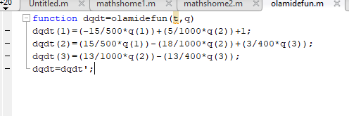

FOR THE STIMULATION FILE
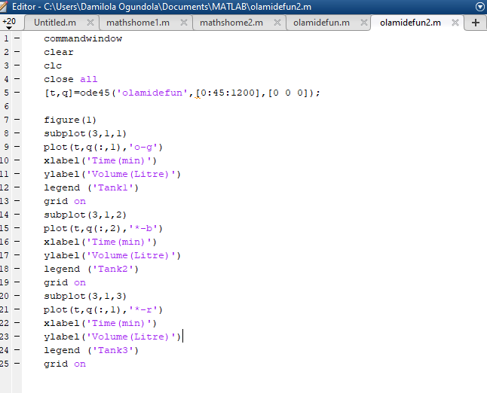
THE GRAPHS AFTER THE CODE WERE INSERTED
