NAME: KEHINDE OLUWATOYIN MARTHA
MATRIC NO: 16/SCI01/023
COURSE CODE: CSC 408
ASSIGNMENT
QUESTION 1
- Project management process is an administration process for the planning and control of the services or the implementation of a project. This process begins after the approval by the customer, is based on the contract, and is targeted on the initial values of the process and the general management of a project.
- Project initiation: this is the starting point of any project. In this process, all the activities related to winning a project takes place. Usually, the main activity of this phase is the pre-sale. During the pre-sale period, the service provider proves the eligibility and ability of completing the project to the client and eventually wins the business. Then, it is the detailed requirements gathering which comes next. During the requirements gathering activity, all the client requirements are gathered and analyzed for implementation.
Usually, project initiation process ends with requirements sign-off.
- Project planning: project planning is one of the main project management processes. If the project management team gets this step wrong, there could be heavy negative consequences during the next phases of the project. In this process, the project plan is derived in order to address the project requirements such as requirements scope, budget and timelines. Once the project plan is derived, then the project schedule is developed.
- Project Execution: during the project execution, there are many reporting activities to be done. The senior management of the company will require daily or weekly status updates on the project progress. In addition to reporting, there are multiple deliveries to be made during the project execution. Usually, project deliveries are not onetime deliveries made at the end of the project. Instead, the deliveries are scattered through out the project execution period and delivered upon agreed timelines.
- Control and validation: project controlling can be done by mainly adhering to the initial protocols such as project plan, quality assurance test plan and communication plan for the project. Validation is a supporting activity that runs from first day to the last day of a project. Each and every activity and delivery should have its own validation criteria in order to verify the successful outcome or the successful completion.
- Closeout and Evaluation: once all the project requirements are achieved, it is time to hand over the implemented system and closeout the project. After the closeout, evaluation is done. In this evaluation, the mistakes made by the project team will be identified and will take necessary steps to avoid them in the future projects.

- PRINCE2: Stands for Projects IN Controlled Environments 2. It presents a suite of process-driven methods and documentation-oriented approaches that allow driving various projects in the private sector. PRINCE2 is a process-based approach that focuses on organization and control over the entire project, from the start to finish. That means projects are thoroughly planned before kickoff, each stage of the process clearly structured, and any loose ends are neatly tied up after the project concludes.
QUESTION 2
A work-breakdown structure (WBS) in project management and systems engineering, is a deliverable-oriented breakdown of a project into smaller components. A work breakdown structure is a key project deliverable that organizes the team's work into manageable sections. The Project Management Body of Knowledge (PMBOK) defines the work-breakdown structure "A hierarchical decomposition of the total scope of work to be carried out by the project team to accomplish the project objectives and create the required deliverables."
A work-breakdown structure element may be a product, data, service, or any combination thereof. A WBS also provides the necessary framework for detailed cost estimating and control along with providing guidance for schedule development and control.^{[3]}

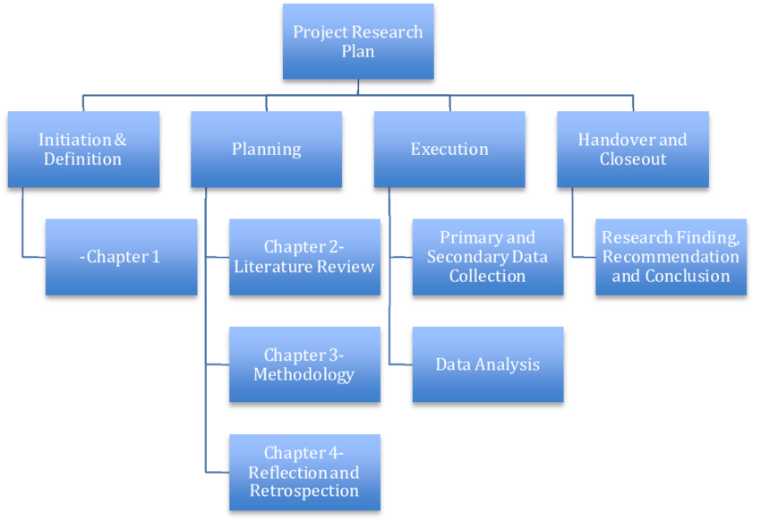
QUESTION 3
- To appreciate the effective benefits project management.
- To identify success criteria for a project.
- Understand the impacts of risks and to be able to develop contingency plans to mitigate them effectively.
- Be able to develop a project schedule.
- To understand the construction of a project budget.

