CHALLENGES FACED/ PROSPECTS FOR SUSTAINABLE DEVELOPMKENTS

PREPARED BY

OLUTAYO AYODEJI S.
17/ENG05/034
A TERM PAPER
SUBMITTED TO
MECHANICAL AND MECHATRONICS ENGINEERING DEPARTMENT,
COLLEGE OF ENGINEERING,
AFE BABALOLA UNIVERSITY, ADO-EKITI,
EKITI STATE, NIGERIA.

IN PARTIAL FULFILMENT OF ENG384: ENGINEERING LAW AND MANAGERIAL ECONOMICS

ABSTRACT
As technology progresses, traditional barriers between different engineering disciplines diminish and hence the birth of Mechatronics as an interdisciplinary branch of engineering at all levels of learning to satisfy the needs of many industrial establishments. Mechatronics is a term that refers to the knowledge area encompassing the traditionally separate disciplines of mechanical, electrical and computer engineering. Speciﬁcally, it is an interdisciplinary ﬁeld that caters to the needs of a growing number of commercial products and industrial processes that involve the integrated use of mechanical and electronic components as well as control software in their design and development. Therefore, for Nigeria as the largest country in Africa to achieve the needed technological development, similar to that of India, Singapore, Malaysia etc., there is a need to establish Mechatronics engineering education in our vocational training centres, technical colleges, polytechnics and universities. This would help to provide education and training for a new breed of engineering practitioners who are proficient in the combined application of systems design as well as mechanical, electronic and computer-based control to managing sophisticated manufacturing processes and technology-intensive operations; developing high value-added products of Mechatronics nature, and providing quality interdisciplinary engineering services. This paper presents a guide to developing Mechatronics engineering education curriculum in the Nigerian institutions.

INTRODUCTION
The course was introduced because of the increasing complexity of automobiles, entailing the integration of computer and communication electronics into their mechanical systems. Its one of the newest branches of engineering, and has far-reaching applications to every sector of society. It is a new course under mechanical engineering department, it is a good and new course that only few universities have been accredited to enroll students. Mechatronics help you to go deep in the relationship between your machines and your computer...it aid you in operating CNC machines. We have few mechatronics engineers in Nigeria. Evidence of Engineering and technology in Nigeria is seen in development and adaptation of appropriate machines and equipment for easing out certain operations in agriculture and industries developed by the government agencies.

TABLE OF CONTENTS
- Abstracts
- Introduction
- Literature Review
- Challenges and Prospects
- Conclusions
- References

Literature Review
INTRODUCTION
HISTORICAL BACKGROUND
What is mechatronics
Mechatronics is a term originated by the Japanese to describe the integration of mechanical and electronics engineering. More specifically, it refers to the automation of machines by introducing computers and other electronic equipment to develop a system which provides new functions and capabilities with more accuracy and lower cost.
A best and well known example of mechatronics is the industrial robot. In a robot, the body and other physical parts are manufactured based on mechanical principles, but the functioning and control of the robot is done by electronic means. Before the 1970s, most of the industrial products and equipment such as machine tools, manufacturing equipment, and home appliances were mainly based on mechanical principles with very few electrical and electronic features. But after the seventies, there was a change in the technology of these products, and the change was an increasing content of electrical and electronic system integrated with the mechanical parts of the products.
History of mechatronics
- The name "mechatronics" was originated in 1969 by senior engineer Tetsura Mori.
- He was working for a Japanese company called Yaskawa Electric Corporation that was famous for building mechanical factory equipment.
- At that time, Yaskawa Electric Corporation was using some electronic features for manufacturing mechanical equipment. Mori wanted to introduce a technical term for that new technology, so he combined the two technical words ‘mechanical’ and ‘electronics’ and created the new word "Mechatronics."
- In 1970, Yaskawa applied to make this word a registered brand and got the rights in 1973. But, at that time this term didn’t gain much popularity. After the 1980s, the term started gaining popularity because of its useful features.
- Earlier, this term was based on only some electrical and electronic computers, but after the 1980s, the use of computer technology was integrated. The controlling and functioning of machines became much easier by use computer hardware and software. This allowed the start of manufacturing of a variety of products of any size with very high accuracy and comparatively low cost.
- Mechatronics, although still a new term as compared to other well established branches of engineering, now seems to be firmly established. Now, individuals and industries around the world use the term freely.
Mechatronics in the Industries and Education
The adoption of mechatronics design philosophy, and concurrent practices by the industries require engineers with a new range of skills, attitudes and abilities. Engineers who can work across boundaries of constituent disciplines, and who can identify and use the right solution to the problem at hand. Engineers with strong management skills that enable them to work in and lead design teams. This eventually guided academic institutions towards creating dedicated mechatronics degree programmes with the aim of developing an interdisciplinary and integrated approach to problem solving, where the most effective engineering solution can be reached without bias from any given traditional engineering discipline. Systems engineers were the first who had to deal with such technical and complex issues raised by interactions between software, mechanical hardware and electronics. The relative complexity of design had increased enormously with many thousands of engineers working on the same mega project. The question that remains is how to develop a curriculum and teach such different philosophy within traditional engineering departments. With the beginning of the 1990s, mechatronics attained an education and research identity as it emerged as an important engineering discipline. The most notable features of the third stage are: the increased use of smart functions in mechatronics products and systems; miniaturization of the product, enhance human computer-interaction; shortening the development cycle time by adopting the use of virtual prototyping and computer simulation.
Closely related topics of development during the 1990s were: rapid prototyping; human computer interaction; optoelectronics, electronic manufacturing and packaging; micro electromechanical systems, advanced manufacturing technology for polymer composite structures, knowledge-based systems, material handling technologies, etc. Furthermore, a new breed of intelligent components and systems started to come out that combined an optimum blend of all available technologies featured by, innovation, shorter development cycles, better quality, high reliability, better performance, compactness, and low cost. In addition, the consideration of human factors during the design process led to ease of product use, safety and increased benefits to the end user. Individual devices such as sensors and actuators had built-in intelligence requiring local computer-based signal processing and control functions. Engineers began to embed microprocessors in mechanical systems to improve their performance. Embedded systems and real-time software engineering are accomplished through various types of embedded microcontrollers, which are indispensable components of modern mechatronics systems.
Mechatronics in the 21st Century
Since 2000, processor speed and advancements of building memory capacity heralded the boom in in-car navigation systems and other audio-visual consumer electronic products, as well as passive and active safety systems. The start of the 21st century marked the identity of mechatronics as an engineering and science discipline. The interdisciplinary mechatronics field has experienced phenomenal growth since its beginning over three decades ago due to rapid advances in enabling technologies: actuators, sensors, power electronics, motion devices, solid state devices, integrated circuits, microprocessors and microcontrollers, digital signal processors, high performance computer aided design, system intelligence, and computation intelligence software and techniques. Today, the term mechatronics encompasses a large array of technologies and it represents most of the research issues of modern design.
The mechatronics design methodology is not only concerned with producing high quality products, but also maintaining the products. This area referred to as life cycle design consideration. The life cycle design factors include delivery, reliability, maintainability, serviceability, upgradeability, and disposability. Life cycle factors should be considered during all stages of mechatronics product design and manufacturing, resulting in products that are designed from conception to retirement. Modern engineering encompasses diverse interdisciplinary areas. Therefore ,it is critical to identify new directions towards the teaching of engineering profession which addresses, pursues, and implements interdisciplinary approach to engineering practice.
Nowadays, at least, mechatronics integrates the classical fields of mechanical engineering, electrical engineering, computer engineering, and information technology. This helps in establishing the basic principles for a contemporary engineering design methodology, thereby providing an interdisciplinary leadership to support current changes.
Mechatronics represents a new philosophy to engineering design that is essential to the success of a wide range of industries as well as academic institutions. It became and remains a significant design trend that has impacted the nature of both product development process and technological changes, both in effect as well as in pace. Mechatronics has a significant and increasing impact on engineering and engineering education as a defining approach to the products design and development. Hence, it is important for government, industries and educational institutions to work together in order to tune the required infrastructures to support and enhance the identity of mechatronics as an engineering discipline at all levels, and also to help practicing engineers gain the requisite mechatronics skills.
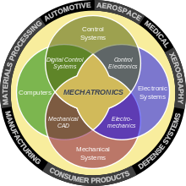
MECHATRONICS ENGINEERING EDUCATION IN NIGERIA
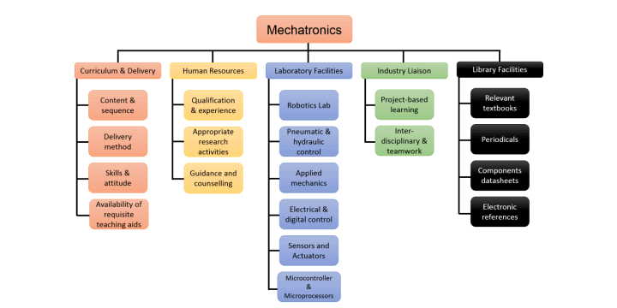
The body responsible for regulation of university education in Nigeria, the National University Commission (NUC) earmarked 14 pilot Nigerian institutions for introduction of mechatronics engineering degree programme in 2010. To date, the programme has been fully taken up in the majority of the institutions. Some of these institutions are Bayero University Kano (BUK), University of Lagos (UniLag), Abubakar Tafawa Balewa University (ATBU) Bauchi and University of Ibadan (UI) among others. However, other private universities, such as Afe Babalola University Ekiti and Bells University of Technology Ogun have also introduced mechatronics at the undergraduate level. More so, the principal organ of Federal Ministry of Education which is a specifically created to handle all aspects of technical and vocational education outside university education in Nigeria, the National Board for Technical Education (NBTE), some few years back drafted curricula for teaching mechatronics at national diploma (ND), technical and vocational education levels, which is in effect now. Another private and non-profit vocational school in Lagos, Nigeria, Institute for Industrial Technology (IIT) also offers six months mechatronics training for engineering graduates of universities and polytechnics.

UNIVERSITIES OFFERING MECHATRONICS ENGINEERING
- Afe Babalola University, Ado-Ekiti
- Bayero University, Kano
- Bells University of Technology, Ota
- Federal University of Technology, Minna
- Federal University of Oye -Ekiti, Ekiti state
- Federal university, Ndufu-Alike, Ebonyi state

SKILLS TO BE LEARNED AS A MECHATRONICS ENGINEER
- One should be thorough with his/her concepts in physics, right from kinematics to electricity and magnetism. Also, your concepts in semiconductor physics should be clear. Maybe you can skip gravitation.
- Mathematics is the language to describe physics, so yes you need to know mathematics as a powerful tool in your skill set. Mostly concentrate on all the transforms (Laplace, Fourier, Z), Differential Equations, Matrix Algebra.
- Knowing the fundamentals of programming is essential to any engineering student today, irrespective of their field of study. If you have any prior experience with programming (with C++ probably), try to get into Python. Or if you have zero knowledge in programming, start with C or C++.
- Also start using Matlab, it’s a very powerful and essential tool you can have at your dispense. You will realise it later how beneficial it is to know Matlab. You can also try your hands on Comsol Multiphysics.
- If you have interest into electronics aspects, you can also learn to write simple codes and do mini-projects using Arduino. Raspberry Pi or other boards are another option but I think Arduino is more simpler if you have zero experience with programming languages.
- Learn at least one CAD/CAM software, either Creo or Catia or Solidworks. They are too vast to know every functionality and it will take a long time to master these software. So start with drafting, then move to simple 3D models and try to create simple mechanism that you will study in Theory of Machines.
- Although it seems easier because of our familiarity, but learn MS Excel, Powerpoint and Word properly. Presentation is very important aspect when you wish to convey your idea to someone, or to give them an outline of certain thing. Word is again essential when you are going to write your dissertation or complete an assignment. Excel have vast functionality than creating simple graphs and doing arithmetic calculations. If you have a mindset that you are going to write technical or research papers then know IEEE format (that’s what most of the people follow) and learn LaTex.
- Also on the soft skills front, please work on professional etiquette (this is something I find gravely missing in current generation), presentation skills, team-work and optimistic attitude towards life.

A mechatronics engineer needs:

- an interest in mechanics and electronics
- creativity and imagination
- problem-solving skills
- the ability to work as part of a team
- practical and technical skills
- a detailed and methodical approach to their work.

THE IMPORTANCE OF MECHATRONICS:
• Mechatronics is important because it enhances functionality and features.
• It brings more efficiency. Mechatronics adds intelligence to design of the system, by which efficiency of the system improves.
• It reduces cost. Mechanical solutions are expensive when compared to mechatronics solutions, which lowers cost.
• A mechatronic solution improves design time, product size and reliability. It is also more user-friendly and safer to use.
• Mechatronic uses microcontroller, by which precision, position, speed, flow rate, and variables can be controlled.
• Using mechatronic solution increases reliability. Mechanical designs get damaged over time whereas mechatronic design is more reliable. An example is the odometer present in the cars.
• Studying mechatronic has a good career scope. The demand of nanotechnology, biomechatronics, and robotics in increasing day by day in developing countries. Also, the salary package offered to mechatronic engineers is very high.

REAL LIFE APPLICATIONS OF MECHATRONICS:
• Mechatronic is widely used in our day to day lives. Be it contact-free magnetic bearings, digitally controlled combustion engines, robots, automated guided vehicles or other machine tools, mechatronics is present everywhere.
• It is used in home appliances such as dish washer and washing machines.
• It is used in laser optical systems. It is part of the image and sound processing devices such as sound operators and automatic focusing device.
• Mechatronic is also used in intelligent measuring devices like calibration devices, measuring and testing of sensors.
• Mechatronic is used in the medical field as well. Many medical applications such as magnetic resonance, ultrasonic probes, arthroscopic devices use mechatronics.
• It is used in automation like automatic air conditioning systems, security system, automatic door systems. It is also used in pressure, heat and position control systems.
• It is widely used in aeronautics engineering for unmanned aerial vehicles and automatic pilots. In the defence industry it is used for automatically guided vehicles and mine detection robots.

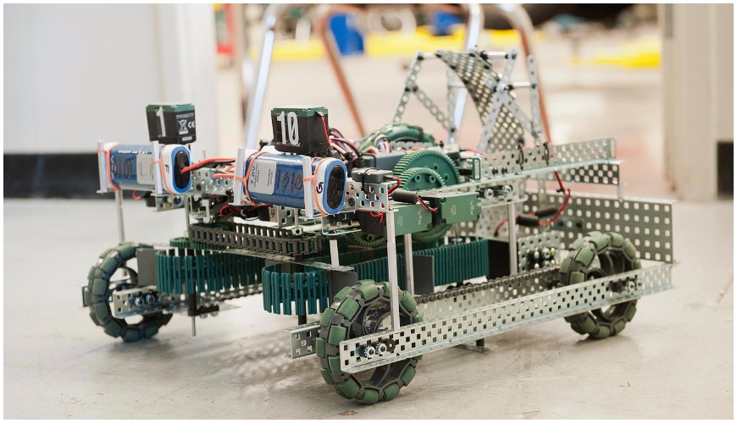

What mechatronics engineering do
Mechatronics engineers work in all aspects of the development of products, from design and testing right through to manufacture. There is almost no product in the world that is solely electronic, electrical or mechanical in nature. With the growing capabilities of electronics, modern mechanical systems are embedded with electronics and controls. This means that the lines between each discipline are becoming increasingly blurred, and there is a growing demand for mechatronics engineers whose knowledge is strong across all of these areas.
From consumer goods, such as microwaves, cars and smart phones, to industrial applications such as CNC machine tools, robots and MRI and X-Ray machines, mechatronics engineers use fundamental principles of electrical, mechanical, software, and control engineering in their design and development in order to generate a simpler, more economical and reliable way to do things.
Mechatronics engineers create machines that are made up of several parts: the mechanical system, the sensing and actuation, the control systems and the software. An industrial robot is an excellent example of a mechatronics system; it includes aspects of electronics, mechanics, and computing to do its day-to-day job.
Some tasks mechatronics engineers undertake:
- Develop solutions to industrial problems by using mechanical/electronic/computer technology
- Design and build new products - for example, developing robotic vehicles for underwater exploration
- Introduce automation to factory production lines to improve existing processes
- Improve previous industrial/manufacturing processes - for example, robotic floor cleaners
- Design and develop engineering systems for the automation of industrial tasks
- Apply mechatronic solutions to the transfer of material, components or finished goods
- Apply control systems which are typically computer-driven
- Apply electronic/mechanical processes and computers to dangerous tasks in underwater exploration, mining or forestry
- Study the feasibility of new mechatronic equipment
- Carry out modelling and analysis of mechanical, electronic or other systems using computers
JOB OPPORTUNITIES FOR MECHATRONICS ENGINEERS IN NIGERIA
- Oil and gas sector ( in designs, modelling and simulation, quality control, process control and automation, etc)
- Telecommunications.
- Production companies and Manufacturing companies such a Nestle, Friesland Foods Wamco Nigeria pLC, PZ Industries pLC, Unilever Nigeria pLC etc.
- Brewing, and drinks production companies such as Guinness (Nigeria)pLc, Coca-Cola plc etc.
- Automobile industry
- Military and Forces.
- Numerous other sectors where there are need for computing, designs, networking, analysis etc.
Challenges of Mechatronics Engineering in Nigeria
• Engineers being all in all: In most government and private establishments in Nigeria, engineering personnel are assuming to know all. A mechatronics engineer can be employed to do the work of a civil engineer, chemical engineer, Mechanical Engineer etc. at the same time. instead of seeking the services of engineering professionals in these other areas of engineering.
• Corruption: most engineering projects in the country is carried out using the fifty percent (50%) rule, thereby eating the capital and not the profit. That is, contractors giving even more than fifty percent of the total cost of a project to some corrupt government officials and politicians before actually embarking on a project and in most cases, since the remaining part of the money will not be enough to do the job, the project may not be carried out and if it is carried out at all, it is usually sub-standard or abandoned.
• Non-Engineers carrying out engineering contracts using engineering credentials: Most engineering contractors carry out engineering projects using engineering credentials of engineering professionals in order to win or get engineering contracts.
• Politics: the nature of the training of the engineers does not actually expose him/her to be actively involved in politics, though they may be passively involved. For instance, a power engineer in a power station cannot be actively involved in politics. Since power stations are usually sited in secluded areas.
• Existing engineering facilities and infrastructures not being upgraded: most engineering establishment ever since they were commissioned have not been upgraded, thereby not able to meet up with the present-day demand.
• Non-adherence to workshop sections in conferences: most engineering conferences do not adhere to workshop sections, usually after technical paper presentation, then, it is all over.
• Attitude towards maintenance: our industries and infrastructures are built “once and for all” without any routine maintenance work, the result is the general decay of industries and infrastructures in the country.
• Reverse engineering not in our engineering curriculum; hence, making technology transfer somehow difficult.
• Engineers not fellowshipping with their colleagues; most engineering personnel occupying managerial positions are not registered with the Nigerian society of Engineers (NSE) and the council for the regulation of engineering in Nigeria. (COREN). Hence, such person’s may seem not concern with the advancement of engineering and technology in the country.
• Research and Development: Government lackadaisical attitude towards research and development hinders research opportunities in research institutions and universities. Government considers research and development to cost a lot of money and there is no link between research institutes, universities and industries in the country.
The Task Ahead for A Sustainable Development
• Different engineering personnel in various fields should be employed in all engineering .Departments in both government and private establishments, so that specific jobs can be given to an engineer in his/her chosen area of specialization. That is, there should be division of labor.
• The pay package of mechatronics engineers in Nigeria should be commensurate with their counterparts in Europe and America, so that they will not be tempted to eat the capital of any project.
• Engineers should be discipline and avoid non-engineers using them to achieve their selfish aim. They should only tender their certificate when they are involved in a project. And establishments should be mandated by the Nigerian society of engineers, to employ at least one registered engineer.
• Just as the office of the Attorney General is occupied by a lawyer, the offices of the ministers and commissioners of Energy, Works and Housing, Environment and Transport should be specially for engineers.
Prospects of Mechatronics Engineering
Jobs in mechatronics are expected to grow rapidly in the next 10 years. Most of the employers in the industry are looking for individuals with skills in electronics, mechanical, and mechatronics engineering technology, and computer systems.
Mechatronics Careers in Agriculture, Food and Forestry:
New career opportunities are opening up in the rapidly advancing fields of agriculture, food and forestry for professionals with a degree in mechatronics engineering. After graduating from the mechatronics engineering technology program, you could go on to design
greenhouses that increase food production, program controllers to manage irrigation systems, or even use engineering principles to ensure the health and sustainability of forests.

Mechatronics Careers in Telecommunications and Information Services:
Mechatronics engineering technology jobs in telecommunication and information services include roles such as high-voltage engineer, field or cable technician, networking technician, and more. Job responsibilities can include installing, maintaining and repairing mobile phones, computer networks, videoconferencing equipment, fiber -optic cables, electrical systems and more.

Conclusion
Establishment of mechatronics education in Nigeria will help a long way in seeing Nigeria realizing this vision and its precursors as done by the BRIC nations. Furthermore, mechatronics education will also to bridge the industry‟s demands for specialized multidisciplinary engineering practitioners. Academia, institutions in most countries, are under pressure to devise ways to increase efficiency. Establishing a mechatronics course in our academic institutions will also help to increase efficiency for better utilisation of human and laboratory resources as most of the available resources are usually located around in different departments that are, usually, separated by psychological barriers. The introduction of Mechatronics course would offer an ideal opportunity for interdepartmental collaborations, which enhances more efficient use of the available human and laboratory resources within departments. If properly delivered, being a project-based course, the introduction of mechatronics education will provide an avenue for resuscitation of the link between academia and industry.
The challenges that maybe encountered in establishing mechatronics education in Nigeria include lack of the appropriate expertise and understanding of mechatronics. Also, some aspects of Mechatronics method of delivery, such as project-based learning, can be perceived sceptically by some traditionalists. Coordination of a mechatronics course can be a trying task. While the essence of mechatronics education is to teach students about team-work to achieve common targets. It at times difficult expect the same attitude from academics. However, despite these challenges, the benefits to be derived if mechatronics is introduced as course in our education system are immeasurable.

References
www.calu.edu/academics
www.researchgate.edu
www.quora.com
semanticscholar.org

