NAME: ADEBAYO ABDULHAFIZ ABIODUN
MATRIC NUMBER: 18/ENG03/004
DEPARTMENT: CIVIL ENGINEERING

DESIGN THE APPLICATION FOLLOWING THE SOFTWARE DEVELOPMENT CYCLE
CRITICALLY DISCUSS THE HARDWARE AND SOFTWARE FEATURES
SUPPORT YOUR ANSWER WITH A FLOWCHART AND ALGORITHM
DRAW THE TOP-DOWN OR BOTTOM -UP DESIGN APPROACH
THE SOFTWARE:
Web-based sensor streaming wearable for respiratory monitoring applications.
FIRST STAGE.
PLANNING PHASE:
This stage involves in creating a set of plans, as a result of the epidemic, COVID-19 which has been claiming the lives of people, so I have set up a web application to help diagnose the disease and help people that may have symptoms, since the disease attacks respiratory organs we set up a system for remote monitoring of respiration of individuals that can detect respiration rate, mode of breathing and identify coughing events. It comprises a series of polymer fabric-sensors incorporated into a sports vest, a wearable data acquisition platform and a novel rich internet application (RIA) which together enable remote real-time monitoring of untethered wearable systems for respiratory rehabilitation. This system will allow therapists to monitor and guide the respiratory efforts of patients in real-time through a web browser.
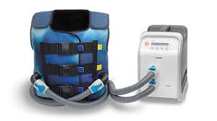
DESIGNING STAGE
A prototype vest with piezoresistive sensors (Fig. 1) has
been developed to detect body movements related to
breathing. The vest is capable of measuring the frequency of
respiration and can also distinguish between deep and
shallow breathing through the use of multiple sensors.
A prototype vest with piezoresistive sensors (Fig. 1) has
been developed to detect body movements related to
breathing. The vest is capable of measuring the frequency of
respiration and can also distinguish between deep and
shallow breathing through the use of multiple sensors.
A prototype vest with piezoresistive sensors (Fig. 1) has
been developed to detect body movements related to
breathing. The vest is capable of measuring the frequency of
respiration and can also distinguish between deep and
shallow breathing through the use of multiple sensors
A prototype vest with piezoresistive sensors has
been developed to detect body movements related to
breathing. The vest is capable of measuring the frequency of
respiration and can also distinguish between deep and
shallow breathing through the use of multiple sensors.
Using a pre-installed bridging application and a web
browser the data can be visualized (Fig. 2) and streamed to a
central web-based signal streaming server
for real-time
distribution to authorized users. Users subscribing to the
respiratory signals need only a web browser and the
appropriate URL to see live data streams from patients, shows an architectural overview of the system.
IMPLEMENTATION STAGE
the system we connected the respiratory shirt to a
cloud hosted server solution. Using the Shimmer platform
(Fig. 3), we are able to transmit and reconstruct acquired
signals sensors at 40 samples per second across a
representative network environment (Bluetooth, WIFI, DSL
(0.5Mb/s upload, commercial ISP backbone) with acceptable
responsiveness and sub second latency
the system we connected the respiratory shirt to a
cloud hosted server solution. Using the Shimmer platform
(Fig. 3), we are able to transmit and reconstruct acquired
signals sensors at 40 samples per second across a
representative network environment (Bluetooth, Wi-Fi___33, DSL
(0.5Mb/s upload, commercial ISP backbone) with acceptable
responsiveness and sub second latency
the system we connected the respiratory shirt to a cloud hosted server solution. Using the Shimmer platform we are able to transmit and reconstruct acquired signals sensors at 40 samples per second across a representative network environment (Bluetooth, Wi-Fi___33, DSL (0.5Mb/s upload, commercial ISP backbone) with acceptable responsiveness and sub second latency, The web browser application shown in displays the breathing signals acquired by the vest in real-time. This information can be accessed by a medical professional as the patient performs their breathing exercises. This has applications for various respiratory illnesses and allows the clinicians to observe their patients physical state remotely.
TESTING STAGE
A prototype vest with piezoresistive sensors has been developed to detect body movements related to breathing. The vest is capable of measuring the frequency of respiration and can also distinguish between deep and shallow breathing through the use of multiple sensors. Another advantage of using multiple sensors is in the detection of anomalies. The vest incorporates six sensors aligned along the front panel. The sensor locations are chosen to maximize the relevant information that each sensor can give from various positions along the torso. In this way it is possible to monitor the about movement of the thoracic abdominal cavity and identify which muscle groups are active.
DEPLOYING STAGE
This project would be deployed as soon as possible in its prototype phase due to the high demand; we would send it to those we are showing symptoms or leaving in an area where the cases are dominant, we shall also target areas where civilization hasn’t reached in case there Is any outbreak there.
MAINTAINING STAGE
the maintenance of the system would be done in two ways, for the software, there would be an occasional software update, to ensure that the system can be up to in ways of serving people better and for the hardware (vest), it would be taken of by the users or consumers.

A prototype vest with piezoresistive sensors (Fig. 1) has
been developed to detect body movements related to
breathing. The vest is capable of measuring the frequency of
respiration and can also distinguish between deep and
shallow breathing through the use of multiple sensors.
Another advantage of using multiple sensors is in the
detection of anomalies

FEATURES.
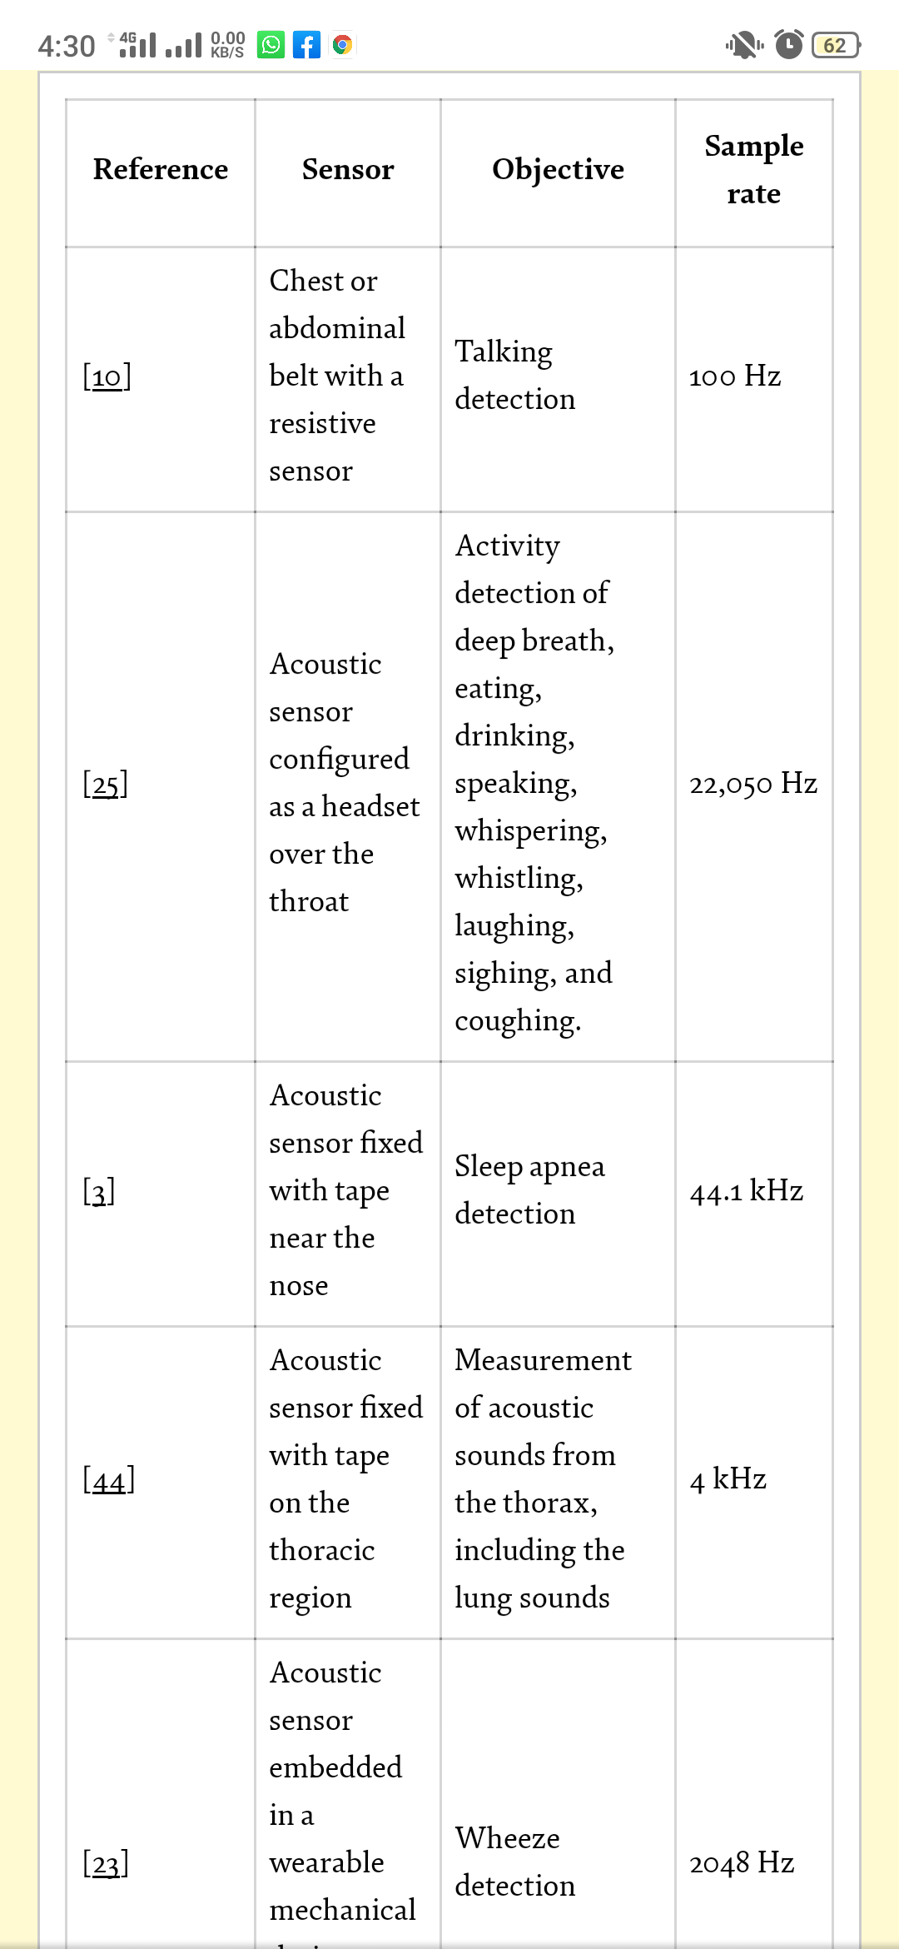
ALGORITHM
- Start
- Let RATE, TIME = 0
- RATE = A+B/TIME
- TIME = 60 seconds
- A = = “first reading per minute” (in chest beats per second)
- B = = “second reading per minute” (in chest beats per second)
- If RATE > -3dB
- Send signal to web site services
- Else
- Do not send to web site services.
- End

FLOWCHART
START
SEND TO WEB SITE
SERVICES
DO NOT SEND TO WEB
SITE SETTINGS
END.
READ,
RATE, TIME = 0
IF RATE > -3dB

A == “FIRST READING OF RESPIRSATORY SYSTEM”
B ==” SECOND READING OF RESPIRATORY SYSTEM”
(IN CHEST BEATS)

READ = A+B/TIME
TIME = 60 seconds

TOP-DOWN DESIGN

