ODIA ANITA PRISCILLIA
16/SCI01/029
CSC 408(PROJECT MANAGEMENT)

QUESTION 1
The processes that are involved that will be needed to support the first two stages of the IT project are;
- Project Initiation phase marks the beginning of a project and is the first phase in the project management life cycle. In this phase, high-level decisions are made regarding why a project is needed, whether or not it can be done, and what is needed. It is most often associated with traditional, linear project management methodologies, but the high-level decisions are relevant for projects being managed using any methodology. These are some of the processes in this stage.
- Business Case/ Purspose: The first is establishing the purpose of the project. This is often referred to as a business case and answers the question, why is the project needed. Reasons may include, meeting a customer need, taking advantage of a market opportunity, and reducing risk or cost. Identifying the purpose is a crucial step because if it cannot be done or the reason is not important, the project should not be taken on. This step prevents wasting money, time, and effort. Here is where you justify the need of the project, which includes analyzing return on investment.

- Feasibility Study: You need to evaluate what the project’s goals are, the timeline to completion and how much the whole endeavor will cost. You also note what resources will be required to fulfill the project, and if it makes financial and business sense. Things to be considered in this study are;
- Resources
- Risk involved
- Uncertainties
- Assumptions
- Staffing, and others
- Determine what is needed; to determine if a project is feasible or not. This is also to determine what is needed for the project, which determines what result will be such as data, prototype, proof of concept, or a working product. Mostly used during project charyer which among other things determines the vision of the projects, set objectives and scope, and details the deliverables.

- Project planning; is at the heart of the project life cycle, and tells everyone involved where you’re going and how you’re going to get there. The planning phase is when the project plans are documented, the project deliverables and requirements are defined, and the project schedule is created. It involves creating a set of plans to help guide your team through the implementation and closure phases of the project. The plans created during this phase will help you manage time, cost, quality, changes, risk, and related issues. They will also help you control staff and external suppliers to ensure that you deliver the project on time, within budget, and within schedule. This is where some of the question will be asked like the who, what, when, how, where of the project . Some of these processes are;
- Scope planning – specifying the in-scope requirements for the project to facilitate creating the work breakdown structure
- Preparation of the work breakdown structure – spelling out the breakdown of the project into tasks and sub-tasks
- Project schedule development – listing the entire schedule of the activities and detailing their sequence of implementation
- Resource planning – indicating who will do what work, at which time, and if any special skills are needed to accomplish the project tasks
- Budget planning – specifying the budgeted cost to be incurred at the completion of the project
- Procurement planning – focusing on vendors outside your company and subcontracting
- Risk management – planning for possible risks and considering optional contingency plans and mitigation strategies
- Quality planning – assessing quality criteria to be used for the project
- Communication planning – designing the communication strategy with all project stakeholders

IT Project Management Methodology
Agile Project Management (Scrum Method)- In rugby, a scrum is a tangle of heavy people who strain against each other to acquire a small, oblong, whitish ball. As business managers find such behaviour undesirable in production teams, they employ the Scrum method of project management. Scrum teams meet for monthly Scrum sessions in which they break down their projects and deliverables into 15- or 30-day chunks, called “sprints.” By working toward these small increments, teams avoid the process overwhelm typical of other PM methodologies. By re-prioritizing their efforts each month to meet consumer demand, they can stay flexible and motivated – increasing both productivity and customer satisfaction! Development teams often apply the popular Scrum variation of Agile Project Management. Managers find Scrum easy to implement and very effective in addressing issues affecting software development teams.

QUESTION 2

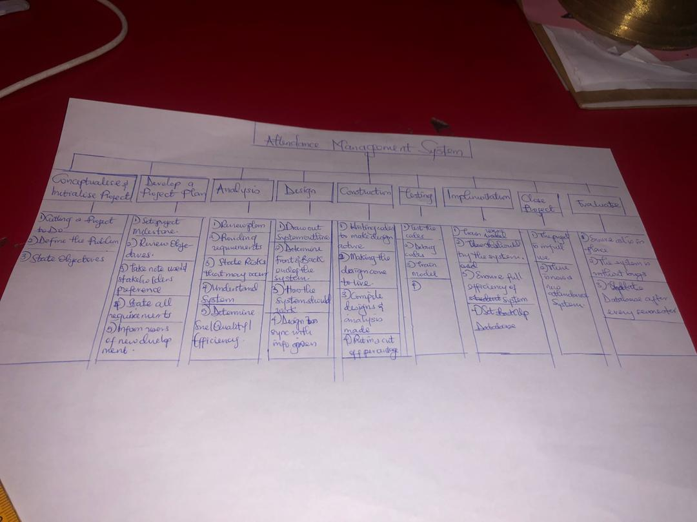

CUSTOMER RELATIONSHIP MANAGEMENT (CRM)
Customer relationship management (CRM) is a technology for managing all your company's relationships and interactions with customers and potential customers. The goal is simple: Improve business relationships. Seeing that the system will be used in a bank the appropriate system for this the Operational CRM which focuses on streamlining customers sales, service, marketing and workflows.
Firstly, This system will have a touchpoint tracking to track communication between the customer and bank representative, to improve overall customer service. Then Email marketing
The integration with the email system allows tracking communication with every customer. It’s very helpful to allow managers send emails every day.
The system will also have a File sharing feature, this piece of functionality keeps all the documentation in one place. It also lets you share them between departments. You can set access levels to prevent employees from seeing files they aren't supposed to see.
A mobile version of the system will be the best to enable bank representatives to move about with good communication with the customers.
The system will contains a pipeline view that will allow you track information on all the sales processes.
The CRM will allow invoicing to be able to keep up with sales project history.
Then lastly the CRM should give reports. All these features will cost less and give the bank an advantage in the business field.

QUESTION 3
Why is the study of project management important for computing and IT development students?
Defines a plan and organises chaos – projects are naturally chaotic. The primary business function of project management is organizing and planning projects to tame this chaos. A clear path mapped out from start to finish ensures the outcome meets the goals of your project.
3. Enforces and encourages teamwork – A project brings people together to share ideas and provide inspiration. Collaboration is the cornerstone to effective project planning and management.
4. Maximises resources – Resources, whether financial or human, are expensive. By enforcing project management disciplines such as project tracking and risk management, all resources are used efficiently and economically.
5. Manages Integration – Projects don’t happen in a vacuum. They need to be integrated with business processes, systems and organizations.
You can’t build a sales system that doesn’t integrate with your sales process and sales organization. It wouldn’t add much value. Integration is often key to project value.
Project management identifies and manages integration.
6. Controls cost – some projects can cost a significant amount of money so on budget performance is essential. Using project management strategies greatly reduces the risk of budget overruns.
7. Manages change and quality – projects always happen in an environment in which nothing is constant except change. Managing change is a complex and daunting task. It is not optional. Project management manages change. Quality is the value of what you produce. Project management identifies, manages and controls quality. This results in a high quality product or service and a happy client.
9. Retain and use knowledge – projects generate knowledge or at least they should. Knowledge represents a significant asset for most businesses. Left unmanaged knowledge tends to quickly fade. Project management ensures that knowledge is captured and managed.
10. Learning from failure – projects do fail. When they do, it is important to learn from the process. Project management ensures that lessons are learned from project success and failure.

Without project management, teams and clients are exposed to chaotic management, unclear objectives, a lack of resources, unrealistic planning, high risk, poor quality deliverables, project going over budget and being delivered late. So, it’s important for IT students to learn it so they can avoid these things and be able to manage a project on their own to a certain extent.

