ASSIGNMENT SUBMISSION

PREPARED BY
OZOEMENA AUGUSTINE
18/ENG01/027

A TERM PAPER SUMMITED TO
DEPARTMENT OF CHEMICAL AND PETROLEUM ENGINEERING

IN PARTIAL FULFILLMENT OF
CHE 312 PROCESS INSTRUMENTATION

DATE
9TH APRIL, 2020
.

ANSWERS

- A What is instrumentation?

Instrumentation is defined as the art and science of measurement and control of process variables within a production or manufacturing area. The process variables used in industries are Level, Pressure, Temperature, Humidity, Flow, pH, Force, Speed etc. it is defined as the process of obtaining current conditions within the process and make it available in a form useable by either the control system, process operator or any other entity

B Explain succinctly the mobile and stationary phases in gas chromatography

Gas chromatography is a common type of chromatography used in analytical chemistry for separating and analyzing compounds that can be vaporized without decomposition. Typical uses of gas chromatography include testing the purity of a particular substance, or separating the different components of a mixture. Gas chromatography have a stationary phase (a solid, or a liquid supported on a solid) and a mobile phase (a liquid or a gas). The mobile phase flows through the stationary phase and carries the components of the mixture with it. There are two types of gas chromatography gas-liquid and gas solid, in gas-liquid the mobile phase is a carrier gas, usually an inert gas such as helium or an unreactive gas such as nitrogen. ... The stationary phase is a microscopic layer of high boiling point liquid absorbed into an inner solid, while in gas-solid the stationary phase is a solid maybe silica gel, charcoal and the solid serve as an adsorbent surface and the mobile phase is an inert gas
The carrier gas is always inert to prevent any reactions between the carrier gas and the sample to be analyzed

C Highlight four reasons why moisture measurement are germane in process industries and list four methods of moisture measurement

Moisture measurements are important because;
- Moisture can affect products
- Moisture can poison reactions
- Moisture can damage equipment
- Moisture can cause explosions

Methods of moisture measurements are;
- Absolute measurement method
- Relative humidity method
- Capacitance method
- Oxide sensor

QUESTION 2

A State four cogent reasons for measuring and controlling process variable

Four cogent reasons for controlling process variable are;
- controlling certain set of process variable (i.e. temperature, flow, level, pressure etc) that leads to control whole process.
- The outcome of any process (say production of a beverage) depends on how closely we monitor the process parameters e.g. temperature, pressure, flow rate etc. In fact, if the process control is excellent, it may not be necessary to test the product.
- In order to ensure that the product obtained is of standard requirements
- In order to prevent wastage of materials and higher cost by production of the wrong product

B Magnetic flow meter are highly important in process industries. Mention three applications
Magnetic flowmeters use Faraday’s Law of Electromagnetic Induction to determine the flow of liquid in a pipe. In a magnetic flowmeter, a magnetic field is generated and channeled into the liquid flowing through the pipe. Following Faraday’s Law, flow of a conductive liquid through the magnetic field will cause a voltage signal to be sensed by electrodes located on the flow tube walls. When the fluid moves faster, more voltage is generated. Faraday’s Law states that the voltage generated is proportional to the movement of the flowing liquid. The electronic transmitter processes the voltage signal to determine liquid flow.
APPLICATION INCLUDE;
- Magnetic flowmeters are used in water treatment plants to measure treated and untreated sewage, process water, water and chemicals.
- With proper attention to materials of construction, the flow of highly corrosive liquids (such as acid and caustic) and abrasive slurries can be measured. Corrosive liquid applications are commonly found in the chemical industry processes, and in chemical feed systems used in most industries. Slurry applications are commonly found in the mining, mineral processing, pulp and paper, and wastewater industries.
- Magnetic flowmeter are used for flow measurements

B With the aid of a diagram briefly explain the working principle of any three pressure measuring device

- PIEZOMETER
The piezometer is used to measure the static pressure head of a liquid flowing at any section of a pipe. It consists of a tube whose open lower end is mounted flush with the inside wall of the pipe. The other end of the tube is exposed to the atmosphere. In the arrangement shown in Fig. 2.21 and 2.22 the height h to which the liquid rises in the tube represents the pressure head at the level A where the tube is connected to the pipe.
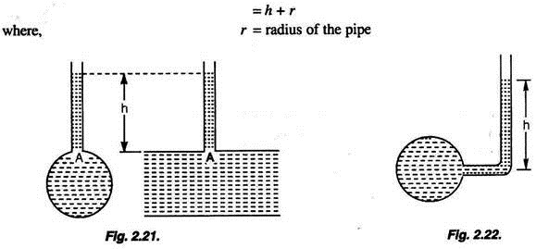
The piezometer may also be so shaped and connected to the pipe so that the pressure head at the level of the centre of the pipe may be directly obtained.

- BOURDON GAUGE
This device consists of a metallic tube of elliptical section closed at one end A, the other end B being fitted to the gauge point where the pressure is to be measured. As the fluid enters the tube, the tube tends to straighten.
By using a pinion-sector arrangement the small elastic deformation of the tube is communicated to a pointer in an amplified manner. The pointer moves over a graduated dial. The device is calibrated by subjecting it to various known pressures.
The Bourdon gauge is suitable for measuring not only high pressures such as those in a steam boiler or a water main but also negative or vacuum pressures. A gauge which is so devised to measure positive as well as negative pressures is called a compound gauge.
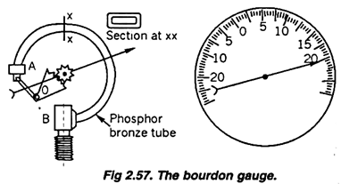

- DIAPHRAGM PRESSURE GAUGE
This device is based on the same principle as that of the Bourdon gauge. In this case a corrugated diaphragm is provided instead of the Bourdon tube. When the device is fitted to any gauge point, the diaphragm will undergo an elastic deformation. This deformation is communicated to a pointer which moves on a graduated scale indicating the pressure. It may be noted that this device works on the same principle as that of the aneroid barometer. This device is found suitable for measuring relatively low pressures.
