DEVELOPMENT OF ENVIRONMENTAL HEALTH ENGINEERING FACILITIES, EQUIPMENT, SENSORS AND PUBLIC HEALTH SYSTEMS FOR TACKLING COVID-19 PANDEMIC.

BY
NAME: AMAINO SAMUEL OTONBARA
MATRIC NO: 18/ENG08/026
DEPARTMENT: DEPARTMENT OF AERONAUTIC, BIOMEDICAL AND AEROSPACE ENGINEERING
PROGRAM: BIOMEDICAL ENGINEERING

DEDICATION
I dedicate this report first and foremost to Almighty God for insight and taking control of everything, also my parents for their love and support, to the staffs of Afebabalola university for expanding my horizon.

ABSTRACT
This report talks about the development of Environmental health engineering facilities, Equipment’s, Sensors and public health systems for tackling the COVID-19 Pandemic. This report explains in a detailed format the sensors, equipment and various facilities which are present in this fight of a present world-wide threat, with a dynamic overview that enlightens and also suggest other measures that could be put in place against the virus.

TABLE OF CONTENTS
TITLE PAGE
COVER PAGE………………………………………………………………………… I
DEDICATION......................................................................................................................II
ABSTRACT ........................................................................................................................III
CHAPTER 1
INTRODUCTION
1.1ENVIRONMENTAL ENGINEERING MEANING 2

CHAPTER 2
2.1 TACKLING THE COVID-19............................................

CHAPTER 3
3.1
VARIOUS HEALTH ISSUES AND IMPLICATIONS OF THE VIRUS..................................................................................................
3.2
IMPACT OF COVID-19 ON THE PLANET AT LARGE.............................................................................................................

CHAPTER 4

4.1 METHODOLOGY ............................................

CHAPTER 5
CONCLUSION............................................
RECOMMENDATION............................................

REFERENCES..............................................................................

CHAPTER 1
INTRODUCTION

1.1 ENVIRONMENTAL HEALTH
Humans interact with the environment constantly. These interactions affect quality of life, years of healthy life lived, and health disparities. The World Health Organization (WHO) defines environment, as it relates to health, as “all the physical, chemical, and biological factors external to a person, and all the related behaviors.”1 Environmental health consists of preventing or controlling disease, injury, and disability related to the interactions between people and their environment.
The Healthy People 2020 Environmental Health objectives focus on 6 themes, each of which highlights an element of environmental health:

- Outdoor air quality
- Surface and ground water quality
- Toxic substances and hazardous wastes
- Homes and communities
- Infrastructure and surveillance
- Global environmental health

Creating healthy environments can be complex and relies on continuing research to better understand the effects of exposure to environmental hazards on people’s health.
In response to cases of COVID-19 rising worldwide, the World Health Organization has recently warned that the pandemic is "accelerating." Thankfully, it does say the trajectory can still be changed.
That's why the global scientific community is pulling together in order to develop viable treatments and vaccines to combat the spread of the infectious disease.
Much in the same vein, the world is in desperate need of ingenious solutions to widespread issues such as supply shortages of medical equipment

CHAPTER TWO

LITERATURE REVIEW

  - BACKGROUNG INFORMATION
On 31 December 2019, the Wuhan Municipal Health Commission in Wuhan City, Hubei province, China, reported a cluster of 27 pneumonia cases (including seven severe cases) of unknown aetiology, with a common reported link to Wuhan's Huanan Seafood Wholesale Market, a wholesale fish and live animal market
The market was closed down on 1 January 2020. According to the Wuhan Municipal Health Commission, samples from the market tested positive for novel coronavirus. Cases showed symptoms such as fever, dry cough, dyspnea; radiological findings showed bilateral lung infiltrates.
On 9 January 2020, the China CDC reported that a novel coronavirus (later named SARS-CoV-2, the virus causing COVID-19) had been detected as the causative agent for 15 of the 59 cases of pneumonia. On 10 January 2020, the first novel coronavirus genome sequence was made publicly available. The sequence was deposited in the GenBank database (accession number MN908947) and uploaded to the Global Initiative on Sharing All Influenza Data (GISAID). A preliminary analysis showed that the novel coronavirus (SARS-CoV-2) clusters with the SARS-related CoV clade and differs from the core genome of known bat CoVs.
By 20 January 2020, there were reports of confirmed cases from three countries outside China: Thailand, Japan and South Korea. These cases had all been exported from China.
On 23 January 2020, Wuhan City was locked down – with all travel in and out of Wuhan prohibited – and movement inside the city was restricted
China changed the case definition several times during the course of the outbreak, which caused uncertainty regarding the exact number of cases and the extent of the spread of the virus, and several EU/EEA countries have modified their testing strategies during the course of the outbreak to test only symptomatic or severe cases.
The first European case was reported from France on 24 January 2020. This case had a travel history to China. In Germany, cases were reported on 28 January, related to a person visiting from China.
On 30 January 2020, the World Health Organization (WHO) declared this first outbreak of novel coronavirus a ‘public health emergency of international concern’ [9]. During the following weeks, several countries implemented entry screening measures for arriving passengers from China. Soon, several major airlines suspended their flights from and to China. Several countries repatriated citizens living in Wuhan.
A large number of cases have been diagnosed on board the Diamond Princess, a cruise ship docked in the port of Yokohama, Japan. The first cases were reported on 4 February 2020; the ship was put in quarantine. In total, 696 cases were identified among the ship’s passengers. Of these cases, seven died.
On 22 February, the Italian authorities reported clusters of cases in Lombardy and additional cases from two other regions, Piedmont and Veneto. Over the following days, cases were reported from several other regions. Transmission appears to have occurred locally, in contrast to first-generation transmission from people returning from affected areas. Transmission events were also reported from hospitals, with COVID-19 cases identified among healthcare workers and patients. During the following week, several European countries reported cases of COVID-19 in travelers from the affected areas in Italy, as well as cases without epidemiological links to Italy, China or other countries with ongoing transmission
On 8 March 2020, Italy issued a decree to install strict public health measures including social distancing starting first in the most affected regions and on 11 March 2020, extending these measures at national level. Following Italy, Spain, France and many other European countries installed similar public health measures.
On 11 March 2020, the Director General of the World Health Organization declared COVID-19 a global pandemic. For the most recent information on the current situation regarding COVID-19,
Since ECDC’s sixth update on coronavirus disease published on 12 March 2020 and as of 25 March 2020, the number of cases and deaths reported in the EU/EEA has increased almost tenfold. During this time, Italy has reported more than 50 000 new cases, followed by Spain, Germany and France also reporting large numbers of new cases. All EU/EEA countries are reporting an exponential growth in the incidence of reported COVID-19 cases that is markedly similar to the reports for Hubei Province by China between January and early February and has been reported by Italy since 23 February. If this trend continues, it is likely that in days or a small number of weeks, prevalence similar to Hubei province and Italy will be observed in most EU/EEA countries.
Figure 1. 1: COVID-19 Cells
The new coronavirus, which has been provisionally named 2019-nCoV, appears to be a young virus that may have emerged sometime in early December, according to attempts to trace its origins. Based on analysis of its genetic code, 2019-nCOV was initially thought to have jumped to humans from bats. The human virus has been found to share many genetic similarities to two coronaviruses in bats, but others have suggested it may have come from snakes, although this idea has been widely dismissed by virologists.
Most recently, endangered pangolins, whose scales are heavily used in Chinese traditional medicine, are being proposed as a likely conduit for the virus. Some researchers have proposed that a bat coronavirus may have combined with another coronavirus in pangolins to produce the strain now infecting humans.

2.2 COMBATING COVID-19
- Italy's reverse-engineered 3D-printed ventilators
After the outbreak soared to uncontrollable levels in Italy this month, Dr Daniele Macchini famously wrote that a scarcity in the medical equipment required to treat patients means that "every ventilator becomes like gold."
That's why a group of volunteers in Italy, including Massimo Temporelli, founder of The FabLab in Milan, decided to help out by making 3D-printed versions of the sorely-needed item. Despite the possibility of being sued by the medical technology company that manufactures a specific ventilator, the volunteers reverse-engineered the piece that was required and were able to print it in a matter of hours to help save lives.

figure 2. 1: 3D-printed Ventilators
- Coronavirus isolation pods made by Mexican engineer
Special fully-sealed isolation pods were recently created by Mexican engineer Fernando Aviles for safely transporting COVID-19 patients. The specially-designed pods are equipped with air pumps that create a negative pressure within the sealed space. The negative pressure means that, even if the plastic lining of the pod is torn during the transfer of a patient, any fluids will remain inside the isolation pod — an ingenious method for stopping the spread of the infectious disease amongst healthcare workers.
figure 2. 2: Isolation Pods
- UV light-emitting disinfection robots
UV light disinfectant robots weren't specifically developed for the COVID-19 pandemic and they haven't been definitively proven to be effective at eradicating the virus (SARS COV-2) from surfaces — and yet, demand has skyrocketed to the point that companies are sending truckloads of the machines to different countries worldwide.

figure 2. 3: Disinfection robots
- Artificial intelligence used to analyze self-isolation habits
Some countries have taken longer than others to announce police-enforced lockdowns. In the United Kingdom, for example, the decision was only enforced yesterday. According to research by Vivacity Labs, a startup that makes camera-based traffic sensors, the enforcement was severely needed Until yesterday, Brits had only been advised to self-isolate. Using its artificial intelligence (AI) traffic sensors Vivacity Labs researchers deducted that the UK government's advice had only resulted in a 30% reduction in pedestrian activity from the week starting on February 3.
The drop in traffic was even smaller with car and motorcycle traffic down only 15% and cyclists down by only 13%. The research is based on anonymous data from over 200 sensors installed across 10 UK cities.

figure 2. 4: Use of AI-integrated Cameras
- U.S. army corps engineers convert buildings to provide 10,000 new beds
Confirmed cases of the coronavirus have surged in New York in the last week. With over 25,000 cases and 210 deaths at the time of writing, it has become the epicenter of coronavirus cases in the U.S. That's why the United States Army Corps of Engineers has stepped in to convert buildings into hospitals in order to create new ICU space for the growing number of patients. The plan is expected to provide 10,000 hospital beds in the state of New York.
Health officials worldwide are monitoring a respiratory illness outbreak caused by a new coronavirus, named “COVID-19,” that originated in Wuhan City, Hubei Province, China. UNC-Chapel Hill continues to monitor updates on the spread of 2019 novel coronavirus from the Centers for Disease Control, and we are using their guidance and recommendations here on our own campus. The CDC believes that symptoms of COVID-19 may appear in as few as two days or as long as 14 days after exposure. The illness can be more serious for individuals with a weakened immune system, the elderly, or those with underlying respiratory problems.
If necessity is the mother of invention, then it is only natural that technology thrives in trying times. When we think of halting the spread of the Coronavirus, many people may envision the brave nurses, doctors, and scientists on the frontlines. However, in recent times, it is the technology that is doing the heavy lifting. Pandemics like the Coronavirus, SARS, and others are pushing infrastructure to its limits and innovation to new heights.

CHAPTER THREE

METHODOLOGY

3.1 CASE STUDY: IMPACT ON THE CORONAVIRUS ON LIFE ON PLANET EARTH.

Fig 2.5 : streets of brussels
Residents of Brussels have been told to stay at home, leaving the city’s streets empty.Credit: Jonathan Raa/NurPhoto via Getty
The coronavirus pandemic has brought chaos to lives and economies around the world. But efforts to curb the spread of the virus might mean that the planet itself is moving a little less. Researchers who study Earth’s movement are reporting a drop in seismic noise — the hum of vibrations in the planet’s crust — that could be the result of transport networks and other human activities being shut down. They say this could allow detectors to spot smaller earthquakes and boost efforts to monitor volcanic activity and other seismic events.
A noise reduction of this magnitude is usually only experienced briefly around Christmas, says Thomas Lecocq, a seismologist the Royal Observatory of Belgium in Brussels, where the drop has been observed.
Just as natural events such as earthquakes cause Earth’s crust to move, so do vibrations caused by moving vehicles and industrial machinery. And although the effects from individual sources might be small, together they produce background noise, which reduces seismologists’ ability to detect other signals occurring at the same frequency.
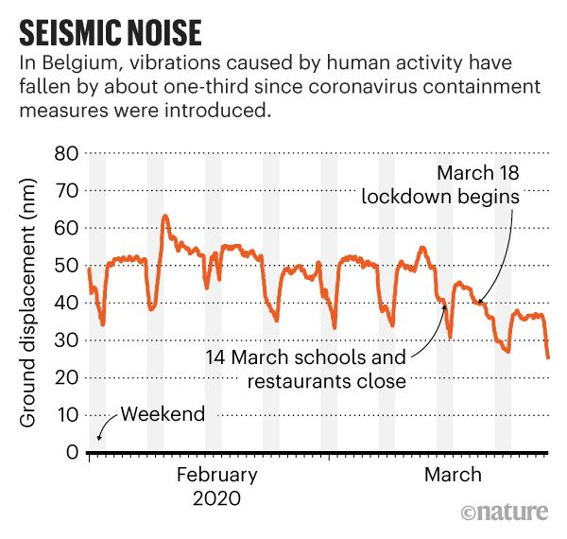
Fig 2.6 : seismic noise of Brussels since the covid -19 pandemic
To understand the technology forces at play, one must recognize that the foundations of developing nations are crumbling in the face of COVID 19. Eighty-five nations have closed all learning institutions, impacting over 776.7 million children and youth. The NBA, La Liga, NHL and other major sporting organizations have all cancelled the remainder of their seasons. Italy and El Salvadore have quarantined their entire countries and more nations are following suit. The UN paints a doomsday scenario of the global economy losing $2 trillion if governments don’t act quick. In this new world where the human touch is a thing of the past, billions of people are depending on technology to hold us all together.

figure 3. 1: Olympic games cancellation

The CONCACAF (Confederation of North, Central American and Caribbean Association Football) Nations League Finals, which were scheduled for June 4–7, have been suspended.The finals, due to be contested by Costa Rica, Honduras, Mexico and the United States and held in the Houston and Dallas areas of Texas, will be rescheduled for a later date in venues to be determined.
Football in Russia has been suspended until April 10. The Russian league was the best-attended sports competition still operating in Europe last weekend, with more than 33,000 fans at one of its games, but the Russian Football Union agreed to immediately suspend all competitions at a meeting on March 17.
In Germany, the top flight Bundesliga has been on hold since March 13, with the German Football League recommending clubs not to return to training until April 5. Bayern Munich football team announced their players will return to training "in small groups from Monday, 6 April" with no members of the public present.
The African Nations Championship 2020 soccer tournament scheduled for April in Cameroon has been postponed indefinitely, the African Football Federation said in a statement on March 17.
This year's Copa America has been postponed until 2021, the South American Football Confederation (CONMEBOL) said on March 17. The 12-team tournament had originally been scheduled to take place from June 12 to July 12 in Colombia and Argentina.
The Euro 2020 tournament has been postponed until 2021, European football's governing body UEFA said in a statement on March 17. UEFA said that the 24-team tournament, which was due to be staged in 12 nations across the continent from June 12 to July 12 this year, would now take place from June 11 to July 11 2021.
In England, all elite football has been suspended until at least April 30.
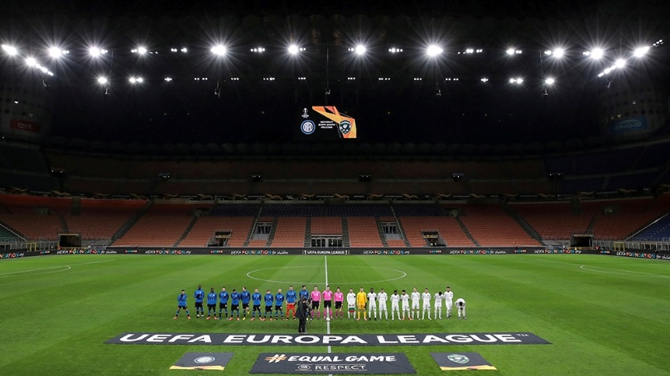
Europa League match between Inter Milan and Ludogorets was played in an empty stadium in Milan, Italy [Emilio Andreoli/Reuters]
UEFA on April 1 suspended all Champions League and Europa League matches "until further notice".
All national team games scheduled for June have also been postponed.
FIFA and the Asian Football Confederation have agreed to postpone the Asian World Cup qualifying matches in March and June.
New seasons in the Chinese, Japanese and South Korean professional leagues have been postponed.
Asian Champions League matches involving Chinese clubs Guangzhou Evergrande, Shanghai Shenhua and Shanghai SIPG have been postponed. The start of the knockout rounds has been moved back to September.
The Confederation of African Football has postponed two rounds of the 2021 Africa Cup of Nations qualifiers scheduled for March 25-31.
An exhibition match between Mexico and Colombia on May 30 at Denver has been cancelled.
The three divisions of England's National League have also been suspended indefinitely.
figure 3. 4: FSTE stocks fall within the first month of the pandemic

figure 3. 5: Dow Jones downfall due to the outbreak

CHAPTER FOUR

PRESENTATION AND ANALYSIS OF RESULTS

4.1 PRESENTATION OF RESULTS
The coronavirus pandemic has taken a toll at the lives and economies of individuals and nations respectively. A cure is yet to be found and cases are rising daily; we examine what can be done so to reduce the spread and hence total containment of the disease. The steps taken to have such an impossible task be achieved are listed as follows;
- Development of public Health Care systems to combat COVID-19
Peru tried to do everything right. Officials declared an early national lockdown — and backed it up with 16,000 arrests. Yet confirmed cases of the novel coronavirus are surging, up nearly 60 percent since last weekend.
In Egypt, observers say a repressive government is vastly undercounting the infected. In Brazil, where the president has dubbed Latin America’s largest outbreak a “fantasy,” numbers are skyrocketing.
New York hospitals and Italian villages are the current front lines of the global pandemic. But ­epidemiologists and other public health experts say the coronavirus is poised to spread dangerously south, engulfing developing nations already plagued by fraying health-care systems, fragile governments, and impoverished populations in which social distancing can be practically impossible.

Figure 4. 1: Soaps and detergents being distributed to rural areas in Brazil.

- Public health surveillance
Public health surveillance is the ongoing systematic collection, analysis, and interpretation of data, closely integrated with the timely dissemination of these data to those responsible for preventing and controlling disease and injury (Thacker and Berkelman 1988). Public health surveillance is a tool to estimate the health status and behavior of the populations served by ministries of health, ministries of finance, and donors. Because surveillance can directly measure what is going on in the population, it is useful both for measuring the need for interventions and for directly measuring the effects of interventions. The purpose of surveillance is to empower decision makers to lead and manage more effectively by providing timely, useful evidence.
Increasingly, top managers in ministries of health and finance in developing countries and donor agencies are recognizing that data from effective surveillance systems are useful for targeting resources and evaluating programs. The HIV and severe acute respiratory syndrome (SARS) epidemics underscored the critical role of surveillance in protecting individual nations and the global community. For example, in 2005, China rapidly began to expand its surveillance and response capacity through its Field Epidemiology Training Program (FETP); Brazil and Argentina chose to use World Bank loans to develop surveillance capacity; and the U.S. Agency for International Development (USAID) redesigned its surveillance strategy to focus on the use of data to improve public health interventions (USAID 2005). Additionally, the guidelines for implementing the 2004 draft revised International Health Regulations require World Health Organization (WHO) member states to have key persons and core capacities in surveillance.

Figure 4. 2: The COVID-19 pandemic cases worldwide

Table 1
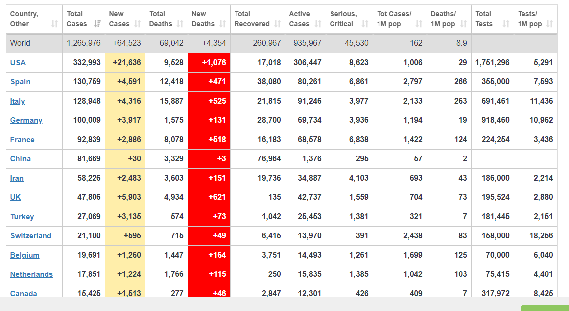
Table showing the countries with the most cases of the COVID-19 worldwide

CHAPTER FIVE

CONCLUSIONS AND RECOMMENDATIONS

5.1 CONCLUSIONS
On 22 January, the members of the Emergency Committee expressed divergent views on whether this event constitutes a PHEIC or not. At that time, the advice was that the event did not constitute a PHEIC, but the Committee members agreed on the urgency of the situation and suggested that the Committee should be reconvened in a matter of days to examine the situation further.
After the announcement of new containment measures in Wuhan on 22 January, the Director-General asked the Emergency Committee to reconvene on 23 January to study the information provided by Chinese authorities about the most recent epidemiological evolution and the risk-management measures taken.
Chinese authorities presented new epidemiological information that revealed an increase in the number of cases, of suspected cases, of affected provinces, and the proportion of deaths in currently reported cases of 4% (17 of 557). They reported fourth-generation cases in Wuhan and second-generation cases outside Wuhan, as well as some clusters outside Hubei province. They explained that strong containment measures (closure of public-transportation systems are in place in Wuhan City, as well as other nearby cities). After this presentation, the EC was informed about the evolution in Japan, Republic of Korea, and Thailand, and that one new possible case had been identified in Singapore.

5.2 RECOMMENDATIONS
The Committee stands ready to be reconvened in approximately ten days’ time, or earlier should the Director-General deem it necessary.
The Committee urged to support ongoing efforts through a WHO international multidisciplinary mission, including national experts. The mission would review and support efforts to investigate the animal source of the outbreak, the extent of human-to-human transmission, the screening efforts in other provinces of China, the enhancement of surveillance for severe acute respiratory infections in these regions, and to reinforce containment and mitigation measures. A mission would provide information to the international community to aid in understanding of the situation and its potential public health impact.
WHO should continue to provide all necessary technical and operational support to respond to this outbreak, including with its extensive networks of partners and collaborating institutions, to implement a comprehensive risk communication strategy, and to allow for the advancement of research and scientific developments in relation to this novel coronavirus.
As this is a new coronavirus, and it has been previously shown that similar coronaviruses required substantial efforts for regular information sharing and research, the global community should continue to demonstrate solidarity and cooperation, in compliance with Article 44 of the IHR (2005), in supporting each other on the identification of the source of this new virus, its full potential for human-to-human transmission.

REFERENCES
- Resnick, Brian (17 March 2020). "Scientists warn we may need to live with social distancing for a year or more". Vox. Retrieved 21 March 2020.
- Ferguson, Neil M (n.d.). "Impact of non-pharmaceutical interventions (NPIs) to reduce COVID19 mortality and healthcare demand" (PDF). Retrieved 21 March 2020.
- Saplakoglu, Yasemin (February 2020). "How will the coronavirus outbreak end?". livescience.com. Retrieved 21 March 2020.
- References for diagram are located at: Commons:File:Symptoms of coronavirus disease 2019 3.0.svg#References.
- Hopkins, Claire. "Loss of sense of smell as marker of COVID-19 infection". Ear, Nose and Throat surgery body of United Kingdom. Retrieved 28 March 2020.
- "2019 Novel Coronavirus (2019-nCoV)". US Centers for Disease Control and Prevention. 11 February 2020. Retrieved 18 February 2020.
- Ma, Josephine; Lew, Linda; and Jeong-ho, Lee, "A third of coronavirus cases may be 'silent carriers', classified Chinese data suggests", South China Morning Post, 22 March 2020.
- "WHO COVID-19 situation report 29" (PDF). World Health Organization. 19 February 202
- https://www.bbc.com/news/business-51829852
https://www.worldometers.info/coronavirus/

