CRITICAL ASSESSMENT OF LEGAL IMPLICATIONS AND ECONOMIC IMPACT OF LOCK DOWN OF ACTIVITIES IN NIGERIA
BY
PHILIP LYDIA
17/ENG07/019
SUBMITTED TO THE COLLEGE OF ENGINEERING
IN PARTIAL FULFILMENT OF ENG 384
ENGINEERING LAW AND MANAGERIAL ECONOMICS
9TH APRIL,2020

Abstract
A critical appraisal is presented in this paper concerning the legal implication and economic impact of the lock down of activities in Nigeria. The emphasis is given on the implications which have risen in the country due to the covid-19 pandemic disease. The analysis is done by viewing the legal and economic impact and providing strategies on the way forwarding during this lock down of activities.
While the relatively low number of cases on the continent so far is good news, African policymakers should not be complacent. They should instead use this window of opportunity to take decisive steps to protect their citizens and economies from the pandemic.
To achieve these goals, we recommend a three-step approach: (1) contain the spread of the virus; (2) swiftly treat identified cases; and (3) cushion the economy from the effects of the pandemic. If these measures are implemented, the human casualties will be limited, and Africa’s economic growth will decline by around 1 percentage point or possibly less. If, on the other hand, the measures to contain the pandemic are not swift, the number of deaths will soar, and economic growth could drop by 2.1 percentage points or more.

Table of content
Title page…………………………………………………………………………………..1
Abstract…………………………………………………………………...………………..2
List of figures………………………………………………………………………………4
CHAPTER ONE………………………………………………………………………….5
1.1 Introduction…………………………………………..………………………………..5
CHAPTER TWO…………………………………………...…………………………….7
2.1 Literature review……………………………………………………………………….7
CHAPTER THREE……………………………….…………………………………….11
3.1 Methodology………………………………………………………………………….11
CHAPTER FOUR……………………………………………………………..………..17
4.1 Analyses of result………………………………………...…………………………..17
CHAPTER FIVE…………………………………….………………………………….20
5.1 Conclusion and recommendation ……………………………………………………20
REFERENCES ……………………………………………………………….................21

List of figures

Plate 1: Drop in crude oil price in 2014 vs. COVID-19.
Plate 2: Select stock market equity index year-to-date returns.
Plate 3: Effect of COVID-19 on regional GDP growth.

CHAPTEER ONE

1.1 INTRODUCTION

In all human endeavours, the principle of Sanctity of Contract guarantees the performance of contractual obligations ensuring that parties are bound by the terms of their agreement and cannot renege from the contract on the basis that the terms of the contract are onerous to perform or unfavourable to either party.
Like other principles of law, Sanctity of Contract is not without exceptions. For instance, parties can agree on the suspension or termination of contractual obligations upon occurrence of certain events. Such events can be in form of the actualization of the purpose of the contract or by the occurrence of a “force majeure” event.
Force Majeure has been defined as the superior force that prevents parties from meeting their contractual obligation. It is inserted as a protection clause in most contracts to remove liability for unavoidable catastrophes that interrupts the expected course of events and restricts the performance of a contract. However, in the absence of force majeure clause in the agreement of parties, the concept of Frustration of Contract can be pleaded and successfully relied upon by a party.
The concept of Frustration of Contract has been recognized as an exception to the Sanctity of Contract. In Nospecto Oil & Gas Ltd. v. Kenney & Ors. (2014) LPELR – 23628 (CA), the Courtheld that frustration in a contract arises when an event occurs without the culpability of any of the parties and which hinders or prevents the performance of an obligation or duty under the contract and fundamentally changes the circumstance and striking at the root of the Agreement.
Flowing from the above judicial authorities and the proactive measures adopted to curtail the spread of Coronavirus Disease 2019 [COVID–19], we consider it necessary to answer the following questions: –
- whether the global outbreak COVID–19 and the resulting measures employed by the Federal Government of Nigeria [i.e. the prohibition of mass gatherings and inter-territorial restrictions] can be regarded as a force majeure to constitute an unforeseen circumstance[s] capable of frustrating the Agreement of parties?
- if the answer is in the affirmative – what happens when the force majeure is longer than the period provided by parties for suspension of their contract? and
- what are the remedies available to parties?
The COVID-19 pandemic is currently omnipresent and has a significant impact on the construction industry. Official restrictions, governmental measures of social and physical distancing, border controls and border closures, but also quarantine measures and sick employees can lead to delays of construction projects. Supply shortages, lack of manpower and inaccessible construction sites are just a few examples. In this respect, for the parties involved the question arises how to deal with these disruptions legally.

CHAPTER TWO
2.1 LITERATURE REVIEW

COVID – 19 AND FORCE MAJEURE OR FRUSTRATION OF CONTRACT:
There will be no difficulty classifying COVID – 19 as force majeure even though parties do not include “pandemics” as part of circumstances constituting force majeure in their contracthowever there are other words that may be construed as addressing the issue of pandemics within the definition/description of what amounts to force majeure in most contracts. In the absence of such express provision, it will be necessary to have recourse to the principle of frustration of contract.
The Supreme Court in Nwaolisah v. Nwabufoh (2011) LPELR – 2115 (SC) held that “a contract is not frustrated merely because its execution becomes more difficult or more expensive that either party originally anticipated and has to be carried out in a manner not envisaged at the time of its negotiation”.
The Supreme Court’s decision in Nwaolisah v. Nwabufoh(Supra) made it pertinent to note that it is the nature of the contractual obligation to be performed by a party that determines whether COVID – 19 pandemic or the prohibition of mass gatherings and interterritorial restrictions can frustrate the contract.
In other words, where the contractual obligation to be performed by a party is such that cannot be performed due to restriction of movements, prohibition of mass gatherings orinterterritorial restrictions, then COVID – 19, can, in that circumstance, constitute circumstances capable of frustrating Agreement of parties.
Exceptions to the above;
- where other options are available to a party in the performance of his contractual obligations; and
- where COVID–19 caused the death of a party to a contract for personal service. In the latter situation it is the death of the party that frustrates the contract and not COVID–19.
In summary the nature of the contractual obligations to be performed by a party to a contract would determine if the COVID-19 pandemic and the Federal Government of Nigeria’s restrictions can be regarded as a force majeure to constitute an unforeseen circumstance[s] capable of frustrating the agreement of parties.
COVID – 19 AND THE SUSPENSION OF A CONTRACTUAL OBLIGATION:
For contractual obligations that cannot be performed, due to the COVID–19 pandemic and the resulting measures imposed by the Federal Government of Nigeria, these can be suspended temporarily until the frustrating intervening event has abated and parties resume business.
It is however not in all circumstances that a contract will be suspended due to frustration. Frustration a times may warrant the immediate discharge of a contract. For instance, the Court in Okereke & Anor v. Abia North L.G.A (2014) LPELR – 23770 (CA) recognized the frustration of contract as one of the ways in which a contract can be discharged.
A discharge of contract by frustration in the present circumstance is where, for instance the COVID-19 situation subsists beyond the period agreed by parties for suspension of their contract and time is of the essence in the performance of the contract; the contract will be discharged.
COVID – 19 – REMEDIES AVAILABLE TO PARTIES:
Except parties expressly provide otherwise in their agreement, the remedy available to them is dependent on whether the contract is suspended or discharged by frustration. Generally, suspension of contract merely puts the rights and obligations of parties in abeyance and does not affect the validity or subsistence of the contract.
Judicial Remedies:
– By an Injunctive Order, a party can be restrained from rescinding the contract during the period of suspension, and at the end of the suspension a party can seek an order of specific performance if the other party fails to discharge his contractual obligation.
– Contrarily, parties are legally relieved of all pending contractual obligations when a contract is discharged by frustration. However, where there is a payment of monetary sum without the performance of any contractual obligation, the party who paid the monetary sum is entitled to recover same in an action for money had and received and under the failure of consideration.
Non Judicial Remedies:
– Parties can proactively extend the agreed period for suspension of their contract. This can be done by an ADDENDUM to the already signed contract.
– Parties can extinguish the rights and obligations that the original contract has created and substitute the same with a new agreement.
The second option above has long been recognized and sanctioned by the Supreme Court in Grover v. Int’l Textile Ind. (Nig.) Ltd (1976) LPELR – 1342
(SC) when the Honorable Court held that:
“the law is well settled that a later Agreement by the parties to an original contract, to extinguish the rights and obligations that the original contract has created is itself a binding contract, provided that the later Agreement is either made under seal or is supported by consideration.”

NIGERIAN citizens are currently at an elevated risk of contracting Coronavirus, and many scientists all over the world have been thrown into the turmoil of finding the cure to this widespread epidemic. Businesses worldwide have also been forced to a halt due to the challenges of the spread of the virus, including interruptions to supply chains and challenges in meeting contractual obligations. With no end to the outbreak in sight, businesses must know, understand and consider their options in order to mitigate their risk exposure. As it stands many businessmen would currently be caught within the devil and the red sea; in a bid to fulfill their contractual obligations within the stipulated time per the contract agreement and the current order of the government on shut down of basic federal and state infrastructures, and other attendant necessities.

The problem will further be escalated for the contractor when the contract does not include a clause which allows for emergency situations as this, or where the contract is written in an iron-clad manner that places the burden of delivery without recuse on the contractor. How about situations where the contractor is to be paid but due to various shutdowns, he cannot be paid and money and resources are being wasted due to the inability to pay the contractor, and the contract did not envisage this. Is coronavirus a legal excuse not to pay or perform a contract? This virus also shows the importance of three legal doctrines and their relevance in cases of emergency, such as this: doctrine of frustration, force majeure and impossibility or impracticability of performance Doctrine of frustration: Performance under a contract can be excused for “frustration”. Frustration as a defend in law is asserted where a change in circumstances or situation, outside of the parties making, makes one party’s performance virtually worthless or unachievable to the other party in relation to the agreement. To prove frustration, you must show that the contract must be in the midst of being performed; the frustrated party’s purpose in making the contract must have been known to both parties when the contract was made; (3) the purpose must have been fundamentally frustrated by an event not reasonably foreseeable at the time the contract was made, not due to the fault of the frustrated party. Force majeure: A party can also be relieved of a contract based on a force majeure clause. A force-majeure clause relieves a party from penalties for breach of contract when circumstances beyond the party’s control render performance untenable or impossible. The purpose and intent of force majeure provision is to protect the parties from events that are agreed to be outside normal business risk. Force majeure clauses excuse the performance of contractual obligations if specified events outside the parties’ control have prevented such performance. If successfully invoked, the clause would excuse a party’s performance of its obligations under the contract, thereby avoiding a breach. READ ALSO: Covid-19: FG denies buying used protective gear from China Force majeure clauses are typically narrowly construed. Such a clause will generally only excuse a party’s nonperformance if the event that caused the party’s nonperformance is specifically identified. Force majeure events may include: acts of God, acts of a government or the public enemy, natural disasters, fire, flood, epidemics, quarantine restrictions, strikes, freight embargoes, war, acts of terrorism, (or) equipment breakage. A force majeure clause applies to objective events that directly affect a party’s ability to perform the contract in question, not the ability to make a profit Performance impossibility or impracticality: The doctrine of impossibility or impracticability may also allow a party to avoid the performance of its obligation. There are two types of impossibility: a). original impossibility and b.) supervening impossibility. The former is the impossibility of performance existing when the contract was entered into so that the contract was to do something which from the outset was impossible; in contrast, supervening impossibility develops sometime after the contract is formed. Under either type, contract performance may be excused when at the making of the contract, or thereafter, performance became impracticable due to some extreme or unreasonable difficulty, expense, injury, or loss involved, rather than that it is scientifically or actually impossible. The important question for the doctrine to apply is whether an unanticipated circumstance has made the performance of the promise vitally different from what should reasonably have been within the contemplation of both parties when they entered into the contract. Although absolute impossibility is not required, there must be a showing of impracticability because of extreme and unreasonable difficulty, expense, injury or loss involved.

An employer is required to protect the health and safety of workers at the workplace in accordance with the provisions of the Factories Act and Labour Law. It is obligatory for the employer, under employment contract, to provide a safe system and place of work and to take measures to ensure the safety of the worker during work-related matters. The rights of employees in Nigeria are heavily guarded by various laws such Labour Act, Employee Compensation Act, Factory Act, etc.

Can my employer terminate my employment during this Covid-19 lockdown? By law, subject to agreement between parties, the employer can terminate the employees’ employment at any time so far he follows the Labour Act by giving you the required notice or payment in lieu of the notice. Can I get a paid sick leave? Every worker is entitled to paid sick leave by law, section 16 & 18 of Labour Act. Apart from the provision of the Mano Act, an employer is entitled to protect the employees. Can my boss force me to take medical test? Medical test may be a common policy but you cannot be forced to take a medical test. It is against your constitutional right to privacy(Section 37 of the 1999 Constitution).
• Taxation during COVID-19 virus: Many tax return will become due during this period coroner pandemic widespread. Government has issued a lockdown of facilities and service, how then will companies effect their returns? For instance, the return date for VAT will be due this March. There are.many companies in which their income tax, tertiary education tax, national information technology development fund levy and capital gains tax are due this March 2020. It is only sensible that the tax authorities make social plans like this and grant a tax extension period. So your inability to file tax returns where the government has issued a lockdown order can not affect or contribute to your liability.
Human right in period of pandemics: Fundamental Human right as we know it is protected by the Constitution and are very germaine. But as important as they are, they are not totally supreme. They can be breached in times of national security or cases of national emergency. In the light of Coronavirus, certain restrictions can be made on individual freedoms under the Law such as the right to movement. Movement of people can be restricted, etc. Companies must understand the legal implications attached to the recent widespread of the COVID-19 as it relates to their various legal obligations to their staff, customers, clients and to themselves; this will help in their decision making ability.

CHAPTER THREE
3.1 METHODOLOGY
Strategies for coping with the health and economic effects of the COVID-19 pandemic in Africa.

The World Health Organization (WHO)’s March 11 recognition of COVID-19 as a global pandemic has removed any doubt about the threat that the virus poses to every country in the world. The virus has now been detected in 152 countries, with more than 180,000 infected and more than 7,000 killed. Though Africa remains one of the regions with the fewest cases, the number of countries affected has increased over the past week. As of this writing, nearly 450 cases have been reported in 30 countries, concentrated in northern Africa and South Africa, with 10 deaths reported.
While the relatively low number of cases on the continent so far is good news, African policymakers should not be complacent. They should instead use this window of opportunity to take decisive steps to protect their citizens and economies from the pandemic.
To achieve these goals, we recommend a three-step approach: (1) contain the spread of the virus; (2) swiftly treat identified cases; and (3) cushion the economy from the effects of the pandemic. If these measures are implemented, the human casualties will be limited, and Africa’s economic growth will decline by around 1 percentage point or possibly less. If, on the other hand, the measures to contain the pandemic are not swift, the number of deaths will soar, and economic growth could drop by 2.1 percentage points or more.
- CONTAIN THE SPREAD OF THE VIRUS
Because many African countries have relatively weak health care systems, proactive measures to prevent the spread of the virus will be critical. Countries should step up campaigns to educate the public on best practices, including promoting good hygiene and social distancing, discouraging large public gatherings, and encouraging employers to protect the jobs of employees who require quarantine or treatment. Campaigns should elicit the help of religious and civil society leaders for maximum effect. Rwanda, which has set up portable sinks throughout public areas to encourage handwashing in its capital, Kigali, provides a good example of how some of these measures can be undertaken.
In addition, governments should suspend all international travel to or from the most-affected countries, and quarantine citizens who have traveled to or through those areas for at least two weeks. Several countries, including Ghana, Kenya, Morocco, Senegal, and South Africa, have already taken these measures. Others should emulate them.
.
- ENSURE HEALTH SYSTEMS ARE PREPARED TO TREAT THOSE AFFECTED
The 2014 Ebola crisis—which lasted two and a half years and resulted in more than 28,600 cases and 11,325 deaths—exposed the inadequacy of health care systems in Africa. Although important lessons were learned from past outbreaks, and health systems have been strengthened since then, there are still critical gaps in preparedness. Governments and health specialists must work in collaboration with the WHO and other partners to ensure that hospitals and clinics have adequately trained personnel and enough capacity for testing and treating the virus. Both Germany and South Korea have developed fast, extensive, and free testing mechanisms that are good examples of what efficient testing looks like.

- PREPARE TO CUSHION THE ECONOMIC EFFECT OF THE PANDEMIC
Africa started 2020 with a positive economic outlook, as outlined in AGI’s annual Foresight Africa report. However, the COVID-19 pandemic will have significant effects on economies in several countries as trade, tourism, remittances, financial markets, and consumer and business sentiment are all disrupted.
Commodity prices and trade
The late 2014 drop in oil prices contributed to a significant decline in GDP growth for sub Saharan Africa from 5.1 percent in 2014 to 1.4 percent in 2016. During that episode, crude oil prices fell by 56 percent over seven months. The current decline in oil prices has been far more rapid, with some analysts projecting even more severe price declines than in 2014. Already, crude oil prices have fallen by 54 percent in the three months since the start of the year, with current prices falling below $30 per barrel. Non-oil commodity prices have also declined since January, with natural gas and metal prices dropping 30 percent and 4 percent, respectively.

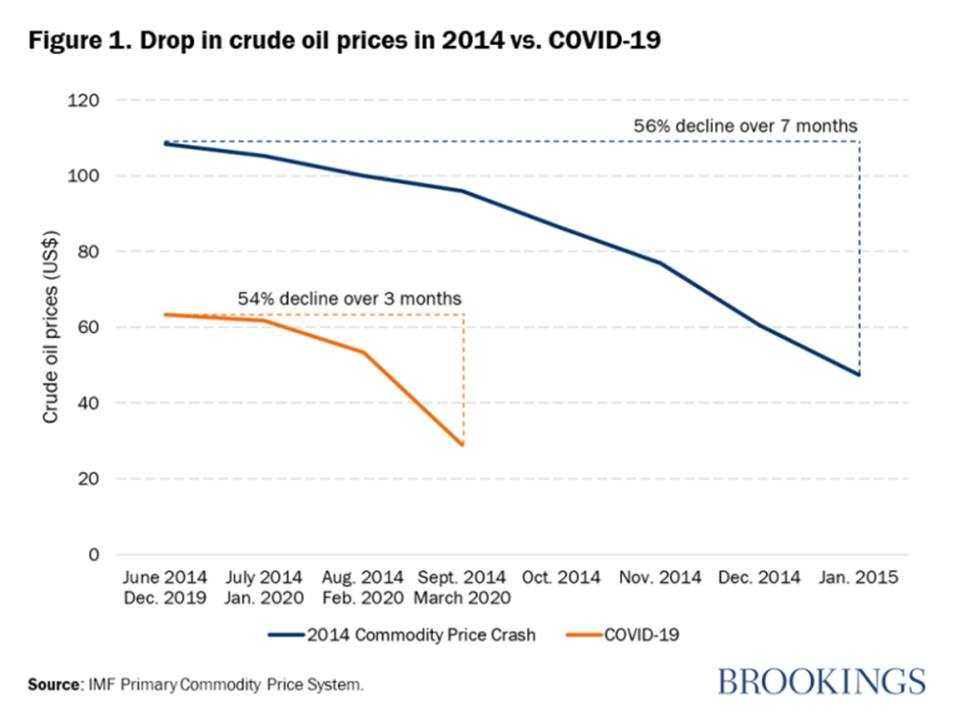
PLATE 1

Because of these price drops, the largest disruption to trade will be for commodity-sensitive economies, with Algeria, Angola, Cameroon, Chad, Equatorial Guinea, Gabon, Ghana, Nigeria, and the Republic of the Congo among the most affected. Oil exports range from 3 percent of GDP in South Africa to as high as 40 percent in Equatorial Guinea and are a key source of foreign exchange earnings. Furthermore, the shock comes at a particularly bad time for three of the largest economies—Angola, Nigeria, and South Africa—which already had weak growth outlooks, with South Africa already in recession. Nigeria is now facing U.S. dollar shortages due to the oil price crash and is expected to devalue its currency by 10 percent by the end of June. We expect similar stresses to surface in some other countries.
Tourism and remittances
Tourism, an important sector of economic activity for many countries, will be heavily affected by COVID-19 as countries begin to place restrictions on travel and encourage social distancing. The sector contributes over 10 percent of GDP in the Seychelles, Cape Verde, and São Tomé and Príncipe, and over 5 percent in The Gambia, Morocco, Mauritius, Tunisia, Lesotho, Madagascar, Egypt, and Rwanda. Tourism employs more than a million people in each of Nigeria, Ethiopia, South Africa, Kenya, and Tanzania, and tourism employment comprises more than 20 percent of total employment in Seychelles, Cape Verde, São Tomé and Príncipe, and Mauritius. In past crises, including the 2008 financial crisis and the 2014 commodity price shock, African tourism experienced losses of up to $7.2 billion.
Similarly, with economic activity in the doldrums in many advanced and emerging market countries, remittances to Africa could experience significant declines. Remittances as a share of GDP exceed 5 percent in 13 African countries, and range as high as 23 percent in Lesotho and more than 12 percent in Comoros, The Gambia, and Liberia.
Tighter financial conditions
The COVID-19 pandemic has severely disrupted financial markets, with equity indices in major economies dropping significantly. Equity markets plunged by over 20 percent in the U.S. and experienced the largest single-day drop of the Dow since “Black Monday” in 1987. African equity markets have not been immune, with S&P All Africa index returns dropping by 30 percent since the beginning of the year, and large drops in Egypt, South Africa, Kenya, Mauritius, and Nigeria.

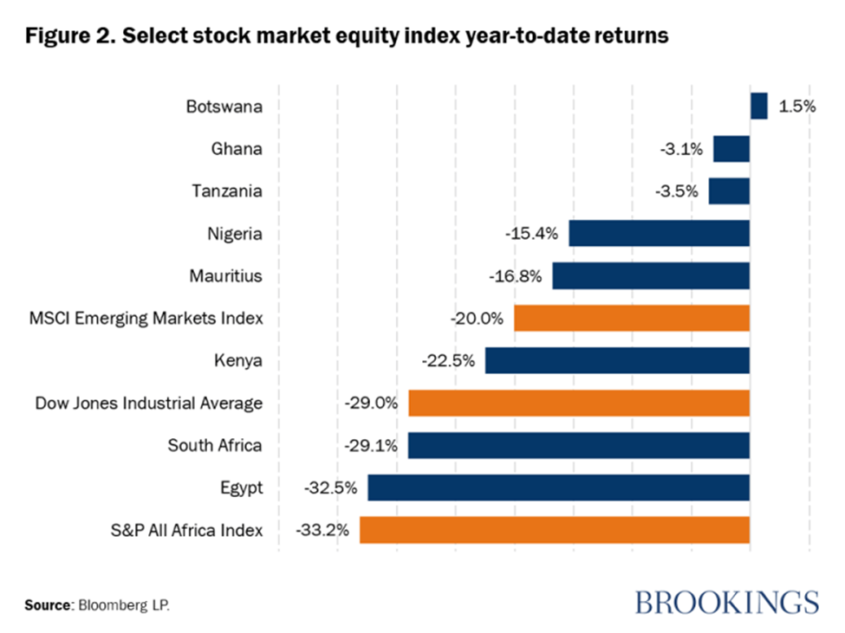
PLATE 2

The pullback from African markets as well as a projected decline in export revenues has led to depreciations of local currencies. These exchange rate depreciations will push up local inflation and trigger monetary policy and financial tightening. In addition, exchange rate depreciations inflate local currency values of foreign currency debt and make debt management and servicing more challenging, a particular threat in Africa, where an estimated one-third of countries are either in or at high risk of debt distress.
Additionally, the risk-off sentiment in global markets will push up the cost of external financing for African countries. According to Euromoney, the yield on Nigeria’s 2031 eurobond nearly doubled from 6.8 percent on February 21 to 12.1 percent on March 13. Similarly, the yield on Ghana’s 2029 eurobond shot up by 400 basis points to 11 percent, and that for Angola doubled to 14.2 percent. Furthermore, investor pull will cause delays in planned eurobond issuance by several countries. Already, Nigeria has announced a delay in the issuance of $3.3 billion eurobond, and Côte d’Ivoire, Benin, and South Africa are all expected to postpone issuances until markets stabilize. These delays will pose challenges for public finances in several countries.

Deteriorated consumer and business sentiment
The other channel through which COVID-19 will affect economic activity is through consumer and business sentiment. According to a survey by KASI Insights, in seven African countries, consumer sentiment for February dropped over COVID-19 concerns, a signal of reductions in consumer spending. Faced with lower and uncertain demand, business confidence will decrease and cause declines in investment.
Effect on economic growth
We estimate that the COVID-19 related disruptions outlined above will lower sub-Saharan Africa’s GDP growth in 2020 to between 1.5 percent and 2.5 percent, down from the projected 3.6 percent pre-COVID-19 projections. Under a scenario where African governments quickly take the appropriate steps to contain the spread of the virus and global conditions stabilize, the regional GDP growth will decline by around 1 percentage point, to 2.5 percent. In a scenario where the responses are not swift, the pandemic lasts longer, and global conditions take more time to normalize, the disruption will be more severe, resulting in a 2.1 percentage point reduction in growth, to 1.5 percent.
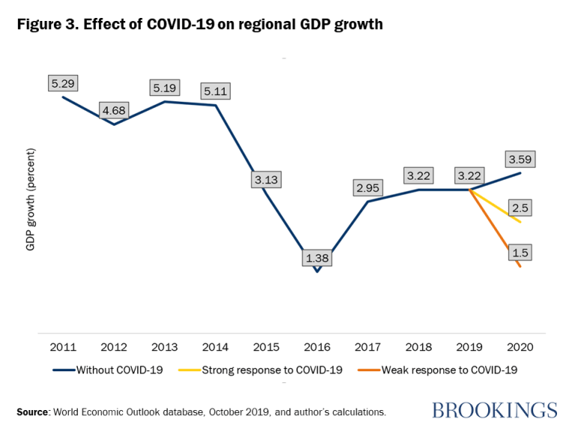
PLATE 3

While the health of those affected by the virus is clearly of paramount concern, business owners, consumers, and governments must also prepare for the pandemic’s economic effects to ensure that their countries emerge from the crisis stronger than before. Strong measures taken in several—but not all—countries are positive steps which will help reduce the human and economic impact of the virus in Africa.
The global community must come together to collaborate, coordinate, share lessons learned, and assist each other to combat the pandemic. Until every country is safe, no country will be safe. The outbreak should serve to highlight the extent to which countries are interconnected and interdependent and should be a call to strengthen global institutions and the global governance system.

CHAPTER FOUR
4.1 ANAYSLES OF RESULTS

The Global Health Hazards and Economic Impacts of COVID-19
In December 2019, a cluster of pneumonia cases from an unknown virus surfaced in Wuhan, China. Based on initial laboratory findings, the disease named Coronavirus disease 2019 (abbreviated as COVID-19), was described as an infectious disease that is caused by severe acute respiratory syndrome coronavirus 2. The COVID-19 outbreak has since spread to about 196 countries and territories in every continent and one international conveyance across the globe. While there are ongoing efforts to curtail the spread of infection which is almost entirely driven by human-to-human transmission, it has accounted for over 400,000 confirmed cases with over 18,000 deaths.
Beyond the tragic health hazards and human consequences of the COVID-19 pandemic, the economic uncertainties, and disruptions that have resulted come at a significant cost to the global economy. The United Nations Trade and Development Agency (UNCTAD) put the cost of the outbreak at about US$2 trillion in 2020. Most central banks, finance ministries and independent economic experts around the world have taken solace in the prediction that the impacts might be sharp but short-lived, and economic activities would return to normal thereafter. This line of thought mirrors the thinking of the events that shaped the 2007 global financial crisis. However, it is quite instructive to note that the 2007 crisis which emanated from the United States’ subprime mortgage crisis was mainly an economic phenomenon, with its fallout spreading across many regions of the world. When compared to COVID-19, the 2007 crisis could be described as minor and manageable. The tumultuous events that COVID-19 had spread across the globe cut across every facet of human existence and the consequences may linger beyond the second half of 2020.
The slowdown in the global economy and lockdown in some countries, such as Italy, Spain and most Eurozone economies and beyond, as a result, COVID-19 has also taken its toll on the global demand for oil. The decline in oil demand is estimated to surpass the loss of nearly 1 million barrels per day during the 2007-08 recession. This is also coming at a time when two key players in the global oil industry – Russia and the OPEC cartel – are at loggerheads on the decision to cut output. The unequivocal oil price war started between these two global oil market giants may have more dire consequences on the oil price that has started to dive. .
Sector-specific implications and impacts could vary. For example, the impacts on the global aviation and tourism sectors are a result of the implications of the pandemic on global travel. As discretionary spending by consumers continues to decline, cruise companies, hotels, and hospitality are facing declining demand and patronage. For example, in Hungary alone, about 40 to 50% of hotel reservations have been canceled. Also, the pandemic is placing up to 8 million jobs in the leisure and hospitality sector at risk, with travel crashes and cancellations expected to continue. Moody’s Analytics, a rating agency, stated that more than half of the jobs in the United States which is about 80 million may be in jeopardy.
The virus is also taking its toll on health facilities and infrastructures across the globe. Italy is currently the largest affected country with a number of deaths surpassing China, since the outbreak of coronavirus. Across northern Italy, the virus has pushed the country’s National Health Service to a breaking point, emphasizing the test that other countries, especially developing and low-income countries, might face in their approach to contain the virus spread. Most hospitals and health facilities that could not handle the hazards are resulting to operating below their capacity by taking a few regular health-related cases or shutting down. What could be more devastating is the fact that the economic pains that accompanied the virus might not go away soon as envisaged.
The conventional policy measures currently being taken such as reducing interest rates and costs of borrowing, tax cuts and tax holidays are quite remarkable. However, these conventional policy measures are quite potent when there are demand shocks. There are limitations to the successes that can be recorded when demand shocks are combined with supply shocks. It is already apparent from the emergence of the current crisis that there are implications on the economy from both the demand and supply sides. Some of the demand factors include social distancing with consumers staying at home, limitations in spending and declining consumptions. On the supply side, factories are shutting down or cutting down production and output, while in other instances, staff work from home to limit physical contact.
The decision to close educational institutions and schools around the globe in an attempt to contain the pandemic has also led to a soaring number of children, youth and adults not attending schools. According to UNESCO Monitoring report on COVID-19 educational disruption and response, the impact of school closures in the over 100 countries that have implemented the decisions around the world has impacted over half of the global students’ population. These educational disruptions are being escalated particularly for the most vulnerable members of society.

Bracing up for COVID-19 consequences on the Nigerian economy
For most developing economies, the odds of sliding into a downturn are gradually expected as the global coronavirus outbreak puts severe pressure on the economy. For Nigeria, the country is still sluggishly grappling with recovery from the 2016 economic recession which was a fall out of global oil price crash and insufficient foreign exchange earnings to meet imports. In the spirit of economic recovery and growth sustainability, the Nigerian federal budget for the 2020 fiscal year was prepared with significant revenue expectations but with contestable realizations. The approved budget had projected revenue collections at N8.24 Trillion, an increase of about 20% from 2019 figure. The revenue assumptions are premised on increased global oil demand and stable market with oil price benchmark and oil output respectively at $57 per barrel and 2.18 Million Barrels Per Day.
The emergence of COVID-19 and its increasing incidence in Nigeria has called for drastic review and changes in the earlier revenue expectations and fiscal projections. Compared to events that led to recession in 2016, the current state of the global economy poses more difficulties ahead as the oil price is currently below US$30 with projections that it will dip further going by the price war among key players in the industry. Unfortunately, the nation has grossly underachieved in setting aside sufficient buffers for rainy days such as it faces in the coming days. In addressing these daunting economic challenges, the current considerations to revise the budget downward is inevitable. However, certain considerations that are expected in the review must not be left out. The assumptions and benchmarks must be based on realizable thresholds and estimates to ensure optimum budget performance, especially on the non-oil revenue components.
Furthermore, cutting expenditures must be done such that the already excluded group and vulnerable are not left to bear the brunt of the economic contraction. The economic and growth recovery program which has the aim of increasing social inclusion by creating jobs and providing support for the poorest and most vulnerable members of society through investments in social programs and providing social amenities will no doubt suffers some setbacks. Besides, the downward review of the budget and contractions in public spending could be devastating on poverty and unemployment. The last unemployment report released by the National Bureau of Statistics (NBS) ranks Nigeria 21st among 181 countries with an unemployment rate of about 23.1%. The country has also been rated as the poverty capital of the world with an estimated 87 million people living on less than $2 a day threshold.
The decision to cut the retail price of gasoline under a price modulation arrangement is a welcome development. The cut is expected to curb rising inflation, especially food price inflation which will mainly benefit the poor. However, rather than the price capping regime introduced, by which it is expected of the Petroleum Products Price Regulation Agency (PPPRA) to constantly issues monthly guide on appropriate pricing regime. It is expected that the government will use this opportunity to completely deregulate the petroleum industry in line with existing suggestions and reports. In the event that the global economy becomes healthier and crude oil prices increases, the government might return to the under-recovery of the oil price shortfall by the Nigerian National Petroleum Corporation (NNPC). A policy that annually costs the government huge revenue and recurring losses to the NNPC.
Basically, the Nigerian government essentially must lead economic diversification drive. It is one practicable way to saddle through the current economic uncertainties and instabilities. What the consequences of COVID-19 pandemic should further offer the Nigerian economic managers and policymakers, is that the one-tracked, monolithic reliance on oil is failing. Diversification priorities to alternative sectors such as agriculture, solid minerals, manufacturing and services sectors, should be further intensified.

CHAPTER FIVE
5.1 CONCLUSION AND RECOMMEDATION

From all intent and purposes, COVID–19 pandemic and its preventive measures may constitute a force majeure event or unforeseen circumstances capable of frustrating performance of the contract. However, it requires a fact-to-fact analysis of the terms of the Agreement of parties and the contractual obligation[s] to be performed to determine whether such a contract can be suspended or discharged and the applicable remedy.
The USA and countries in Europe should also step up their level of assistance outside their borders. One way to quickly and effectively do this has been suggested by Imran Khan, the Prime Minister of Pakistan: – cancel, or at least reschedule, some of the debt of developing countries affected by the pandemic. Debt repayment takes a large proportion of public expenditures. At this time, this money would be far better spent at helping people survive the crisis.

REFERENCES

https://wigweandpartners.com/news/2020/04/02/the-effect-of-covid-19-pandemic-on-contractractual-obligations-in-a-contract/
https://www.brookings.edu/blog/africa-in-focus/2020/03/18/strategies-for-coping-with-the-health-and-economic-effects-of-the-covid-19-pandemic-in-africa/
https://www.vanguardngr.com/2020/03/legal-implications-of-covid-19-virus-for-businesses-and-companies/
http://cseaafrica.org/the-implication-of-covid19-on-the-nigerian-economy/

