AKERELE DEBORAH FADEKEMI
17/SCI01/083
CSC 408 (Project Managment)
QUESTION 1
- Project Management Processes
  - Project Initiation- this is the starting point of any project. In this process, all the activities related to winning a project takes place. The main activity of this phase is the pre-sale.
During the pre-sale period, the service provider proves the eligibility and ability of completing the project to the client and eventually wins the business. Then, it is the detailed requirements gathering which comes next.
During the requirements gathering activity, all the client requirements are gathered and analysed for implementation. In this activity, negotiations may take place to change certain requirements or remove certain requirements altogether.
  - Project Planning- Project planning is one of the main project management processes. If the project management team gets this step wrong, there could be heavy negative consequences during the next phases of the project.
Therefore, the project management team will have to pay detailed attention to this process of the project.
In this process, the project plan is derived in order to address the project requirements such as, requirements scope, budget and timelines. Once the project plan is derived, then the project schedule is developed.
Depending on the budget and the schedule, the resources are then allocated to the project. This phase is the most important phase when it comes to project cost and effort.
  - Project Execution- the project management executes the project in order to achieve project objectives, after all paperwork is done. During this, each member of the team carries out their own assignments within the given deadline for each activity. The detailed project schedule will be used for tracking the project progress. When doing the project execution, there are many reporting activities to be done. The senior management of the company will require daily or weekly status updates on the project progress.
In addition to that, the client may also want to track the progress of the project. During the project execution, it is a must to track the effort and cost of the project in order to determine whether the project is progressing in the right direction or not.
  - Control and Validation- During the project life cycle, the project activities should be thoroughly controlled and validated. The controlling can be mainly done by adhering to the initial protocols such as project plan, quality assurance test plan and communication plan for the project.
Sometimes, there can be instances that are not covered by such protocols. In such cases, the project manager should use adequate and necessary measurements in order to control such situations.
Validation is a supporting activity that runs from first day to the last day of a project. Each and every activity and delivery should have its own validation criteria in order to verify the successful outcome or the successful completion.
When it comes to project deliveries and requirements, a separate team called 'quality assurance team' will assist the project team for validation and verification functions.
  - Closeout and Evaluation- Once all the project requirements are achieved, it is time to hand over the implemented system and closeout the project. If the project deliveries are in par with the acceptance criteria defined by the client, the project will be duly accepted and paid by the customer.
Once the project closeout takes place, it is time to evaluate the entire project. In this evaluation, the mistakes made by the project team will be identified and will take necessary steps to avoid them in the future projects.
During the project evaluation process, the service provider may notice that they haven't gained the expected margins for the project and may have exceeded the timelines planned at the beginning.
In such cases, the project is not a 100% success to the service provider. Therefore, such instances should be studied carefully and should take necessary actions to avoid in the future.
- IT Project Management Methodology
Agile Project Management (Scrum Method)- In rugby, a scrum is a tangle of heavy people who strain against each other to acquire a small, oblong, whitish ball. As business managers find such behaviour undesirable in production teams, they employ the Scrum method of project management. Scrum teams meet for monthly Scrum sessions in which they break down their projects and deliverables into 15- or 30-day chunks, called “sprints.” By working toward these small increments, teams avoid the process overwhelm typical of other PM methodologies. By re-prioritizing their efforts each month to meet consumer demand, they can stay flexible and motivated – increasing both productivity and customer satisfaction! Development teams often apply the popular Scrum variation of Agile Project Management. Managers find Scrum easy to implement and very effective in addressing issues affecting software development teams.

QUESTION 2
- WBS for Integrated Medical Consultation System.
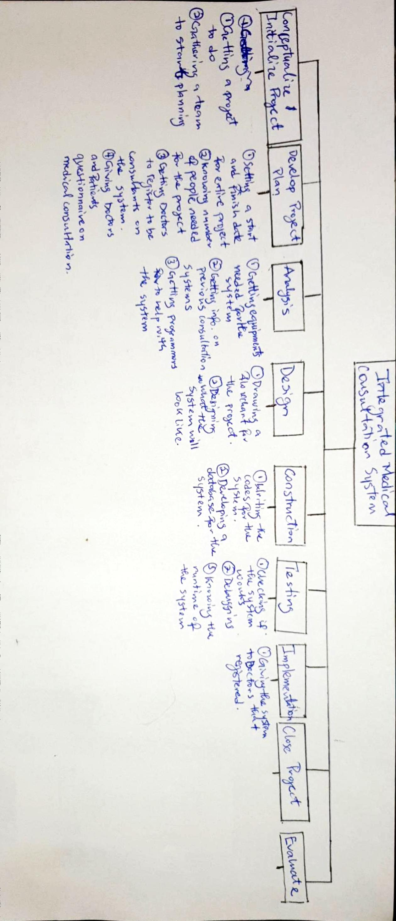
- CRM

QUESTION 3
Why is the study of Project Management important for computing and Information Technology (IT) students?
Without project management, teams and clients are exposed to chaotic management, unclear objectives, a lack of resources, unrealistic planning, high risk, poor quality deliverables, project going over budget and being delivered late. So, it’s important for IT students to learn it so they can avoid these things and be able to manage a project on their own to a certain extent.

