DEVELOPMENT OF AUTOMATED MACHINE AND ELECROMECHANICAL DEVICES FOR PRODUCTION OF INFECTION PREVENTION AND CONTROL (IPC) AND PERSONAL PROTECTIVE EQUIPMENT (PPE) FOR PUBLIC HEALTH AND ECONOMIC GROWTH IN NIGERIA
PREPARED BY:
NAME: AGIAMAH BENJAMIN E.O
MATRIC NUMBER: 17/ENG05/005
PROGRAMME: MECHATRONICS ENGINEEERING

A TERM PAPER SUBMITTED TO THE DEPARTMENT OF MECHATRONICS ENGINEERING, AFE BABALOLA UNIVERSITY ADO-EKITI, EKITI STATE IN PARTIAL AGREEMENT TO ENG384 (ENGINEERING LAW AND MANAGERIAL ECONOMICS)

SESSION: 2019/2020
DEDICATION
T
his report is dedicated to under graduate mechatronics engineers, likewise the younger generation who are intended future prospects in mechatronics engineering, that are committed to ensuring a proper working environment whilst anticipating an economic growth in the country with the aid of technological intervention in order to have a better future.

ACKNOWLEDGEMENT
P
utting together a report like this requires knowledge, understanding and also the help of so many people; be it a book, an article or some random conversation.
I want to appreciate the Almighty God for his grace and abundant supply of inspiration during the short period of time I was able to put this report together.
I would like to thank the Lecturers in charge of this course for aiding my understanding from time to time in classes. I also thank the various authors who kept articles on IPC and PPE online, your work is very much appreciated.

CONTENT
DEDICATION………………………………………………………………………….……..2
ACKNOWLEDGEMENT…………………………………………………………….……....3
ABSTRACT…………………………………………………………………………….…..…5
INTRODUCTION TO HAI AND IPC......................................................................................6
IPC PRINCIPLES…………………………….…………………………………………….…7
COMMON AND IMPORTANT HAIs…………………………………………......................8
STANDARD PRECAUTIONS………………………………………………………………10
PERSONAL PROTECTIVE EQUIPMENT…………………………………………………12
PRODUCTION OF PPE……………….…………………………………………………….17
ALTERNATIVE TO PPE AND ECONOMIC GROWTH………………….....……………19
CONCLUSION………………………………………………………………………………20

ABSTRACT
I
ntroduction of electromechanical machines in IPC and PPE such as robots in areas such as construction and marketing will help reduce the number of workers in a particular area hence reducing the flow of any virus (especially at such a time like this where there is an outrage of the COVID-19 virus), the demand of such hardware will also help improve the economic status.

INTRODUCTION TO HAI AND IPC

The Chain of Infection
Understanding how infections spread and the contributory factors that facilitate spread is important in developing robust prevention approaches. The “chain of infection” is an easy way of visualising this and provides a focus for health care associated infection (HAI) prevention activities. The chain of infection illustrates the six conditions that need to

be present and in the sequential order shown for a microorganism to spread and cause infection. Breaking any link in the chain will prevent infection, though control measures are most often directed at interrupting the ‘Mode of Transmission’ link.
Figure 1: The Chain of Infection
Microorganism (capable of being pathogenic): a bacteria, virus, fungus or protozoa. If it has potential to cause infection and disease it is considered a pathogen.
Sus
c
eptible
H
ost
Rese
r
v
oir
P
o
r
tal of Exit
P
o
r
tal of E
n
t
r
y
Reservoir: a place where microorganisms can multiply or at least survive for a period of time (e.g. in or on humans and animals or on objects such as sinks).
Pathogen
Portal of Exit: a means by which a micro-organism can leave the reservoir (e.g. via the hands from contact with a patient).
Mode of Transmission: how the microorganism moves from one person to another (e.g. through direct contact via the hands, via respiratory droplets/secretions).
Portal of Entry: an opening that allows the microorganism to gain access to the host.

Susceptible Host: a person that is susceptible to colonisation or infection. The outcome of transmission (colonisation or infection) depends on the properties of the microorganism and the susceptibility of the host at that time.

IPC Principles
Infection prevention and control (IPC) strategies within healthcare are designed to break the chain of infection. IPC
performing hand hygiene at the correct moment will reduce the number of microorganisms on a his or her hands (reservoir), making it less likely that he or she will transfer a microorganism (mode of transmission) to others via direct contact. Hand hygiene blocks the mode of transmission, breaks the chain and therefore prevents cross infection.
The basic set of IPC strategies that should be implemented in healthcare facilities (HCFs) at all times are known as “standard precautions.” These evidence-based practices are designed to protect HCWs and also prevent transmission of infections among patients. Standard precautions include hand hygiene, use of personal protective equipment, practising appropriate respiratory hygiene, safe use and disposal of sharps, appropriate decontamination of medical equipment, laundry and environment and waste management.
For certain infectious diseases e.g. those considered highly transmissible and/or caused by epidemiologically important pathogens. An additional set of IPC interventions known as “transmission based precautions” are implemented
Contact precautions are implemented to prevent transmission of diseases that are spread via contact with infectious material. Droplet precautions are used to prevent transmission of diseases that are spread via contaminated respiratory droplets. Airborne precautions are implemented to prevent transmission of diseases that can spread through aerosolized particles.

Common and Important HAIs
HAIs, also termed nosocomial infections, are infections occurring in a patient during the process of care in a hospital or other health-care facility, which was not present or incubating at the time of admission. HCWs are also at risk for developing HAIs. IPC programs are implemented to prevent HAIs from occurring and spreading within health facilities.
-
Endogenous infection. Many microorganisms that cause HAIs come from the patient’s own body (the term
vent by conventional measures since the microorganism causing the infection comes directly from the patient. However, they can be controlled by helping to protect the resistance of the person to infection (e.g. mobilising the patient, providing adequate nutrition, or avoiding the use of urinary catheters and intravenous catheters if possible, promoting patient hand hygiene after defecation and before eating and before touching wounds/skin breaks).
Exogenous infection. Result from the transfer of microorganisms to the patient or HCW from an external reservoir. For example, microorganisms can be transferred through direct contact with contaminated hands of HCWs and other patients (cross-contamination), contaminated instruments and needles, or the environment
greatly reduce the frequency of cross contamination between patients and HCWs and thus reduce the incidence of infection. As with endogenous infection, measures to protect a persons natural resistance to infection can also help to reduce the likelihood of infection if cross transmission does occur.
IPC is important in HCF’s because on-going cross transmission can result in certain types of microorganisms becoming established (resident) in the HCF with the potential for antimicrobial resistance to occur. In Sierra Leone it is also essential to prevent the cross transmission of infectious diseases within the Health Care Facility such as Viral Haemorrhagic Fevers , Cholera and other transmissible diseases which may not present with all the classic symptoms.
Ebola Virus Disease and other Viral Haemorrhagic Fever
!
Ebola Virus Disease (EVD) and other Viral Haemorrhagic Fevers (VHF) are uncommon in HCF in general, but given recent experience in Sierra Leone it is vital that all HCWs have a basic knowledge of these conditions and how to prevent transmission in HCFs.
The key to reducing the risk of transmission of EVD in HCFs is twofold – maintenance of a very high level of adherence to standard precautions at all times and strictly adhering to EVD IPC precautions in patients with EVD-like symptoms. In particular great care should be taken with undiagnosed seriously ill febrile patients with diarrhoea and undiagnosed fever in women in childbirth. It is possible to care for such patients safely and appropriately by following standard precautions and additional transmission based precautions. All health care workers should be vigilant for such cases and alert their supervisor immediately of cases that may suggest EVD. Remember that EVD has an incubation period of up to 3 weeks so that even if the patient had no features of EVD on admission a febrile illness that develops some days later could still be EVD. Triage screening, isolation, assessment and testing on admission and each shift needs to be maintained. This is part of good clinical practise in monitoring the condition of any patient. Testing for EVD and other infectious diseases should be carried out promptly.

Coronavirus disease
Coronaviruses (CoV) are a large family of viruses that cause illness ranging from the common cold to more severe diseases such as Middle East Respiratory Syndrome (MERS-CoV) and Severe Acute Respiratory Syndrome (SARS-CoV). A novel coronavirus (nCoV) is a new strain that has not been previously identified in humans.
Coronaviruses are zoonotic, meaning they are transmitted between animals and people. Detailed investigations found that SARS-CoV was transmitted from civet cats to humans and MERS-CoV from dromedary camels to humans. Several known coronaviruses are circulating in animals that have not yet infected humans.
Common signs of infection include respiratory symptoms, fever, cough, shortness of breath and breathing difficulties. In more severe cases, infection can cause pneumonia, severe acute respiratory syndrome, kidney failure and even death.
Standard recommendations to prevent infection spread include regular hand washing, covering mouth and nose when coughing and sneezing, thoroughly cooking meat and eggs. Avoid close contact with anyone showing symptoms of respiratory illness such as coughing and sneezing.

Standard Precautions
Standard Precautions represent the minimum infection prevention measures that apply at all times to all patient care, regardless of suspected or confirmed infection status of the patient, in any setting where healthcare is delivered. These evidence-based practices are designed to protect HCWs and prevent the spread of infections among patients. Standard Precautions are based on the principle that all blood, body fluids, secretions, excretions (except sweat), non-intact skin, and mucous membranes may contain transmissible infectious agents. In addition to the consistent use of Standard Precautions, additional precautions may be warranted in certain situation. These additional (Transmission based) precautions may be needed when the route of transmission is not completely interrupted using Standard Precautions alone.
Standard precautions include:
- Hand Hygiene
- Personal Protective Equipment (PPE) appropriate for the level of care being given or the potential infection risk associated with an activity, even when there is no known risk of infection
- Respiratory hygiene and cough etiquette
- Injection and phlebotomy safety and sharps injury prevention
- Safe decontamination and sterilization of medical equipment
- safe handling of Linen and laundry
- Environmental decontamination

PERSONAL PROTECTIVE EQUIPMENT (PPE)
Before undertaking any activity / procedure staff should assess the risk of likely exposure to blood or body fluids. If there is a possible risk then Personal Protective Equipment (PPE) should be worn that provides adequate protection against the risks associated with the procedure or task being undertaken.
All PPE should be:
- Available close to the point of use and readily accessible
- Stored in a clean / dry area to prevent contamination until required for use
- Preferably single use If reusable there must be a clear policy and SOP for placement in bins after use and removal for laundering and recycling
- Have an SOP for stock ordering and rotation to ensure there is always an adequate supply based on usage and that older items are always used first. Do not wait for stocks to run out before ordering more

Table 1: Recommended PPE for Standard and Transmission-Based Precautions
 | Standard Precautions (All patients) | Transmission-based Precautions* (In addition to Standard Precautions)
Recommended PPE (nonEbola context) | SEE CHAPTER 5 .3 for maternity PPE specific guidance | Contact | Droplet | Airborne
Scrubs and closed-toe shoes | √ | √ | √ | √
Gloves | √  When likely to touch blood or other body fl uids and contaminated items or surfaces | √ | As per risk assessment, according to Standard Precautions | As per risk assessment, according to Standard  Precautions
Gown | √  When soiling of scrubs or other body parts likely (i.e., during procedures likely to generate contamination from blood or other body fl uids) | √ | As per risk assessment, according to Standard Precautions | As per risk assessment, according to Standard  Precautions
Apron** | √  If splashes of large amount of body fluid likely (e.g., during  delivery or invasive surgical procedures) | As per risk assessment, according to Standard Precautions | As per risk assessment, according to Standard Precautions | As per risk assessment, according to Standard Precautions
Surgical Facemask*** | √  Wear regular sugical or medical mask during procedures  likely to generate splashes into your mouth and nose | As per risk assessment, according to Standard Precautions | √  Fluid resistant surgical/medical mask | Not appropriate
Respirator  (e.g., N95)**** | Respirators may be required for certain aerosol generating procedures even when patient is not on airborne precautions | Respirators may be required for certain aerosol generating procedures even when patient is not on airborne precautions | Respirators may be required for certain aerosol generating procedures even when patient is not on airborne precautions | √  High efficiency filtration mask (respirator)  (FFP3 or N95)
Face shield | √  If splashes of body fluid likely (e.g., during delivery or invasive surgical procedure) | As per risk assessment, according to Standard Precautions | As per risk assessment, according to Standard Precautions | As per risk assessment, according to Standard Precautions
Goggles + Surgical Facemask | √  If face shield indicated but not available | √  As per risk assessment, according to Standard Precautions | √  As per risk assessment, according to Standard Precautions | √  Not appropriate. Need Goggles and a respirator (e.g., N95 mask)

Putting on and Removing PPE

- It is recommended to use a buddy (trained observer) while putting on PPE to ensure that it is put on correctly before attending to a patient in or entering an isolation area - see TBP section
- During patient care, PPE must remain in place and be worn correctly while in the contaminated areas
- PPE should not be adjusted during patient care. If there is concern of a breach, leave the area and properly remove and change the PPE in the PPE removal area
- PPE must be removed carefully in the correct sequence to reduce the possibility of self-contamination
- It is recommended to use a buddy (trained observer) while removing used PPE after providing care to isolated patients
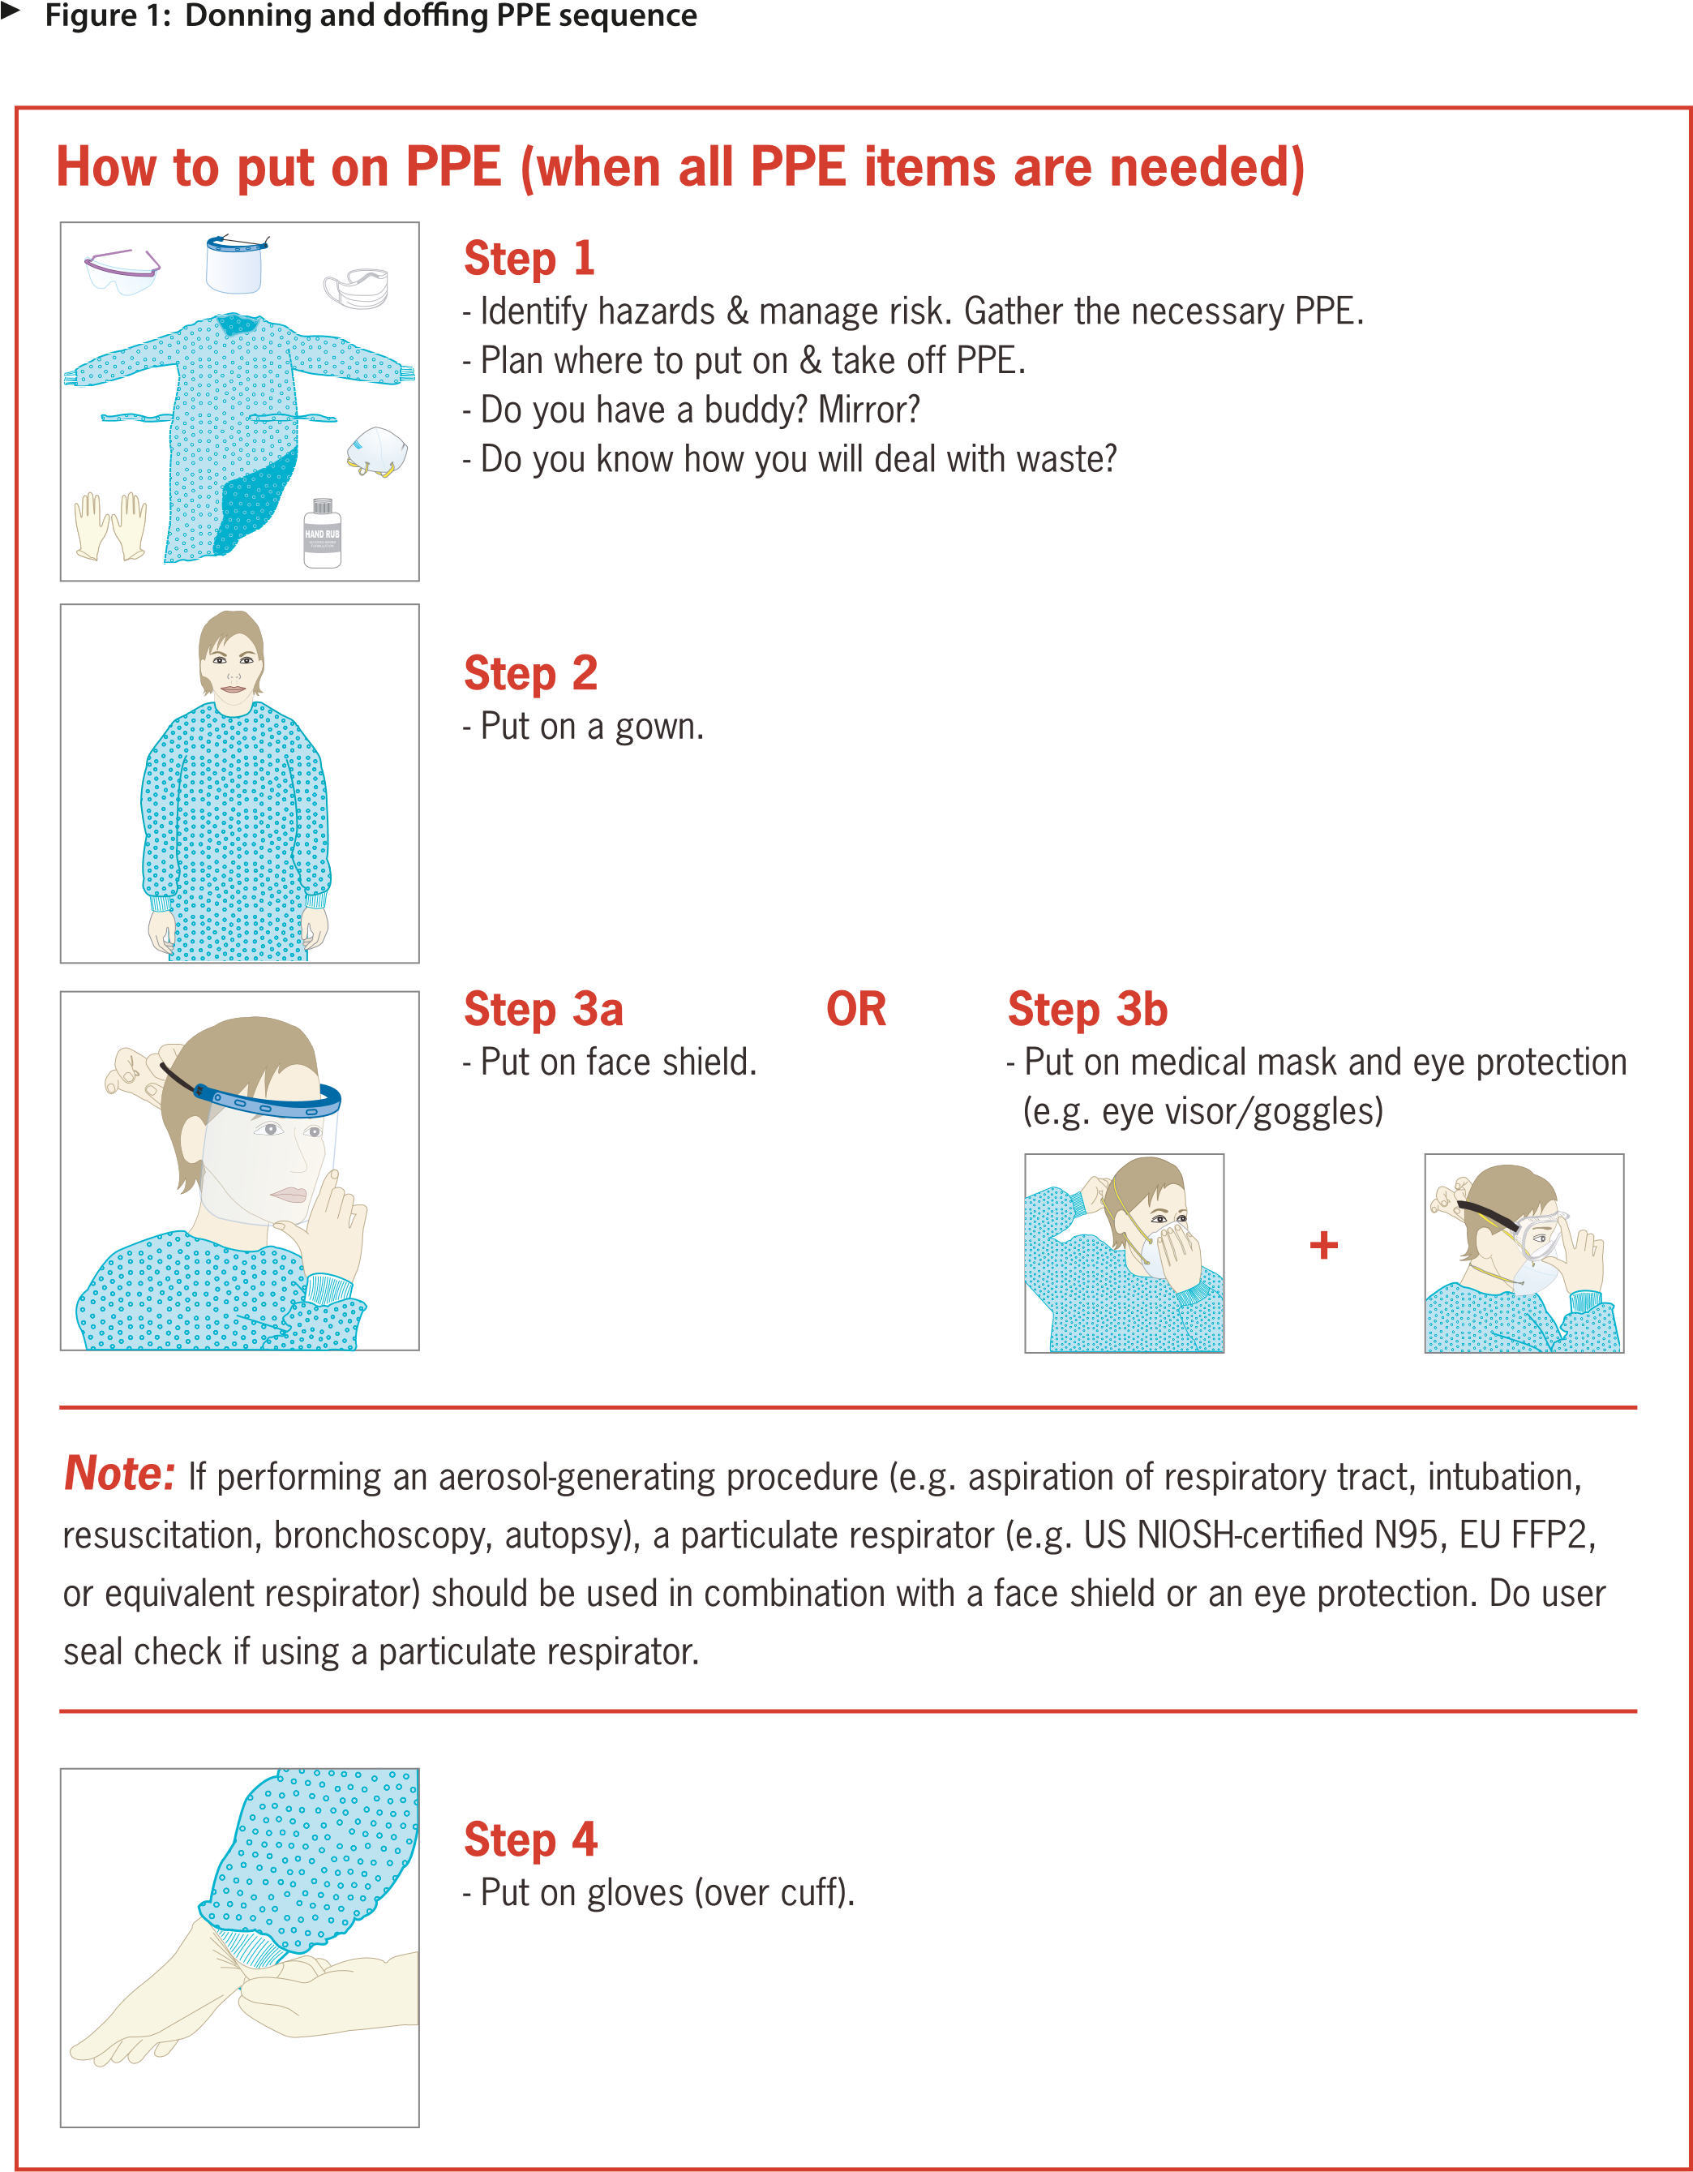

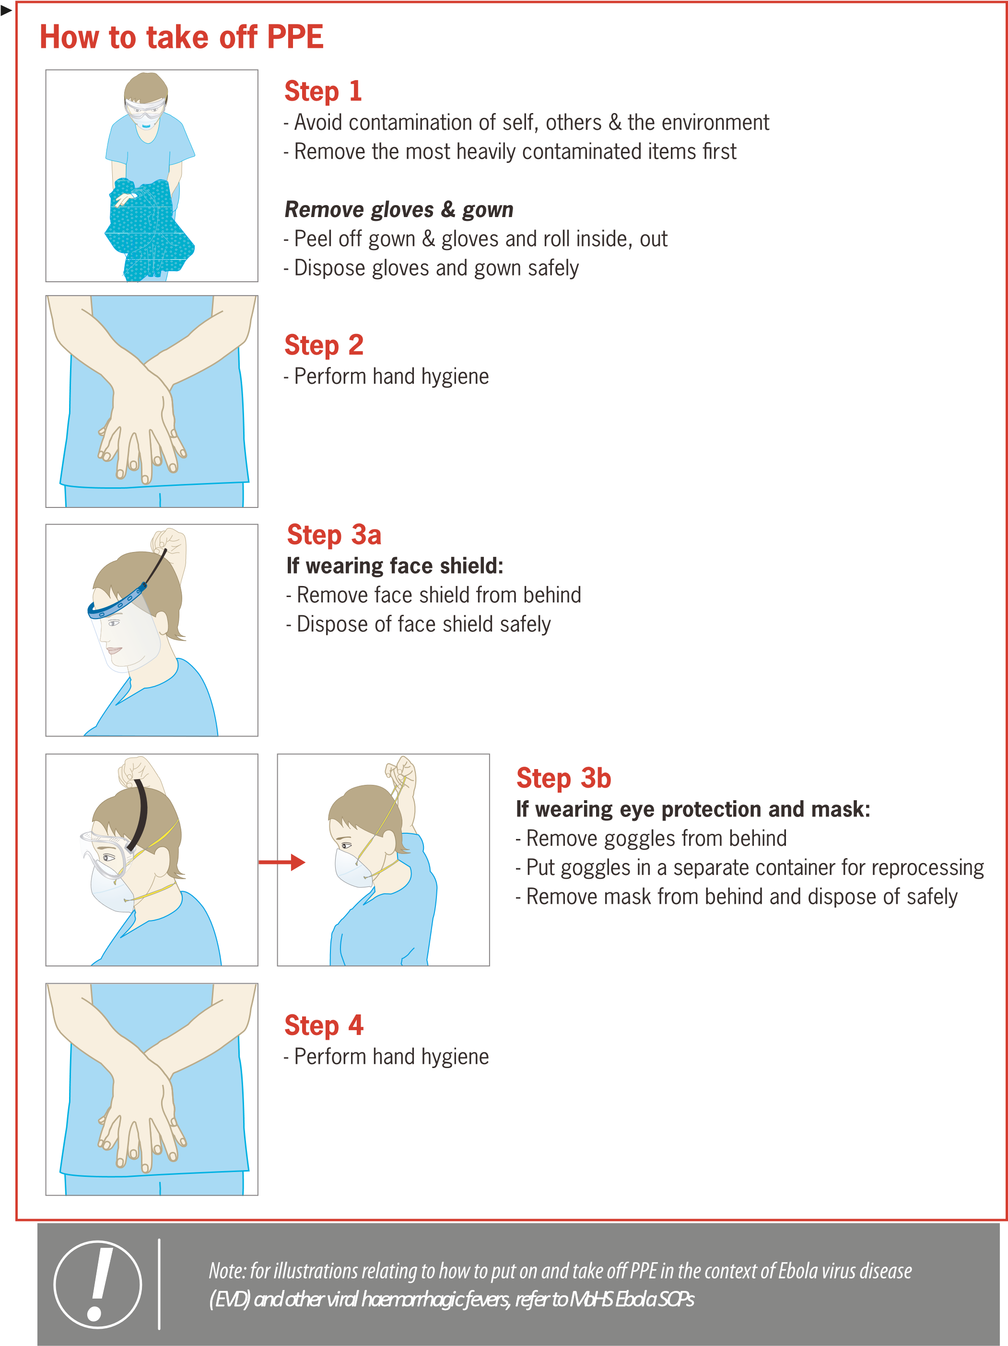

PRODUCTION OF PPE

Latex Surgical Gloves: How they’re made
Latex surgical gloves are a huge part of day to day activity at a hospital, protecting both patients and workers from transmission of diseases or other types of illness. Their manufacturing process is actually pretty simple, which helps make them affordable and disposable.

The Manufacturing Process
First, latex must be collected from the rubber tree. Growing mostly in southeastern Asian countries, farmers will extract the latex sap from trees by tapping them, similar in process to how maple trees are tapped for their syrup. The difference is that rather than drilling a hole into the tree, strips of bark are removed in a downward spiral, which allows the sap to run into a collection bucket. Next, the sap is sent to a production facility for preparation.
Once delivered to a production facility, various compounds are added to the sap that add to the latex’s ability to stretch, and to stabilize the material. It is at this time that liquid pigment dispersions can be added to color the latex to any color or shade. Chromatech has specially developed liquid pigment dispersions for latex, and are designed to be seamlessly added into the production process.
After the latex has been colored and prepared, the hand shaped molds must be cleaned and prepped for use. Manufacturers dip ceramic hand shaped formers into a water bath, and then into a bleach solution. This removes any residue that may be left over from the previous batch of gloves. Now that they’ve been cleaned, the formers are dipped into a calcium carbonate/calcium nitrate solution which helps the latex stick to the formers. Now that the preparation is complete, the formers are dipped into the latex bath, and varying the time that the formers are submerged controls the thickness of the glove.
The next step is to vulcanize the latex. Vulcanizing is crucial to the process as it is what gives latex its elasticity, and the gloves are also dried during this process. After drying, the gloves are rinsed with water to remove excess latex, which also gives the latex a softer texture.
At this point, the gloves are almost finished. If the gloves are meant to be powdered, they are dipped in a corn starch slurry, and then dried once more. For powder-free gloves, they are chlorinated and then coated with a polymer that makes the glove smooth. Finally, either air pressure or man power is used to remove the gloves from the formers and then prepared for quality checks and packaging.

Colorants from Chromatech
Chromatech has a line of pigment dispersions that are formulated to be compatible in latex surgical gloves. Whether you’re trying to color code different glove types or just want to have more color options, contact Chromatech today and talk to one of our technical sales representatives to learn more.
ALTERNATIVE TO PPEs AND ECONOMIC GROWTH
There would be less need for personal protective equipment if there were less need to move out i.e. to work. Due to technological advancement, we now have what we call robots, machines that have been programmed to carry out tasks just the way we want it. If for example most construction workers were replaced by robots, it would reduce the amount of health hazards brought to the workers and also the demand for such machines will aid in the growth of the economy, Yes some people may say that by doing do many will be made jobless however its bound to happen someday. With humanoid robots, all the company needs to do is get people to watch it while it works, if it needs to be controlled manually, do so, ensure its properly greased from time to time and life easier now.

CONCLUSION
In the production of most IPC and PPEs, they are often involved with automated or electromechanical machines, sometimes it could be when procuring the raw materials like with the latex gloves or the refinement process.
Technology has progress so much that if we take advantage of it, there might be less need for IPC and PPE since there’s little or no contact made on a daily bases.

